Forest plot for the all-causes mortality in different studies

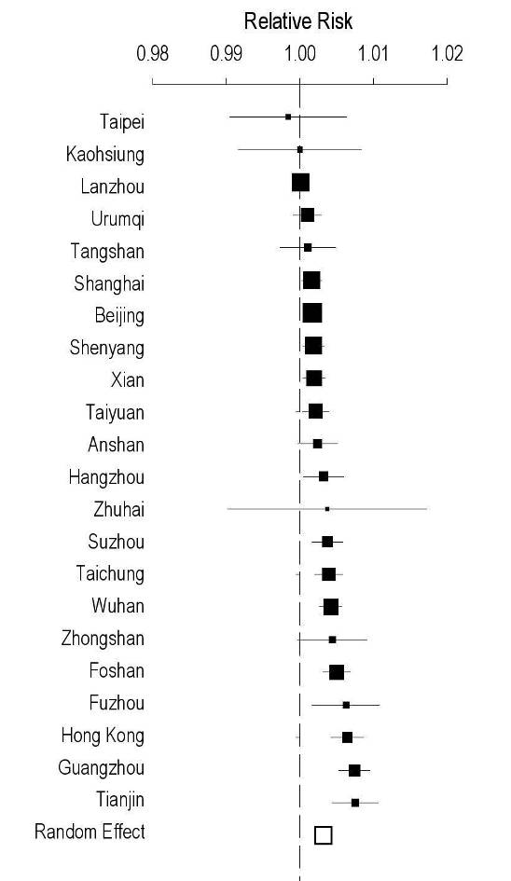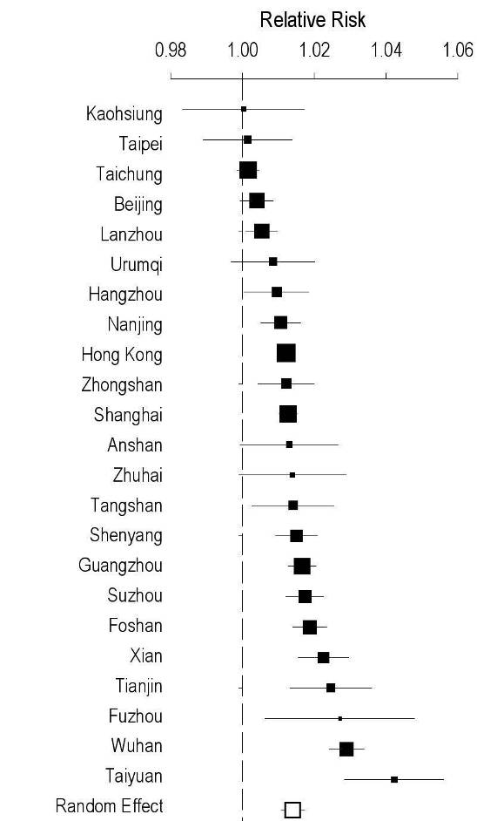
NO₂
PM₁₀

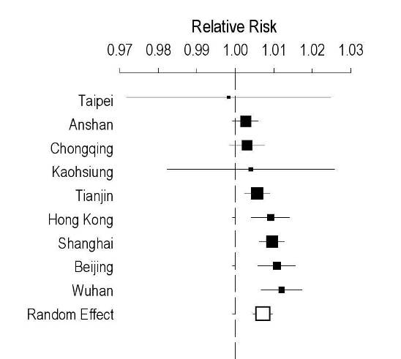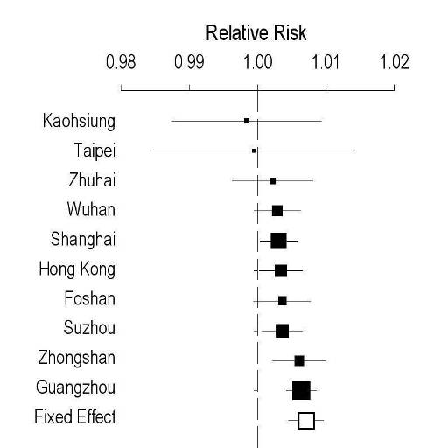
O₃
SO₂

Analysis of differences in ICD used in the literatures

Health effects | ICD-9 | ICD-10 | Ref # | Difference(%)
All-causes | 1-799 | A00-R99 | [33, 34, 45, 46, 50, 52-65, 67] | 0
All-causes | 1-999 | A00-T98 | [71] | 25.0
Cardiovascular diseases | 390-459 | I00-I99 | [33, 34, 50, 52-54, 56-59, 61, 67, 68, 72-74] | 0
Cardiovascular diseases | 390-414,417-448 | I00-I25,I27-I78 | [45, 46, 60] | 18.6
Cardiovascular diseases | 410-444 | I20-I74 | [76] | 50.0
Cardiovascular diseases | 410-411,414,430-437 | I21-I25,I60-I68 | [62] | 84.3
Ischemia heart diseases | 410-414 | I20-I25 | [54, 58, 72, 73] | 0
 | 410,411,414 | I21-I25 | [48] | 40.0
Stroke/ Cerebrovascular diseases | 430-438 | I60-I69 | [53, 54, 58, 61, 65, 72] | 0
Stroke/ Cerebrovascular diseases | 430-437 | I60-I68 | [48] | 11.1
Hypertension | 401 | I10 | [80, 81] | NA
Cardiac diseases | 390-398,410-429 | I00-I09,I20-I52 | [53, 54, 58, 65] | 0
 | 390-429 | I00-I52 | [73] | 37.9
Heart failure | 428 | I50 | [48, 73] | NA
Cardiac arrhythmias | 427 | I47-I49 | [73] | NA
Respiratory diseases | 460-519 | J00-J98/99 | [33, 34, 52-58, 62-66, 68, 71, 73, 78, 79] | 0
Respiratory diseases | 460-466,470-478,480-487,490-496 | J00-06,J09-J18, J20-J21,J30-J47 | [48] | 50.0
Asthma | 493 | J45-J46 | [54, 74] | NA
Chronic obstructive pulmonary diseases | 490-496 | J40-J47 | [53, 54, 69] | 0
Chronic obstructive pulmonary diseases | 490-493 | J40-J45 | [45, 46] | 42.9
Chronic obstructive pulmonary diseases | 491,492,496 | J41-J43,J47 | [74] | 57.1
Influenza and pneumonia | 480-487 | J09-J18 | [54, 58] | 0
 | 466,480-487 | J10-J22 | [72] | 12.5
Pneumonia | 486 | J18 | [72] | NA
Acute upper respiratory infections | 460-466 | J00-J06 | [78] | NA
Acute respiratory diseases | 460-466,480-487 | J00-J06,J09-J18 | [54] | NA
Acute pharyngitis | 462 | J02 | [78] | NA
Cardiopulmonary disease | 390-519 | I00-J98 | [50, 58, 65] | NA
Diabetes | 250 | E10-E14 | [70] | NA
Cancer | 140-208 | C00-C96 | [45, 46, 50] | NA
Non-cardiopulmonary, natural | 1-389,520-799 | A00-H95,K00-R99 | [54, 58, 65] | NA
Accidental | 800-999 | S00-T98 | [54, 58] | NA
Stillbirths | 740-758 | Q00-Q99 | [26] | NA
Note. Difference (%) in ICD-9 was shown. ICD codes in Italic were translated from the adjacent non-italic codes based on two reference sources (http://apps.who.int/classifications/icd10/browse/2010/en & http://icd9cm.chrisendres.com). NA, Not applicable.
60 locations without relevant literatures:

Anqing, Beihai, Bengbu, Changchun, Changde, Changsha, Changzhou, Chengdu, Dali, Dalian, Dandong, Fuzhou, Ganzhou, Guilin, Guiyang, Haikou, Harbin, Hefei, Hohhot, Hsinchu, Huizhou, Jilin, Jinan, Jinhua, Jining, Jinzhou, Jiujiang, Kunming, Luoyang, Luzhou, Macau, Mudanjiang Nanchang, Nanchong, Nanjing, Nanning, Ningbo, Pingdingshan, Qinhuangdao, Sanya, Shaoguan, Shijiazhuang, Tainan, Tangshan, Taoyuan, Ürümqi, Wenzhou, Wuxi, Xiamen, Xiangyang, Xining, Xi'an, Xuzhou, Yangzhou, Yantai, Yichang, Yinchuan, Yueyang, Zhanjiang and Zunyi.
Additional table: Relative risks of all-cause mortality in all age groups due to air pollution in older period of the same city. They were excluded from Table 1 and not pooled in the meta-analysis.

Ref# | City | Period | PM₁₀ |  | NO₂ |  | SO₂ |  | O₃
 |  |  | RR | SE | RR | SE | RR | SE | RR | SE
[1,2] | Anshan | 2001-2004 | 1.0007 | 12 | 1.0111 | 57
[1,2] | Guangzhou | 2007-2008 | 1.0115* | 12 | 1.0204* | 19
[3] | Hong Kong | 1995-1997 | 1.0037* | 19 | 1.0091* | 12 | 1.0111* | 38 | 1.0018 | 18
[1,2] | Shanghai | 2001-2004 | 1.0030* | 5
[4] |  | 2002-2003 | 1.0053* | 16
[5] |  | 2000-2001 | 1.0030* | 10 | 1.0200* | 36 | 1.0160* | 26
[6] | Taiyuan | 2004-2005 | 1.0025* | 11
[7,8] | Tianjin | 2005-2007 | 1.0045* | 12 | 1.0094* | 39
[9] | Wuhan | 2000-2004 | 1.0043* | 10 | 1.0196* | 34
Note. RR, Relative risk per 10 μg/m³ increase in pollutant concentration; SE, Standard error in 10⁻⁴. * indicated statistically significant at alpha = 0.05. 95%Cl = 1.96*SE ± RR.
References:
- Chen R, Kan H, Chen B, Huang W, Bai Z, Song G, Pan G, Group oBotCC: Association of particulate air pollution with daily mortality: the china air pollution and health effects study. Am J Epidemiol 2012, 175:1173–1181.
- Chen R, Samoli E, Wong CM, Huang W, Wang Z, Chen B, Kan H, CCG: Associations between short-term exposure to nitrogen dioxide and mortality in 17 chinese cities: the china Air pollution and health effects study (CAPES). Environ Int 2012, 45C:32–38.
- Wong CM, Ma S, Hedley AJ, Lam TH: Effect of air pollution on daily mortality in Hong Kong. Environ Health Perspect 2001, 109:335–340.
- Wong CM, Thach TQ, Chau PY, Chan EK, Chung RY, Ou CQ, Yang L, Peiris JS, Thomas GN, Lam TH, et al: Part 4. Interaction between air pollution and respiratory viruses: time-series study of daily mortality and hospital admissions in Hong Kong. Res Rep Health Eff Inst 2010:283–362.
- Kan H, Chen B: Air pollution and daily mortality in Shanghai: a time-series study. Arch Environ Health 2003, 58:360–367.
- Zhang YP, Zhang ZQ, Liu XH, Zhang XP, Feng BQ, Li HP: Concentration-response relationship between particulate air pollution and daily mortality in Taiyuan. Beijing Da Xue Xue Bao 2007, 39:153–157.
- Zhang YS, Zhou MG, Jia YP, Hu YS, Zhang JL, Jiang GH, Pan XC: Time-series analysis of association between inhalable particulate matter and daily mortality among urban residents in Tianjin. Zhonghua Liu Xing Bing Xue Za Zhi 2010, 31:544–548.
- Zhang YS, Zhou MG, Jia YP, Hu YS, Zhang JL, Jiang GH, Pan XC: Time-series analysis on the association between gaseous air pollutants and daily mortality in urban residents in Tianjin. Zhonghua Liu Xing Bing Xue Za Zhi 2010, 31:1158–1162.
- Qian Z, He Q, Lin HM, Kong L, Zhou D, Liang S, Zhu Z, Liao D, Liu W, Bentley CM, et al: Part 2. Association of daily mortality with ambient air pollution, and effect modification by extremely high temperature in Wuhan, China. Res Rep Health Eff Inst 2010:91–217.

