Photo 1: A typical slum location in Kampala City
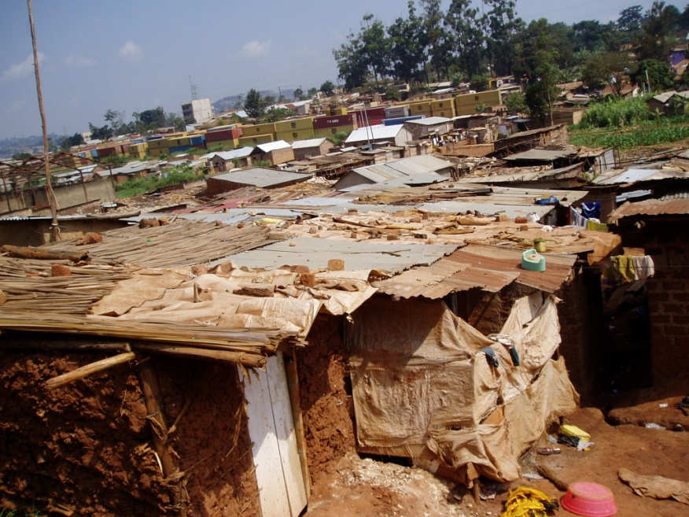

Photo 2: A case of challenging access to latrine by Women
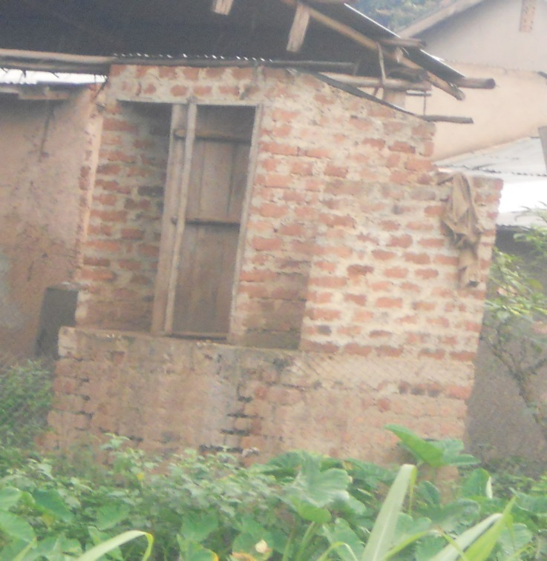

Photo 3: A case of a discouraging route for a female latrine user
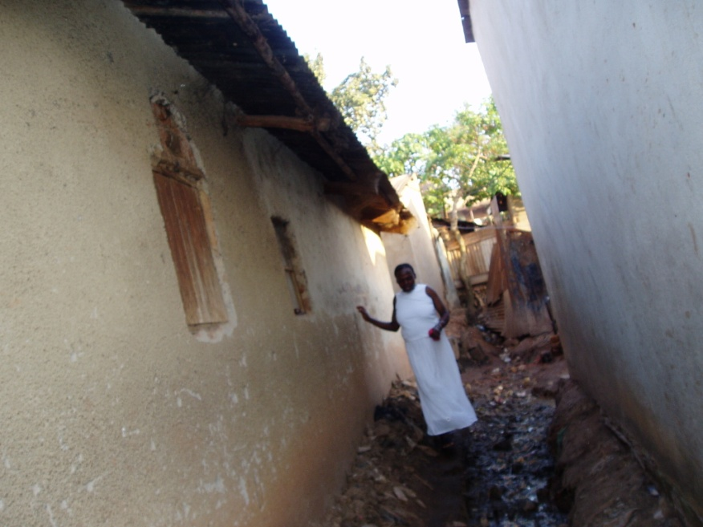
Photo 4: A child potty for Human waste disposal among female adults

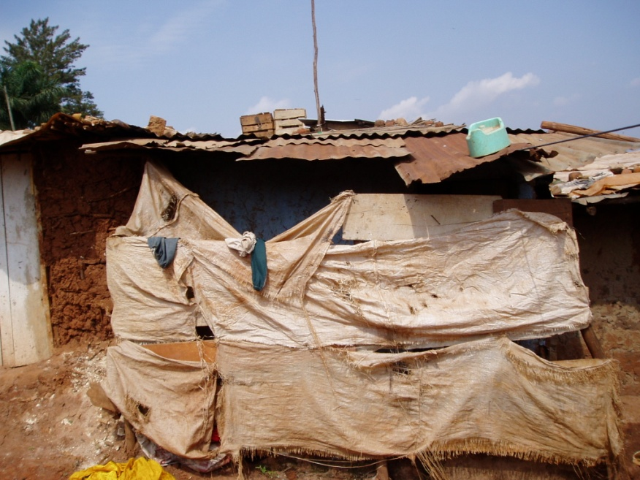

Photo 5: Doorless latrines serve no purpose especailly for adult females
