Schematic presentation of sampling procedure
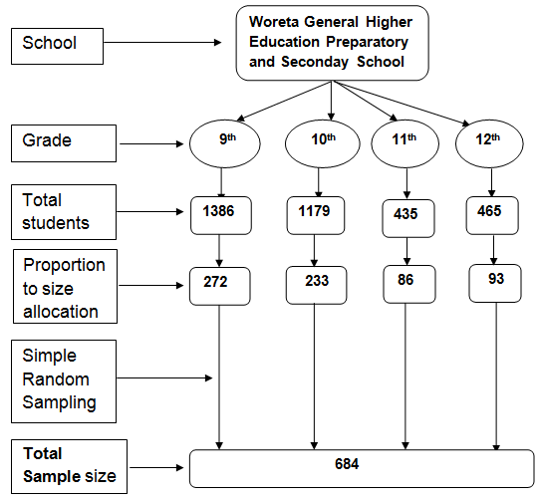
Figure 1: Schematic presentation for the sampling procedure, Woreta town, Northwest Ethiopia, May, 2012.

