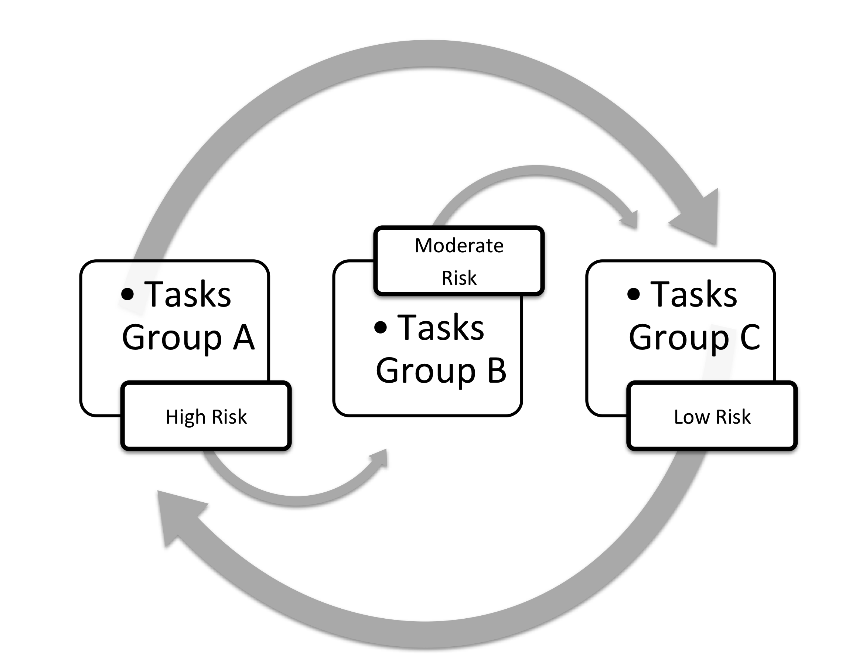
Figure 2 – Job Rotation Desing
Legend: Group A (operate Alome machine; Firsan- shaping socks; separation of product`s color and size; stamping; Tecma machine packaging; silicon preparing); Group B (Alome - choice of pair of socks; operate Satellite machine; operate Sealing machine; fix fast pin; automatic packaging); Group C (Firsan- choice of pair of socks; Satellite packing socks; Alome – socks review; manual packaging; operate Autotex machine; application of silicon; seamless products review)

