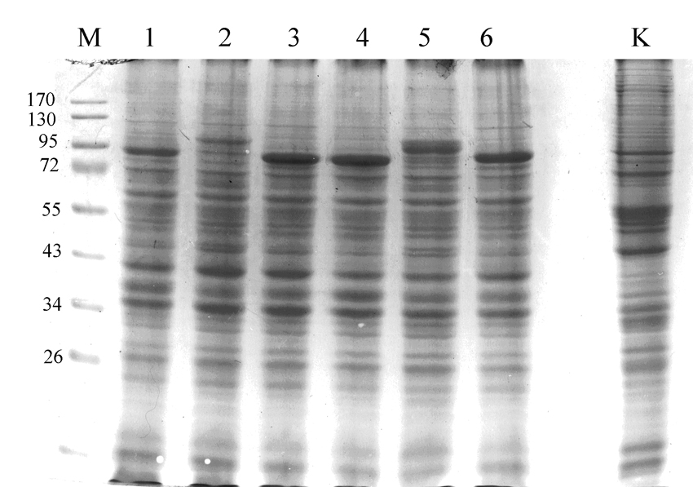

Naskalska et al, Fig 1. Supplementary data

