Table S1: The molecular descriptor values of the ethno compounds used in this study along with their pubchem compound IDs.
S.No | Name of the compound | Pubchem Compound ID | Molecular Formula | Mol. wt. | Log P | No. of H-bond donors | No. of H-bond acceptors | No. of rotatable bonds | TPSA | Drug score
 | Aloe-emodin | 10207 | C₁₅H₁₀O₅ | 270.23 | 1.8 | 3 | 5 | 1 | 101.15 | 0.34
 | Allicin | 65036 | C₆H₁₀OS₂ | 162.27 | 1.3 | 0 | 1 | 5 | 61.6 | 0.48
 | Anthra quinine | 6780 | C₁₄H₈O₂ | 208.21 | 3.4 | 0 | 2 | 0 | 34.14 | 0.08
 | Apigenin | 5280443 | C₁₅H₁₀O₅ | 270.23 | 1.7 | 3 | 5 | 1 | 87.0 | 0.22
 | Baicalein | 5281605 | C₁₅H₁₀O₅ | 270.23 | 1.7 | 3 | 5 | 1 | 87.0 | 0.44
 | Bisbenzylisoquinoline | 22169421 | C₂₃H₁₉N | 309.40 | 6 | 0 | 1 | 4 | 12.890 | 0.24
 | Caffeic acid | 689043 | C₉H₈O₄ | 180.15 | 1.2 | 3 | 4 | 2 | 77.76 | 0.19
 | Caffeoylquinic acid | 1794427 | C₁₆H₁₈O₉ | 354.30 | -0.4 | 6 | 9 | 5 | 164.75 | 0.62
 | Catechin | 9064 | C₁₅H₁₄O₆ | 290.26 | 0.4 | 5 | 6 | 1 | 110.38 | 0.87
 | Cochinolide | 10332730 | C₁₅H₁₄O₄ | 258.26 | 1.3 | 2 | 4 | 2 | 66.76 | 0.79
 | Epiafzelechin | 443639 | C₁₅H₁₄O₅ | 274.26 | 0.7 | 4 | 5 | 1 | 90.15 | 0.85
 | Galangin | 5281616 | C₁₅H₁₀O₅ | 270.23 | 2.3 | 3 | 5 | 1 | 87.0 | 0.28
 | Isoborneol | 64685 | C₁₀H₁₈O | 154.24 | 2.7 | 1 | 1 | 0 | 20.23 | 0.48
 | Kaempferol | 5280863 | C₁₅H₁₀O₆ | 286.23 | 1.9 | 4 | 6 | 1 | 107 | 0.22
 | Lignan | 261166 | C₂₅H₃₀O₈ | 458.50 | 3.8 | 0 | 8 | 9 | 89.52 | 0.6
 | Linalool | 6549 | C₁₀H₁₈O | 154.24 | 2.7 | 1 | 1 | 4 | 20.23 | 0.13
 | (3-chloro phenyl) methyl-3,4,5 trihydroxybenzoate | 10732589 | C₁₄H₁₁ClO₅ | 294.68 | 2.8 | 3 | 5 | 4 | 86.99 | 0.72
 | Methylgallate | 7428 | C₈H₈O₅ | 184.14 | 0.9 | 3 | 5 | 2 | 86.99 | 0.55
 | Morin | 5281670 | C₁₅H₁₀O₇ | 302.23 | 1.5 | 5 | 7 | 1 | 127 | 0.28
 | Oxyresveratrol | 5281717 | C₁₄H₁₂O₄ | 244.24 | 2.8 | 4 | 4 | 2 | 80.92 | 0.46
 | Phloroglucinol | 359 | C₆H₆O₃ | 126.11 | 0.2 | 3 | 3 | 0 | 60.69 | 0.18
 | Physcion | 10639 | C₁₆H₁₂O₅ | 284.26 | 3 | 2 | 5 | 1 | 83.83 | 0.33
 | Quercetin | 5280343 | C₁₅H₁₀O₇ | 302.23 | 1.5 | 5 | 7 | 1 | 127 | 0.32
 | Resveratrol | 445154 | C₁₄H₁₂O₃ | 228.24 | 3.1 | 3 | 3 | 2 | 60.69 | 0.22
 | Rhein | 10168 | C₁₅H₈O₆ | 284.22 | 2.2 | 3 | 6 | 1 | 111.90 | 0.61
 | Rosmarinic acid | 5281792 | C₁₈H₁₆O₈ | 360.31 | 2.4 | 5 | 8 | 7 | 144.52 | 0.49
 | Wogonin | 5281703 | C₁₆H₁₂O₅ | 284.26 | 3 | 2 | 5 | 2 | 76.0 | 0.43
 | Yatein | 442835 | C₂₂H₂₄O₇ | 400.42 | 3.8 | 0 | 7 | 7 | 72.45 | 0.69
 | Zeatin | 449093 | C₁₀H₁₃N₅O | 219.24 | 0.7 | 3 | 1 | 4 | 86.72 | 0.1

Table S2: Toxicity of ethno compounds based on Osiris Property Explorer predictions:

S.No | Name of the compound | Mutagenic | Tumorigenic | Irritant | Reproductive effective
 | Aloe-emodin | Red | Green | Green | Green
 | Allicin | Green | Green | Green | Green
 | Anthra quinone | Red | Red | Red | Green
 | Apigenin | Red | Yellow | Green | Red
 | Baicalein | Red | Green | Green | Green
 | Bisbenzylisoquinoline | Green | Green | Green | Green
 | Caffeic acid | Red | Red | Green | Red
 | Caffeoylquinic acid | Green | Green | Green | Green
 | Catechin | Green | Green | Green | Green
 | Cochinolide | Green | Green | Green | Green
 | Epiafzelechin | Green | Green | Green | Green
 | Galangin | Red | Yellow | Green | Yellow
 | Isoborneol | Green | Green | Green | Green
 | Kaempferol | Red | Yellow | Green | Red
 | Lignan | Green | Green | Green | Green
 | Linalool | Red | Green | Red | Yellow
 | (3-chloro phenyl) methyl-3,4,5 trihydroxybenzoate | Green | Green | Green | Green
 | Methylgallate | Green | Green | Green | Green
 | Morin | Red | Yellow | Green | Yellow
 | Oxyresveratrol | Green | Green | Green | Green
 | Phloroglucinol | Red | Green | Green | Red
 | Physcion | Yellow | Green | Green | Green
 | Quercetin | Red | Yellow | Green | Yellow
 | Resveratrol | Yellow | Green | Green | Red
 | Rhein | Green | Green | Green | Green
 | Rosmarinic acid | Green | Green | Green | Green
 | Wogonin | Green | Green | Green | Green
 | Yatein | Green | Green | Green | Green
 | Zeatin | Red | Green | Red | Red

Table S3: Toxicity of ethno compounds based on Lazar program predictions:
 |  | Mutagenicity |  | Carcinogenicity
S.No | Name of the compound | Salmonella typhimurium (CPDB) | Salmonella typhimurium (Kazius/Bursi) | Mouse
 | Aloe-emodin | Yes | Yes | No
 | Allicin | Yes | No | No
 | Anthra quinone | Yes | Yes | NA
 | Apigenin | Yes | No | No
 | Baicalein | Yes | Yes | No
 | Bisbenzylisoquinoline | Yes | Yes | NA
 | Caffeic acid | No | No | No
 | Caffeoylquinic acid | No | No | No
 | Catechin | No | No | No
 | Cochinolide | No | No | No
 | Epiafzelechin | No | No | No
 | Galangin | Yes | Yes | No
 | Isoborneol | No | NA* | No
 | Kaempferol | Yes | No | No
 | Lignan | No | No | No
 | Linalool | No | No | No
 | (3-chloro phenyl) methyl-3,4,5 trihydroxybenzoate | No | No | No
 | Methylgallate | No | No | No
 | Morin | Yes | Yes | No
- e | Oxyresveratrol | No | No | No
 | Phloroglucinol | No | No | No
 | Physcion | Yes | Yes | No
 | Quercetin | Yes | Yes | No
 | Resveratrol | No | No | No
 | Rhein | Yes | Yes | No
 | Rosmarinic acid | No | No | No
 | Wogonin | Yes | Yes | No
 | Yatein | No | No | No
- n | Zeatin | Yes | Yes | Yes

NA = Not enough similar compounds in training dataset. NA*= No measured activity

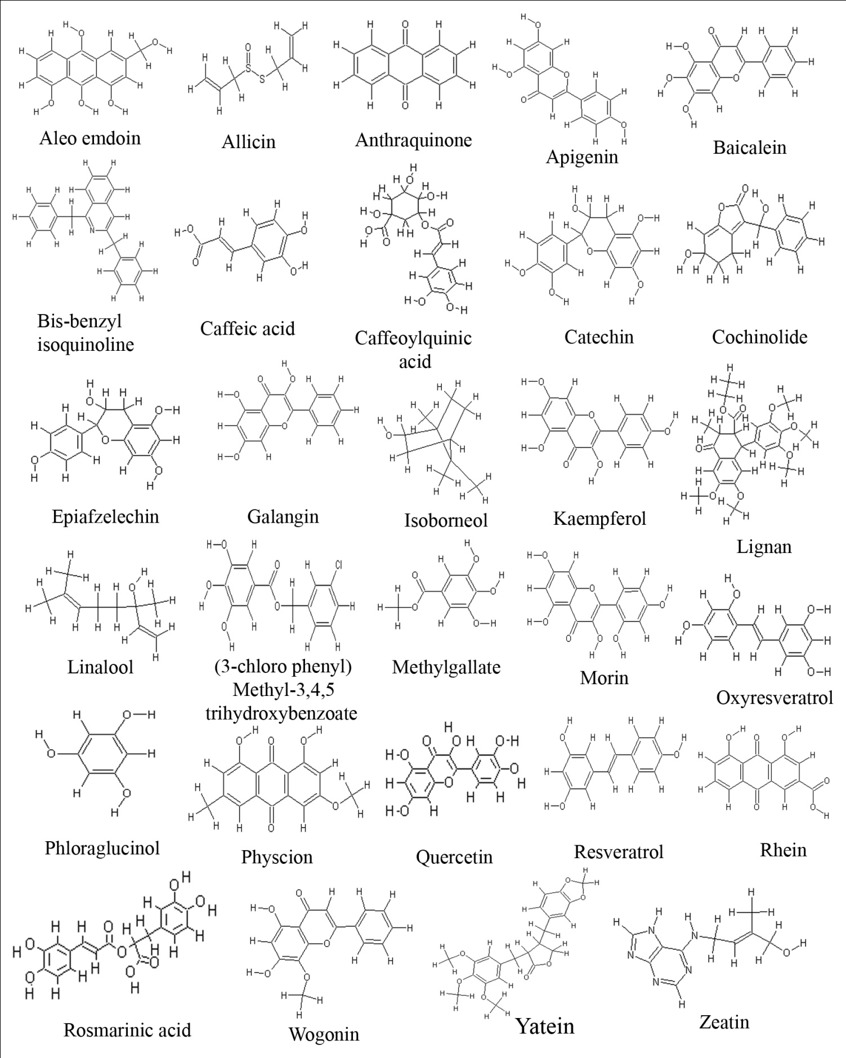Figure S1: Structures of the ethno compounds used in the present study.

