Additional file
Table S1
Results from multiple level analysis: Univariate Kaplan Meier analysis of 5-year disease-specific death for 80 patients with oral squamous cell carcinoma with various subtypes of tertiary lymphoid structures (TLSs).
Patients | N=80  (no. (%)) | 5-Year death (%) | P-value
classical TLS | 5 (6.3) | 0.0 | 0.150
all others | 75 (93.8) | 36.0 | 0.150
non-classical TLSs | 8 (10.0) | 25.0 | 0.574
all others | 72 (90.0) | 34.7 | 0.574
both classical and non-classical TLS | 4 (5.0) | 0.0 | 0.165
all others | 76 (95.0) | 35.5 | 0.165
P-values were calculated using the log-rank test.

Figure S1

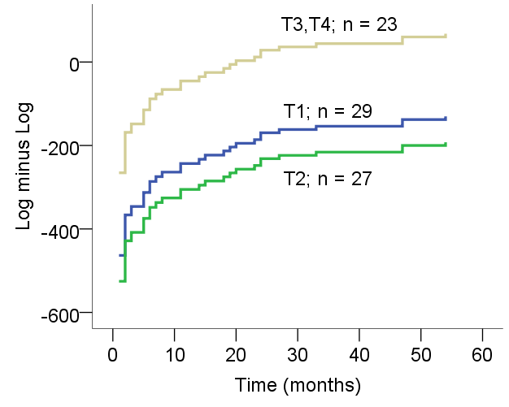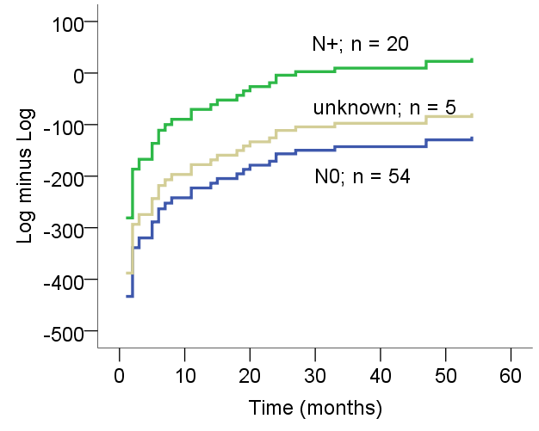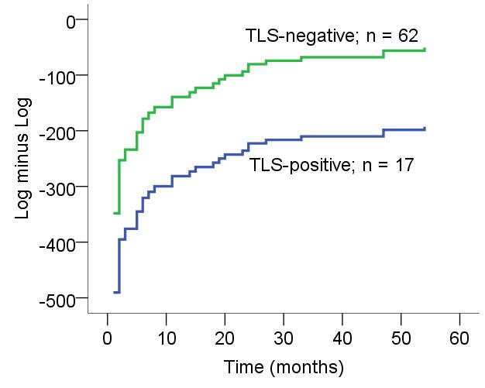
A
C
B

Results: Log minus log plots for proportional hazards checking; (A) T stage; (B) N stage; (C) tertiary lymphoid structure (TLS).

