Figure 3: Trends in key indicators

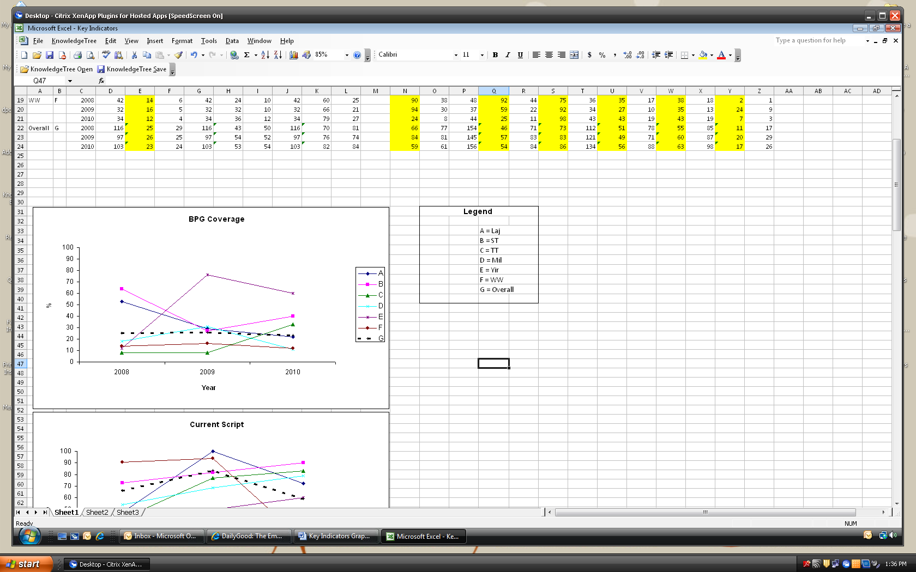

Clinic:

BPG Coverage = % patients receiving ≥80% of scheduled injections; Current script = % patients with a current BPG prescription on file; Management Plans refers to %patients with a current management plan in the clinical record; Doctor review (and Specialist review) refer to % patients with a record of having their health and RHD care reviewed by a doctor (specialist) within a specified period in relation to RHD risk status; Echo = %patients with a record of having an echocardiogram within a specified period in relation to RHD risk status; Dental review = %patients with a record of having a dental review within two years of the audit date.

Solid lines each show data for a specific health centre (as identified by the letters in the legend). The dashed line shows the aggregate data for the six health centres.

