Additional file 2: Percentage distribution of cost per procedure across cost components, by agency and delivery mode
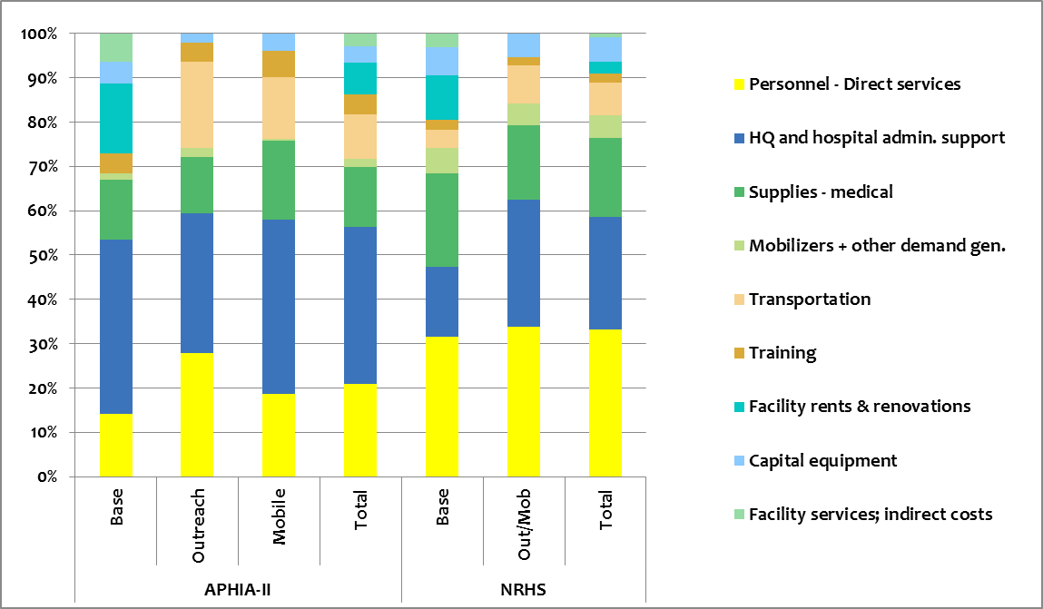
Note: Transportation includes fuel, maintenance, depreciation, insurance, and the value of staff time.

