Supplementary Information
Extensive Exometabolome Analysis Reveals Extended Overflow Metabolism in various Microorganism
Nicole Paczia¹, Anke Nilgen¹, Tobias Lehmann¹, Jochem Gätgens¹, Wolfgang Wiechert¹, Stephan Noack*¹

Content
1. Abbreviations 2
2. Organism-wide exometabolome analysis 3
3. Hypotheses on metabolite occurrence 7
4. Metabolite transport 8
5. References 9

Abbreviations

Central metabolic intermediates |  |  | Amino acids
G6P | Glucose-6-phosphate |  | ALA | Alanine
F6P | Fructose-6-phosphate |  | LEU | Leucine
FBP | Fructose-1,6-bisphosphate |  | VAL | Valine
DHAP | Dihydroxyacetone phosphate |  | ASP | Aspartate
GA3P | Glyceraldehyde-3-phosphate |  | HOM | Homoserine
13PG | 1,3-phosphoglycerate |  | THR | Threonine
2PG | 2-phosphoglycerate |  | MET | Methionine
3PG | 3-phosphoglycerate |  | LYS | Lysine
PEP | Phosphoenolpyruvate |  | ILEU | Isoleucine
PYR | Pyruvate |  | MET | Methionine
R5P | Ribose-5-phosphate |  | TRP | Tryptophane
RU5P | Ribulose-5-phosphate |  | TYR | Tyrosine
X5P | Xylulose-5-phosphate |  | PHE | Phenylalanine
E4P | Erythrose-4-phosphate |  | GLU | Glutamate
S7P | Sedoheptulose-7-phosphate |  | GLN | Glutamine
CIT | Citrate |  | PRO | Proline
CAN | Cis-aconitate |  | SER | Serine
ICIT | Isocitrate |  | GLY | Glycine
AKG | α-Ketoglutarate |  | ARG | Arginine
SUC | Succinate |  | HIS | Histidine
FUM | Fumarate
Others
ACT | Acetate
ETH | Ethanol
ORO | Orotate
URA | Uracil

Organism-wide exometabolome analysis

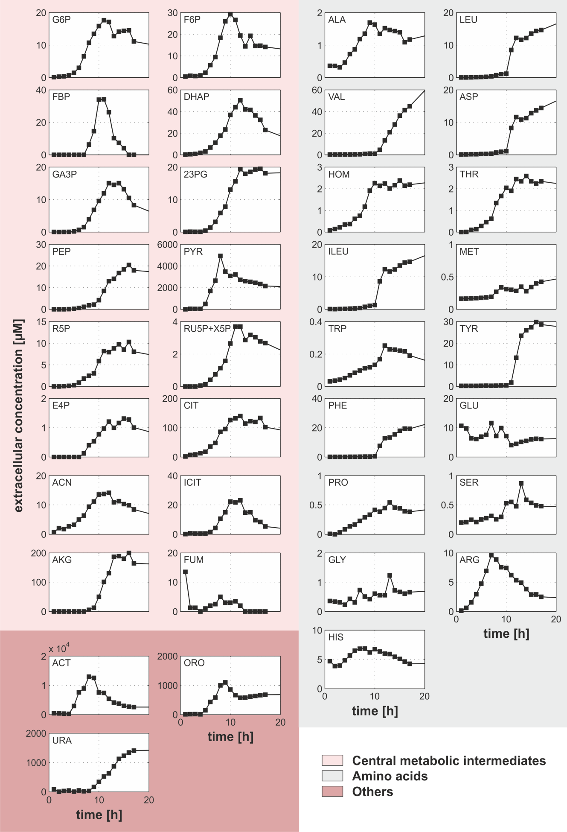
Figure S1: Exometabolome analysis of intermediates and free amino acids from central metabolism during batch-cultivation of E. coli WT on defined media with 20 g l⁻¹ glucose.

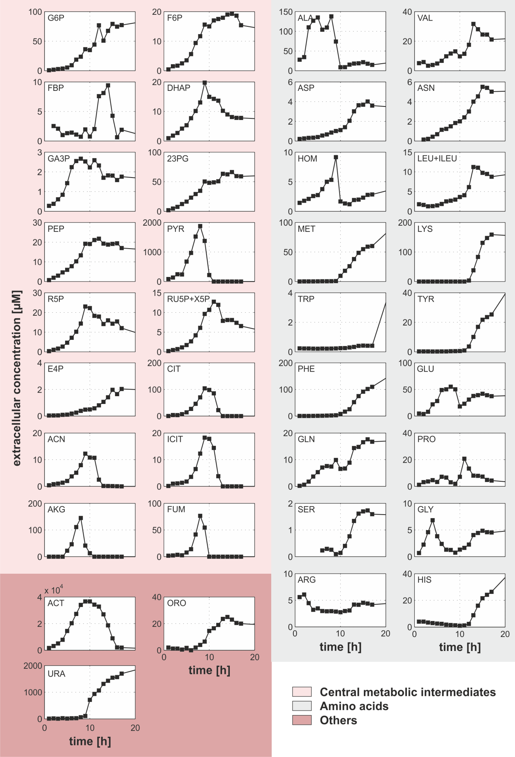
Figure S2: Exometabolome analysis of intermediates and free amino acids from central metabolism during batch-cultivation of B. licheniformis WT on defined media with 16 g l⁻¹ glucose.

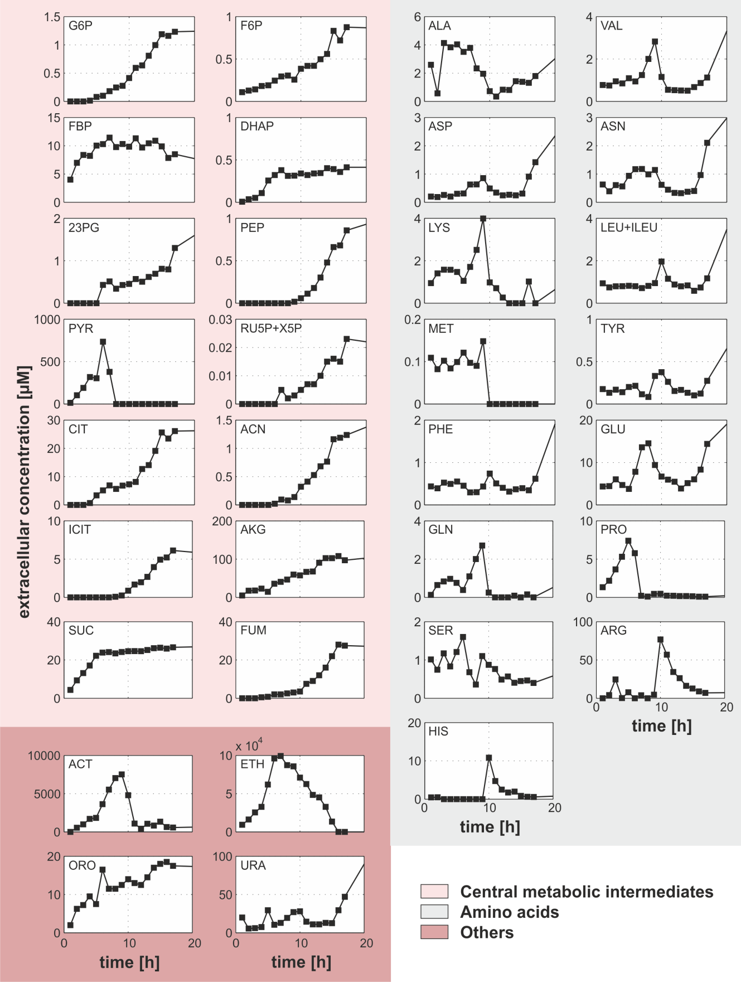
Figure S3: Exometabolome analysis of intermediates and free amino acids from central metabolism during batch-cultivation of S. cerevisiae WT on defined media with 16 g l⁻¹ glucose.

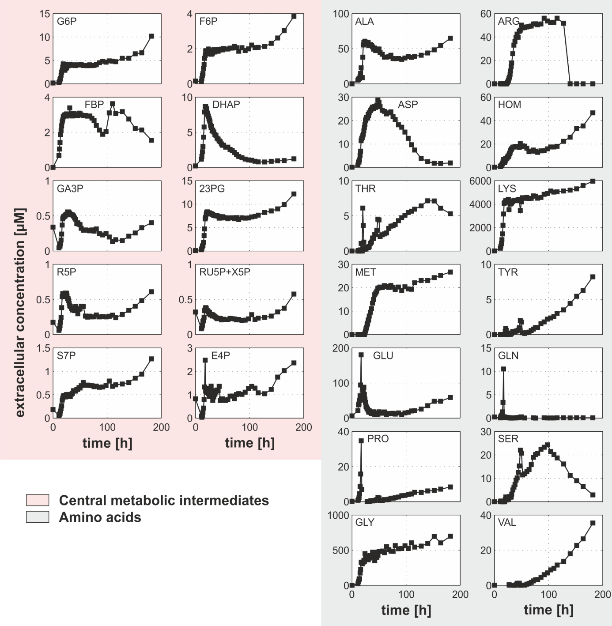
Figure S4: Exometabolome analysis of intermediates and free amino acids from central metabolism during batch-cultivation of C. glutamicum DM1800 on defined media with 10 g l⁻¹ glucose.

Hypotheses on metabolite occurrence

Table S1: Theoretically lysed biomass to explain the occurrence of extracellular metabolites in the culture broth during E. coli WT batch cultivations. Applying mass balancing the measured concentration data of intracellular metabolites found in the culture medium were set into relation with the specific minimum and maximum intracellular concentration value reported for E. coli WT so far (shown in bold blue and red, respectively). If necessary reference values were recalculated to biomass specific values using the reported specific intracellular volumes (see table footer). The maximal biomass dry weight in our experiment was CDW_{max} ≈ 8 g.
Central  metabolic  intermediate | Measured  Culture  medium  concentrationª  [µmol l⁻¹] | Reference intracellular concentration  [µmol g_{CDW}⁻¹] |  |  |  |  |  |  | Theoretically  lysed biomass^{g}  [g_{CDW}]
Central  metabolic  intermediate | Measured  Culture  medium  concentrationª  [µmol l⁻¹] | [1]^{b} | [2]^{c} | [3]^{d} | [4]^{e} | [5] | [6] | [7]^{f} | min | max
G6P | 17.65 ± 0.53 | 0.61 | 8.28 | 0.47 | - | 1.42 | 1.22 | - | 2.1 | 37.6
F6P | 29.29 ± 0.60 | 0.70 | 1.43 | 0.21 | - | 0.38 | 0.27 | - | 20.5 | 139.5
FBP | 34.21 ± 0.72 | 9.15 | 0.65 | 0.65 | 37.50 | - | 0.67 | 0.43 | 0.9 | 79.6
GA3P | 15.04 ± 0.17 | - | 0.52 | 0.52 | 0.12 | 0.17 | - | - | 28.9 | 125.3
2/3PG | 19.45 ± 1.55 | - | - | - | 3.75 | 1.65 | 1.24 | - | 5.2 | 15.7
PEP | 20.43 ± 0.28 | - | 6.36 | 0.94 | 0.45 | 1.61 | 1.22 | 0.08 | 3.2 | 255.4
AKG | 2.27 ± 0.35 | - | - | - | 1.10 | 0.31 | - | - | 2.1 | 7.3
FUM | 12.45 ± 2.31 | - | - | - | 0.30 | 0.22 | - | - | 41.5 | 56.6
ªThe time dependent maximum is taken from Table 1.
^{b}2.78 ml g_{CDW}⁻¹
^{c}2.38 ml g_{CDW}⁻¹
^{d}2.6 ml g_{CDW}⁻¹
^{e}2.5 ml g_{CDW}⁻¹
^{f}2.15 ml g_{CDW}⁻¹
^{g}The working volume of the bioreactor was 1 l.

Metabolite transport

Table S2: Comparison between intermediate pools measured extracellular during batch cultivation in the culture medium and current knowledge on corresponding transport reactions. Red areas indicate mismatches between intermediates measured in this study and annotations in organism specific genome scale models.
 | E. coli  (K12 W3110) |  | C. glutamicum  (DM1800) |  | B. licheniformis  (DSM13D102) |  | S. cerevisiae  (CEN.PK 113-7D)
Central  metabolic  intermediates | Measured  extracellular  (this study) | Annotated  transport  reaction [8] | Measured  extracellular  (this study) | Annotated  transport  reaction [9] | Measured  extracellular  (this study) | Annotated  transport  reaction [10]^{c} | Measured  extracellular  (this study) | Annotated  transport  reaction [11]
G6P | + | + | + |  | + | + | +
F6P | + | + | + |  | + | + | +
FBP | + |  | + |  | + |  | +
GA3P | + |  | + |  | +
DHAP | + |  | + |  | + |  | +
13PG | +ª |  | +ª |  | +ª |  | +ª
3PG | +ª |  | +ª |  | +ª | + | +ª
2PG | +ª |  | +ª |  | +ª | + | +ª
PEP | + |  |  |  |  | + | +
PYR | + | + |  |  | + | + | + | +
R5P | + | + | + |  | +
RU5P | +ª |  | +ª |  | +ª |  | +ª
X5P | +ª |  | +ª |  | +ª |  | +ª
E4P | + |  | + |  | +
S7P |  |  | +
CIT | + | + |  | + | + | + | + | +
CAN | + |  |  |  | + |  | +
ICIT | + |  |  |  | + |  | +
AKG | + | + |  |  | + | + | + | +
SUC |  | + |  |  |  | + | + | +
FUM | + | + |  |  | + | + | + | +
Amino acids
SER | + | + | + | + | + | + | + | +
GLY | + | + | + |  | + | + |  | +
ALA | + | + | + | + | + | + | + | +
VAL | + | + | + | + | + | + | + | +
LEU | +ª | + |  | + | +ª | + | +ª | +
ILEU | +ª | + |  | + | +ª | + | +ª | +
ASP | + | + |  | + | + | + | + | +
ASN |  | + | + |  | + | + | + | +
HOM | + | + | + |  | +
THR | + | + | + | + |  | + |  | +
MET | + | + | + | + | + | + | + | +
LYS |  | + | +^{b} | + | + | + | + | +
TRP | + | + |  | + | + | + |  | +
PHE | + | + |  |  | + |  | + | +
TYR | + | + | + | + | + | + | + | +
GLU | + | + | + | + | + | + | + | +
GLN |  | + | + | + | + | + | + | +
PRO | + | + | + | + | + | + | + | +
ARG | + | + | + | + | + | + | + | +
HIS | + | + |  |  | + | + | + | +
ª intermediates are not separable by the applied analytics
^{b} L-lysine production strain
^{c} annotation based on the published genome scale model for B. subtilis

… Table S2: Continued.
 | E. coli  (K12 W3110) |  | C. glutamicum  (DM1800) |  | B. licheniformis  (DSM13D102) |  | S. cerevisiae  (CEN.PK 113-7D)
Others | Measured  extracellular  (this study) | Annotated  transport  reaction [8] | Measured  extracellular  (this study) | Annotated  transport  reaction [9] | Measured  extracellular  (this study) | Annotated  transport  reaction [10]^{c} | Measured  extracellular  (this study) | Annotated  transport  reaction [11]
ACT | + | + |  | + | + | + | + | +
ETH |  | + |  |  |  | + | + | +
ORO | + | + |  |  | + |  | +
URA | + | + |  |  | + | + | + | +
ª Intermediates are not separable by the applied analytics
^{b} L-lysine production strain
^{c} Annotation based on the published genome scale model for B. subtilis

References

1. Buchholz A, Takors R, Wandrey C: Quantification of intracellular metabolites in Escherichia coli K12 using liquid chromatographic-electrospray ionization tandem mass spectrometric techniques. Analytical biochemistry 2001, 295:129-137.
2. Chassagnole C, Noisommit-Rizzi N, Schmid JW, Mauch K, Reuss M: Dynamic modeling of the central carbon metabolism of Escherichia coli. Biotechnology and Bioengineering 2002, 79:53-73.
3. Hiller J, Franco-Lara E, Weuster-Botz D: Metabolic profiling of Escherichia coli cultivations: evaluation of extraction and metabolite analysis procedures. Biotechnology letters 2007, 29:1169-1178.
4. Bennett BD, Kimball EH, Gao M, Osterhout R, Van Dien SJ, Rabinowitz JD: Absolute metabolite concentrations and implied enzyme active site occupancy in Escherichia coli. Nature chemical biology 2009, 5:593-599.
5. Heijnen JJ: Impact of thermodynamic principles in systems biology. Adv Biochem Eng Biotechnol 2010, 121:139-162.
6. De Mey M, Taymaz-Nikerel H, Baart G, Waegeman H, Maertens J, Heijnen JJ, van Gulik WM: Catching prompt metabolite dynamics in Escherichia coli with the BioScope at oxygen rich conditions. Metabolic Engineering 2010, 12:477-487.
7. Park C, Lee Y, Lee SY, Oh HB, Lee J: Determination of the Intracellular Concentrations of Metabolites in Escherichia coli Collected during the Exponential and Stationary Growth Phases using Liquid Chromatography-Mass Spectrometry. Bulletin of the Korean Chemical Society 2011, 32:524-530.
8. Orth JD, Conrad TM, Na J, Lerman JA, Nam H, Feist AM, Palsson B: A comprehensive genome-scale reconstruction of Escherichia coli metabolism--2011. Mol Syst Biol 2011, 7:535.
9. Shinfuku Y, Sorpitiporn N, Sono M, Furusawa C, Hirasawa T, Shimizu H: Development and experimental verification of a genome-scale metabolic model for Corynebacterium glutamicum. Microb Cell Fact 2009, 8:43.
10. Henry CS, Zinner JF, Cohoon MP, Stevens RL: iBsu1103: a new genome-scale metabolic model of Bacillus subtilis based on SEED annotations. Genome Biol 2009, 10:R69.
11. Mo ML, Palsson BO, Herrgård MJ: Connecting extracellular metabolomic measurements to intracellular flux states in yeast. BMC Syst Biol 2009, 3:37.

