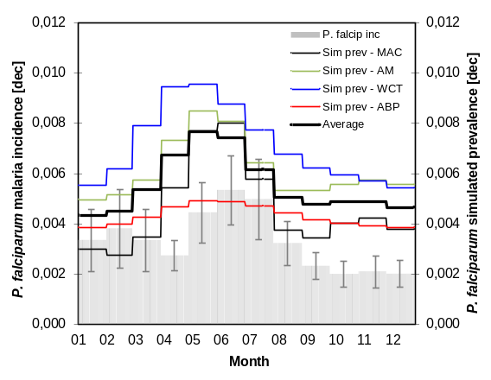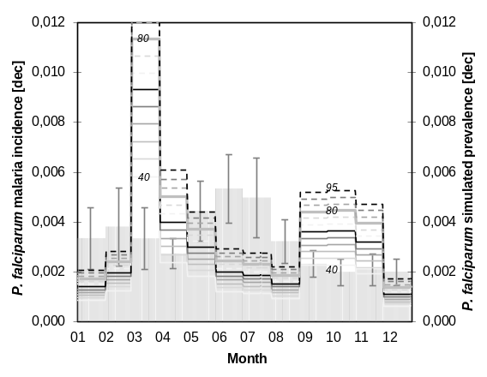
Simulation outputs for base scenarios
Left panel: actual Plasmodium falciparum malaria incidence observed in Tea Plantation 1 over the period spanning from January, 1970 through October, 2004 (grey solid bars), along with malaria prevalence simulated by the MAC (black solid line labeled Sim prev – MAC), AM (green solid line labeled Sim prev – AM), WCT (blue solid line labeled Sim prev – WCT), and ABP (red solid line labeled Sim prev – ABP) models for the historical annual cycles of mean temperature and rainfall. The black thick line depicts the annual cycle of P. falciparum malaria prevalence obtained by averaging all models’ simulation outputs. The following parameter values were assumed for the MAC model: b=0.01; HD=20 days; WN=20 days; r=1/(HD+WN); α=exp(-1/1.229); υ=1.26 days; f_{U}=36.5°C-days; l=5.0 °C; g_{U}=9.9°C; U=υ + (f_{U}/(T+l-g_{U})); p=α^(1/U); x_{p}=0.01; T_{e}=T+(1-x_{p})*l; a=0.091678*T_{e}-1.7982; and d=27,000 individuals. For the AM model (besides the set of parameters proposed for the MAC model): f_{N}=116°C-days; g_{N}=16°C; n=f_{N}/(T+l-g_{N}); t_{h}=13 days; t_{m}=10 days; μ₁=(1/(70*365)) days⁻¹; μ₂=(1/21) days⁻¹; and c=1.0. For the WCT model (besides the set of parameters proposed for the MAC and AM models): μ=6,500; C=0.24; β=exp(-1/0.4); x=0.1; h=0.8; k=1; v=0.4; r_{WCT}=1/(80/30) month⁻¹; and λ=1.00. And for the ABP model (besides the set of parameters proposed for the MAC, AM and WCT models): δ_{H}=1/20*(1/135); b_{ABP}=0.5; β_{e}=0.0000257; σ₀=0.0805; ρ=0.428; r₀=0.00555; γ=0.0486; ξ=0.825; η=0.0346; ν=0.05; F=66; k_{A}=695; k_{E}=0.198; δ₀=0.0329; c_{ABP}=0.365; x_{ABP}=0.01; and ΔT=4.2°C. Right panel: actual P. falciparum malaria incidence (grey solid bars) along with malaria prevalence simulated by the WCT model for various mean durations of infectivity, 1/r_{WCT} (from 40 to 95 days).

