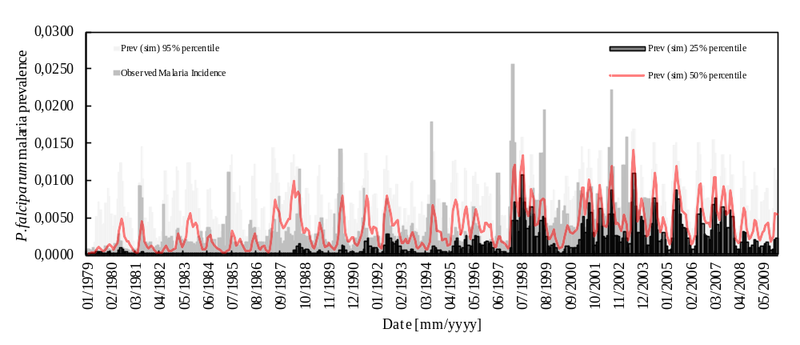(A)
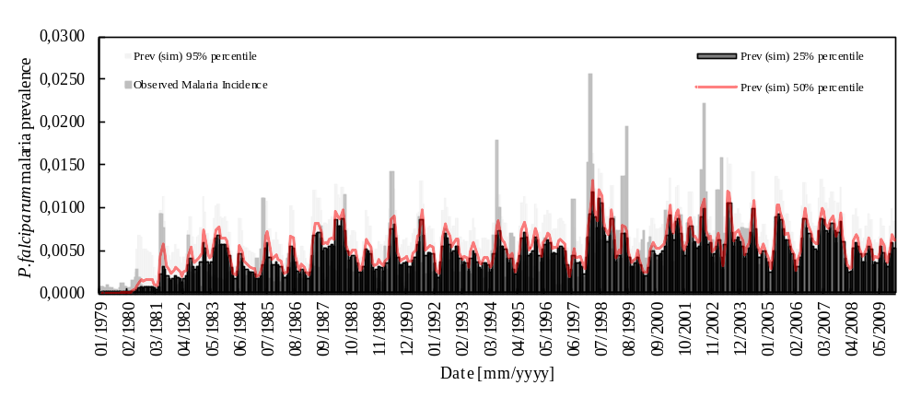(B)
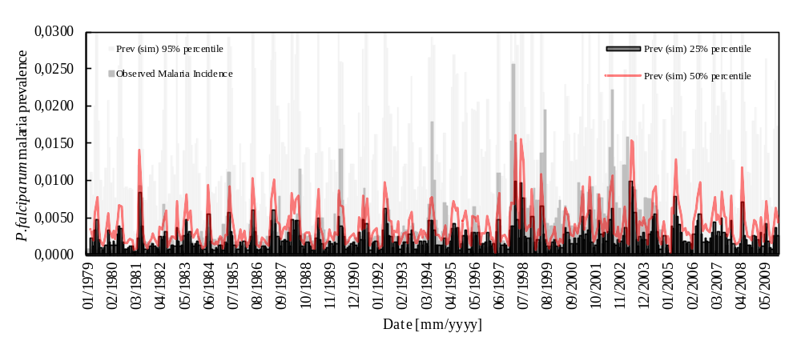(C)
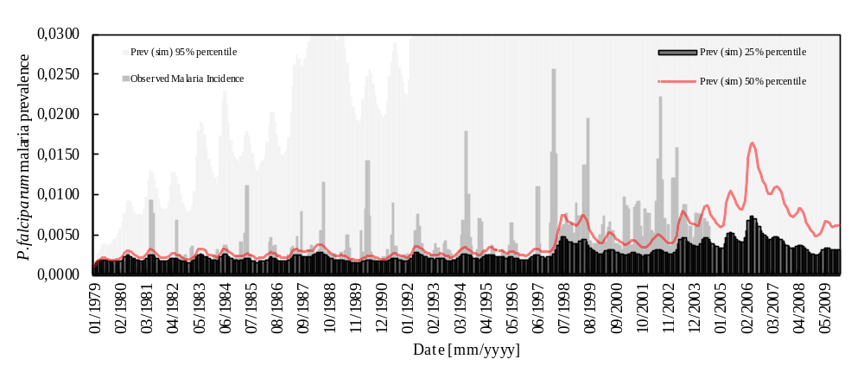(D)
Individual model simulation outputs
Monthly Plasmodium falciparum malaria incidence observed in Kericho over the period spanning from January, 1979 through October, 2004 (grey solid bars), along with the 25%, 50% and 95% percentiles of the distributions of monthly P. falciparum malaria prevalence simulated by the MAC (panel A), AM (panel B), WCT (panel C), and ABP (panel D) models, for the actual climatic conditions, for the period spanning from January, 1979 through December, 2009, and for 1-, 1-, 2-, and 0-month time lags, respectively. The following parameter ranges were assumed for the MAC model: b=[0.001;0.010] (10 values); HD=[11;26 days] (9 values); WN=[12;30 days] (10 values); α=[0.4;0.6] (11 values); υ=[0.5;4.0 days] (9 values); f_{U}=[36.5;37.1 °C-days] (7 values); l=[1;10 °C] (10 values); g_{U}=[7.7;9.9 °C] (12 values); x_{p}=[0.00;1.00] (12 values); and d=[fixed constant]. For the AM model (besides the set of parameters proposed for the MAC model): f_{N}=[111.0;204.4 °C-days] (11 values); g_{N}=[14.2;19.0 °C] (11 values); t_{h}=[5.5;16 days] (12 values); t_{m}=[8;30 days] (8 values); μ₁=[(1/(60*365));(1/(80*365)) days⁻¹] (5 values); μ₂=[(1/30);(1/11.2) days⁻¹] (5 values); and c=[unknown; fixed constant]. For the WCT model (besides the set of parameters proposed for the MAC and AM models): μ=[2,000;10,000] (10 values); C=[0.00;0.50] (7 values); β=[unknown; fixed constant]; x=[0.0;0.3] (7 values); h=[0.5;1.0] (6 values); k=[0.0;1.0] (10 values); v=[0.0;1.0] (10 values); r_{WCT}=[1/(666.66/30);1/(25.97/30) month⁻¹] (10 values); and λ=[unknown; fixed constant]. And for the ABP model (besides the set of parameters proposed for the MAC, AM and WCT models): δ_{H}=[fixed constant]; b_{ABP}=[0.01;0.50] (6 values); β_{e}=[0;10⁻⁴] (12 values); σ₀=[0.00;0.10] (12 values); ρ=[0.00;1.00] (11 values); r₀=[0.00;0.01] (12 values); γ=[0.0475;0.1435] (11 values); ξ=[fixed constant]; η=[0.00;0.10] (12 values); ν=[0.2;1.0] (10 values); F=[fixed constant]; k_{A}=[0;3*103] (8 values); k_{E}=[0;0.3] (7 values); δ₀=[fixed constant]; c_{ABP}=[0.00;0.379] (9 values); x_{ABP}=[0;1] (12 values); and ΔT=[2.2;5.0°C] (8 values). Literature ranges are reported in 36 and [50-66].

