Supplemental Material

Table 1. Specification of seasonal effects and partial autocorrelation function (PACF) coefficients in simulated time-series studies
- Seasonal effects C_{i} of 4 candidate pollutants
 | X₁ | X₂ | X₃ | X₄
C₁ | 1.10 | 2.23 | 1.72 | 0.97
C₂ | 1.08 | 1.93 | 1.94 | 0.82
C₃ | 1.55 | 2.27 | 1.75 | 1.11
C₄ | 1.20 | 2.78 | 2.14 | 1.12

- PACF coefficients Ф_{kj} on previous 10 days in simulation scenario 3 with 4 candidate pollutants
 | Lag 1 | Lag 2 | Lag 3 | Lag 4 | Lag 5 | Lag 6 | Lag 7 | Lag 8 | Lag 9 | Lag 10
Ф_{1j} | 0.3243 | 0.0310 | 0.0568 | 0.0400 | 0.0146 | 0.0434 | 0.0900 | 0.0386 | 0.0130 | 0.0522
Ф_{2j} | 0.5287 | -0.0372 | 0.0939 | 0.0022 | 0.0375 | 0.1192 | 0.0445 | 0.0514 | 0.0203 | 0.0235
Ф_{3j} | 0.8155 | -0.3358 | -0.0184 | 0.0444 | -0.0153 | 0.0465 | -0.0160 | 0.0140 | 0.0444 | -0.0517
Ф_{4j} | 0.3301 | -0.0174 | 0.0198 | -0.0094 | -0.0266 | 0.0362 | 0.0326 | 0.0305 | -0.0288 | -0.0030

- PACF coefficients Ф_{kj} on previous 5 days in simulation scenario 4 with 10 candidate pollutants
 | Lag 1 | Lag 2 | Lag 3 | Lag 4 | Lag 5
Ф_{1j} | 0.32 | 0.03 | 0.06 | 0.04 | 0.05
Ф_{2j} | 0.53 | -0.04 | 0.09 | 0 | 0.02
Ф_{3j} | 0.82 | -0.34 | -0.02 | 0.04 | -0.05
Ф_{4j} | 0.33 | -0.02 | 0.02 | -0.01 | -0.03
Ф_{5j} | 0.40 | 0.05 | 0.08 | 0.03 | -0.02
Ф_{6j} | 0.80 | -0.40 | -0.02 | 0.05 | -0.05
Ф_{7j} | 0.34 | 0.07 | -0.05 | 0.02 | 0.05
Ф_{8j} | 0.70 | -0.20 | 0.02 | -0.02 | 0.01
Ф_{9j} | 0.55 | -0.03 | 0.08 | 0.01 | 0.02
Ф_{10j} | 0.50 | 0.03 | -0.04 | 0.05 | 0.02

Table 2. Distribution of National Health and Nutrition Examination Survey (NHANES) study population by covariates (2005-2008)
Covariate | Level |  | N (percent)*
Age |  | 12-19 | 944 (25.0%)
 |  | 20-34 | 753 (20.0%)
 |  | 35-49 | 741 (19.6%)
 |  | 50-64 | 688 (18.2%)
 |  | 65-79 | 488 (12.9%)
 |  | 80+ | 159 (4.2%)
Gender |  | Male | 1871 (49.6%)
 |  | Female | 1902 (50.4%)
Race/Ethnicity |  | Mexican American | 800 (21.2%)
 |  | Other Hispanic | 248 (6.60%)
 |  | Non-Hispanic White | 1698 (45.0%)
 |  | Non-Hispanic Black | 870 (23.1%)
 |  | Other Race/Multi-Racial | 157 (4.20%)
Poverty income ratio (PIR) |  | 0-0.99 | 812 (21.5%)
 |  | 1-1.99 | 984 (26.1%)
 |  | 2-2.99 | 583 (15.5%)
 |  | 3-3.99 | 450 (11.9%)
 |  | 4-5 | 944 (25.0%)
BMI (kg/m²) |  | Underweight (<18.5) | 185 (4.90%)
 |  | Normal weight (18.5-24) | 1262 (33.4%)
 |  | Overweight (25-29) | 1132 (30.0%)
 |  | Obese I (30-34) | 644 (17.1%)
 |  | Obese II 35+ | 550 (14.6%)
* Sample sizes and percents unadjusted for sampling weights.
Table 3. Pearson correlation coefficients between four groups of exposures from NHANES study (2005-2008)
(a) Phthalates
 | MEHHP | MEHP | MECPP | MnBP | MiBP | MBzP | MEP | MCPP
MEOHP | 0.98536* | 0.81658* | 0.95667* | 0.54447* | 0.52374* | 0.52859* | 0.27337* | 0.59584*
MEHHP | 1 | 0.82230* | 0.95433* | 0.53583* | 0.52126* | 0.51874* | 0.26925* | 0.59385*
MEHP |  | 1 | 0.78788* | 0.38143* | 0.38111* | 0.36291* | 0.21415* | 0.43349*
MECPP |  |  | 1 | 0.49884* | 0.48635* | 0.48030* | 0.25963* | 0.59618*
MnBP |  |  |  | 1 | 0.74923* | 0.70880* | 0.40139* | 0.60915*
MiBP |  |  |  |  | 1 | 0.62461* | 0.37842* | 0.56644*
MBzP |  |  |  |  |  | 1 | 0.33354* | 0.55979*
MEP |  |  |  |  |  |  | 1 | 0.28092*
*p<0.05

(b) Phenols
 | BP3 | OP | TCS | BPAR | EPAR | MPAR | PPAR
BPA | 0.18428* | 0.09741* | 0.15452* | 0.09382* | 0.11745* | 0.20001* | 0.17284*
BP3 | 1 | 0.01205 | 0.15869* | 0.26749* | 0.23744* | 0.28799* | 0.28631*
OP |  | 1 | 0.05218* | 0.01437 | 0.00237 | 0.01412 | 0.02352
TCS |  |  | 1 | 0.10362* | 0.10303* | 0.15256* | 0.14034*
BPAR |  |  |  | 1 | 0.51478* | 0.46087* | 0.48405*
EPAR |  |  |  |  | 1 | 0.42804* | 0.43767*
MPAR |  |  |  |  |  | 1 | 0.81628*
*p<0.05

(c) Pesticides
 | 2,5-DCP | OPP | 2,4,5-TCP | 2,4,6-TCP
2,4-DCP | 0.87198* | 0.07817* | 0.23637* | 0.25995*
2,5-DCP | 1 | 0.07469* | 0.19863* | 0.20625*
OPP |  | 1 | 0.06466* | 0.10072*
2,4,5-TCP |  |  | 1 | 0.36657*
*p<0.05

(d) Perchlorate and related anions
 | NO3 | SCN
P8 | 0.54723* | 0.19034*
NO3 | 1 | 0.39261*
*p<0.05

Table 4. Estimates of regression coefficients from single-exposure models from NHANES study (2005-2008)
 | Bilirubin |  |  |  |  | GGT
 | Estimate | SE | t value | Pr(>|t|) |  | Estimate | SE | t value | Pr(>|t|)
MnBP | -0.025 | 0.008 | -3.270 | 0.001 |  | 0.020 | 0.012 | 1.735 | 0.083
MEP | -0.008 | 0.005 | -1.713 | 0.087 |  | 0.003 | 0.007 | 0.465 | 0.642
MEHP | -0.028 | 0.005 | -5.416 | <0.001 |  | 0.003 | 0.008 | 0.396 | 0.692
MBzP | -0.021 | 0.006 | -3.391 | 0.001 |  | 0.006 | 0.009 | 0.619 | 0.536
MCPP | -0.024 | 0.007 | -3.690 | <0.001 |  | -0.022 | 0.010 | -2.147 | 0.032
MEHHP | -0.030 | 0.005 | -5.678 | <0.001 |  | 0.013 | 0.008 | 1.577 | 0.115
MEOHP | -0.033 | 0.005 | -6.136 | <0.001 |  | -0.019 | 0.008 | -2.308 | 0.021
MiBP | -0.009 | 0.007 | -1.265 | 0.206 |  | 0.032 | 0.011 | 3.017 | 0.003
MECPP | -0.020 | 0.006 | -3.353 | 0.001 |  | <0.001 | 0.009 | -0.042 | 0.967
BPA | -0.007 | 0.007 | -0.903 | 0.367 |  | -0.013 | 0.011 | -1.207 | 0.227
BP3 | 0.006 | 0.003 | 1.898 | 0.058 |  | 0.009 | 0.005 | 1.881 | 0.060
OP | 0.018 | 0.020 | 0.923 | 0.356 |  | -0.015 | 0.030 | -0.503 | 0.615
TCS | <0.001 | 0.003 | -0.086 | 0.932 |  | 0.002 | 0.005 | 0.473 | 0.636
BPAR | <0.001 | 0.004 | 0.046 | 0.963 |  | 0.002 | 0.006 | 0.376 | 0.707
EPAR | 0.015 | 0.004 | 3.627 | <0.001 |  | 0.034 | 0.006 | 5.421 | <0.001
MPAR | -0.001 | 0.004 | -0.273 | 0.785 |  | -0.001 | 0.006 | -0.089 | 0.929
PPAR | -0.001 | 0.003 | -0.169 | 0.865 |  | -0.002 | 0.005 | -0.448 | 0.654
2,4-DCP | -0.010 | 0.005 | -2.133 | 0.033 |  | -0.015 | 0.007 | -2.093 | 0.036
2,5-DCP | -0.007 | 0.003 | -2.244 | 0.025 |  | -0.012 | 0.005 | -2.402 | 0.016
OPP | 0.006 | 0.009 | 0.643 | 0.520 |  | 0.001 | 0.014 | 0.044 | 0.965
2,4,5-TCP | -0.021 | 0.011 | -1.940 | 0.052 |  | -0.017 | 0.017 | -1.040 | 0.298
2,4,6-TCP | -0.033 | 0.012 | -2.676 | 0.007 |  | -0.022 | 0.019 | -1.179 | 0.238
P8 | -0.068 | 0.008 | -8.416 | <0.001 |  | -0.030 | 0.013 | -2.403 | 0.016
NO3 | -0.045 | 0.011 | -3.974 | <0.001 |  | -0.013 | 0.018 | -0.763 | 0.445
SCN | -0.005 | 0.007 | -0.700 | 0.484 |  | 0.013 | 0.011 | 1.202 | 0.229

SE, standard error.

Figure 5. Pre-screening of exposure variables by correlation analysis and CART for the NHANES data (2005-2008)
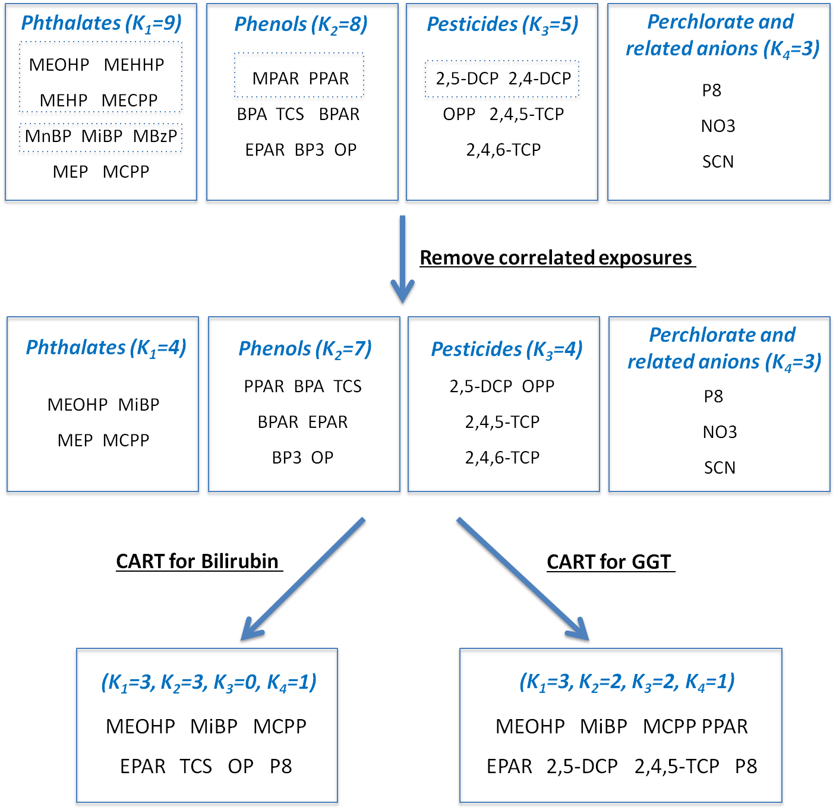
Exposures in the same dashed rectangle were highly correlated (Pearson correlation coefficient > 0.60). K_{i} refers to the number of variables retained in the i^{th} group of exposures.

Table 6. Additional measures of performance for five statistical methods under different simulated scenarios over 1000 replicates
Scenario | Measure | BMA | DSA | LASSO | PLSR | SPCA
Scenario 1 | FPR ¹ | 16.6% | 34.5% | 22.9% | N/A | 64.2%
Scenario 1 | TPR ² | 66.9% | 68.1% | 74.0% | N/A | 87.9%
Scenario 1 | MSE-CP ³ | 0.446 | 0.969 | 0.373 | 0.424 | 0.440
Scenario 1 | MSE-NP ⁴ | 0.044 | 0.381 | 0.266 | 0.025 | 0.049
Scenario 2:  (A) Regression analysis | FPR | N/A | 7.9% | 9.6% | N/A | 35.8%
Scenario 2:  (A) Regression analysis | TPR | N/A | 57.3% | 46.5% | N/A | 94.4%
Scenario 2:  (A) Regression analysis | MSE-CP | N/A | 0.868 | 1.005 | 0.955 | 1.005
Scenario 2:  (A) Regression analysis | MSE-NP | N/A | 0.993 | 1.028 | 0.099 | 0.062
Scenario 2:  (B) Two-step modeling strategy | FPR | 0.60% | 0.08% | 0.80% | N/A | 1.45%
Scenario 2:  (B) Two-step modeling strategy | TPR | 68.0% | 57.5% | 71.8% | N/A | 75.8%
Scenario 2:  (B) Two-step modeling strategy | MSE-CP | 0.864 | 0.816 | 0.743 | 0.685 | 1.049
Scenario 2:  (B) Two-step modeling strategy | MSE-NP | 0.103 | 0.0003 | 0.125 | 0.102 | 0.122
Scenario 3 | FPR | 23.3% | N/A | 34.3% | N/A | 2.4%
Scenario 3 | TPR | 94.0% | N/A | 100% | N/A | 36.5%
Scenario 3 | MSE-CP | 0.061 | N/A | 0.006 | 0.016 | 0.188
Scenario 3 | MSE-NP | 0.003 | N/A | 0.001 | 0.010 | 0.0004
Scenario 4 | FPR | 15.1% | N/A | 30.8% | N/A | 14.2%
Scenario 4 | TPR | 95.5% | N/A | 99.9% | N/A | 47.6%
Scenario 4 | MSE-CP | 0.040 | N/A | 0.017 | 0.035 | 0.165
Scenario 4 | MSE-NP | 0.021 | N/A | 0.001 | 0.013 | 0.007

1: FPR, false positive rate, measures the mean of the ratio that the number of falsely “identified” null predictors divided by the total number of null predictors, where in BMA predictors with their posterior probabilities greater than 10% are regarded as identified, in DSA those selected into the best predictive model by cross-validation are viewed as identified, in LASSO estimated regression coefficients not equal to zero are considered identified, and in SPCA predictors are identified if their Wald’s statistics from univariate models are larger than a threshold value. 2: TPR, true positive rate, represents the mean of ratio that the number of correctly identified causal predictors divided by the total number of causal predictors. PLSR does not have a FPR or TPR since it involves no variable selection. 3: MSE-CP, mean squared error for causal predictors. 4: MSE-NP, mean squared error for null predictors.

Table 7. Estimated effects of exposure variables in proposed models for the NHANES data
Response - Bilirubin |  |  |  |  | Response - GGT
Exposure | Estimate | SE | p-value |  | Exposure | Estimate | SE | p-value
EPAR | 0.029 | 0.007 | <0.001 |  | EPAR | 0.075 | 0.016 | <0.001
MEOHP | -0.027 | 0.005 | <0.001 |  | P8 | -0.045 | 0.014 | 0.001
P8 | -0.061 | 0.008 | <0.001 |  | 2,4,5-TCP | -0.075 | 0.025 | 0.003
TCS | 0.003 | 0.004 | 0.361 |  | MiBP | 0.031 | 0.012 | 0.009
TCS*EPAR | -0.005 | 0.002 | 0.021 |  | MCPP | -0.039 | 0.016 | 0.015
 |  |  |  |  | PPAR | 0.036 | 0.016 | 0.029
 |  |  |  |  | 2,5-DCP | -0.011 | 0.005 | 0.034
 |  |  |  |  | MEOHP | -0.017 | 0.009 | 0.062
 |  |  |  |  | EPAR*PPAR | -0.015 | 0.003 | <0.001
 |  |  |  |  | EPAR*MCPP | -0.021 | 0.006 | 0.001
 |  |  |  |  | P8*MCPP | 0.027 | 0.008 | 0.001
 |  |  |  |  | EPAR*MiBP | 0.019 | 0.006 | 0.002
 |  |  |  |  | PPAR*2,4,5-TCP | 0.019 | 0.007 | 0.005

SE, standard error.

Table 8. Estimated effects of exposure variables in the proposed model for the DAMAT data
Exposure | Estimate | Standard error | p-value
PM_{2.5} | 0.004 | 0.002 | 0.01
CO | 0.069 | 0.034 | 0.04

