Additional File: Modelling of environmental factors correlated with podoconiosis in Ethiopia

Yordanos B. Molla, Nicola Wardrop, Jennifer S. Le Blond, Peter Baxter, Melanie J. Newport, Peter M. Atkinson, Gail Davey

Table of contents

Additional File, Table 1: Description of the soil characteristics analysis 2
Additional File, Tables 2: Spearman’s correlation for soil covariates 3
Soil minerals 3
Soil particle size in µm - analysis done with water 3
Soil particle size in µm - analysis done with Na pyrophosphate de-flocculant 4
Soil content of carbon, hydrogen and nitrogen 4
Soil trace elements 5
Additional File, Figure 1: Spatial dependence plot examples 6
Additional File, Table 3: Univariate analysis for soil characteristics and podoconiosis prevalence 7

Additional File, Table 1: Description of the soil characteristics analysis

Soil characteristic | Method used
Organic/inorganic carbon (C), hydrogen (H) and nitrogen (N) | CHN analyser
Major oxides (Al₂O₃, CaO, Fe₂O₃, K₂O, MgO, MnO, Na₂O, P₂O₅, SiO₂ and TiO₂) and trace elements (As, Ba, Cd, Co, Cr, Cu, Ni, Pb, Sb, Sc, Sr, Y, V and Zr) | Digestion and inductively coupled plasma - atomic emission spectroscopy/ mass spectrometry  Soil chemical content measured as weight percent plus loss on ignition. Chemical composition and elements will together add up to 100%.
Soil minerals: Crystalline (quartz) and amorphous components (volcanic glass), and phyllosilicates (smectite, kaolinite, mica and chlorite) | X-ray diffraction: fixed and scanning geometry  Random powders, oriented mounts and glycolated samples were analysed
Particle size, cumulative volume of the following cut-off sizes: 1 µm (in aerodynamic diameter), 2 µm, 5 µm, 10 µm, 20 µm, 100 µm, 500 µm, 1000 µm and 2000 µm. | Laser diffraction, using both water and de-flocculant (Na pyrophosphate) as a dispersant

Additional File, Tables 2: Spearman’s correlation for soil covariates

Soil minerals

 | Fe oxide | Quartz | Volcanic glass | Feldspars | Kaolinite | Smectite | Mica | Chlorite
Fe oxide | 1.00 | -0.490 | 0.420 | -0.223 | 0.329 | 0.396 | -0.231 | -0.159
Quartz | -0.490 | 1.00 | -0.540 | 0.035 | -0.028 | -0.392 | -0.276 | 0.035
Volcanic glass | 0.420 | -0.540 | 1.00 | -0.106 | -0.249 | 0.163 | 0.260 | -0.016
Feldspars | -0.223 | 0.035 | -0.106 | 1.00 | -0.363 | -0.269 | -0.231 | 0.147
Kaolinite | 0.329 | -0.028 | -0.249 | -0.363 | 1.00 | 0.391 | -0.605 | -0.318
Smectite | 0.396 | -0.392 | 0.163 | -0.269 | 0.391 | 1.00 | -0.135 | -0.320
Mica | -0.231 | -0.276 | 0.260 | -0.231 | -0.605 | -0.135 | 1.00 | -0.008
Chlorite | -0.159 | 0.035 | -0.016 | 0.147 | -0.318 | -0.320 | -0.008 | 1.00

Soil particle size in µm - analysis done with water

 | < 1 | < 2 | < 5 | < 10 | < 20 | < 100
< 1 | 1.00 | 0.995 | 0.756 | 0.619 | 0.942 | 0.184
< 2 | 0.995 | 1.00 | 0.779 | 0.645 | 0.946 | 0.191
< 5 | 00.756 | 0.779 | 1.00 | 0.956 | 0.714 | 0.495
< 10 | 0.619 | 0.645 | 0.956 | 1.00 | 0.624 | 0.554
< 20 | 0.942 | 0.946 | 0.714 | 0.624 | 1.00 | 0.235
< 100 | 0.184 | 0.191 | 0.495 | 0.554 | 0.235 | 1.00

Soil particle size in µm - analysis done with Na pyrophosphate de-flocculant

 | < 1 | < 2 | < 5 | < 10 | < 20 | < 100
< 1 | 1.00 | 0.900 | 0.268 | 0.595 | 0.485 | 0.282
< 2 | 0.900 | 1.00 | 0.434 | 0.808 | 0.698 | 0.487
< 5 | 0.268 | 0.434 | 1.00 | 0.554 | 0.513 | 0.373
< 10 | 0.595 | 0.808 | 0.554 | 1.00 | 0.975 | 0.807
< 20 | 0.485 | 0.698 | 0.513 | 0.975 | 1.00 | 0.885
< 100 | 0.282 | 0.487 | 0.373 | 0.807 | 0.885 | 1.00

Soil content of carbon, hydrogen and nitrogen

 | Organic carbon | Inorganic carbon | Nitrogen | Hydrogen
Organic carbon | 1.00 | 0.120 | 0.399 | 0.285
Inorganic carbon | 0.120 | 1.00 | 0.242 | 0.453
Nitrogen | 0.399 | 0.242 | 1.00 | 0.181
Hydrogen | 0.285 | 0.453 | 0.181 | 1.00

Soil trace elements

 | As | Ba | Cd | Co | Cr | Cu | Ni | Pb | Sb | Sc | Sr | Y | V | Zr
As | 1.00 | 0.06 | -0.10 | -0.02 | -0.19 | -0.13 | -0.20 | 0.08 | 0.15 | -0.07 | -0.03 | -0.04 | 0.13 | -0.13
Ba | 0.06 | 1.00 | -0.46 | -0.10 | -0.25 | -0.17 | -0.29 | 0.09 | 0.02 | 0.23 | 0.64 | -0.40 | -0.01 | -0.61
Cd | -0.10 | -0.46 | 1.00 | 0.03 | 0.47 | 0.34 | 0.15 | 0.01 | -0.02 | -0.34 | -0.29 | 0.20 | -0.26 | 0.35
Co | -0.02 | -0.10 | 0.03 | 1.00 | -0.03 | 0.02 | -0.02 | 0.04 | 0.24 | 0.10 | -0.10 | 0.11 | -0.07 | 0.10
Cr | -0.19 | -0.25 | 0.47 | -0.03 | 1.00 | 0.58 | 0.60 | -0.07 | -0.03 | -0.33 | 0.08 | 0.11 | -0.01 | 0.10
Cu | -0.13 | -0.17 | 0.34 | 0.02 | 0.58 | 1.00 | 0.31 | 0.13 | 0.02 | -0.13 | 0.09 | 0.19 | 0.12 | 0.13
Ni | -0.20 | -0.29 | 0.15 | -0.02 | 0.60 | 0.31 | 1.00 | -0.15 | -0.15 | -0.06 | -0.23 | 0.19 | 0.12 | 0.29
Pb | 0.08 | 0.09 | 0.01 | 0.04 | -0.07 | 0.13 | -0.15 | 1.00 | 0.02 | 0.02 | -0.04 | -0.03 | -0.02 | -0.04
Sb | 0.15 | 0.02 | -0.02 | 0.24 | -0.03 | 0.02 | -0.15 | 0.02 | 1.00 | 0.05 | 0.22 | 0.12 | 0.05 | 0.01
Sc | -0.07 | 0.23 | -0.34 | 0.10 | -0.33 | -0.13 | -0.06 | 0.02 | 0.05 | 1.00 | 0.09 | -0.24 | 0.01 | -0.19
Sr | -0.03 | 0.64 | -0.29 | -0.10 | 0.08 | 0.09 | -0.23 | -0.04 | 0.22 | 0.09 | 1.00 | -0.16 | -0.08 | -0.38
Y | -0.04 | -0.40 | 0.20 | 0.11 | 0.11 | 0.19 | 0.19 | -0.03 | 0.12 | -0.24 | -0.16 | 1.00 | 0.19 | 0.68
V | 0.13 | -0.01 | -0.26 | -0.07 | -0.01 | 0.12 | 0.12 | -0.02 | 0.05 | 0.01 | -0.08 | 0.19 | 1.00 | 0.04
Zr | -0.13 | -0.61 | 0.35 | 0.10 | 0.10 | 0.13 | 0.29 | -0.04 | 0.01 | -0.19 | -0.38 | 0.68 | 0.04 | 1.00

Additional File, Figure 1: Spatial dependence plot examples

The MnO and Sc measurement distribution exhibited higher values to the north-eastern part due to the volcanic ash around the summit of the mount Choke indicating spatial distribution unrelated with podoconiosis prevalence.
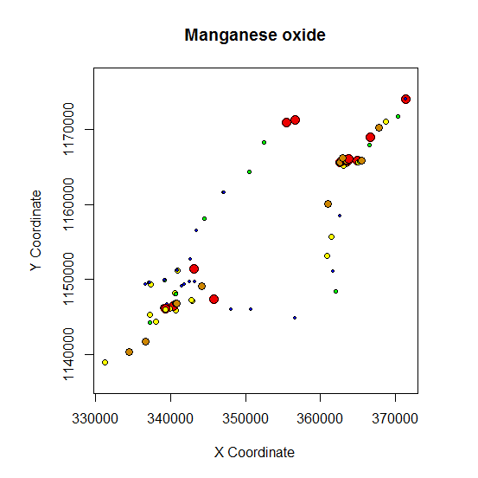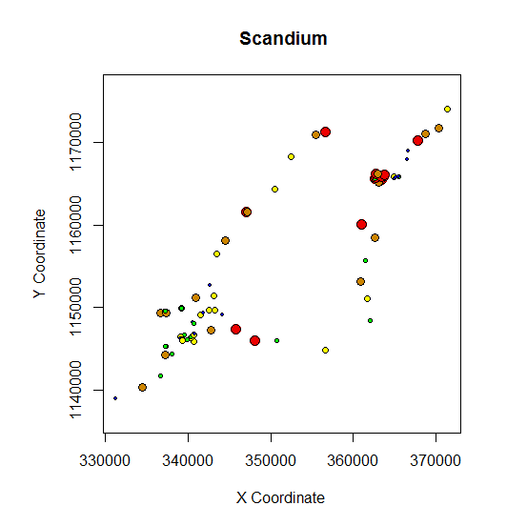

Additional File, Table 3: Univariate analysis for soil characteristics and podoconiosis prevalence

Soil Characteristics | Univariate analysis
Soil Characteristics | AIC | Estimate | p – value | OR | CI
Al2O3^{Ϯ} | 86.45 | 0.11 | 0.520 | 1.12 | (0.85, 1.49)
Fe2O3 | 65.02 | -0.73 | 0.001 | 0.48 | (0.29, 0.70)
Particle size <1microns- analysis by water | 83.11 | -0.27 | 0.055 | 0.76 | (0.57, 0.99)
Particle size <2microns- analysis by de-flocculant ª | 87.05 | 0.01 | 0.800 | 1.01 | (0.95, 1.07)
Particle size <10microns-analysis by de-flocculant ª | 86.74 | 0.01 | 0.545 | 1.01 | (0.97, 1.05)
Organic carbon ^{Ϯ} | 87.01 | 0.08 | 0.745 | 1.09 | (0.65, 1.83)
Quartz | 85.42 | 0.04 | 0.212 | 1.05 | (0.98, 1.13)
Smectite | 85.37 | 0.32 | 0.200 | 1.38 | (0.86, 2.34)
Kaolinite | 85.11 | -0.05 | 0.168 | 0.95 | (0.88, 1.02)
Mica | 75.28 | 0.11 | 0.003 | 1.12 | (1.05, 1.21)
Chlorite | 57.82 | -1.14 | 0.0003 | 0.32 | (0.15, 0.55)
As ^{Ϯ} | 87.11 | 0.001 | 0.970 | 1.00 | (0.94, 1.07)
Pb ^{Ϯ} | 87.10 | -0.007 | 0.931 | 0.99 | (0.84, 1.17)
Sb ^{Ϯ} | 87.11 | -0.002 | 0.979 | 1.00 | (0.85, 1.19)
V ^{Ϯ} | 87.08 | 0.001 | 0.851 | 1.01 | (0.99, 1.03)
Cd ^{Ϯ} | 86.10 | 0.66 | 0.354 | 1.00 | (0.99, 1.01)
Ba | 52.41 | -0.04 | 0.0003 | 0.96 | (0.94, 0.98)
Zr | 64.50 | 0.03 | 0.0003 | 1.03 | (1.01, 1.05)
Cr | 77.23 | 0.02 | 0.012 | 1.02 | (1.01, 1.04)
ª variables removed; AIC – Akaki Information Criterion, OR – Odds ratio, CI – Confidence interval
Variables were retained based on p – value < 0.500 which included AIC < 85.50 (the median AIC).

