Table 1.

Isogenic Ba/F3 model: Apoptosis and Proliferation Assays - IC50s
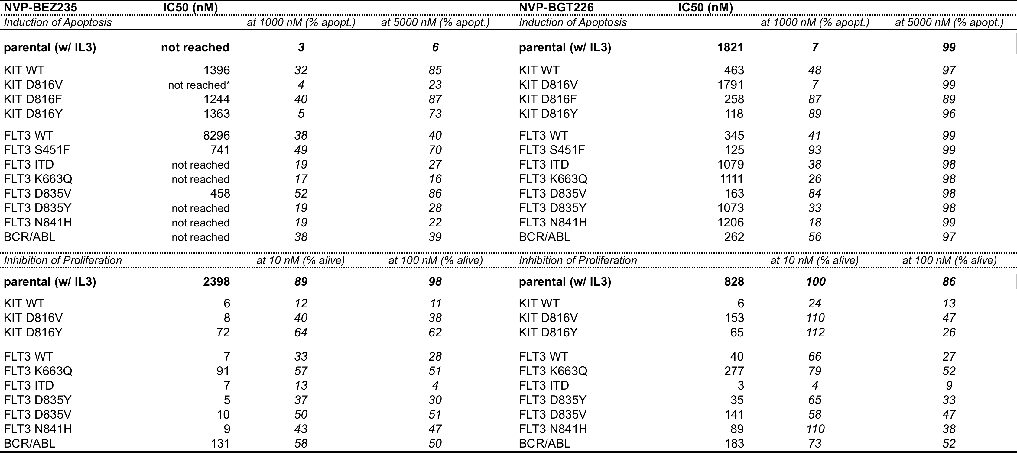
*IC50s not reached (> 5 000 nM)

