Results:
Additional file 2: Figure S2:
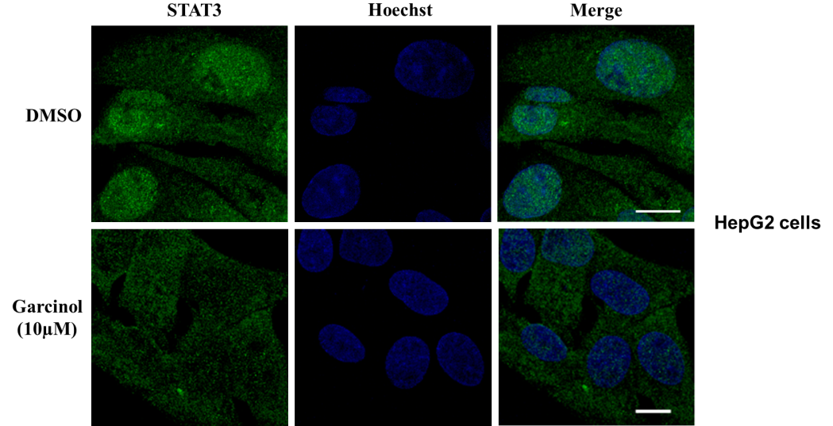

Figure S2: Garcinol treatment suppressed nuclear translocation of STAT3 in HepG2 cells: HepG2 cells were grown on poly-lysine coated coverslips. Cells were then treated with either DMSO or 10μM of garcinol for 3h and processed for confocal imaging after immune-staining with antibody against STAT3.

