Additional file 1

Detailed search strategy: PUBMED (02.06.2013); 2000 results

("dietary fat"[All Fields] OR "fatty acids"[All Fields] OR "monounsaturated fat"[All Fields] OR "mufa"[All Fields] OR "olive oil"[All Fields] OR "oleic acid"[All Fields] OR "mediterranean diet"[All Fields]) AND ("cardiovascular disease"[All Fields] OR "myocardial infarction"[All Fields] OR "coronary heart disease"[All Fields] OR "stroke"[All Fields] OR "mortality"[All Fields]) AND ("incidence"[All Fields] OR "cohort"[All Fields] OR "follow-up"[All Fields] OR "prospective"[All Fields] OR "risk ratio"[All Fields] OR "hazard ratio"[All Fields] OR "rate ratio"[All Fields])

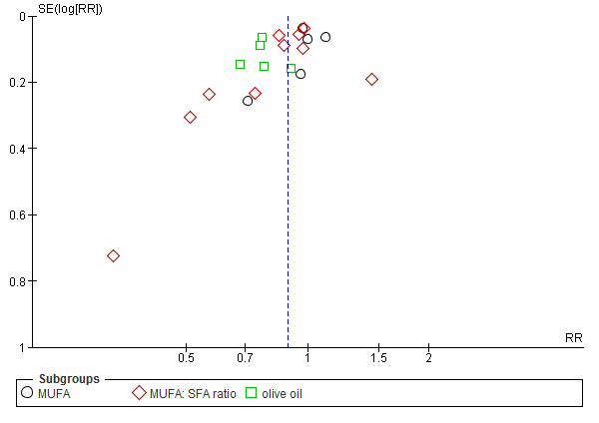
Figure S1. Funnel plot showing study precision against the relative risk with 95% CIs for all-cause mortality. SE = Standard error

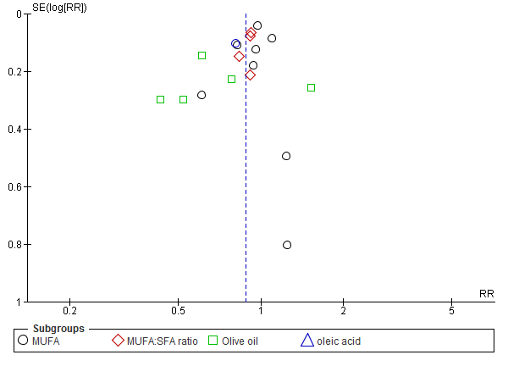
Figure S2. Funnel plot showing study precision against the relative risk with 95% CIs for cardiovascular mortality. SE = Standard error

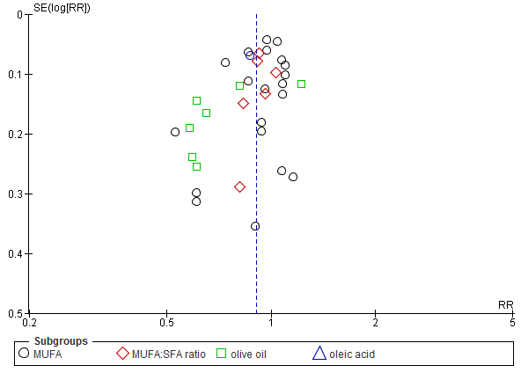
Figure S3. Funnel plot showing study precision against the relative risk with 95% CIs for combined cardiovascular events. SE = Standard error

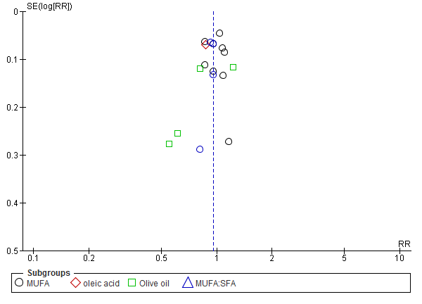
Figure S4. Funnel plot showing study precision against the relative risk with 95% CIs for coronary heart disease. SE = Standard error

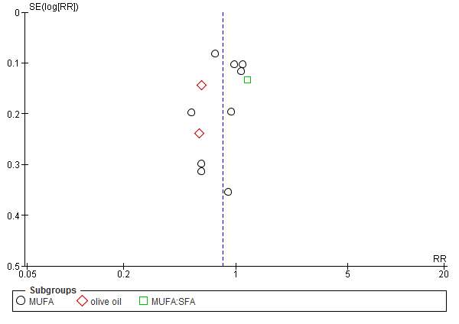
Figure S5. Funnel plot showing study precision against the relative risk with 95% CIs for stroke. SE = Standard error

