Supplementary information
Folic Acid-conjugated Silica capped Gold Nanoclusters for Targeted Fluorescence/X-ray Computed Tomography Imaging
Zhijun Zhou¹, Chunlei Zhang¹, Qirong Qian², Jiebing Ma¹, Peng Huang¹, Xizhang¹, Liyuan Pan¹, Guo Gao¹, Hualin Fu¹, Shen Fu³, Hua Song¹, Xiao Zhi¹,Jian Ni¹, Daxiang Cui¹*
Figure S1. Pictures of AuNCs (A) and AuNCs@SiO₂ (B) show intense red fluorescence under a UV-vis (365nm). (C) Dynamic Light Scattering of AuNCs (blue curve) and AuNCs@SiO₂ (red curve).
Figure S2. (A) Us-Vis spectrum of AuNCs. (B) X-ray photoelectron spectroscopy of AuNCs. lamp irradiation.
The XPS binding energies values show Au4f_{7/2} ~83.9 eV and Au4f_{5/2} ~87.6eV, respectively. It is valuable that the banding energy of Au4f_{7/2} and Au4f_{5/2} locate at the region between the Au(0) binding energy (84 eV) of a metallic gold film and the Au(I) binding energy(86 eV) of gold thiolate, suggesting the exhibition both of Au(0) and Au(I) in the BSA-stabilized clusters[28-29].
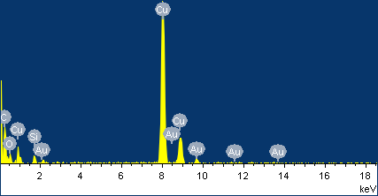
Figure S3. Energy Dispersive X-Ray Spectroscopy (EDX) of AuNCs.

Figure S4. TEM images of AuNCs@SiO₂ (B) with adding different doses of TEOS (100μl, 150μl, 200μl, from left to right) one time. All experiments were under the same operation and conditions. When TEOS was increased to 200μl, the obtained nanoparticles show monodisperse spherical nanoparticles.
.
Figure S5. CT images of subcutaneous pre-injection and post-injection of nude models with gastric cancer with AuNCs@SiO2-FA nanoprobes in 0.01M PBS at the concentration of 226mg/ml and 56mg/ml.

