¹³CO₂ plant labeling system

User’s manual

Version 1.3

January 22, 2011

Protein Turnover Group
Department of Horticultural Science
Department of Plant Biology
University of Minnesota

Supported by the U.S. National Science Foundation,
Plant Genome Program, grant DBI 0606666

CONTENT
- Overview
- System design
  - Hardware
  - Control system
  - Power system
- Operation of the system
  - Power on
  - Open control VI
  - Enclosure purge
  - Replacement of ethylene scrubber
  - Adding ¹³CO₂
  - Cold plate temperature setup
- Preparation for plant growth
  - Preparation of acid-washed sand
  - Preparation of rockwool blocks
  - Preparation of hydroponic medium
  - Stratification of seeds
  - Sowing seeds
- Plant labeling with ¹³CO₂
  - Plant tray setup
  - Lighting
  - Enclosure sealing
  - Air purge
- Troubleshooting
- Supplemental pictures

1. Overview

This close plant growth chamber is designed and built for plant labeling studies with ¹³CO₂. Plants can be fully labeled starting from seed in the chamber then chased with ambient CO₂ of natural abundance or pulse-labeled with ¹³CO₂ after growing with CO₂ of natural abundance.

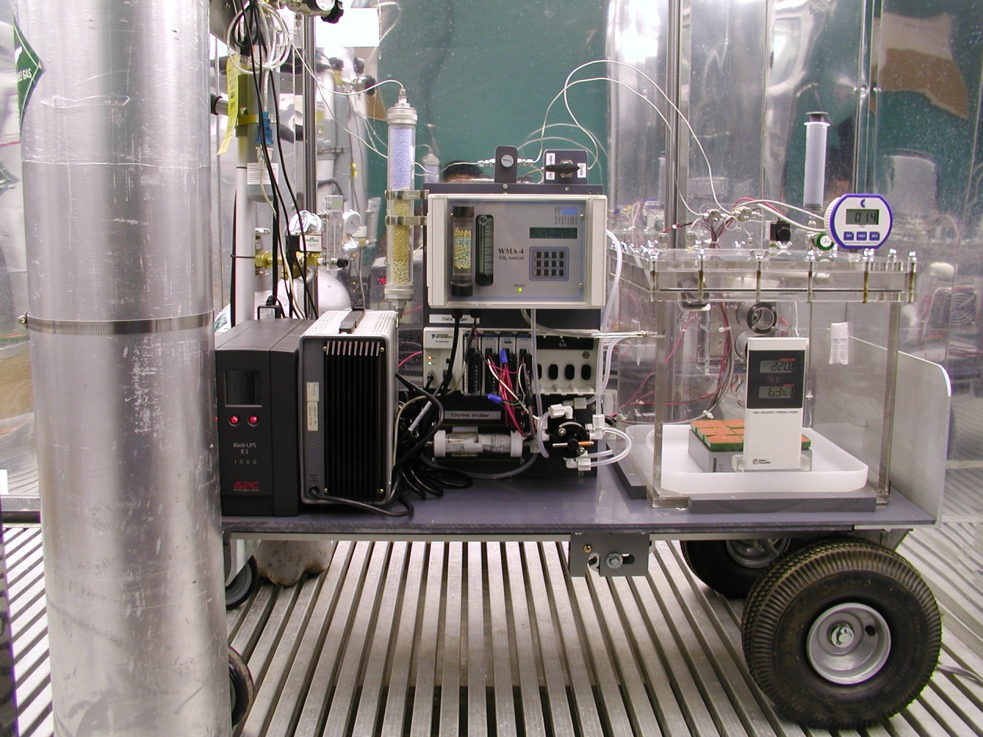

Figure 1. A front view of the ¹³CO₂ labeling system.

2. System design

2.1. Hardware setup
This closed growth chamber was built with thick plexiglass and has a two-floor design. A small plexiglass chamber with a cold plate installed on one side of its walls is connected to the main chamber by one inlet plexiglass pipe and one outlet aluminum pipe. This cold box is designed to control the humidity of the main chamber by removing air from the main chamber using a fan onto the cold plate such that the excess moisture in the air can be condensed on the surface of the cold plate. Two solenoid valves located on the lid of the chamber control CO₂-free air and CO₂ gas flows. In addition, a pressure relief valve, pressure sensor and humidity/temperature sensor are installed on the lid. The CO₂ analyzer manufactured by PP Systems is located outside the chamber and a pneumatic diaphragm pump inside the analyzer continuously circulates air from the growth chamber thru a small air chamber where the CO₂ sensor is located. After sampling, the air flows back to the growth chamber. An ethylene scrubber is installed inline after CO₂ sensor and the air coming out from the CO₂ sensor is directed by a stack 4-way valve to either the ethylene scrubber or to a bypass. This valve design allows for easy replacement of the ethylene scrubber bags in the column while an experiment is running. After replacement, the scrubber column together with the fresh bags containing potassium permanganate pellets are purged by CO₂ free air that is directed by a manually operating 3-way valve located at the top of the CO₂ sensor. The CO₂ free air purchased from Minneapolis Oxygen Company contains less than 1ppm CO₂ but is further polished by a CO₂ scrubber column before use to supply the chamber or traps for purging or maintaining the slightly positive pressure of the chamber. To prevent CO₂ gas levels from overshooting, the flow rate of the CO₂ gas is controlled by a needle valve set at the lowest rate. The outlet pressure of ¹³CO₂ was controlled by the regulator hooked up directly on the lecture bottle. A pressure of around 10 psi was found to be ideal to finely control the flow rate of ¹³CO₂. The flow rate of CO₂ free air is not valve controlled but the outlet pressure is set between 100 and 120 psi and the flow is somewhat restricted by the narrow bore stainless steel gas line.

2.2. Power setup
A12V DC power supply is used to power the thermoelectric cooler (cold plate), 2 fans inside the chamber for air circulation, PWM controller. A 24V DC power supply is used to power a 3-way solenoid valve for directing either CO₂-free-air or CO₂ to the chamber, a 2-way solenoid as a pressure relief valve, temperature/relative humidity sensor and chamber pressure sensor. The CO₂ analyzer is powered by 120V AC. The power supplies, the laptop controller, the data logger as well as the CO₂ analyzer are directly plugged into a backup power system (APC) that is plugged into the wall outlet.

2.3. System control setup
This system can simultaneously monitor humidity/temperature, chamber pressure and CO₂ concentration and controlling humidity, chamber pressure and CO₂ level by a laptop computer/controller running Labview 8.5. All signals (in current) from the sensors are acquired by a data logger, Compact DAQ, from National Instruments. The signal values are acquired and compared to set points and actions are triggered to adjust the values to the set points.

2.3.1 The control of relative humidity in the chamber
The humidity is controlled as described earlier by directing air onto the cold plate. When the chamber humidity is higher than the set point, a relay that controls a fan inside the cold box will turn on. The air in the main chamber where plants grow will be directed into the cold box and excess moisture can be condensed on the surface of the cold plate. The condensed water will accumulate in the box to a certain point then flow back by gravity to the tray in which the plants grow.

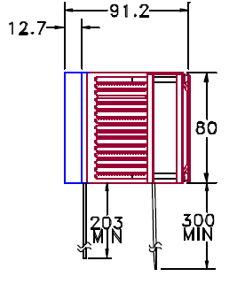

Fan
Fan
Heat sink
Bellow
All dimensions are in millimeter
Aluminum plate
Gasket
Drained to chamber

Insulation foam
Cold side
100mmx120mm surface area for this aluminum wall
Cold plate dimension: 101.6mmx80mm
Aluminum pipe

2.3.2 The control of chamber pressure
The chamber pressure is maintained slightly positive all the time. It is regulated by a control loop that compares actual pressure with the set minimum pressure and energizes the solenoid to inject enough CO₂-free air into the system to maintain the set pressure. The chamber pressure is also controlled below a maximum value by a solenoid serving as a pressure relief valve. It would be energized when the chamber pressure goes over the set maximum value. The chamber pressure is kept at > 2 kPa to prevent ambient CO₂ from entering the chamber. Chamber pressures over 5 kPa are not recommended.

2.3.3 The control of CO₂ levels
The air from the chamber is continuously pumped through the CO₂ analyzer and is monitored for CO₂ concentration in ppm. The signal transmitted from the CO₂ analyzer can be in either voltage or current. It has been shown that current signals are more stable than the voltage signals under most circumstances especially when surrounded by many electrical devices, thus current is used. The CO₂ levels (SP in ppm) can be easily set at the control panel. Usually CO₂ at 400-600 ppm for growing Arabidopsis gives good results. When ¹³CO₂ is applied, the set points should be around 1/3 of the attempted concentrations because of the CO₂ sensor used can reflect only around 1/3 of the actual CO₂ concentrations due to the difference in the near infrared absorption of ¹³CO₂ relative to ¹²CO₂ for which the commercial sensor is calibrated. A PID (proportional–integral–derivative) control loop is used to control the solenoid valve for CO₂ gas in a proportional manner. The voltage signal generated by a voltage signal module on the CompactDAQ is transmitted to a pulse-width modulator where the signal is translated into power to the load. In addition, tuning parameters were also programmed into the control loop to deal with the delay report of CO₂ level in the chamber due to the distance between injection site and CO₂ sensor.
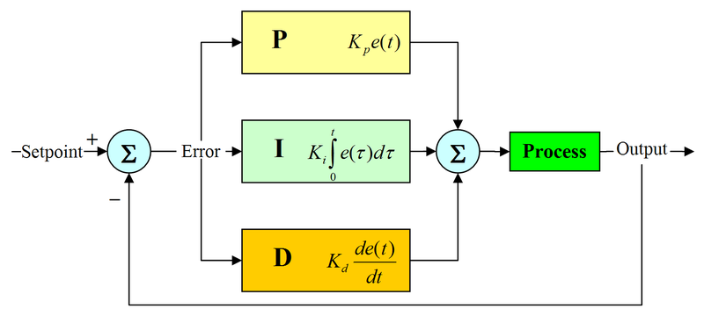

http://en.wikipedia.org/wiki/PID_controller

2.3.4 The control of light intensity
No lighting system is integrated in the system because the system was designed to be running inside a walk-in growth chamber where the lighting can be set by the control panel of the growth chamber. Even though plexiglass filters out most of the UV light as well as visible light with short wavelengths such as purple, it does not absorb visible light that is necessary for plant growth (see Figure 2).
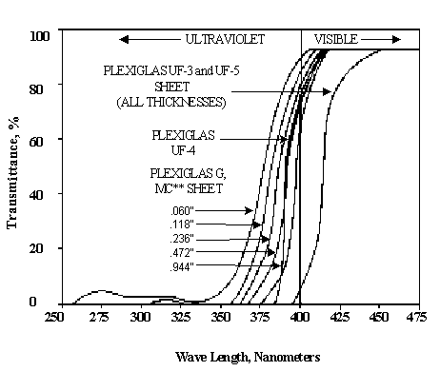

Figure 2. Visible and Ultraviolet Light Transmission in Colorless plexiglass. (from http://www.rplastics.com/plexiglass-transmittance.html)

The light intensity however might needs to be checked before an experiment is about to be performed. A light intensity of approximately 100 mmole m⁻² s⁻¹ is optimal to support healthy and normal-looking Arabidopsis plants growing in the system.

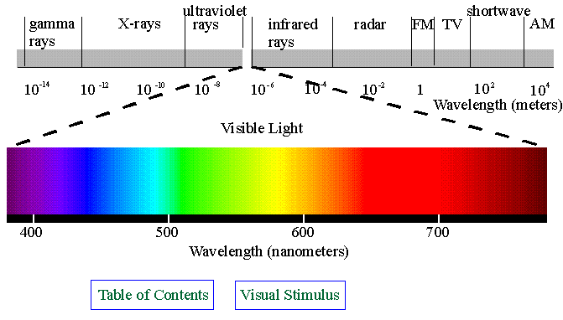
http://www.yorku.ca/eye/spectrum.gif

3. Operation of the system

3.1. Power on
- Once the main power cord is connected to the electrical outlet, both the 12V and 24V power supplies that power most of the sensors, fans and cold plates, should be on. The CO₂ analyzer, data logger and laptop controller are powered by 120V AC and are plugged directly to the power backup system. A switch in the back of the control panel where the CO₂ sensor is mounted is used to turn on/off the two circulation fans inside the chamber. Make sure the fans are initially switched to ON.
- Turn on the gas regulators for CO₂-free air and CO₂ and check the seal of gas lines using soapy water.

3.2. Open control VI (virtual instrument)
- Turn on the labtop controller. Once Windows has booted up, double click on a LabView VI icon, called ¹³CO₂ PID control.
- Enter desirable parameters for relative humidity (65%), maximum (3 kPa) and minimum (2 kPa) chamber pressures, CO₂ level (SP: 200 ppm for ¹³CO₂ or 400ppm for natural abundance), PID tuning factor (4.99) and response delay (RPD) factor (10 ppm).
- Press the empty arrow at the top of the front panel. The LabView VI program should then be running.

3.3. Enclosure purge with CO₂-free air
- Set the maximum chamber pressure at 1 kPa; at this setting the pressure relief valve will be activated and opened when pressure is higher than 1kPa and the allow air in the chamber to be purged out.
- Press the Air Purge ON button. The solenoid for controlling air flow into the chamber will be activated.
- Wait at least 1 hour until the CO₂ level in the chamber goes lower than 5 ppm. In practice it is very difficult to get the CO₂ level lowered to closer to 0 ppm, due partly to the accuracy of the CO₂ analyzer at the lower levels.

3.4. Adding ¹³CO₂ gas to the chamber
- Slightly open the ¹³CO₂ tank valve. Little or no bottle pressure shown in the regulator primary gauge is OK.
- Adjust the outlet pressure gauge to 10 psi.
- Open the outlet valve.
- Adjust the needle valve that is used to control the CO₂ flow to slightly greater than 0.

  - Replacement of ethylene scrubber
- Turn the stacked 4-way valve to bypass mode.
- Disassemble the ethylene scrubber column.
- Remove the used the sachets and put two fresh ones back.
- Reassemble the column.
- Switch the CO₂ free air valve to ethylene scrubber mode and purge the ethylene scrubber with the air for at least one minute.
- Switch the 4-way valve back to RUN mode
- Switch the air valve back to the Chamber mode.

CO2 sensor
Ethylene scrubber
Chamber
Stack 4-way valve
Run mode
Bypass mode
Purge inlet
CO2 free air
Purge outlet
Purge inlet
CO2 free air
Purge outlet

4. Preparation for plant growth

4.1. Preparation of modified Gibeaut’s solution (http://www.ag.unr.edu/Cramer/hydroponic.html)
The macronutrient stock solutions are kept in separate containers. The iron stock solution is kept in aluminum-foil-covered or a dark-brown bottle to prevent light degradation. The 1000X micronutrient stock solution is a mixture of all micronutrients combined together in one container. Be sure to make with deionized-glass distilled water. After making the complete modified solution, the pH should be around pH 6.0 without titration. The medium then heated to 60˚C and is purged with helium gas for at least 15 min in a bottle as shown in the figure below.
Gib Macronutrients | FW | [STOCK] | STOCK  (g/L) | mL (solution)/  L (water)
Ca(NO₃)₂ x 4H₂O | 236.15 | 1M | 236.15 | 1.50
KNO₃ | 101.11 | 1M | 101.11 | 1.25
Mg(SO₄) x 7H₂O | 246.48 | 1M | 246.48 | 0.75
KPO4 buffer, pH5.6 | 136.09 | 1M | 136.09 | 0.50
Na₂O₃Si x 9H₂O | 284.20 | 0.1M | 28.42 | 1.00
FeCl₃ (or Fe-EDTA) | 162.2 | 0.02 M | 3.25 | 4
Gib Micronutrients
KCl | 74.56 | 50mM | 3.728 | 1.00
MnSO₄ x H₂O | 169.01 | 10mM | 1.690
CuSO₄ x 5H₂O | 249.68 | 1.5mM | 0.375
ZnSO₄ x 7H₂O | 287.54 | 2mM | 0.575
H₃BO₃ | 61.83 | 50mM | 3.092
CoCl₂ x 6 H₂O | 237.93 | 0.01mM | 0.00238
Na₂MoO₄-2H₂O | 241.95 | 0.2mM | 0.048

4.2. Preparation of acid-washed sand (not preferred due to poor plant growth)
- Industrial silica sand (Badger Mining Corporation, Berlin, WI) was used. Sand, abound 2.5 L in volume in a 5 L beaker was first washed with distilled water several times to remove water soluble contaminants. A long glass pipette with the tip cut can be prepared for this purpose. Simply connect it to a distilled water faucet by plastic tubing.
- Decant the excess water leaving the water level at 2.5 L
- Slowly add 300 ml of concentrated HCl to the beaker
- Mix the acid solution by digging into the sand with the long pipette.
- Cover the beaker with aluminum foil and let it stand for at least one day.
- Pour out the acidic water in a sink with the tap water is running
- Rinse the sand with distilled water by injecting water into the bottom of beaker using the long glass pipette. Move the pipette to different corners of the beaker.
- Once the water has filled up, pour out the water and repeat step 7.
- Repeat step 7-8 at least 10 times then let the sand sit overnight with the water.
- Pour out the excess water and repeat step 7-8 three to four more times
- Check the pH of the water after letting it sit for another hour.
- It would be a safe precaution to rinse the sand again just before it is used for growing plants.

4.3. Preparation of rockwool (preferred)
- Rockwool (Grodan) can be used as a preferred substitute for sand.
- Rinse rockwool blocks with distilled water 3 times before use.

4.4. Preparation of plant pots
- 2’ x 2’ square plastic pots are used. Soak the pots with ZeroTol sterilizing agent (BioSafe Systems LLC, Brentwood, TN) for a day before use.
- Place acid-washed sand or rockwool block in the pots.
- Rinse with distilled water at least 2 times.
- Place the pots on a holding tray and add 10 ml of 0.5X Gib medium onto the top of the sand or rockwool.
- Layer a cover made of silicon rubber as shown in the figure below.

4.5. Stratification and sowing of Arabidopsis seeds
- Arabidopsis seeds after being rinsed with distilled water are left in a cold room (4 °C) for at least one day before sowing on sand or rockwool blocks in small pots on a solution holding tray.
- Layer a silicon rubber cover with a hole in the center is placed on the top of the sand or rockwook block
- Next, add a small amount of wet sand to the center of the holes, but don’t fill the holes up fully with the sand. Alternatively, you may skip this step and sow seeds directly onto the sand or rockwool.
- Take one seed at a time using a pipette and drop the seeds into the holes individually

5.0. Preparation of helium-purged medium and medium injection to the chamber
- Set up a glass bottle with two valves as shown in the figure below.
- Pour 300 ml of Gib medium into the bottle and seal with the cap.
- Open the two valves and connect helium tubing to the inlet valve
- Place the medium on a hot plate and bring to 60˚C with stir bar mixing for 30 min while purging with helium.
- Close two valves and cool medium using tap water or let it sit at room temperature until it has cooled.
- When withdrawing the medium, connect a CO₂ scrubber, as shown in figure, to the outlet valve and a 60 ml syringe to the inlet valve, then pull the syringe piston to fill.
- Inject the medium into the chamber through the designated valve.

5. Plant labeling with ¹³CO₂
- Open the chamber
- Disconnect the tray from the water-recycle tubing of the dehumidifier box and clean it up with detergent then rinse with water
- Prepare the pots and seeds as described in 4.4 and 4.5
- Connect the tray back to the water-recycle tubing
- Check the light intensity with a light meter before the chamber is sealed.
- Make sure the ethylene scrubber is fresh. Replace it when necessary
- Seal the chamber
- Inject helium purged Gibeaut’s medium to the tray from the feeding valve. See medium preparation for details.
- Set the humidity at 50% to activate the dehumidifier fan in order to circulate the air in the dehumidifier box to the main chamber when purging
- Purge the chamber with CO₂ free air until the CO₂ reading is below 3 ppm
- Set the CO₂ concentration at 100 ppm (the actual CO₂ concentration for ¹³CO₂ would be approximately 300 ppm).
- Slowly turn on the ¹³CO₂ gas regulator until the pressure is about 10 psi
- Monitor the CO₂ level approaching 100 ppm on the controller. If it increases too fast, adjust the valve to lower the flow rate.
- Wait until the CO₂ level reading is stable at 100 ppm.
- Stand for at least 1 hour.
- Repeat steps 8-14 twice.
- Set the maximum and minimum chamber pressure at 3 kPa and 2 kPa, respectively and the CO₂ concentration at 200 ppm (the actual CO₂ concentration for ¹³CO₂ would be approximately 600 ppm).
- Monitor the cold plate temperature occasionally to make sure the dehumidifier is working properly.
- Make sure the light intensity is adequate so that the plants would have optimal growth.

6. Troubleshooting

Q1. Seedlings stop growing or flowers are aborted.
A1. The capability of ethylene scrubber may have been exceeded. Change the ethylene scrubber sachets as required to avoid this problem.

Q2. Cannot bring the chamber humidity down to the set point.
A2. Check the temperature of the cold plate on the cold box. Re-adjust the temperature of the cold temperature to at least below 15°C. Refer to the Operation Manual for the Model TC-48-20 Thermoelectric Cooler Temperature Controller for specific details.

Q3. CO₂ gas level is overshooting.
A3. Try to turn down the outlet pressure of the CO₂ gas regulator to less than 10 psi and adjust the CO₂ flow rate on the scale as low as possible.

Q4. The labeling ratios of plant metabolites and proteins are low.
A4. (1) Make sure to purge the CO₂ line with ¹³CO₂ at least twice before you start to grow plants in the chamber. (2) Remember to use FeCl₃ or Fe-EDTA as iron sources of the medium but never Fe-citrate. (3) Purge the medium with helium gas well before each use. (4) Change the CO₂ scrubber medium more often (5) Check for chamber or connection leaks.

Supplements

- Cartoon of the chamber system
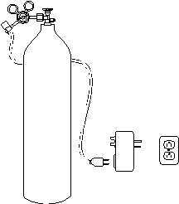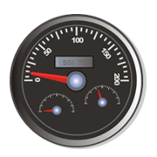
Tray

¹³CO₂
Air
O₂/N₂
CO₂ sensor
solenoid
Laptop controller w/ PID
Pressure sensor
Hoagland Solution
Fan
condensed water
Electronic
Cooling unit
Plugs
Defrost
timer
Thermometer
Heat sink
For chamber purge
Air pressure control valve
Filter
CO2 scrubber
RH/Temp sensor
Ethylene scrubber
Data logger


System on a cart
Cold plate

Laptop controller
Air
DAQ
Backup power
Chamberrrr
CO2 sensor
12V power supply

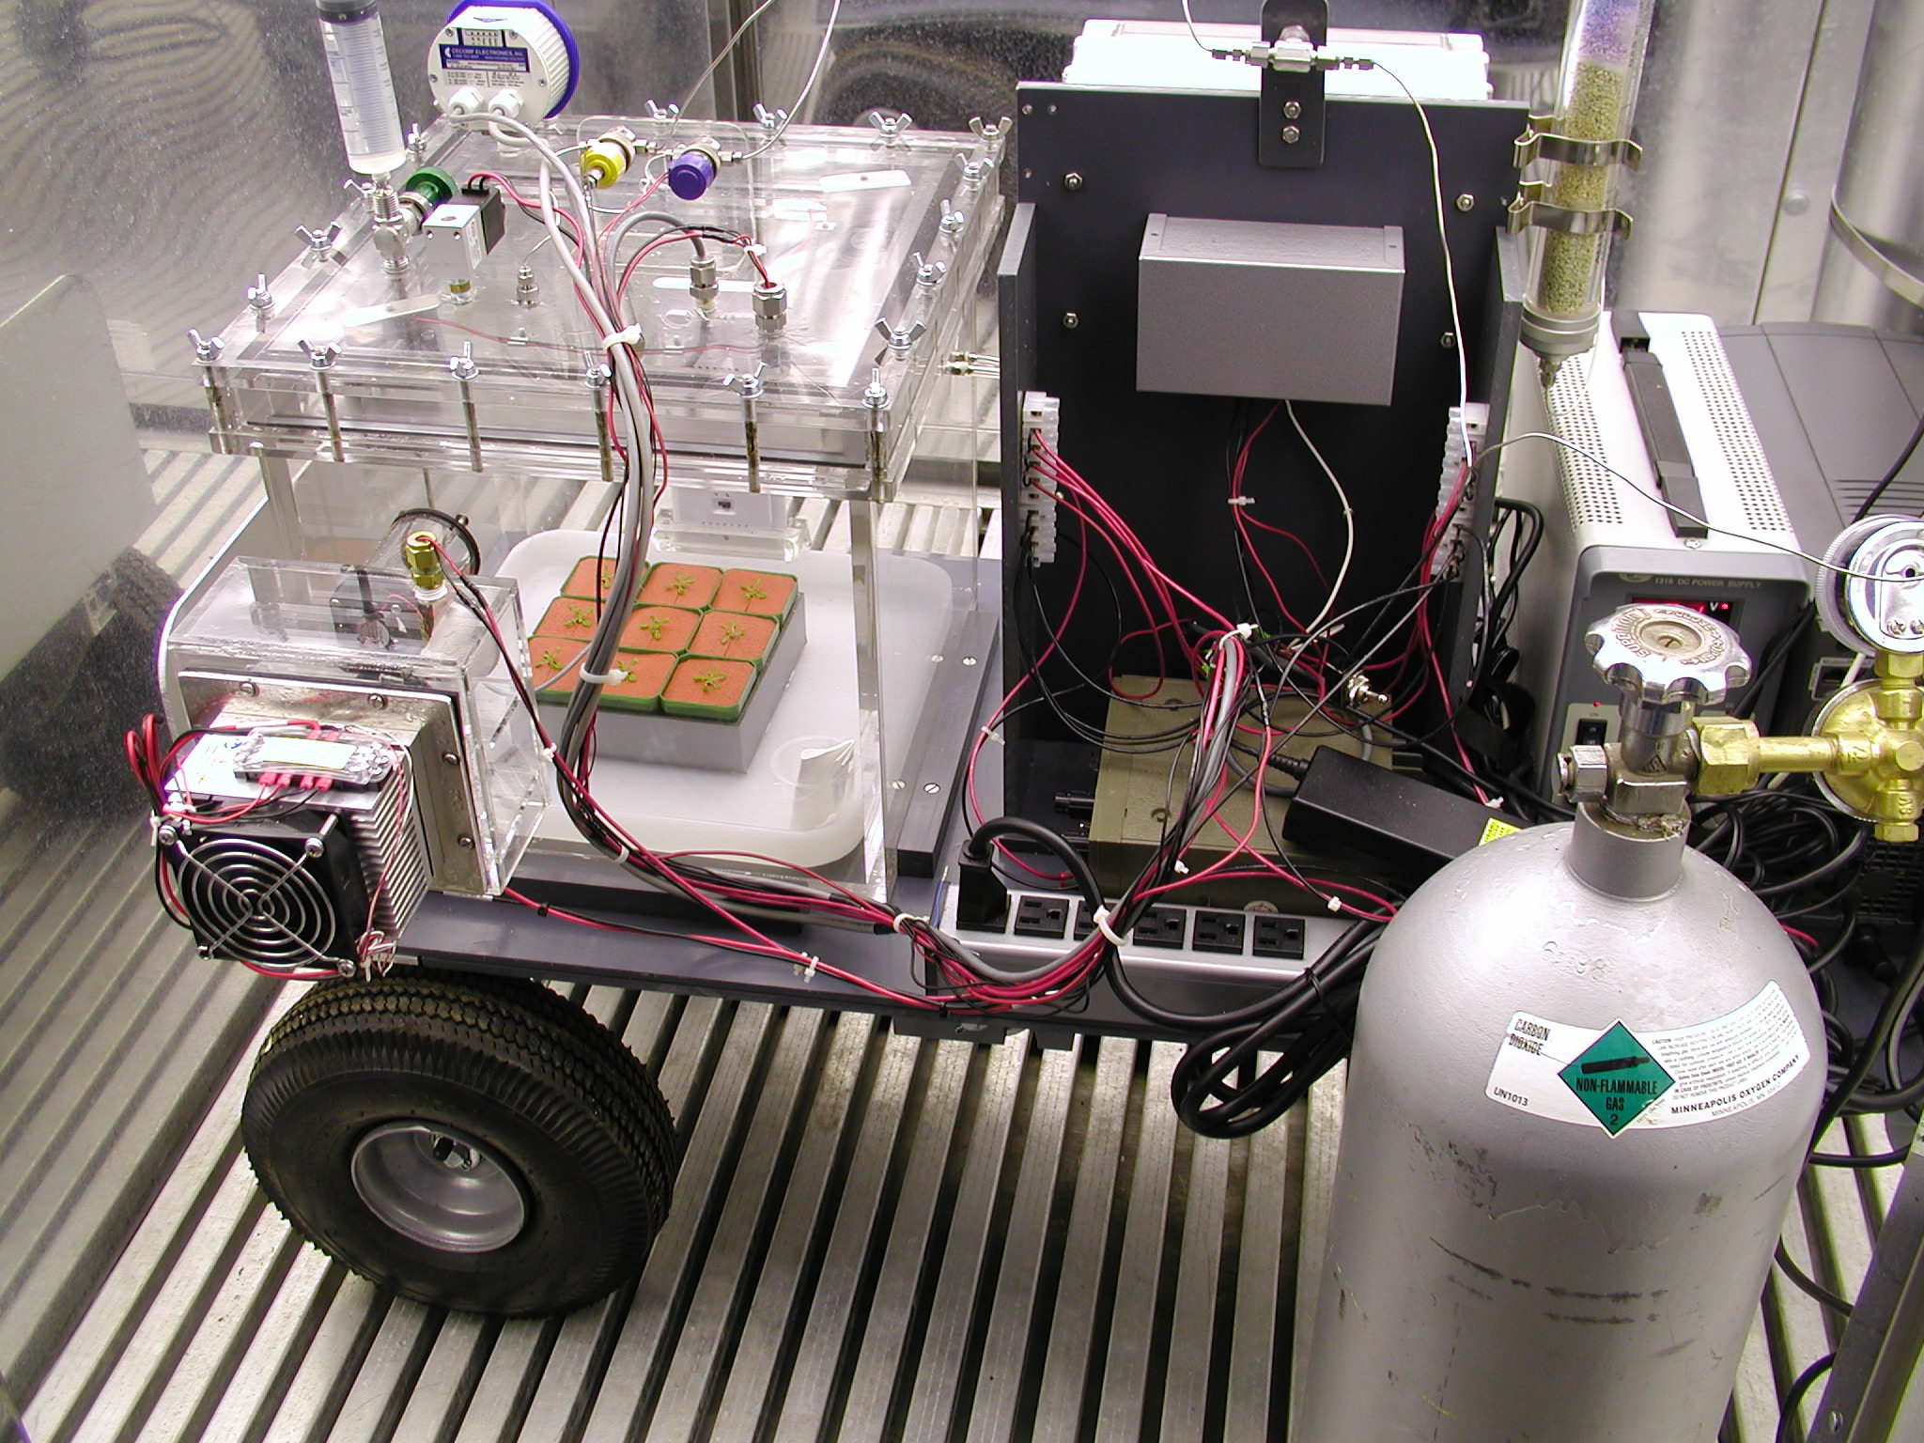
Backup power supply
PWM
controller
¹²CO₂ tank
12V power
supply
24V power
supply
Cold plate
dehumidifier
Temperature controller
(underneath the box)

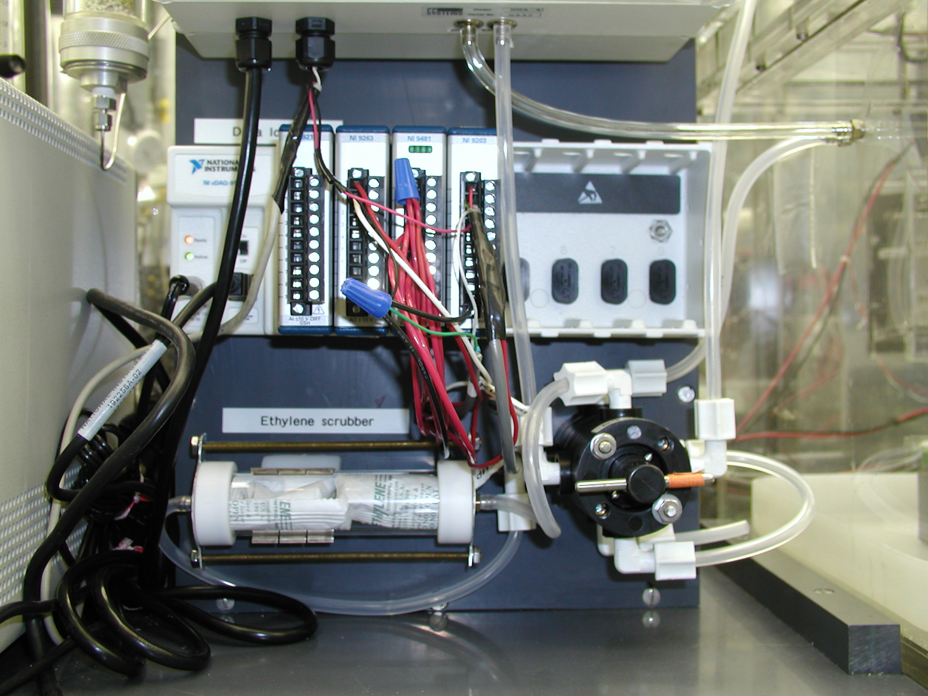
Compact DAQ
Ethylene scrubber
Stacked 4-way valve
Chamber
Air out
Air in
12V power supply
CO2 analyzer
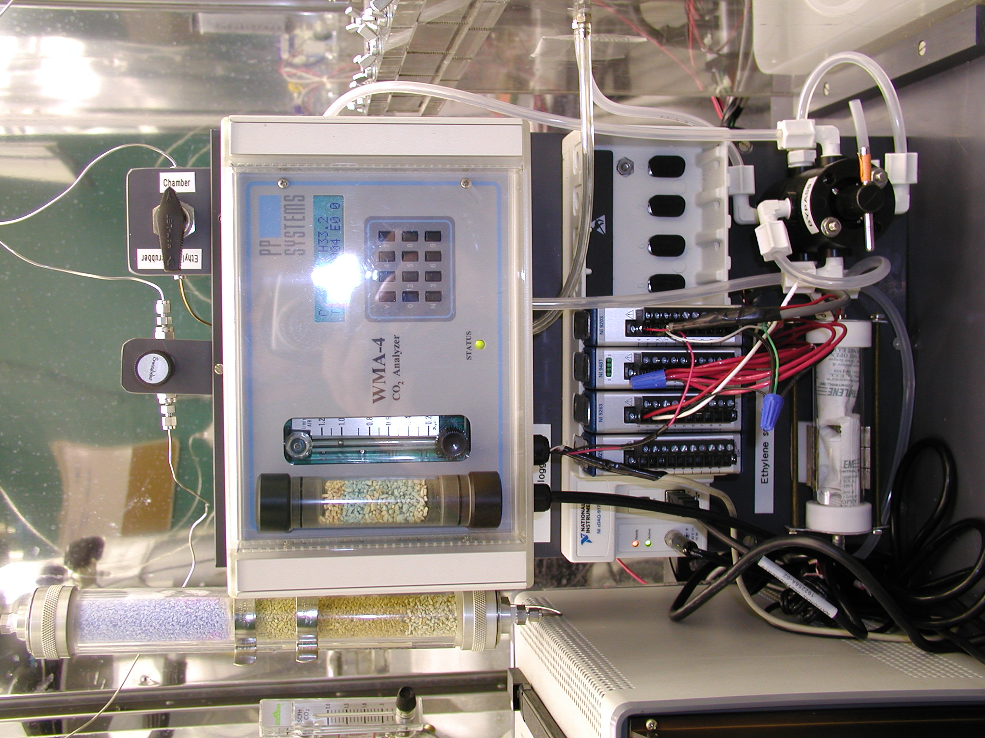
CO₂ flow control valve
CO₂ free air directing valve
CO₂ analyzer
CO₂ scrubber for
CO₂ free air
CO₂ scrubber for
autozeroing of CO₂ analyzer

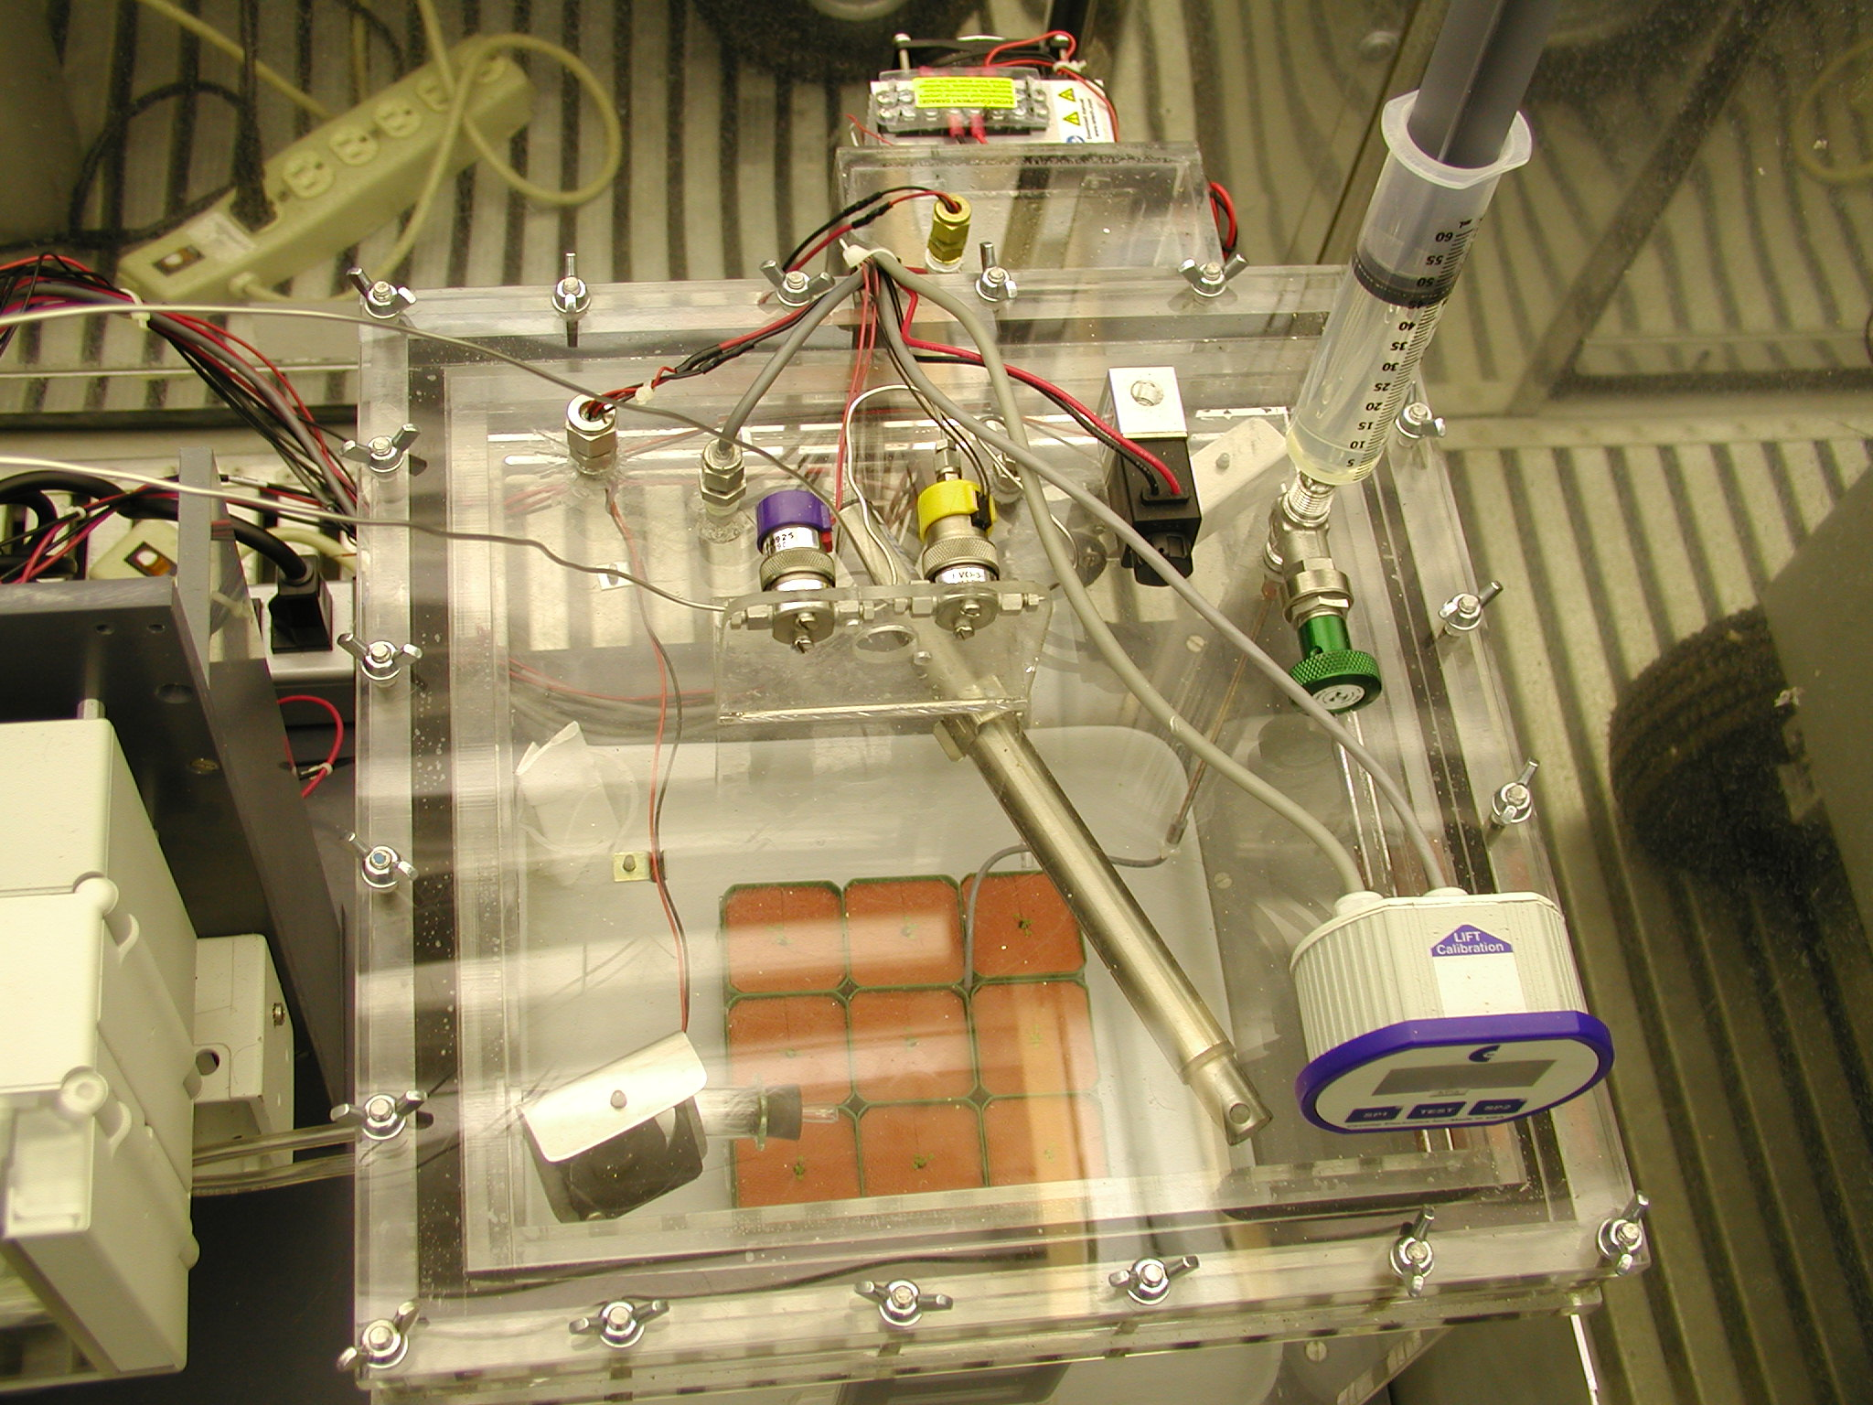
Medium syringe syringe
CO₂ analyzer
Humidity/Temp sensor
Circulation fan
2-way valve as
Pressure relief valve
3-way valve for
gas directing
2-way valve for
CO₂ control
Pressure sensor

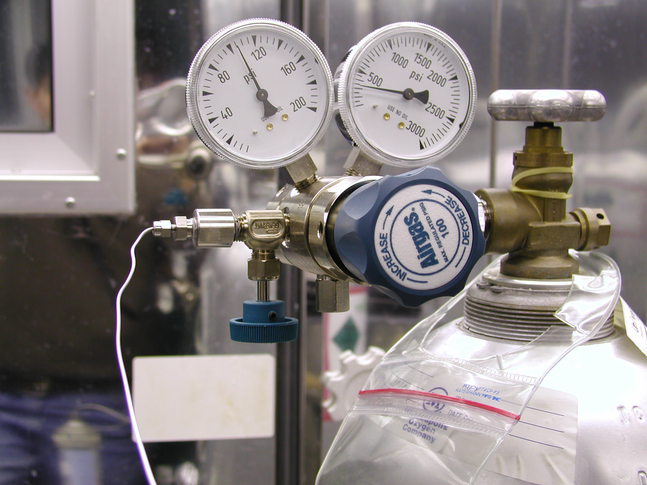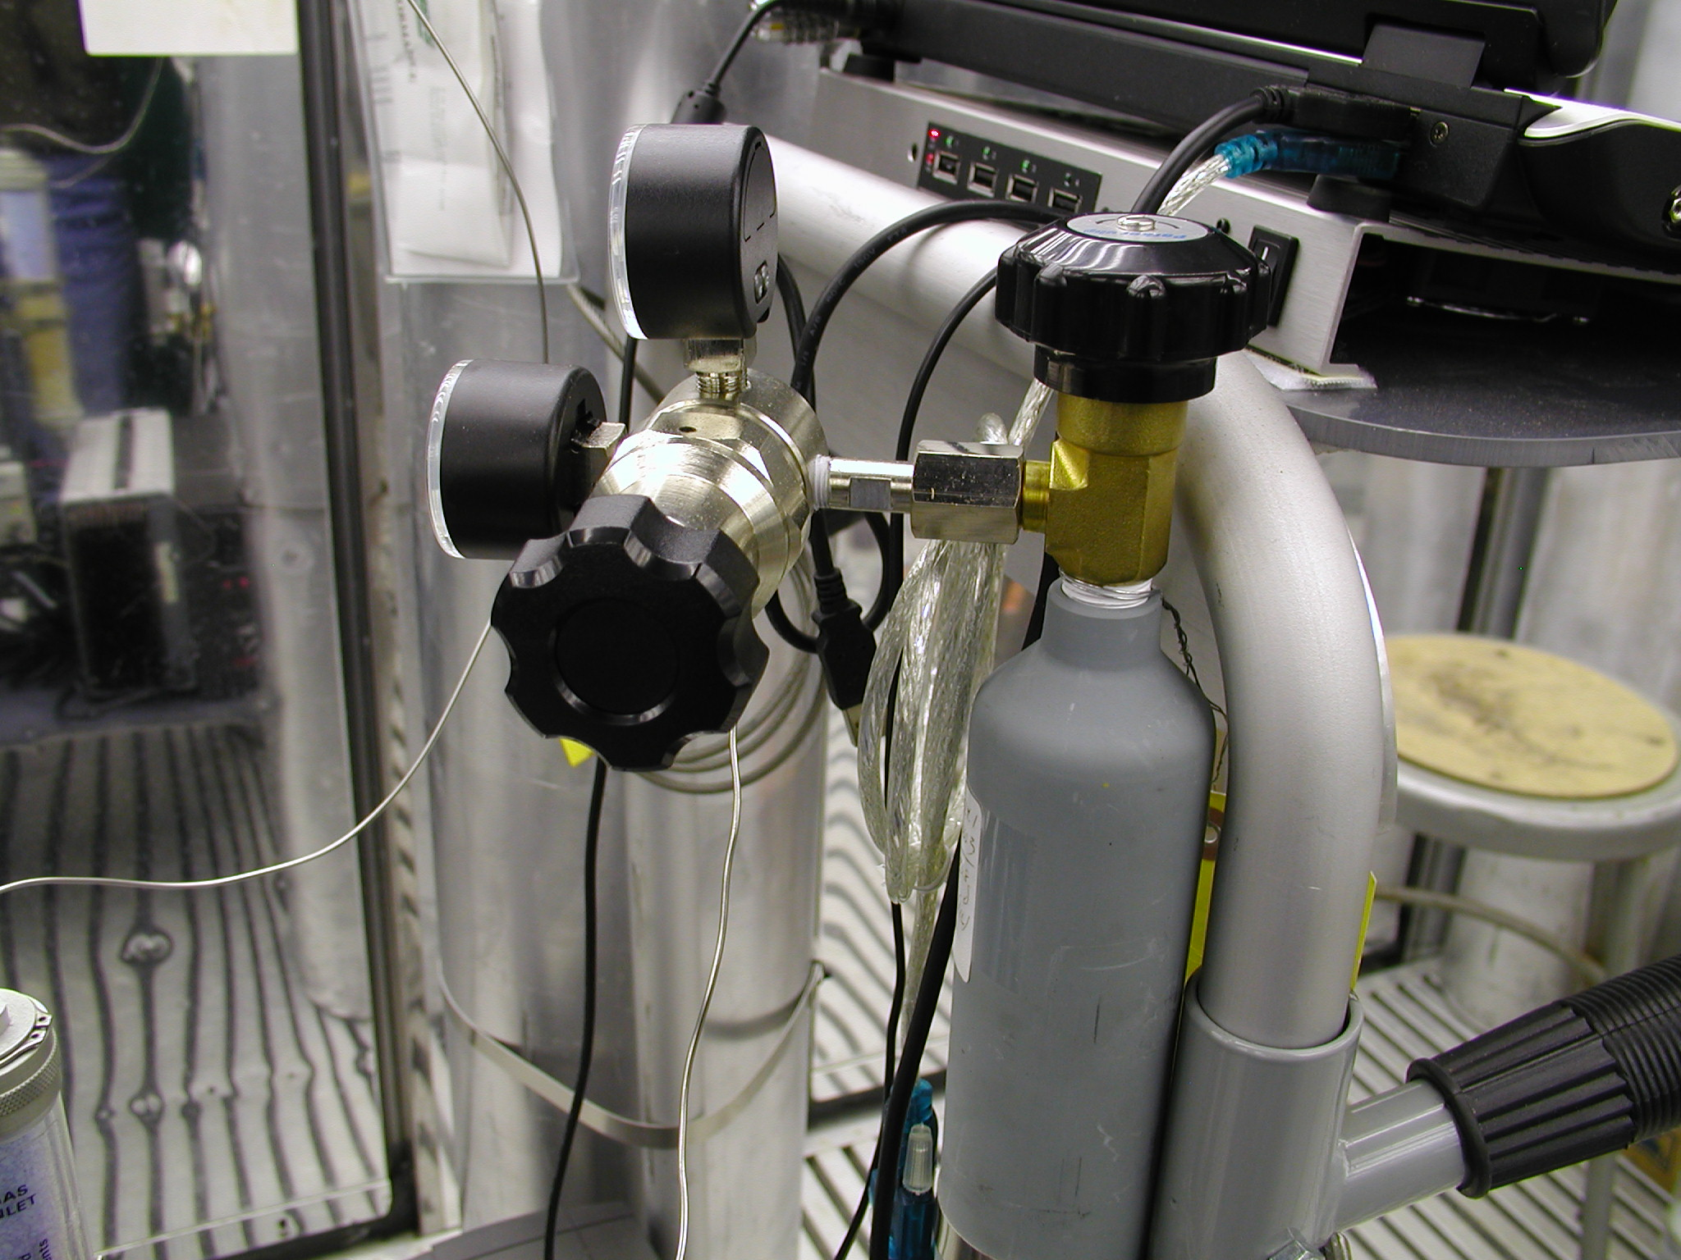
Gas regulator setup for CO₂ free air.
Output pressure: 100 psi
Gas regulator setup for ¹³CO₂ lecture bottle. Output pressure: 10 psi
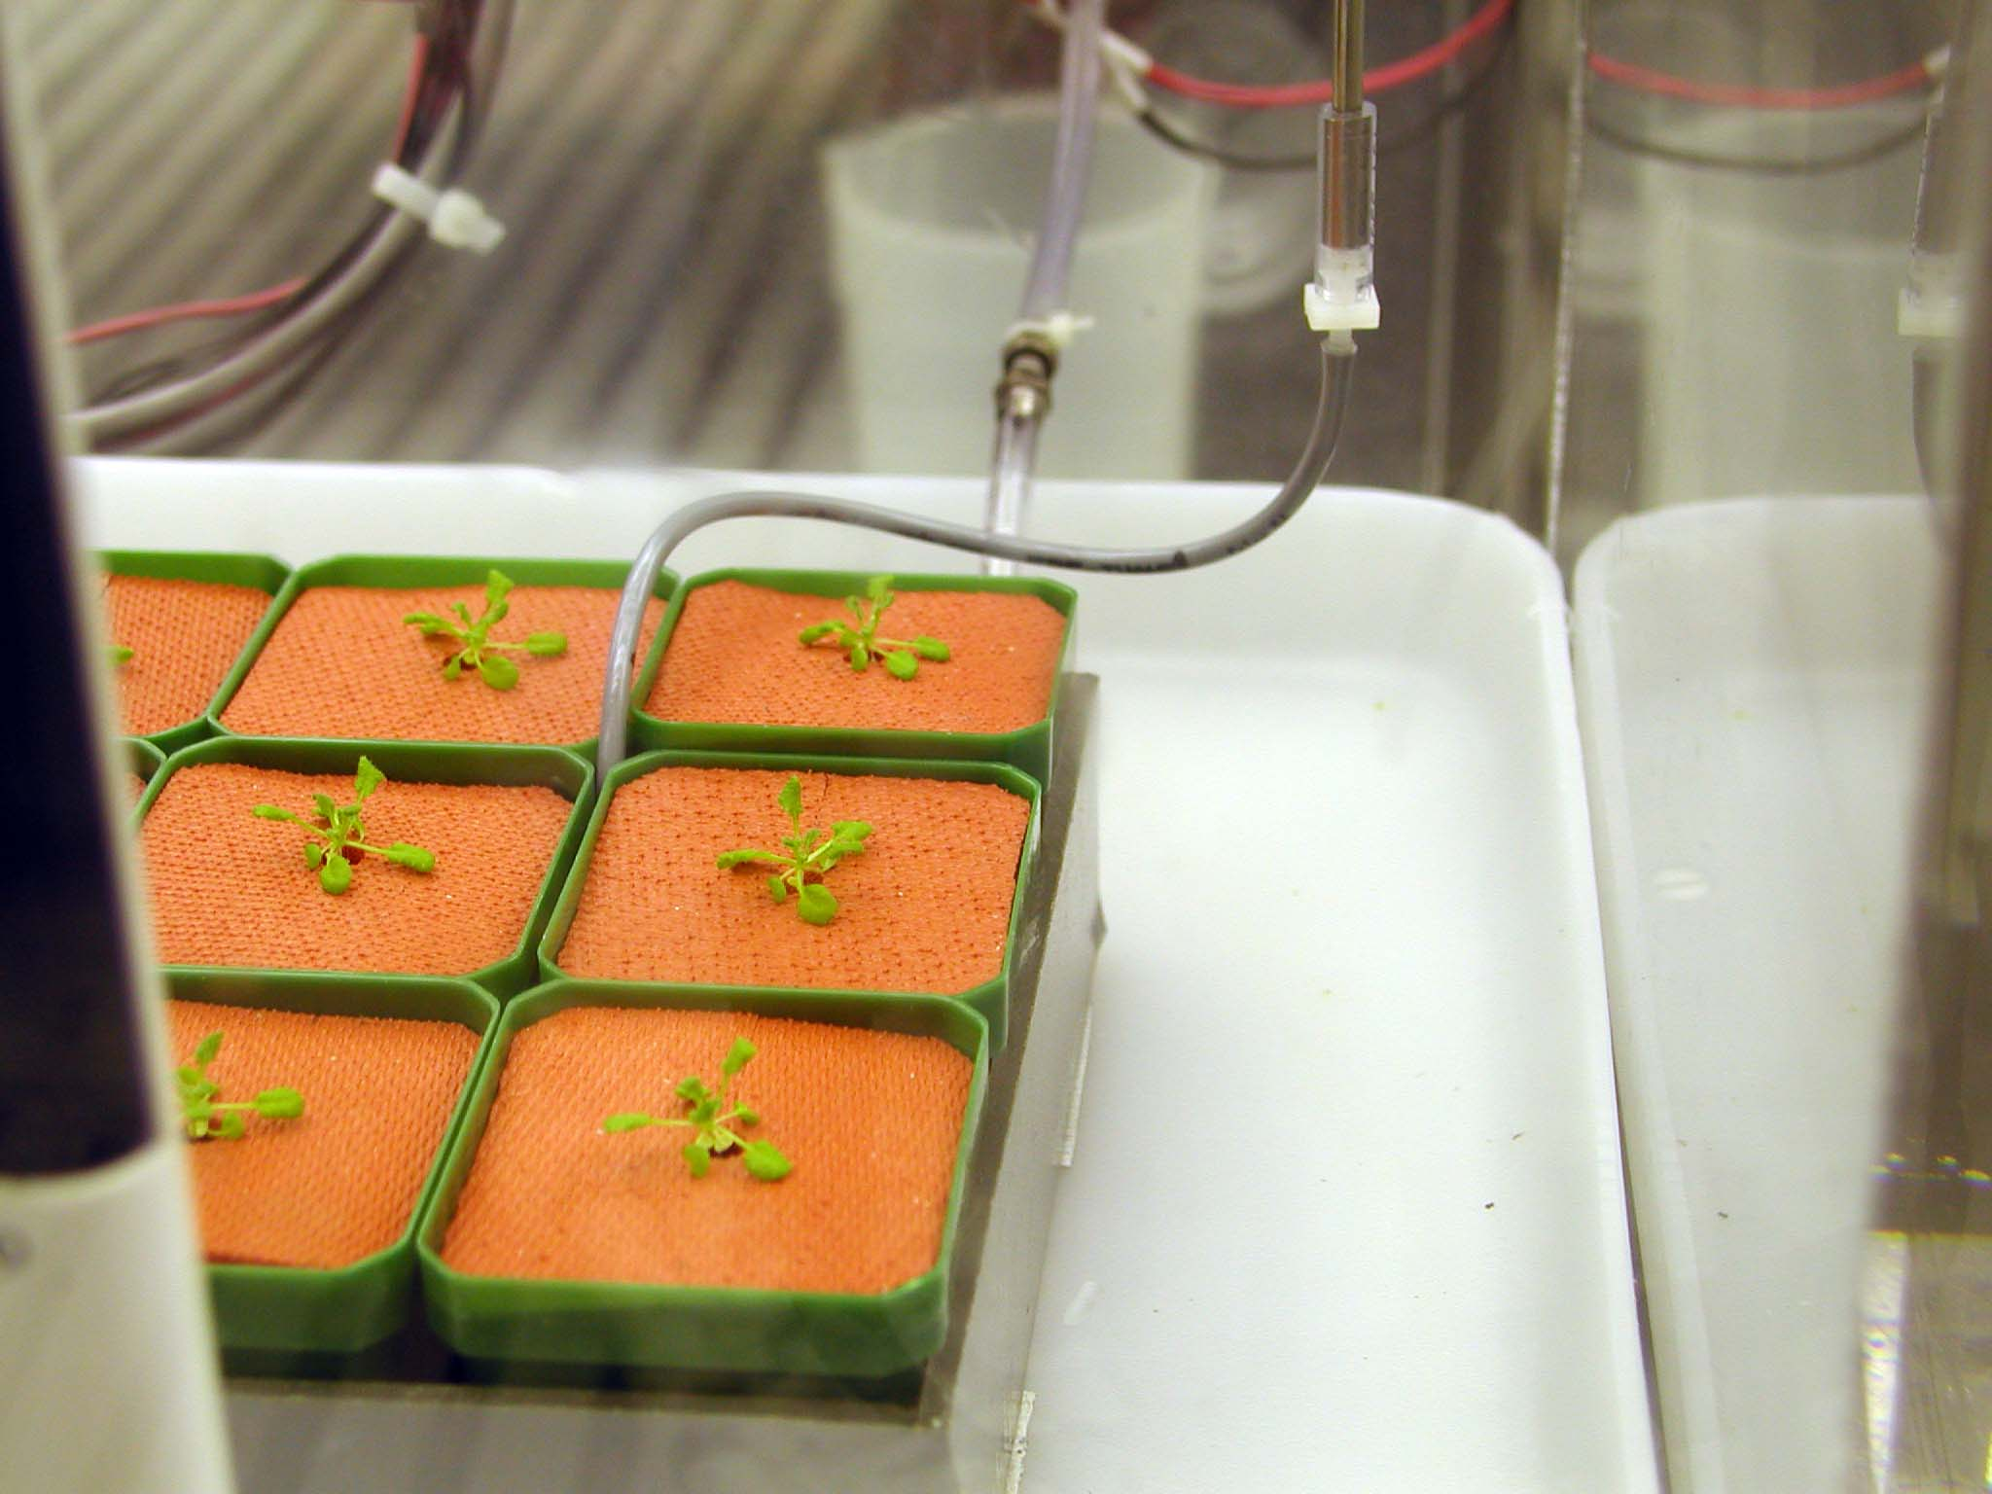
Water recycle tubing
Medium feeding tubing
Silicone rubber cover

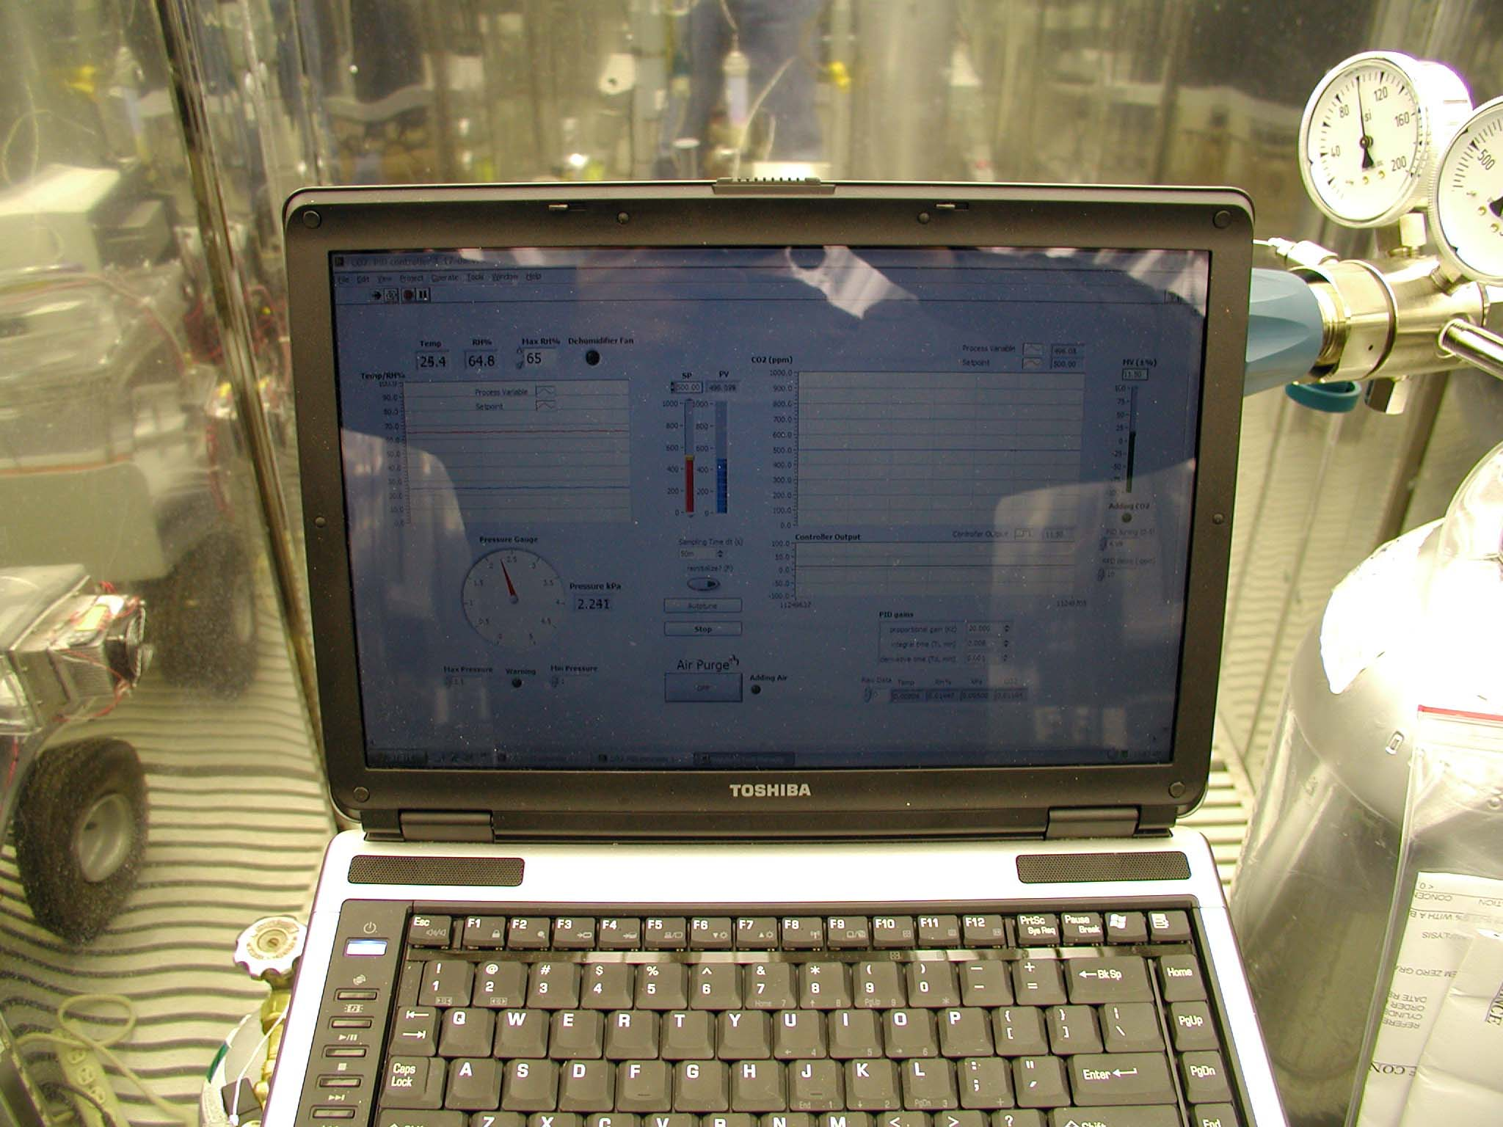
Chamber control VI in Labview 8.5
Laptop controller
Gas regulator

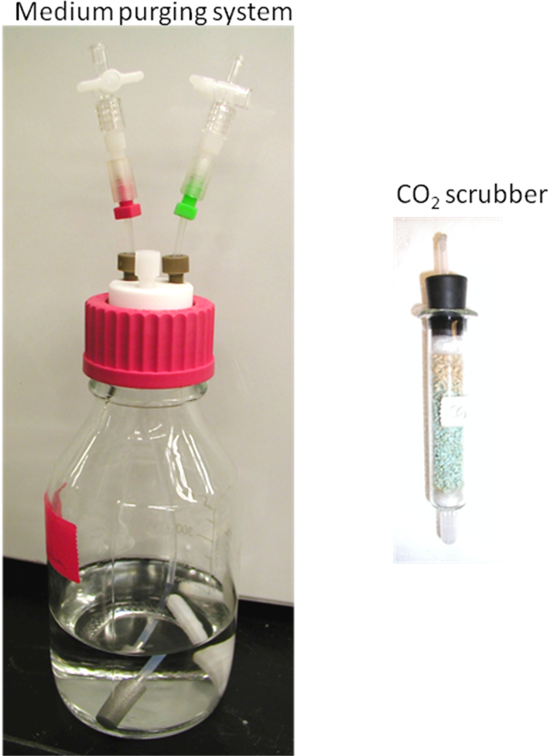

Seedlings grown in the enclosure for 3 weeks from seed
