Supp. Info 1. Performance of Computational Prediction Algorithms when tasked with discriminating between inherited disease-causing variants and putative neutral polymorphisms.
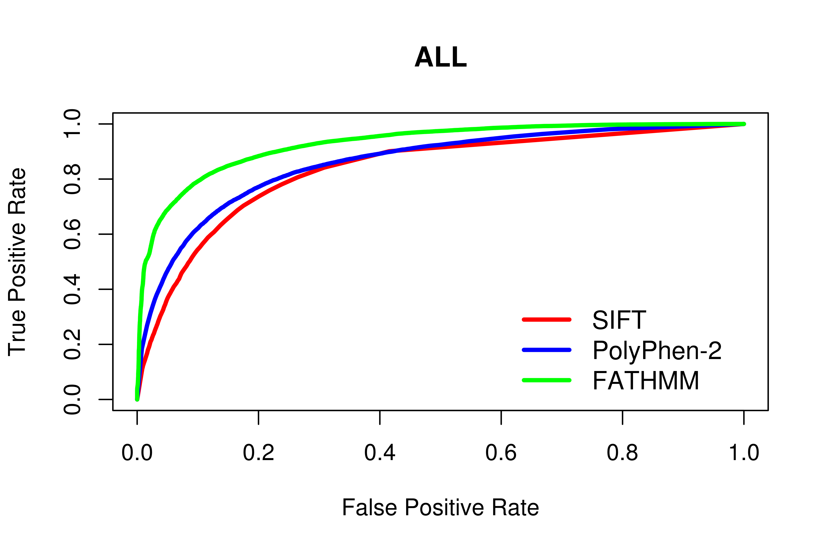
Algorithm | tp | fp | tn | fn | Accuracy | Precision | Specificity | Sensitivity | NPV | MCC | AUC
SIFT | 38059 | 4372 | 13695 | 10572 | 0.77 | 0.76 | 0.76 | 0.78 | 0.78 | 0.54 | 0.83
PolyPhen-2 | 39768 | 9557 | 27229 | 8344 | 0.78 | 0.76 | 0.74 | 0.83 | 0.81 | 0.57 | 0.86
FATHMM | 44330 | 7007 | 29931 | 5633 | 0.85 | 0.82 | 0.81 | 0.89 | 0.88 | 0.7 | 0.93
In the above, tp, fp, tn and fn refer to the number of true positive, false positive, true negative and false negatives observed. Accuracy, Precision, Specificity, Sensitivity, Negative Predictive Value (NPV) and Matthew’s Correlation Coefficient (MCC) were calculated using normalized numbers.

Supp. Info 2. Performance of computational prediction algorithms when tasked with discriminating between “Blood” disease mutations and other disease-causing mutations/putative neutral polymorphisms.
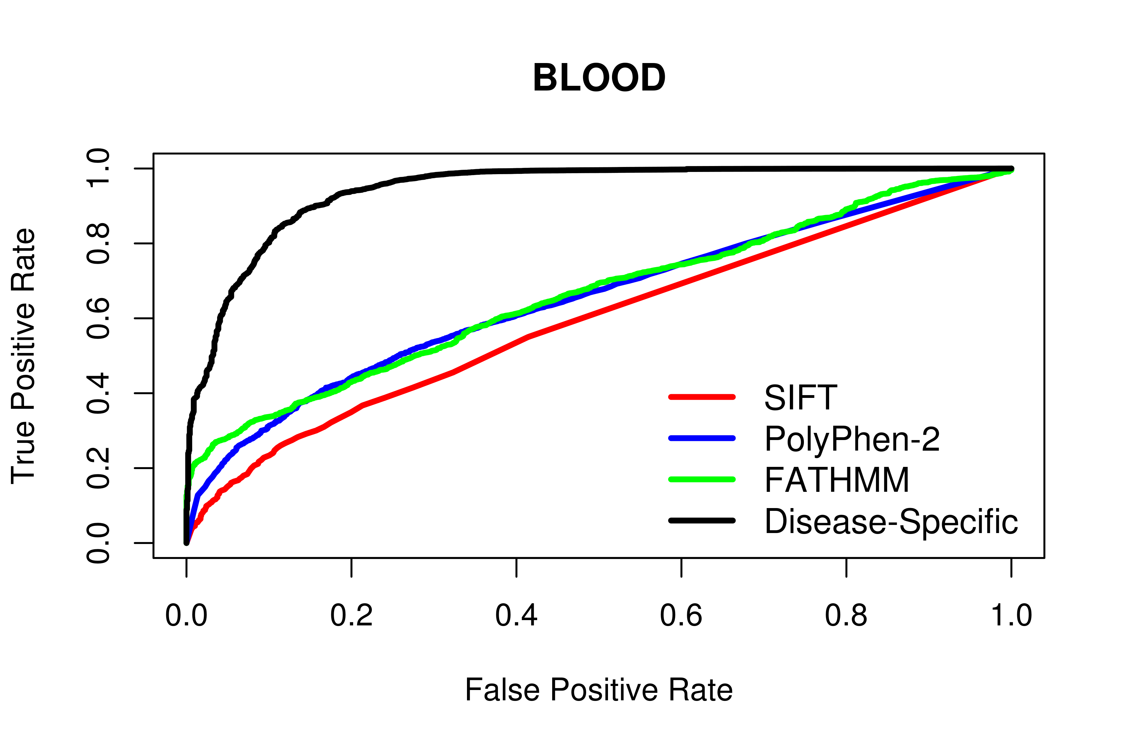
Algorithm | tp | fp | tn | fn | Accuracy | Precision | Specificity | Sensitivity | NPV | MCC | AUC
SIFT | 1151 | 41280 | 23955 | 312 | 0.58 | 0.55 | 0.37 | 0.79 | 0.63 | 0.17 | 0.59
PolyPhen-2 | 1191 | 48134 | 35309 | 264 | 0.62 | 0.59 | 0.42 | 0.82 | 0.7 | 0.26 | 0.65
FATHMM | 1187 | 49345 | 36081 | 288 | 0.61 | 0.58 | 0.42 | 0.8 | 0.68 | 0.25 | 0.66
Disease-Specific | 860 | 487 | 84939 | 615 | 0.79 | 0.99 | 0.99 | 0.58 | 0.7 | 0.63 | 0.94
Disease-Specific (20-Fold) | - | - | - | - | 0.78 | 0.99 | 0.99 | 0.57 | 0.7 | 0.62 | -
In the above, tp, fp, tn and fn refer to the number of true positive, false positive, true negative and false negatives observed. Accuracy, Precision, Specificity, Sensitivity, Negative Predictive Value (NPV) and Matthew’s Correlation Coefficient (MCC) were calculated using normalized numbers.
Supp. Info 3. Performance of computational prediction algorithms when tasked with discriminating between “Blood Coagulation” disease mutations and other disease-causing mutations/putative neutral polymorphisms.
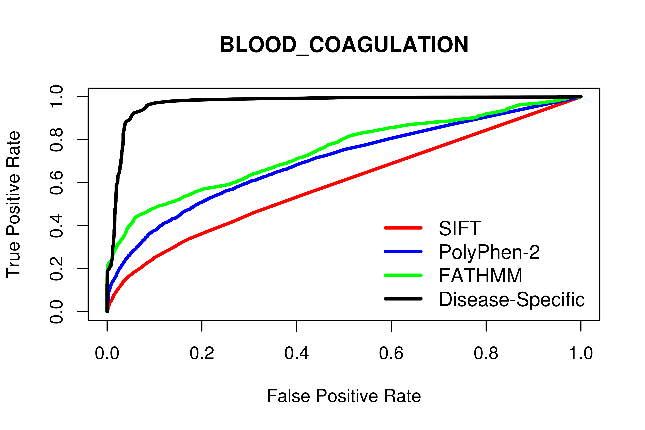
Algorithm | tp | fp | tn | fn | Accuracy | Precision | Specificity | Sensitivity | NPV | MCC | AUC
SIFT | 2755 | 39676 | 23533 | 734 | 0.58 | 0.56 | 0.37 | 0.79 | 0.64 | 0.18 | 0.6
PolyPhen-2 | 3019 | 46306 | 35094 | 479 | 0.65 | 0.6 | 0.43 | 0.86 | 0.76 | 0.33 | 0.7
FATHMM | 3354 | 50843 | 32550 | 154 | 0.67 | 0.61 | 0.39 | 0.96 | 0.9 | 0.42 | 0.75
Disease-Specific | 2885 | 1292 | 82101 | 623 | 0.9 | 0.98 | 0.98 | 0.82 | 0.85 | 0.82 | 0.97
Disease-Specific (20-Fold) | - | - | - | - | 0.9 | 0.97 | 0.98 | 0.81 | 0.84 | 0.8 | -
In the above, tp, fp, tn and fn refer to the number of true positive, false positive, true negative and false negatives observed. Accuracy, Precision, Specificity, Sensitivity, Negative Predictive Value (NPV) and Matthew’s Correlation Coefficient (MCC) were calculated using normalized numbers.
Supp. Info 4. Performance of computational prediction algorithms when tasked with discriminating between “Developmental” disease mutations and other disease-causing mutations/putative neutral polymorphisms.
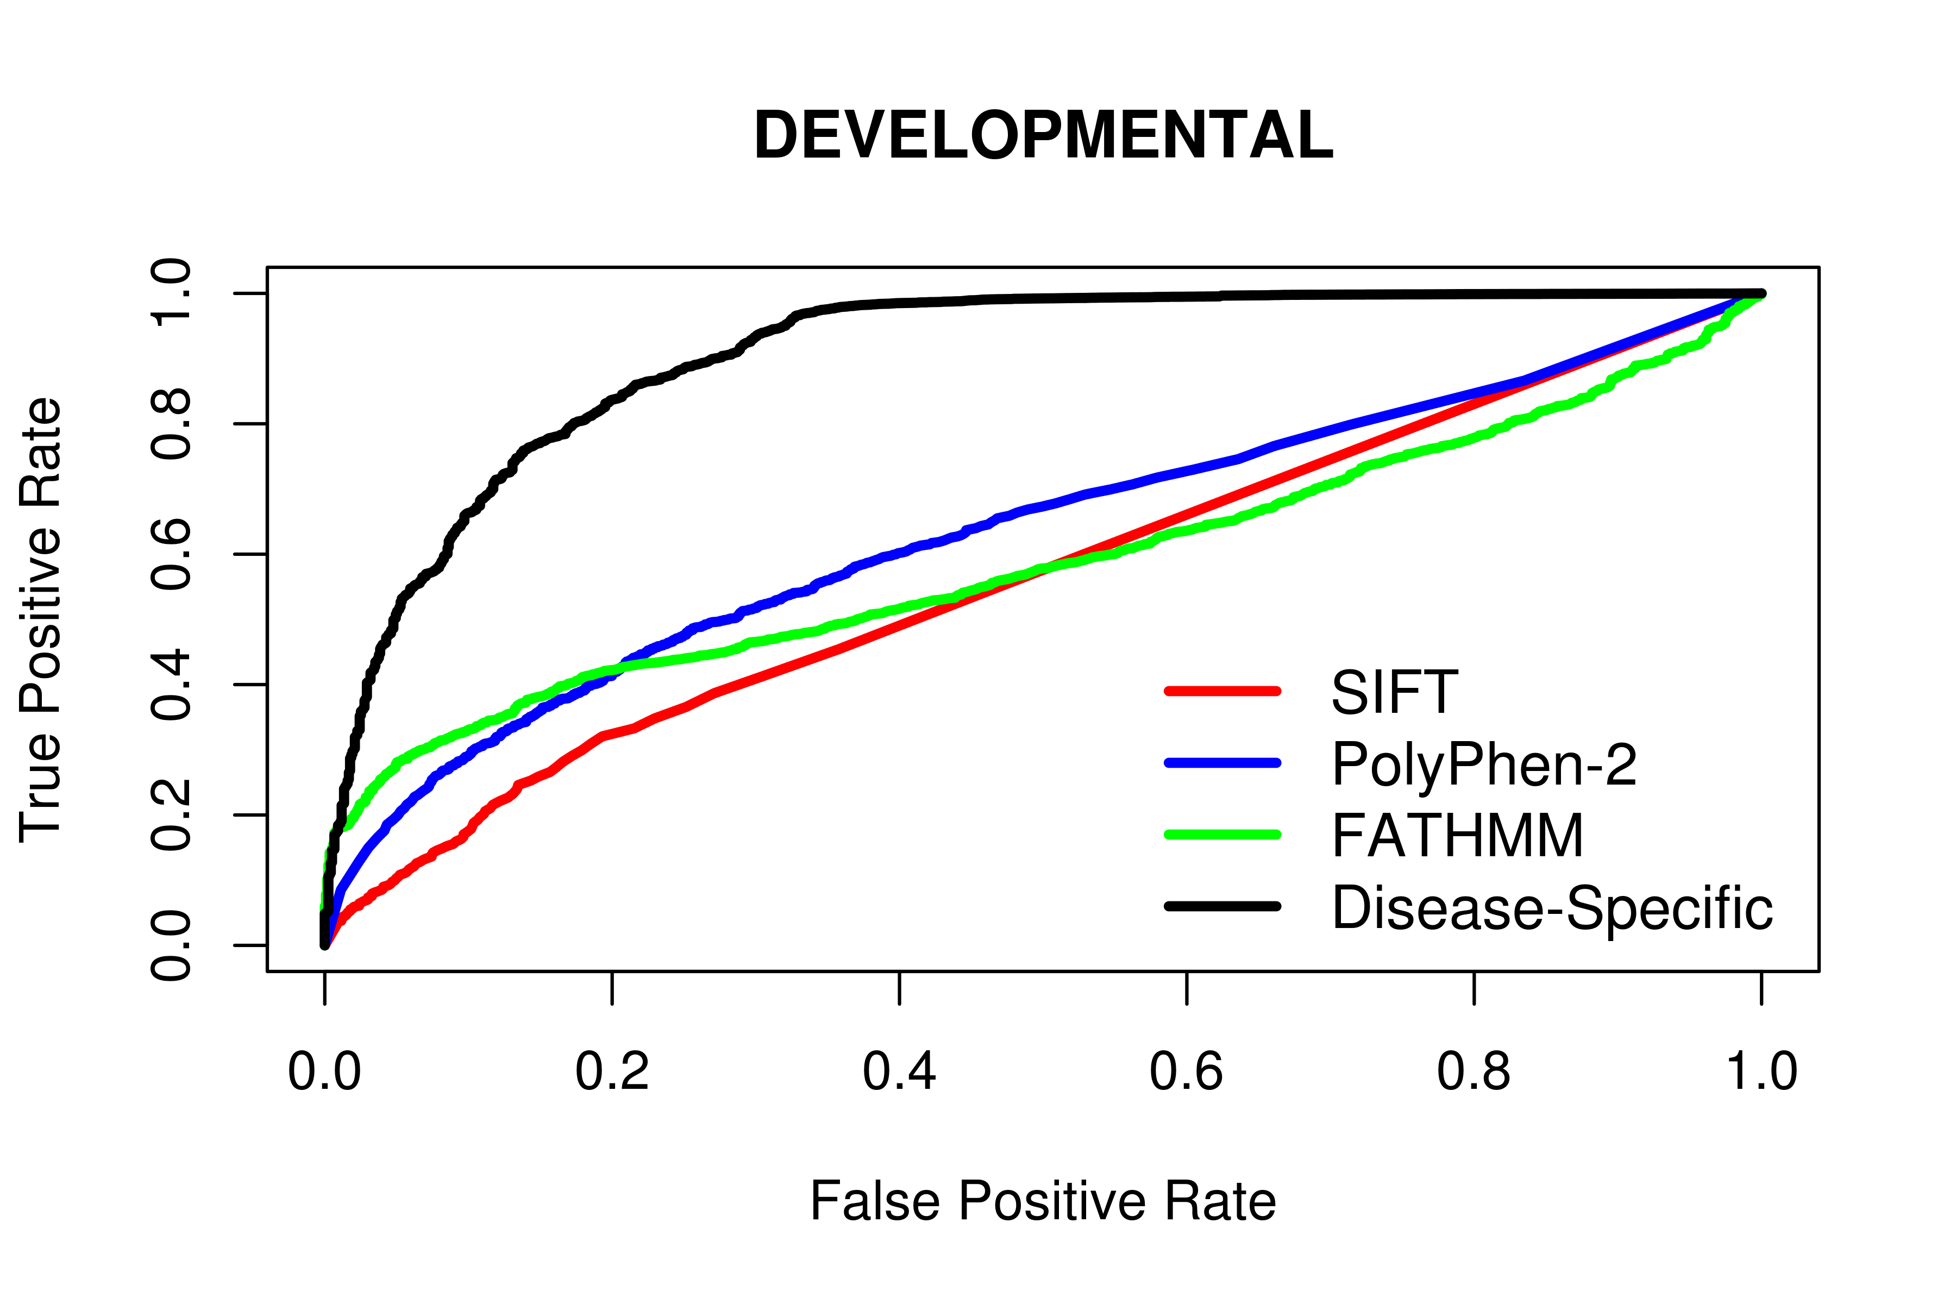
Algorithm | tp | fp | tn | fn | Accuracy | Precision | Specificity | Sensitivity | NPV | MCC | AUC
SIFT | 845 | 41586 | 23983 | 284 | 0.56 | 0.54 | 0.37 | 0.75 | 0.59 | 0.12 | 0.56
PolyPhen-2 | 920 | 48405 | 35337 | 236 | 0.61 | 0.58 | 0.42 | 0.8 | 0.67 | 0.23 | 0.63
FATHMM | 1006 | 52429 | 33278 | 188 | 0.62 | 0.58 | 0.39 | 0.84 | 0.71 | 0.26 | 0.59
Disease-Specific | 621 | 710 | 84997 | 573 | 0.76 | 0.98 | 0.99 | 0.52 | 0.67 | 0.58 | 0.9
Disease-Specific (20-Fold) | - | - | - | - | 0.74 | 0.97 | 0.99 | 0.49 | 0.66 | 0.55 | -
In the above, tp, fp, tn and fn refer to the number of true positive, false positive, true negative and false negatives observed. Accuracy, Precision, Specificity, Sensitivity, Negative Predictive Value (NPV) and Matthew’s Correlation Coefficient (MCC) were calculated using normalized numbers.
Supp. Info 5. Performance of computational prediction algorithms when tasked with discriminating between “Digestive” disease mutations and other disease-causing mutations/putative neutral polymorphisms.
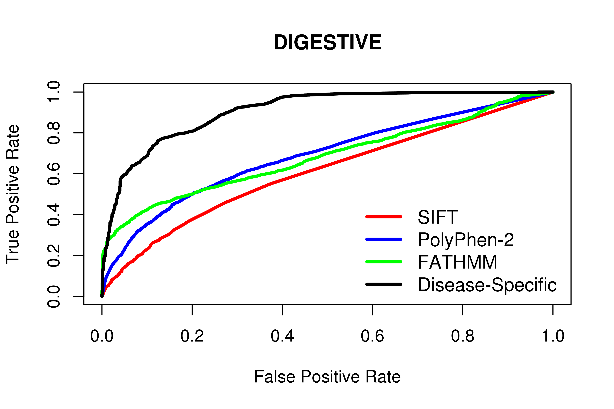
Algorithm | tp | fp | tn | fn | Accuracy | Precision | Specificity | Sensitivity | NPV | MCC | AUC
SIFT | 1444 | 40987 | 23923 | 344 | 0.59 | 0.56 | 0.37 | 0.81 | 0.66 | 0.2 | 0.61
PolyPhen-2 | 1496 | 47829 | 35319 | 254 | 0.64 | 0.6 | 0.42 | 0.85 | 0.75 | 0.31 | 0.69
FATHMM | 1662 | 52450 | 32663 | 126 | 0.66 | 0.6 | 0.38 | 0.93 | 0.84 | 0.37 | 0.68
Disease-Specific | 844 | 734 | 84379 | 944 | 0.73 | 0.98 | 0.99 | 0.47 | 0.65 | 0.54 | 0.91
Disease-Specific (20-Fold) | - | - | - | - | 0.72 | 0.97 | 0.99 | 0.45 | 0.64 | 0.52 | -
In the above, tp, fp, tn and fn refer to the number of true positive, false positive, true negative and false negatives observed. Accuracy, Precision, Specificity, Sensitivity, Negative Predictive Value (NPV) and Matthew’s Correlation Coefficient (MCC) were calculated using normalized numbers.
Supp. Info 6. Performance of computational prediction algorithms when tasked with discriminating between “Ear, Nose and Throat” disease mutations and other disease-causing mutations/putative neutral polymorphisms.
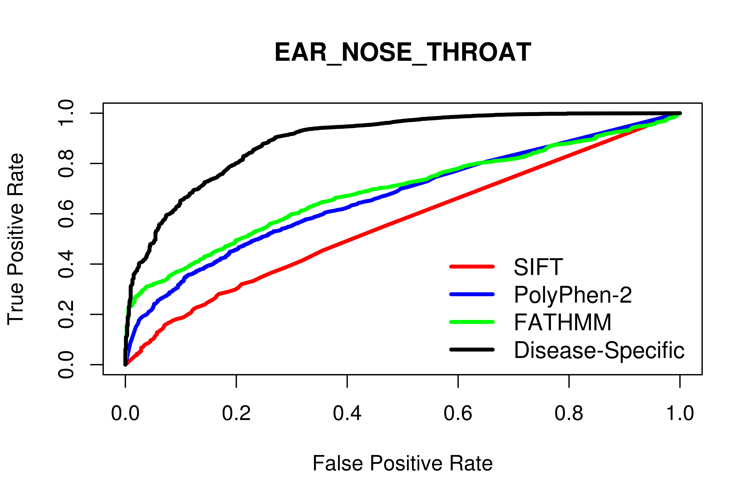
Algorithm | tp | fp | tn | fn | Accuracy | Precision | Specificity | Sensitivity | NPV | MCC | AUC
SIFT | 673 | 41758 | 24027 | 240 | 0.55 | 0.54 | 0.37 | 0.74 | 0.58 | 0.11 | 0.56
PolyPhen-2 | 751 | 48574 | 35417 | 156 | 0.62 | 0.59 | 0.42 | 0.83 | 0.71 | 0.27 | 0.67
FATHMM | 681 | 36967 | 48994 | 259 | 0.65 | 0.63 | 0.57 | 0.72 | 0.67 | 0.3 | 0.69
Disease-Specific | 192 | 199 | 85762 | 748 | 0.6 | 0.99 | 1 | 0.2 | 0.56 | 0.33 | 0.89
Disease-Specific (20-Fold) | - | - | - | - | 0.59 | 0.98 | 1 | 0.18 | 0.55 | 0.31 | -
In the above, tp, fp, tn and fn refer to the number of true positive, false positive, true negative and false negatives observed. Accuracy, Precision, Specificity, Sensitivity, Negative Predictive Value (NPV) and Matthew’s Correlation Coefficient (MCC) were calculated using normalized numbers.
Supp. Info 7. Performance of computational prediction algorithms when tasked with discriminating between “Endocrine” disease mutations and other disease-causing mutations/putative neutral polymorphisms.
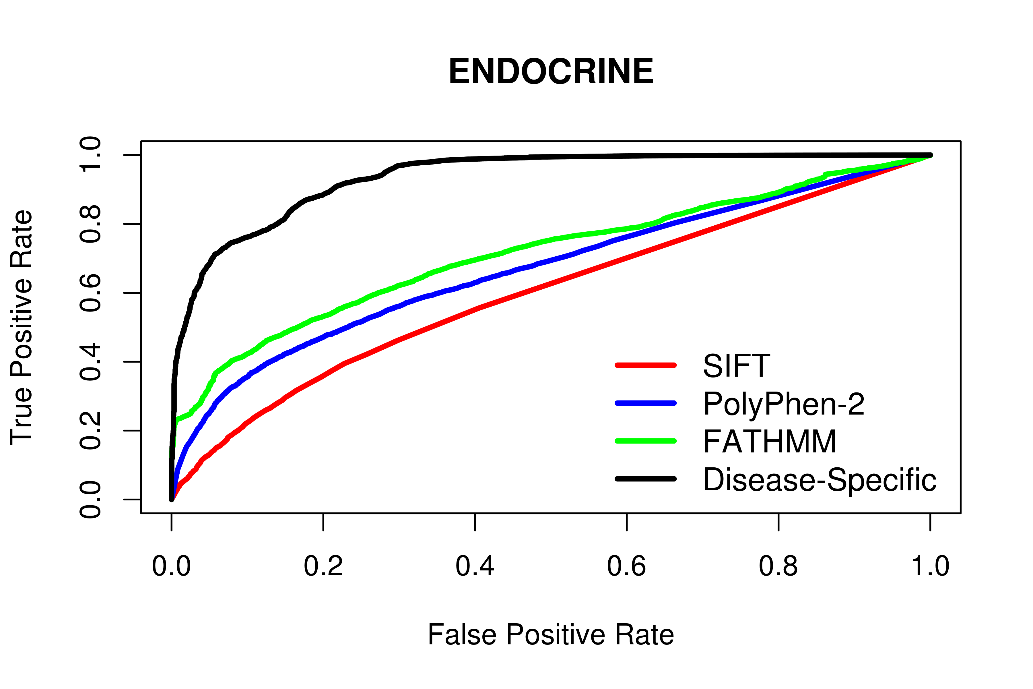
Algorithm | tp | fp | tn | fn | Accuracy | Precision | Specificity | Sensitivity | NPV | MCC | AUC
SIFT | 3084 | 39347 | 23443 | 824 | 0.58 | 0.56 | 0.37 | 0.79 | 0.64 | 0.18 | 0.6
PolyPhen-2 | 2890 | 46435 | 35031 | 542 | 0.64 | 0.6 | 0.43 | 0.84 | 0.73 | 0.3 | 0.67
FATHMM | 3597 | 49466 | 33522 | 316 | 0.66 | 0.61 | 0.4 | 0.92 | 0.83 | 0.38 | 0.71
Disease-Specific | 2392 | 1015 | 81973 | 1521 | 0.8 | 0.98 | 0.99 | 0.61 | 0.72 | 0.65 | 0.94
Disease-Specific (20-Fold) | - | - | - | - | 0.79 | 0.97 | 0.98 | 0.6 | 0.71 | 0.63 | -
In the above, tp, fp, tn and fn refer to the number of true positive, false positive, true negative and false negatives observed. Accuracy, Precision, Specificity, Sensitivity, Negative Predictive Value (NPV) and Matthew’s Correlation Coefficient (MCC) were calculated using normalized numbers.
Supp. Info 8. Performance of computational prediction algorithms when tasked with discriminating between “Eye” disease mutations and other disease-causing mutations/putative neutral polymorphisms.
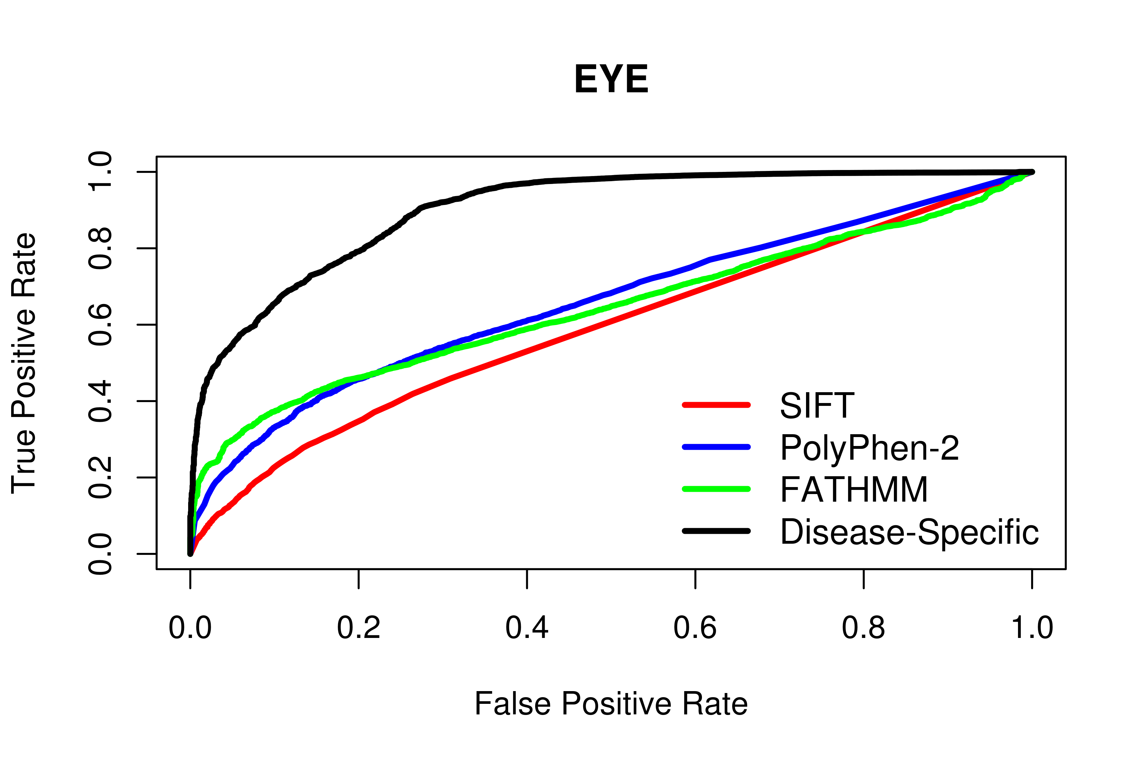
Algorithm | tp | fp | tn | fn | Accuracy | Precision | Specificity | Sensitivity | NPV | MCC | AUC
SIFT | 2362 | 40069 | 23607 | 660 | 0.58 | 0.55 | 0.37 | 0.78 | 0.63 | 0.17 | 0.59
PolyPhen-2 | 2472 | 46853 | 35055 | 518 | 0.63 | 0.59 | 0.43 | 0.83 | 0.71 | 0.28 | 0.66
FATHMM | 2701 | 51737 | 32134 | 329 | 0.64 | 0.59 | 0.38 | 0.89 | 0.78 | 0.32 | 0.64
Disease-Specific | 1433 | 1127 | 82744 | 1597 | 0.73 | 0.97 | 0.99 | 0.47 | 0.65 | 0.54 | 0.9
Disease-Specific (20-Fold) | - | - | - | - | 0.72 | 0.96 | 0.98 | 0.45 | 0.64 | 0.51 | -
In the above, tp, fp, tn and fn refer to the number of true positive, false positive, true negative and false negatives observed. Accuracy, Precision, Specificity, Sensitivity, Negative Predictive Value (NPV) and Matthew’s Correlation Coefficient (MCC) were calculated using normalized numbers.
Supp. Info 9. Performance of computational prediction algorithms when tasked with discriminating between “Genitourinary” disease mutations and other disease-causing mutations/putative neutral polymorphisms.
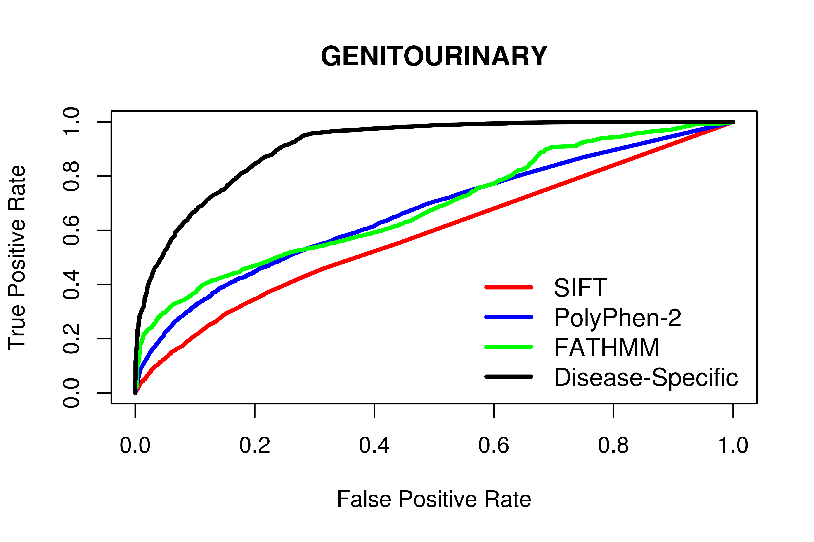
Algorithm | tp | fp | tn | fn | Accuracy | Precision | Specificity | Sensitivity | NPV | MCC | AUC
SIFT | 2352 | 40079 | 23600 | 667 | 0.57 | 0.55 | 0.37 | 0.78 | 0.63 | 0.16 | 0.59
PolyPhen-2 | 2214 | 47111 | 35083 | 490 | 0.62 | 0.59 | 0.43 | 0.82 | 0.7 | 0.27 | 0.66
FATHMM | 2661 | 49707 | 34164 | 369 | 0.64 | 0.6 | 0.41 | 0.88 | 0.77 | 0.32 | 0.68
Disease-Specific | 1601 | 1327 | 82544 | 1429 | 0.76 | 0.97 | 0.98 | 0.53 | 0.68 | 0.58 | 0.91
Disease-Specific (20-Fold) | - | - | - | - | 0.74 | 0.96 | 0.98 | 0.5 | 0.66 | 0.55 | -
In the above, tp, fp, tn and fn refer to the number of true positive, false positive, true negative and false negatives observed. Accuracy, Precision, Specificity, Sensitivity, Negative Predictive Value (NPV) and Matthew’s Correlation Coefficient (MCC) were calculated using normalized numbers.
Supp. Info 10. Performance of computational prediction algorithms when tasked with discriminating between “Heart” disease mutations and other disease-causing mutations/putative neutral polymorphisms.
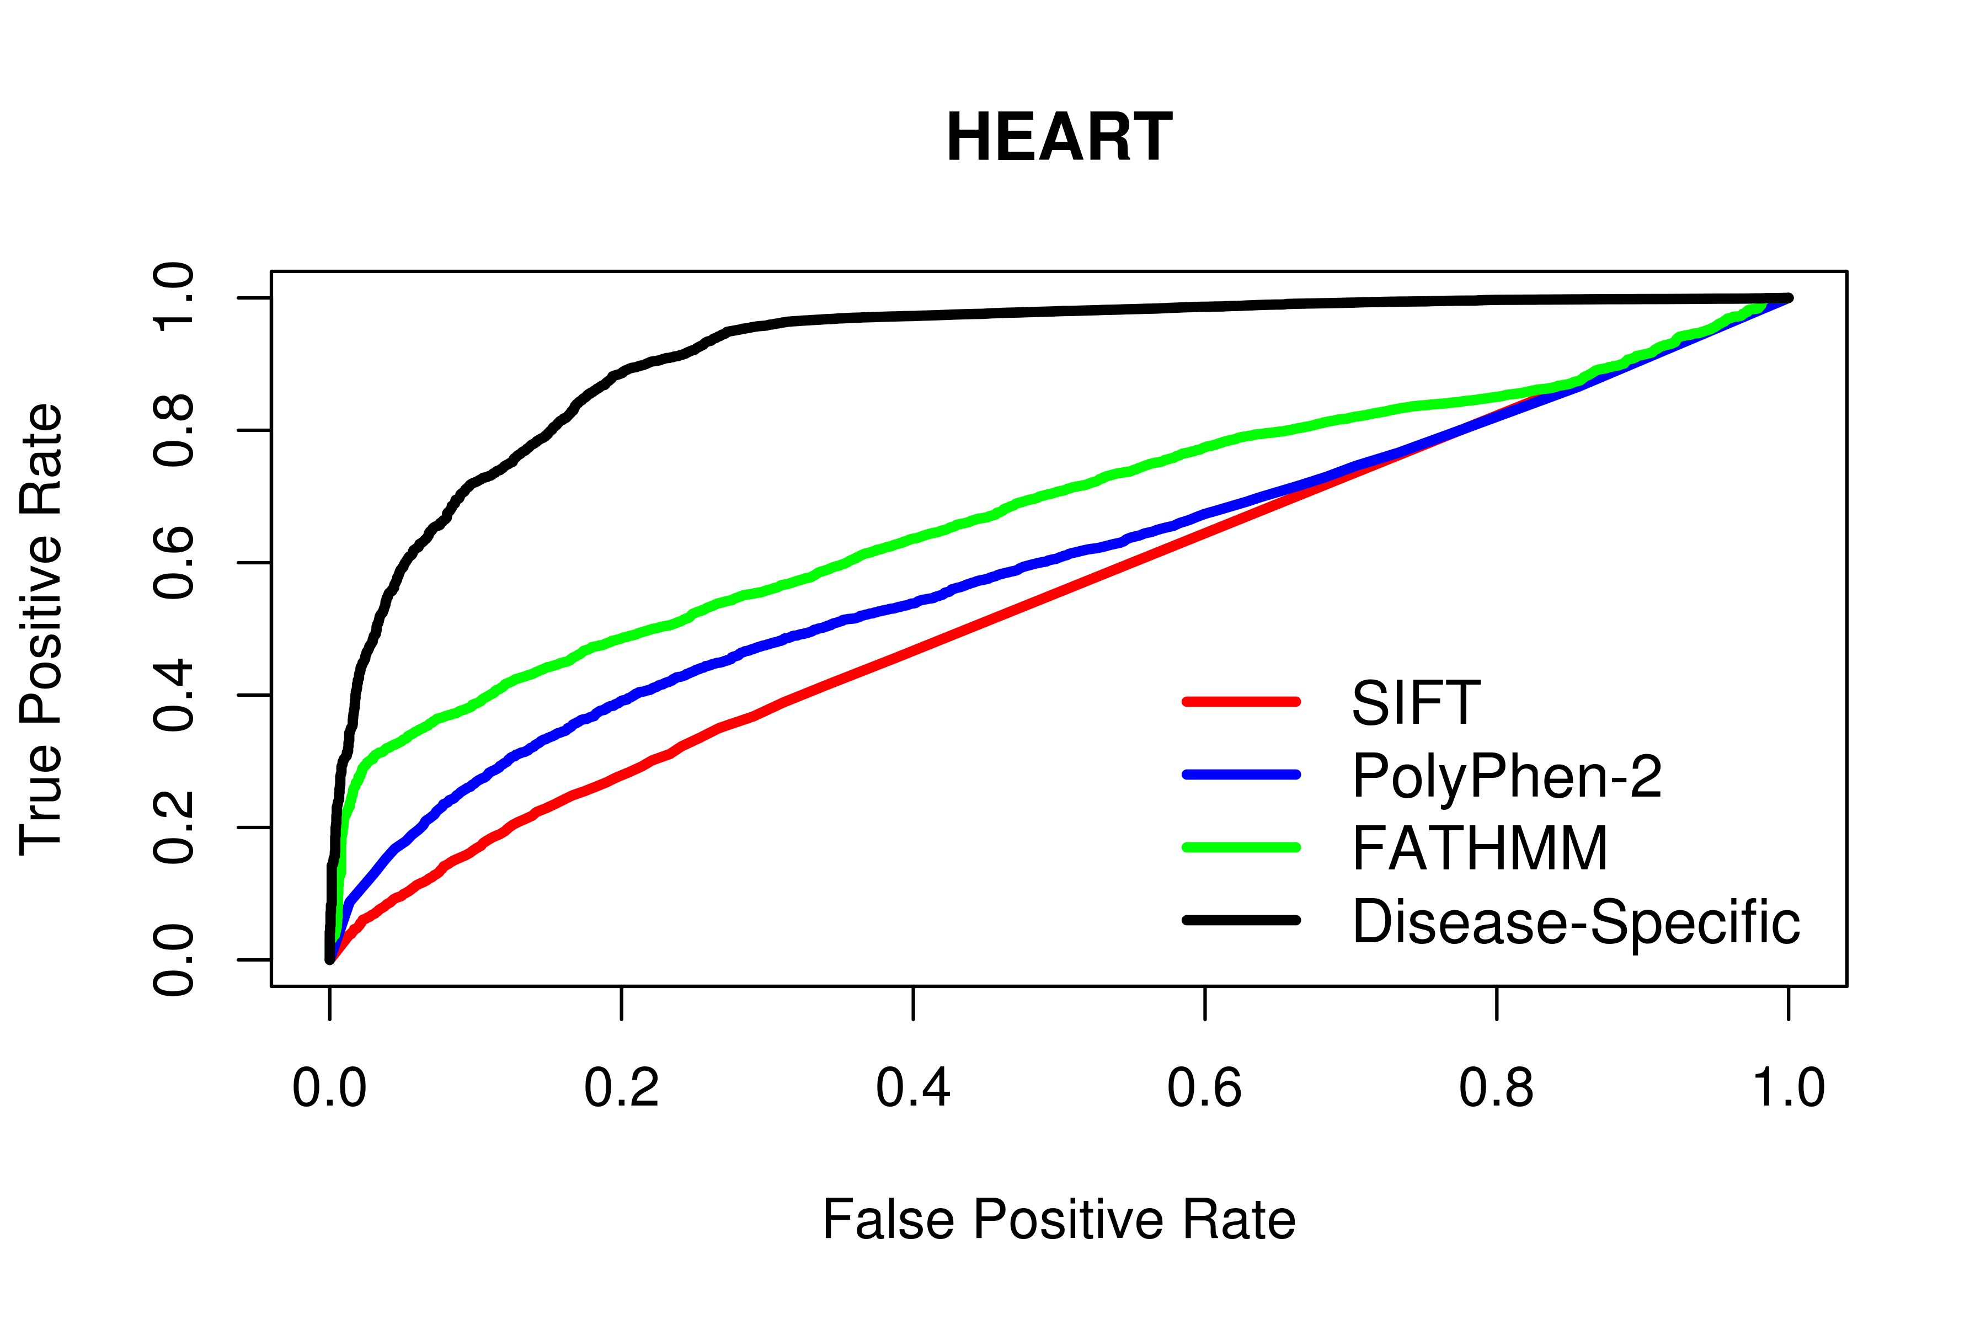
Algorithm | tp | fp | tn | fn | Accuracy | Precision | Specificity | Sensitivity | NPV | MCC | AUC
SIFT | 2422 | 40009 | 23276 | 991 | 0.54 | 0.53 | 0.37 | 0.71 | 0.56 | 0.08 | 0.55
PolyPhen-2 | 2683 | 46642 | 34736 | 837 | 0.59 | 0.57 | 0.43 | 0.76 | 0.64 | 0.2 | 0.6
FATHMM | 3588 | 56453 | 26706 | 154 | 0.64 | 0.59 | 0.32 | 0.96 | 0.89 | 0.36 | 0.68
Disease-Specific | 2536 | 2885 | 80274 | 1206 | 0.82 | 0.95 | 0.97 | 0.68 | 0.75 | 0.67 | 0.92
Disease-Specific (20-Fold) | - | - | - | - | 0.8 | 0.91 | 0.93 | 0.66 | 0.73 | 0.62 | -
In the above, tp, fp, tn and fn refer to the number of true positive, false positive, true negative and false negatives observed. Accuracy, Precision, Specificity, Sensitivity, Negative Predictive Value (NPV) and Matthew’s Correlation Coefficient (MCC) were calculated using normalized numbers.
Supp. Info 11. Performance of computational prediction algorithms when tasked with discriminating between “Immune” disease mutations and other disease-causing mutations/putative neutral polymorphisms.
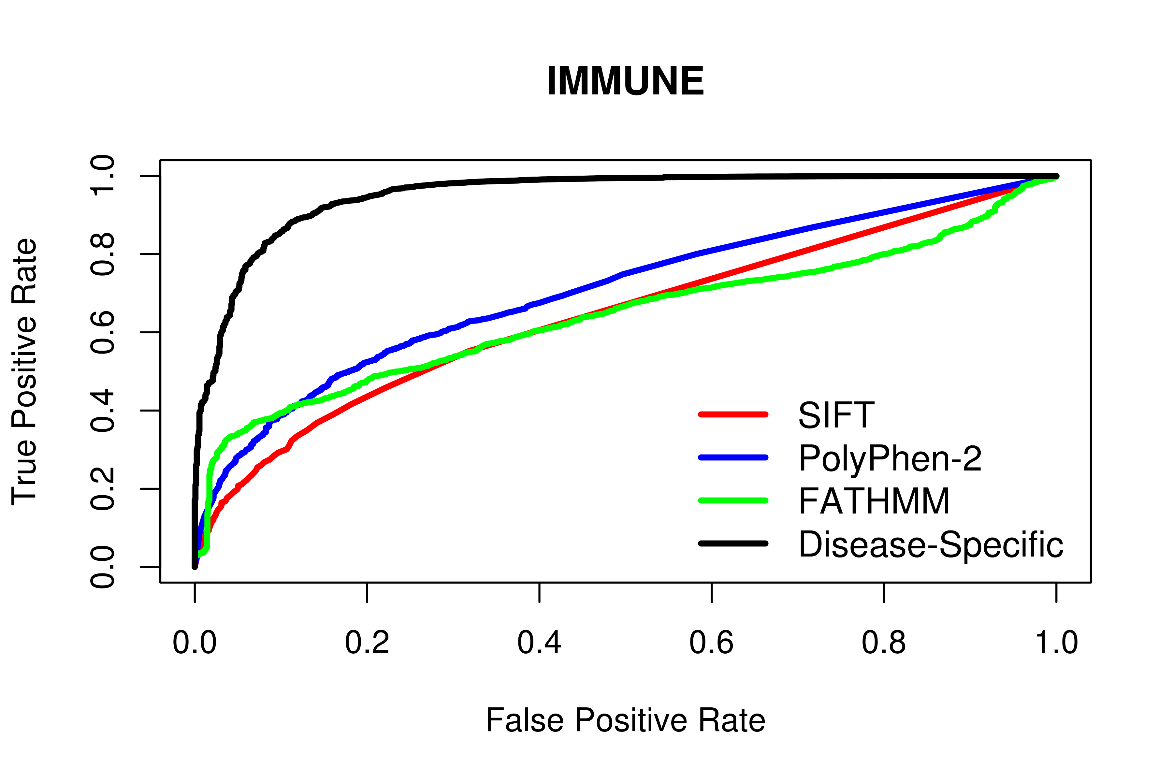
Algorithm | tp | fp | tn | fn | Accuracy | Precision | Specificity | Sensitivity | NPV | MCC | AUC
SIFT | 1110 | 41321 | 24084 | 183 | 0.61 | 0.58 | 0.37 | 0.86 | 0.72 | 0.26 | 0.64
PolyPhen-2 | 1125 | 48200 | 35413 | 160 | 0.65 | 0.6 | 0.42 | 0.88 | 0.77 | 0.34 | 0.7
FATHMM | 1046 | 45596 | 40012 | 247 | 0.64 | 0.6 | 0.47 | 0.81 | 0.71 | 0.29 | 0.64
Disease-Specific | 590 | 385 | 85223 | 703 | 0.73 | 0.99 | 1 | 0.46 | 0.65 | 0.54 | 0.95
Disease-Specific (20-Fold) | - | - | - | - | 0.72 | 0.99 | 0.99 | 0.44 | 0.64 | 0.52 | -
In the above, tp, fp, tn and fn refer to the number of true positive, false positive, true negative and false negatives observed. Accuracy, Precision, Specificity, Sensitivity, Negative Predictive Value (NPV) and Matthew’s Correlation Coefficient (MCC) were calculated using normalized numbers.
Supp. Info 12. Performance of computational prediction algorithms when tasked with discriminating between “Metabolic” disease mutations and other disease-causing mutations/putative neutral polymorphisms.
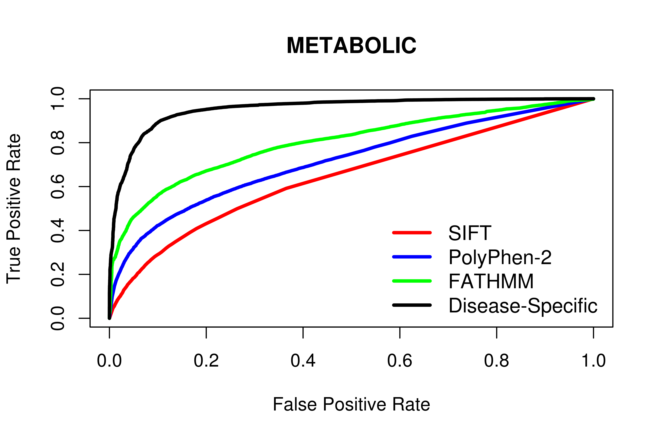
Algorithm | tp | fp | tn | fn | Accuracy | Precision | Specificity | Sensitivity | NPV | MCC | AUC
SIFT | 10731 | 31700 | 21913 | 2354 | 0.61 | 0.58 | 0.41 | 0.82 | 0.69 | 0.25 | 0.64
PolyPhen-2 | 11337 | 37988 | 33788 | 1785 | 0.67 | 0.62 | 0.47 | 0.86 | 0.78 | 0.36 | 0.72
FATHMM | 13068 | 39914 | 33271 | 648 | 0.7 | 0.64 | 0.45 | 0.95 | 0.91 | 0.47 | 0.8
Disease-Specific | 10767 | 3209 | 69976 | 2949 | 0.87 | 0.95 | 0.96 | 0.78 | 0.82 | 0.75 | 0.95
Disease-Specific (20-Fold) | - | - | - | - | 0.86 | 0.94 | 0.95 | 0.77 | 0.81 | 0.74 | -
In the above, tp, fp, tn and fn refer to the number of true positive, false positive, true negative and false negatives observed. Accuracy, Precision, Specificity, Sensitivity, Negative Predictive Value (NPV) and Matthew’s Correlation Coefficient (MCC) were calculated using normalized numbers.
Supp. Info 13. Performance of computational prediction algorithms when tasked with discriminating between “Musculoskeletal” disease mutations and other disease-causing mutations/putative neutral polymorphisms.
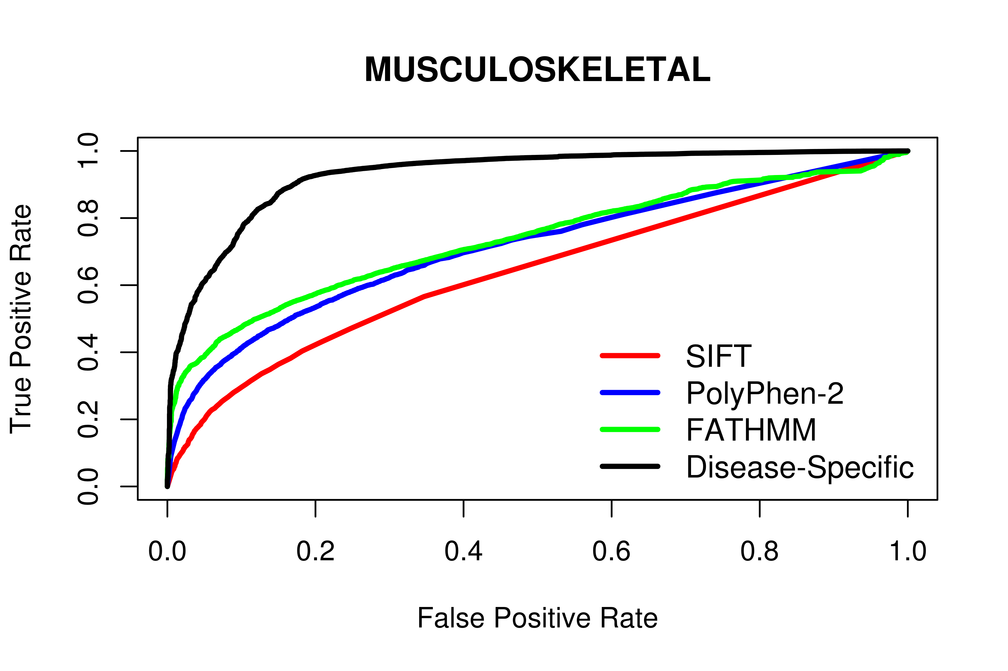
Algorithm | tp | fp | tn | fn | Accuracy | Precision | Specificity | Sensitivity | NPV | MCC | AUC
SIFT | 4730 | 37701 | 23323 | 944 | 0.61 | 0.57 | 0.38 | 0.83 | 0.7 | 0.24 | 0.64
PolyPhen-2 | 5278 | 44047 | 34859 | 714 | 0.66 | 0.61 | 0.44 | 0.88 | 0.79 | 0.36 | 0.71
FATHMM | 5902 | 51596 | 29202 | 201 | 0.66 | 0.6 | 0.36 | 0.97 | 0.92 | 0.41 | 0.73
Disease-Specific | 4120 | 3123 | 77675 | 1983 | 0.82 | 0.95 | 0.96 | 0.68 | 0.75 | 0.66 | 0.93
Disease-Specific (20-Fold) | - | - | - | - | 0.8 | 0.92 | 0.94 | 0.66 | 0.74 | 0.63 | -
In the above, tp, fp, tn and fn refer to the number of true positive, false positive, true negative and false negatives observed. Accuracy, Precision, Specificity, Sensitivity, Negative Predictive Value (NPV) and Matthew’s Correlation Coefficient (MCC) were calculated using normalized numbers.
Supp. Info 14. Performance of computational prediction algorithms when tasked with discriminating between “Nervous System” disease mutations and other disease-causing mutations/putative neutral polymorphisms.
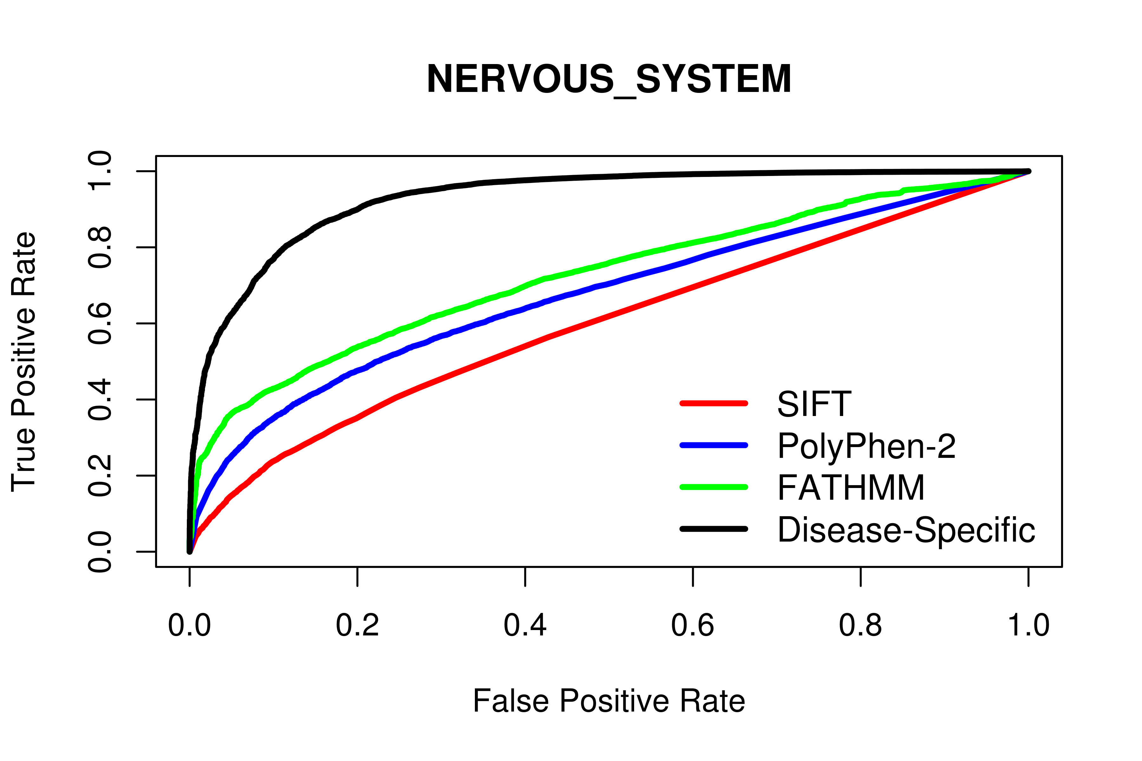
Algorithm | tp | fp | tn | fn | Accuracy | Precision | Specificity | Sensitivity | NPV | MCC | AUC
SIFT | 6550 | 35881 | 22344 | 1923 | 0.58 | 0.56 | 0.38 | 0.77 | 0.63 | 0.17 | 0.6
PolyPhen-2 | 6672 | 42653 | 34182 | 1391 | 0.64 | 0.6 | 0.44 | 0.83 | 0.72 | 0.29 | 0.67
FATHMM | 7939 | 47844 | 30506 | 612 | 0.66 | 0.6 | 0.39 | 0.93 | 0.84 | 0.38 | 0.72
Disease-Specific | 5560 | 2419 | 75931 | 2991 | 0.81 | 0.95 | 0.97 | 0.65 | 0.73 | 0.65 | 0.93
Disease-Specific (20-Fold) | - | - | - | - | 0.8 | 0.94 | 0.96 | 0.63 | 0.72 | 0.63 | -
In the above, tp, fp, tn and fn refer to the number of true positive, false positive, true negative and false negatives observed. Accuracy, Precision, Specificity, Sensitivity, Negative Predictive Value (NPV) and Matthew’s Correlation Coefficient (MCC) were calculated using normalized numbers.
Supp. Info 15. Performance of computational prediction algorithms when tasked with discriminating between “Psychiatric” disease mutations and other disease-causing mutations/putative neutral polymorphisms.
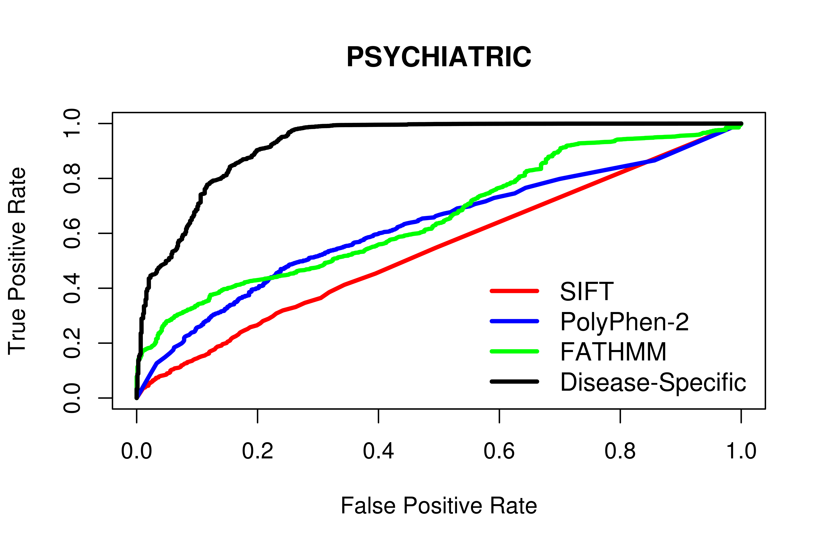
Algorithm | tp | fp | tn | fn | Accuracy | Precision | Specificity | Sensitivity | NPV | MCC | AUC
SIFT | 500 | 41931 | 24048 | 219 | 0.53 | 0.52 | 0.36 | 0.7 | 0.54 | 0.06 | 0.54
PolyPhen-2 | 571 | 48754 | 35418 | 155 | 0.6 | 0.58 | 0.42 | 0.79 | 0.66 | 0.22 | 0.62
FATHMM | 504 | 42672 | 43483 | 242 | 0.59 | 0.58 | 0.5 | 0.68 | 0.61 | 0.18 | 0.66
Disease-Specific | 379 | 165 | 85990 | 367 | 0.75 | 1 | 1 | 0.51 | 0.67 | 0.58 | 0.92
Disease-Specific (20-Fold) | - | - | - | - | 0.74 | 0.99 | 1 | 0.48 | 0.66 | 0.56 | -
In the above, tp, fp, tn and fn refer to the number of true positive, false positive, true negative and false negatives observed. Accuracy, Precision, Specificity, Sensitivity, Negative Predictive Value (NPV) and Matthew’s Correlation Coefficient (MCC) were calculated using normalized numbers.
Supp. Info 16. Performance of computational prediction algorithms when tasked with discriminating between “Reproductive” disease mutations and other disease-causing mutations/putative neutral polymorphisms.
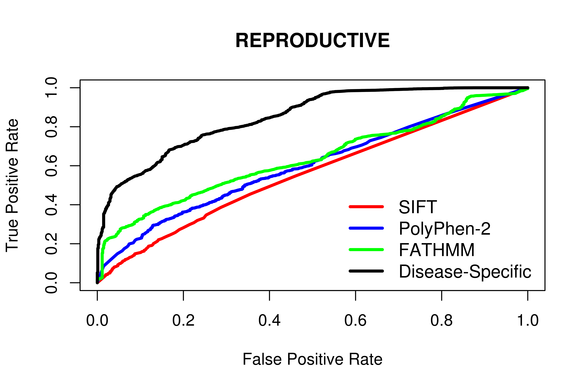
Algorithm | tp | fp | tn | fn | Accuracy | Precision | Specificity | Sensitivity | NPV | MCC | AUC
SIFT | 645 | 41786 | 24030 | 237 | 0.55 | 0.54 | 0.37 | 0.73 | 0.58 | 0.1 | 0.56
PolyPhen-2 | 451 | 48874 | 35402 | 171 | 0.57 | 0.56 | 0.42 | 0.73 | 0.6 | 0.15 | 0.6
FATHMM | 370 | 24336 | 61682 | 513 | 0.57 | 0.6 | 0.72 | 0.42 | 0.55 | 0.14 | 0.64
Disease-Specific | 131 | 36 | 85982 | 752 | 0.57 | 1 | 1 | 0.15 | 0.54 | 0.28 | 0.85
Disease-Specific (20-Fold) | - | - | - | - | 0.57 | 0.99 | 1 | 0.14 | 0.54 | 0.26 | -
In the above, tp, fp, tn and fn refer to the number of true positive, false positive, true negative and false negatives observed. Accuracy, Precision, Specificity, Sensitivity, Negative Predictive Value (NPV) and Matthew’s Correlation Coefficient (MCC) were calculated using normalized numbers.
Supp. Info 17. Performance of computational prediction algorithms when tasked with discriminating between “Respiratory” disease mutations and other disease-causing mutations/putative neutral polymorphisms.
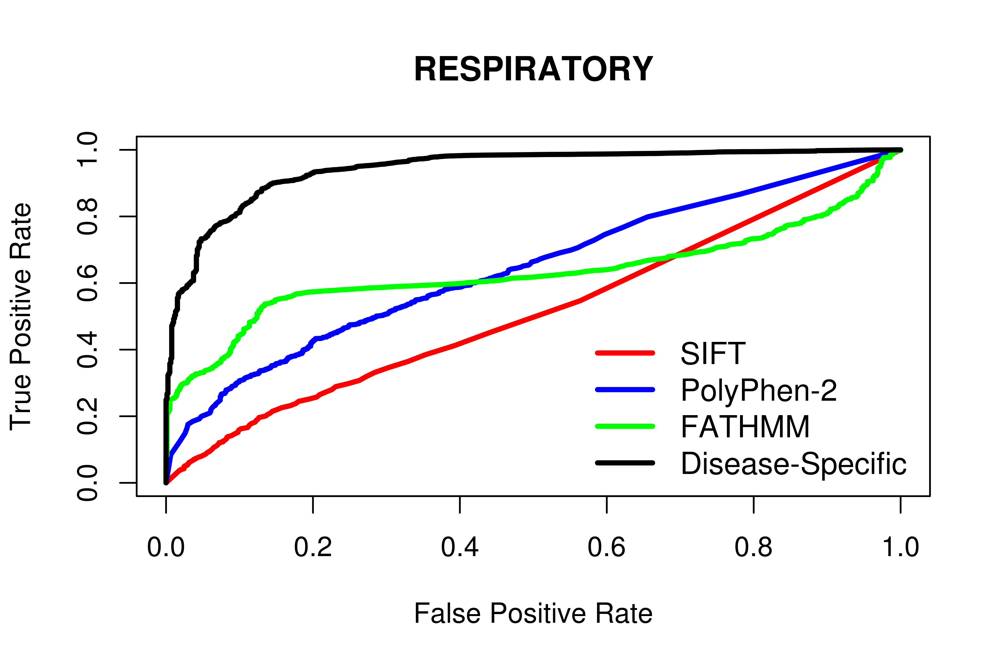
Algorithm | tp | fp | tn | fn | Accuracy | Precision | Specificity | Sensitivity | NPV | MCC | AUC
SIFT | 520 | 41911 | 24012 | 255 | 0.52 | 0.51 | 0.36 | 0.67 | 0.53 | 0.04 | 0.51
PolyPhen-2 | 619 | 48706 | 35420 | 153 | 0.61 | 0.58 | 0.42 | 0.8 | 0.68 | 0.24 | 0.64
FATHMM | 758 | 60581 | 25545 | 17 | 0.64 | 0.58 | 0.3 | 0.98 | 0.93 | 0.38 | 0.63
Disease-Specific | 478 | 1604 | 84522 | 297 | 0.8 | 0.97 | 0.98 | 0.62 | 0.72 | 0.64 | 0.94
Disease-Specific (20-Fold) | - | - | - | - | 0.78 | 0.92 | 0.95 | 0.6 | 0.71 | 0.59 | -
In the above, tp, fp, tn and fn refer to the number of true positive, false positive, true negative and false negatives observed. Accuracy, Precision, Specificity, Sensitivity, Negative Predictive Value (NPV) and Matthew’s Correlation Coefficient (MCC) were calculated using normalized numbers.
Supp. Info 18. Performance of computational prediction algorithms when tasked with discriminating between “Skin” disease mutations and other disease-causing mutations/putative neutral polymorphisms.
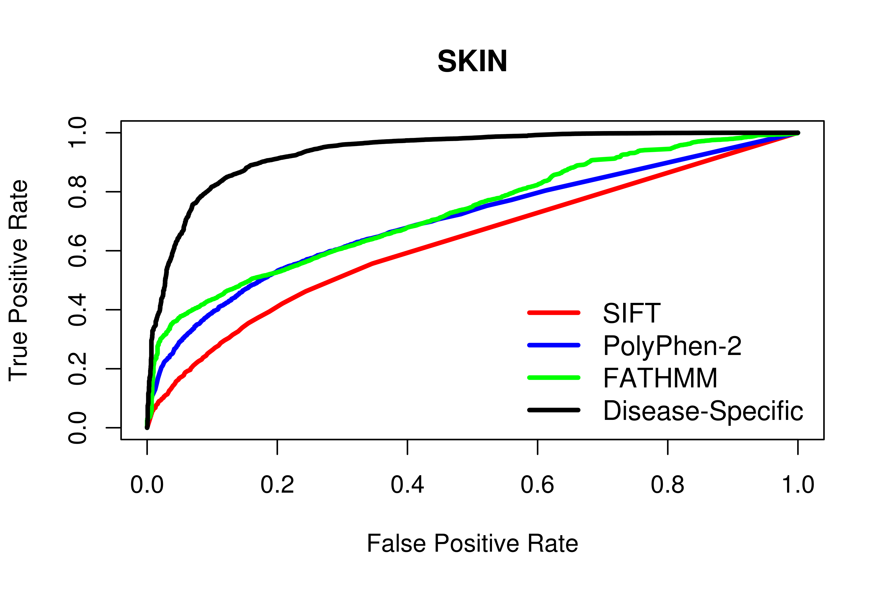
Algorithm | tp | fp | tn | fn | Accuracy | Precision | Specificity | Sensitivity | NPV | MCC | AUC
SIFT | 2425 | 40006 | 23770 | 497 | 0.6 | 0.57 | 0.37 | 0.83 | 0.69 | 0.23 | 0.63
PolyPhen-2 | 2675 | 46650 | 35188 | 385 | 0.65 | 0.61 | 0.43 | 0.87 | 0.77 | 0.34 | 0.7
FATHMM | 2727 | 43148 | 40570 | 456 | 0.67 | 0.62 | 0.48 | 0.86 | 0.77 | 0.37 | 0.73
Disease-Specific | 1230 | 537 | 83181 | 1953 | 0.69 | 0.98 | 0.99 | 0.39 | 0.62 | 0.48 | 0.93
Disease-Specific (20-Fold) | - | - | - | - | 0.68 | 0.98 | 0.99 | 0.37 | 0.61 | 0.46 | -
In the above, tp, fp, tn and fn refer to the number of true positive, false positive, true negative and false negatives observed. Accuracy, Precision, Specificity, Sensitivity, Negative Predictive Value (NPV) and Matthew’s Correlation Coefficient (MCC) were calculated using normalized numbers.
Supp. Info 19. Performance of our Disease-Specific Approach and Naive Weighting Scheme when using Balanced and Imbalanced Weights (Inherited Disease Mutations).

Algorithm | tp | fp | tn | fn | Accuracy | Precision | Specificity | Sensitivity | NPV | MCC
Disease-Specific (All) | 44330 | 7007 | 29931 | 5633 | 0.85 | 0.82 | 0.81 | 0.89 | 0.88 | 0.7
Naive (All) | 46103 | 10286 | 26652 | 3860 | 0.82 | 0.77 | 0.72 | 0.92 | 0.9 | 0.66
Disease-Specific (5) | 3962 | 2271 | 10748 | 669 | 0.84 | 0.83 | 0.83 | 0.86 | 0.85 | 0.68
Naive (5) | 3176 | 1550 | 11469 | 1455 | 0.78 | 0.85 | 0.88 | 0.69 | 0.74 | 0.58
Disease-Specific (10) | 6565 | 3235 | 15058 | 1008 | 0.85 | 0.83 | 0.82 | 0.87 | 0.86 | 0.69
Naive (10) | 5678 | 2464 | 15829 | 1895 | 0.81 | 0.85 | 0.87 | 0.75 | 0.78 | 0.62
Disease-Specific (25) | 12432 | 4923 | 19122 | 1450 | 0.85 | 0.81 | 0.8 | 0.9 | 0.88 | 0.69
Naive (52) | 11405 | 4096 | 19949 | 2477 | 0.83 | 0.83 | 0.83 | 0.82 | 0.82 | 0.65
Disease-Specific (100) | 27481 | 8148 | 22144 | 2159 | 0.83 | 0.78 | 0.73 | 0.93 | 0.91 | 0.67
Naive (100) | 26324 | 7292 | 23000 | 3316 | 0.82 | 0.79 | 0.76 | 0.89 | 0.87 | 0.65
Disease-Specific (250) | 36302 | 9492 | 23019 | 2231 | 0.83 | 0.76 | 0.71 | 0.94 | 0.92 | 0.67
Naive (250) | 35121 | 8630 | 23881 | 3412 | 0.82 | 0.77 | 0.73 | 0.91 | 0.89 | 0.66
In the above, tp, fp, tn and fn refer to the number of true positive, false positive, true negative and false negatives observed. Accuracy, Precision, Specificity, Sensitivity, Negative Predictive Value (NPV) and Matthew’s Correlation Coefficient (MCC) were calculated using normalized numbers. The number shown in brackets refer to the maximum difference between disease-associated mutations and other germline polymorphisms allowed in the weighting scheme; the higher this number is, the more imbalanced the weighting scheme is.

Supp. Info 20. Performance of our Disease-Specific Approach and Naive Weighting Scheme when using Balanced and Imbalanced Weights (Blood Disease Mutations).

Algorithm | tp | fp | tn | fn | Accuracy | Precision | Specificity | Sensitivity | NPV | MCC
Disease-Specific (All) | 860 | 487 | 84939 | 615 | 0.79 | 0.99 | 0.99 | 0.58 | 0.7 | 0.63
Naive (All) | 886 | 202 | 85224 | 589 | 0.8 | 1 | 1 | 0.6 | 0.71 | 0.65
Disease-Specific (5) | 111 | 373 | 11348 | 40 | 0.85 | 0.96 | 0.97 | 0.74 | 0.79 | 0.72
Naive (5) | 79 | 44 | 11677 | 72 | 0.76 | 0.99 | 1 | 0.52 | 0.68 | 0.59
Disease-Specific (10) | 266 | 498 | 17891 | 83 | 0.87 | 0.97 | 0.97 | 0.76 | 0.8 | 0.75
Naive (10) | 220 | 89 | 18300 | 129 | 0.81 | 0.99 | 1 | 0.63 | 0.73 | 0.67
Disease-Specific (25) | 376 | 622 | 28259 | 179 | 0.83 | 0.97 | 0.98 | 0.68 | 0.75 | 0.69
Naive (52) | 321 | 119 | 28762 | 234 | 0.79 | 0.99 | 1 | 0.58 | 0.7 | 0.63
Disease-Specific (100) | 828 | 797 | 50682 | 384 | 0.83 | 0.98 | 0.98 | 0.68 | 0.76 | 0.7
Naive (100) | 745 | 195 | 51284 | 467 | 0.81 | 0.99 | 1 | 0.61 | 0.72 | 0.66
Disease-Specific (250) | 969 | 905 | 64188 | 430 | 0.84 | 0.98 | 0.99 | 0.69 | 0.76 | 0.71
Naive (250) | 886 | 202 | 64891 | 513 | 0.82 | 1 | 1 | 0.63 | 0.73 | 0.68
In the above, tp, fp, tn and fn refer to the number of true positive, false positive, true negative and false negatives observed. Accuracy, Precision, Specificity, Sensitivity, Negative Predictive Value (NPV) and Matthew’s Correlation Coefficient (MCC) were calculated using normalized numbers. The number shown in brackets refer to the maximum difference between disease-associated mutations and other germline polymorphisms allowed in the weighting scheme; the higher this number is, the more imbalanced the weighting scheme is.

Supp. Info 21. Performance of our Disease-Specific Approach and Naive Weighting Scheme when using Balanced and Imbalanced Weights (Blood Coagulation Disease Mutations).

Algorithm | tp | fp | tn | fn | Accuracy | Precision | Specificity | Sensitivity | NPV | MCC
Disease-Specific (All) | 2885 | 1292 | 82101 | 623 | 0.9 | 0.98 | 0.98 | 0.82 | 0.85 | 0.82
Naive (All) | 2813 | 832 | 82561 | 695 | 0.9 | 0.99 | 0.99 | 0.8 | 0.83 | 0.81
Disease-Specific (5) | 171 | 458 | 11332 | 28 | 0.91 | 0.96 | 0.96 | 0.86 | 0.87 | 0.82
Naive (5) | 131 | 111 | 11679 | 68 | 0.82 | 0.99 | 0.99 | 0.66 | 0.74 | 0.69
Disease-Specific (10) | 402 | 643 | 17984 | 71 | 0.91 | 0.96 | 0.97 | 0.85 | 0.87 | 0.82
Naive (10) | 339 | 211 | 18416 | 134 | 0.85 | 0.98 | 0.99 | 0.72 | 0.78 | 0.73
Disease-Specific (25) | 586 | 911 | 28494 | 179 | 0.87 | 0.96 | 0.97 | 0.77 | 0.81 | 0.75
Naive (52) | 432 | 258 | 29147 | 333 | 0.78 | 0.98 | 0.99 | 0.56 | 0.69 | 0.61
Disease-Specific (100) | 1080 | 1178 | 50731 | 316 | 0.88 | 0.97 | 0.98 | 0.77 | 0.81 | 0.77
Naive (100) | 862 | 342 | 51567 | 534 | 0.81 | 0.99 | 0.99 | 0.62 | 0.72 | 0.66
Disease-Specific (250) | 1478 | 1301 | 63683 | 449 | 0.87 | 0.97 | 0.98 | 0.77 | 0.81 | 0.76
Naive (250) | 1257 | 443 | 64541 | 670 | 0.82 | 0.99 | 0.99 | 0.65 | 0.74 | 0.69
In the above, tp, fp, tn and fn refer to the number of true positive, false positive, true negative and false negatives observed. Accuracy, Precision, Specificity, Sensitivity, Negative Predictive Value (NPV) and Matthew’s Correlation Coefficient (MCC) were calculated using normalized numbers. The number shown in brackets refer to the maximum difference between disease-associated mutations and other germline polymorphisms allowed in the weighting scheme; the higher this number is, the more imbalanced the weighting scheme is.

Supp. Info 22. Performance of our Disease-Specific Approach and Naive Weighting Scheme when using Balanced and Imbalanced Weights (Developmental Disease Mutations).

Algorithm | tp | fp | tn | fn | Accuracy | Precision | Specificity | Sensitivity | NPV | MCC
Disease-Specific (All) | 621 | 710 | 84997 | 573 | 0.76 | 0.98 | 0.99 | 0.52 | 0.67 | 0.58
Naive (All) | 599 | 272 | 85435 | 595 | 0.75 | 0.99 | 1 | 0.5 | 0.67 | 0.57
Disease-Specific (5) | 167 | 413 | 11340 | 76 | 0.83 | 0.95 | 0.96 | 0.69 | 0.76 | 0.68
Naive (5) | 123 | 59 | 11694 | 120 | 0.75 | 0.99 | 0.99 | 0.51 | 0.67 | 0.57
Disease-Specific (10) | 267 | 520 | 17949 | 121 | 0.83 | 0.96 | 0.97 | 0.69 | 0.76 | 0.69
Naive (10) | 222 | 92 | 18377 | 166 | 0.78 | 0.99 | 1 | 0.57 | 0.7 | 0.63
Disease-Specific (25) | 481 | 738 | 28255 | 225 | 0.83 | 0.96 | 0.97 | 0.68 | 0.75 | 0.69
Naive (52) | 415 | 196 | 28797 | 291 | 0.79 | 0.99 | 0.99 | 0.59 | 0.71 | 0.64
Disease-Specific (100) | 670 | 941 | 50514 | 350 | 0.82 | 0.97 | 0.98 | 0.66 | 0.74 | 0.68
Naive (100) | 599 | 272 | 51183 | 421 | 0.79 | 0.99 | 0.99 | 0.59 | 0.71 | 0.64
Disease-Specific (250) | 670 | 1038 | 64483 | 414 | 0.8 | 0.98 | 0.98 | 0.62 | 0.72 | 0.65
Naive (250) | 599 | 272 | 65249 | 485 | 0.77 | 0.99 | 1 | 0.55 | 0.69 | 0.61
In the above, tp, fp, tn and fn refer to the number of true positive, false positive, true negative and false negatives observed. Accuracy, Precision, Specificity, Sensitivity, Negative Predictive Value (NPV) and Matthew’s Correlation Coefficient (MCC) were calculated using normalized numbers. The number shown in brackets refer to the maximum difference between disease-associated mutations and other germline polymorphisms allowed in the weighting scheme; the higher this number is, the more imbalanced the weighting scheme is.

Supp. Info 23. Performance of our Disease-Specific Approach and Naive Weighting Scheme when using Balanced and Imbalanced Weights (Digestive Disease Mutations).

Algorithm | tp | fp | tn | fn | Accuracy | Precision | Specificity | Sensitivity | NPV | MCC
Disease-Specific (All) | 844 | 734 | 84379 | 944 | 0.73 | 0.98 | 0.99 | 0.47 | 0.65 | 0.54
Naive (All) | 808 | 248 | 84865 | 980 | 0.72 | 0.99 | 1 | 0.45 | 0.65 | 0.54
Disease-Specific (5) | 150 | 423 | 11332 | 61 | 0.84 | 0.95 | 0.96 | 0.71 | 0.77 | 0.7
Naive (5) | 93 | 55 | 11700 | 118 | 0.72 | 0.99 | 1 | 0.44 | 0.64 | 0.52
Disease-Specific (10) | 228 | 572 | 18010 | 121 | 0.81 | 0.96 | 0.97 | 0.65 | 0.74 | 0.66
Naive (10) | 116 | 63 | 18519 | 233 | 0.66 | 0.99 | 1 | 0.33 | 0.6 | 0.44
Disease-Specific (25) | 525 | 771 | 28171 | 190 | 0.85 | 0.96 | 0.97 | 0.73 | 0.79 | 0.73
Naive (52) | 406 | 146 | 28796 | 309 | 0.78 | 0.99 | 0.99 | 0.57 | 0.7 | 0.62
Disease-Specific (100) | 831 | 991 | 50660 | 347 | 0.84 | 0.97 | 0.98 | 0.71 | 0.77 | 0.71
Naive (100) | 700 | 221 | 51430 | 478 | 0.79 | 0.99 | 1 | 0.59 | 0.71 | 0.64
Disease-Specific (250) | 949 | 1127 | 64583 | 499 | 0.82 | 0.97 | 0.98 | 0.66 | 0.74 | 0.68
Naive (250) | 808 | 248 | 65462 | 640 | 0.78 | 0.99 | 1 | 0.56 | 0.69 | 0.62
In the above, tp, fp, tn and fn refer to the number of true positive, false positive, true negative and false negatives observed. Accuracy, Precision, Specificity, Sensitivity, Negative Predictive Value (NPV) and Matthew’s Correlation Coefficient (MCC) were calculated using normalized numbers. The number shown in brackets refer to the maximum difference between disease-associated mutations and other germline polymorphisms allowed in the weighting scheme; the higher this number is, the more imbalanced the weighting scheme is.

Supp. Info 24. Performance of our Disease-Specific Approach and Naive Weighting Scheme when using Balanced and Imbalanced Weights (Ear, Nose and Throat Disease Mutations).

Algorithm | tp | fp | tn | fn | Accuracy | Precision | Specificity | Sensitivity | NPV | MCC
Disease-Specific (All) | 192 | 199 | 85762 | 748 | 0.6 | 0.99 | 1 | 0.2 | 0.56 | 0.33
Naive (All) | 281 | 65 | 85896 | 659 | 0.65 | 1 | 1 | 0.3 | 0.59 | 0.42
Disease-Specific (5) | 94 | 353 | 11285 | 36 | 0.85 | 0.96 | 0.97 | 0.72 | 0.78 | 0.71
Naive (5) | 73 | 27 | 11611 | 57 | 0.78 | 1 | 1 | 0.56 | 0.69 | 0.62
Disease-Specific (10) | 126 | 437 | 17927 | 69 | 0.81 | 0.96 | 0.98 | 0.65 | 0.73 | 0.66
Naive (10) | 105 | 32 | 18332 | 90 | 0.77 | 1 | 1 | 0.54 | 0.68 | 0.6
Disease-Specific (25) | 149 | 539 | 28273 | 114 | 0.77 | 0.97 | 0.98 | 0.57 | 0.69 | 0.6
Naive (52) | 123 | 36 | 28776 | 140 | 0.73 | 1 | 1 | 0.47 | 0.65 | 0.55
Disease-Specific (100) | 322 | 662 | 51229 | 321 | 0.74 | 0.98 | 0.99 | 0.5 | 0.66 | 0.56
Naive (100) | 281 | 65 | 51826 | 362 | 0.72 | 1 | 1 | 0.44 | 0.64 | 0.53
Disease-Specific (250) | 329 | 771 | 65507 | 526 | 0.69 | 0.97 | 0.99 | 0.38 | 0.62 | 0.47
Naive (250) | 281 | 65 | 66213 | 574 | 0.66 | 1 | 1 | 0.33 | 0.6 | 0.44
In the above, tp, fp, tn and fn refer to the number of true positive, false positive, true negative and false negatives observed. Accuracy, Precision, Specificity, Sensitivity, Negative Predictive Value (NPV) and Matthew’s Correlation Coefficient (MCC) were calculated using normalized numbers. The number shown in brackets refer to the maximum difference between disease-associated mutations and other germline polymorphisms allowed in the weighting scheme; the higher this number is, the more imbalanced the weighting scheme is.

Supp. Info 25. Performance of our Disease-Specific Approach and Naive Weighting Scheme when using Balanced and Imbalanced Weights (Endocrine Disease Mutations).

Algorithm | tp | fp | tn | fn | Accuracy | Precision | Specificity | Sensitivity | NPV | MCC
Disease-Specific (All) | 2392 | 1015 | 81973 | 1521 | 0.8 | 0.98 | 0.99 | 0.61 | 0.72 | 0.65
Naive (All) | 2388 | 610 | 82378 | 1525 | 0.8 | 0.99 | 0.99 | 0.61 | 0.72 | 0.65
Disease-Specific (5) | 241 | 457 | 11334 | 59 | 0.88 | 0.95 | 0.96 | 0.8 | 0.83 | 0.77
Naive (5) | 194 | 112 | 11679 | 106 | 0.82 | 0.99 | 0.99 | 0.65 | 0.74 | 0.68
Disease-Specific (10) | 348 | 599 | 17925 | 107 | 0.87 | 0.96 | 0.97 | 0.76 | 0.8 | 0.75
Naive (10) | 287 | 174 | 18350 | 168 | 0.81 | 0.99 | 0.99 | 0.63 | 0.73 | 0.67
Disease-Specific (25) | 777 | 828 | 27993 | 168 | 0.9 | 0.97 | 0.97 | 0.82 | 0.85 | 0.8
Naive (52) | 706 | 302 | 28519 | 239 | 0.87 | 0.99 | 0.99 | 0.75 | 0.8 | 0.76
Disease-Specific (100) | 1297 | 1156 | 50143 | 525 | 0.84 | 0.97 | 0.98 | 0.71 | 0.77 | 0.72
Naive (100) | 1193 | 498 | 50801 | 629 | 0.82 | 0.99 | 0.99 | 0.65 | 0.74 | 0.68
Disease-Specific (250) | 2517 | 1457 | 63000 | 764 | 0.87 | 0.97 | 0.98 | 0.77 | 0.81 | 0.76
Naive (250) | 2382 | 608 | 63849 | 899 | 0.86 | 0.99 | 0.99 | 0.73 | 0.78 | 0.74
In the above, tp, fp, tn and fn refer to the number of true positive, false positive, true negative and false negatives observed. Accuracy, Precision, Specificity, Sensitivity, Negative Predictive Value (NPV) and Matthew’s Correlation Coefficient (MCC) were calculated using normalized numbers. The number shown in brackets refer to the maximum difference between disease-associated mutations and other germline polymorphisms allowed in the weighting scheme; the higher this number is, the more imbalanced the weighting scheme is.

Supp. Info 26. Performance of our Disease-Specific Approach and Naive Weighting Scheme when using Balanced and Imbalanced Weights (Eye Disease Mutations).

Algorithm | tp | fp | tn | fn | Accuracy | Precision | Specificity | Sensitivity | NPV | MCC
Disease-Specific (All) | 1433 | 1127 | 82744 | 1597 | 0.73 | 0.97 | 0.99 | 0.47 | 0.65 | 0.54
Naive (All) | 1338 | 488 | 83383 | 1692 | 0.72 | 0.99 | 0.99 | 0.44 | 0.64 | 0.52
Disease-Specific (5) | 337 | 585 | 11390 | 131 | 0.84 | 0.94 | 0.95 | 0.72 | 0.77 | 0.69
Naive (5) | 236 | 146 | 11829 | 232 | 0.75 | 0.98 | 0.99 | 0.5 | 0.67 | 0.56
Disease-Specific (10) | 525 | 785 | 17962 | 182 | 0.85 | 0.95 | 0.96 | 0.74 | 0.79 | 0.72
Naive (10) | 417 | 250 | 18497 | 290 | 0.79 | 0.98 | 0.99 | 0.59 | 0.71 | 0.63
Disease-Specific (25) | 905 | 1094 | 28133 | 336 | 0.85 | 0.95 | 0.96 | 0.73 | 0.78 | 0.71
Naive (52) | 737 | 371 | 28856 | 504 | 0.79 | 0.98 | 0.99 | 0.59 | 0.71 | 0.63
Disease-Specific (100) | 1409 | 1392 | 49912 | 639 | 0.83 | 0.96 | 0.97 | 0.69 | 0.76 | 0.69
Naive (100) | 1168 | 461 | 50843 | 880 | 0.78 | 0.98 | 0.99 | 0.57 | 0.7 | 0.62
Disease-Specific (250) | 1608 | 1589 | 62911 | 850 | 0.81 | 0.96 | 0.98 | 0.65 | 0.74 | 0.66
Naive (250) | 1338 | 488 | 64012 | 1120 | 0.77 | 0.99 | 0.99 | 0.54 | 0.69 | 0.6
In the above, tp, fp, tn and fn refer to the number of true positive, false positive, true negative and false negatives observed. Accuracy, Precision, Specificity, Sensitivity, Negative Predictive Value (NPV) and Matthew’s Correlation Coefficient (MCC) were calculated using normalized numbers. The number shown in brackets refer to the maximum difference between disease-associated mutations and other germline polymorphisms allowed in the weighting scheme; the higher this number is, the more imbalanced the weighting scheme is.

Supp. Info 27. Performance of our Disease-Specific Approach and Naive Weighting Scheme when using Balanced and Imbalanced Weights (Genitourinary Disease Mutations).

Algorithm | tp | fp | tn | fn | Accuracy | Precision | Specificity | Sensitivity | NPV | MCC
Disease-Specific (All) | 1601 | 1327 | 82544 | 1429 | 0.76 | 0.97 | 0.98 | 0.53 | 0.68 | 0.58
Naive (All) | 1410 | 377 | 83494 | 1620 | 0.73 | 0.99 | 1 | 0.47 | 0.65 | 0.54
Disease-Specific (5) | 240 | 481 | 11329 | 60 | 0.88 | 0.95 | 0.96 | 0.8 | 0.83 | 0.77
Naive (5) | 193 | 124 | 11686 | 107 | 0.82 | 0.98 | 0.99 | 0.64 | 0.74 | 0.67
Disease-Specific (10) | 389 | 654 | 17905 | 138 | 0.85 | 0.95 | 0.96 | 0.74 | 0.79 | 0.72
Naive (10) | 311 | 195 | 18364 | 216 | 0.79 | 0.98 | 0.99 | 0.59 | 0.71 | 0.63
Disease-Specific (25) | 677 | 874 | 28188 | 248 | 0.85 | 0.96 | 0.97 | 0.73 | 0.78 | 0.72
Naive (52) | 584 | 306 | 28756 | 341 | 0.81 | 0.98 | 0.99 | 0.63 | 0.73 | 0.66
Disease-Specific (100) | 1107 | 1074 | 50054 | 672 | 0.8 | 0.97 | 0.98 | 0.62 | 0.72 | 0.64
Naive (100) | 954 | 342 | 50786 | 825 | 0.76 | 0.99 | 0.99 | 0.54 | 0.68 | 0.6
Disease-Specific (250) | 1423 | 1226 | 63419 | 849 | 0.8 | 0.97 | 0.98 | 0.63 | 0.72 | 0.65
Naive (250) | 1256 | 376 | 64269 | 1016 | 0.77 | 0.99 | 0.99 | 0.55 | 0.69 | 0.61
In the above, tp, fp, tn and fn refer to the number of true positive, false positive, true negative and false negatives observed. Accuracy, Precision, Specificity, Sensitivity, Negative Predictive Value (NPV) and Matthew’s Correlation Coefficient (MCC) were calculated using normalized numbers. The number shown in brackets refer to the maximum difference between disease-associated mutations and other germline polymorphisms allowed in the weighting scheme; the higher this number is, the more imbalanced the weighting scheme is.

Supp. Info 28. Performance of our Disease-Specific Approach and Naive Weighting Scheme when using Balanced and Imbalanced Weights (Heart Disease Mutations).

Algorithm | tp | fp | tn | fn | Accuracy | Precision | Specificity | Sensitivity | NPV | MCC
Disease-Specific (All) | 2536 | 2885 | 80274 | 1206 | 0.82 | 0.95 | 0.97 | 0.68 | 0.75 | 0.67
Naive (All) | 1748 | 928 | 82231 | 1994 | 0.73 | 0.98 | 0.99 | 0.47 | 0.65 | 0.53
Disease-Specific (5) | 355 | 588 | 11360 | 116 | 0.85 | 0.94 | 0.95 | 0.75 | 0.79 | 0.72
Naive (5) | 240 | 161 | 11787 | 231 | 0.75 | 0.97 | 0.99 | 0.51 | 0.67 | 0.56
Disease-Specific (10) | 521 | 752 | 17895 | 180 | 0.85 | 0.95 | 0.96 | 0.74 | 0.79 | 0.72
Naive (10) | 357 | 200 | 18447 | 344 | 0.75 | 0.98 | 0.99 | 0.51 | 0.67 | 0.57
Disease-Specific (25) | 1211 | 1431 | 28416 | 423 | 0.85 | 0.94 | 0.95 | 0.74 | 0.79 | 0.71
Naive (52) | 778 | 446 | 29401 | 856 | 0.73 | 0.97 | 0.99 | 0.48 | 0.65 | 0.54
Disease-Specific (100) | 2068 | 2093 | 49707 | 722 | 0.85 | 0.95 | 0.96 | 0.74 | 0.79 | 0.72
Naive (100) | 1572 | 875 | 50925 | 1218 | 0.77 | 0.97 | 0.98 | 0.56 | 0.69 | 0.6
Disease-Specific (250) | 2286 | 2295 | 63736 | 1132 | 0.82 | 0.95 | 0.97 | 0.67 | 0.74 | 0.66
Naive (250) | 1748 | 928 | 65103 | 1670 | 0.75 | 0.97 | 0.99 | 0.51 | 0.67 | 0.57
In the above, tp, fp, tn and fn refer to the number of true positive, false positive, true negative and false negatives observed. Accuracy, Precision, Specificity, Sensitivity, Negative Predictive Value (NPV) and Matthew’s Correlation Coefficient (MCC) were calculated using normalized numbers. The number shown in brackets refer to the maximum difference between disease-associated mutations and other germline polymorphisms allowed in the weighting scheme; the higher this number is, the more imbalanced the weighting scheme is.

Supp. Info 29. Performance of our Disease-Specific Approach and Naive Weighting Scheme when using Balanced and Imbalanced Weights (Immune Disease Mutations).

Algorithm | tp | fp | tn | fn | Accuracy | Precision | Specificity | Sensitivity | NPV | MCC
Disease-Specific (All) | 590 | 385 | 85223 | 703 | 0.73 | 0.99 | 1 | 0.46 | 0.65 | 0.54
Naive (All) | 677 | 160 | 85448 | 616 | 0.76 | 1 | 1 | 0.52 | 0.68 | 0.59
Disease-Specific (5) | 160 | 426 | 11374 | 48 | 0.87 | 0.96 | 0.96 | 0.77 | 0.81 | 0.75
Naive (5) | 87 | 55 | 11745 | 121 | 0.71 | 0.99 | 1 | 0.42 | 0.63 | 0.51
Disease-Specific (10) | 220 | 510 | 17992 | 92 | 0.84 | 0.96 | 0.97 | 0.71 | 0.77 | 0.7
Naive (10) | 134 | 64 | 18438 | 178 | 0.71 | 0.99 | 1 | 0.43 | 0.64 | 0.52
Disease-Specific (25) | 395 | 654 | 28218 | 149 | 0.85 | 0.97 | 0.98 | 0.73 | 0.78 | 0.73
Naive (52) | 295 | 100 | 28772 | 249 | 0.77 | 0.99 | 1 | 0.54 | 0.69 | 0.6
Disease-Specific (100) | 759 | 850 | 50386 | 263 | 0.86 | 0.98 | 0.98 | 0.74 | 0.79 | 0.75
Naive (100) | 652 | 158 | 51078 | 370 | 0.82 | 1 | 1 | 0.64 | 0.73 | 0.68
Disease-Specific (250) | 815 | 1037 | 64514 | 363 | 0.84 | 0.98 | 0.98 | 0.69 | 0.76 | 0.71
Naive (250) | 677 | 160 | 65391 | 501 | 0.79 | 1 | 1 | 0.57 | 0.7 | 0.63
In the above, tp, fp, tn and fn refer to the number of true positive, false positive, true negative and false negatives observed. Accuracy, Precision, Specificity, Sensitivity, Negative Predictive Value (NPV) and Matthew’s Correlation Coefficient (MCC) were calculated using normalized numbers. The number shown in brackets refer to the maximum difference between disease-associated mutations and other germline polymorphisms allowed in the weighting scheme; the higher this number is, the more imbalanced the weighting scheme is.

Supp. Info 30. Performance of our Disease-Specific Approach and Naive Weighting Scheme when using Balanced and Imbalanced Weights (Metabolic Disease Mutations).

Algorithm | tp | fp | tn | fn | Accuracy | Precision | Specificity | Sensitivity | NPV | MCC
Disease-Specific (All) | 10767 | 3209 | 69976 | 2949 | 0.87 | 0.95 | 0.96 | 0.78 | 0.82 | 0.75
Naive (All) | 10716 | 2731 | 70454 | 3000 | 0.87 | 0.95 | 0.96 | 0.78 | 0.81 | 0.76
Disease-Specific (5) | 890 | 844 | 11310 | 186 | 0.88 | 0.92 | 0.93 | 0.83 | 0.84 | 0.76
Naive (5) | 704 | 386 | 11768 | 372 | 0.81 | 0.95 | 0.97 | 0.65 | 0.74 | 0.66
Disease-Specific (10) | 1559 | 1230 | 17585 | 307 | 0.89 | 0.93 | 0.93 | 0.84 | 0.85 | 0.77
Naive (10) | 1339 | 659 | 18156 | 527 | 0.84 | 0.95 | 0.96 | 0.72 | 0.77 | 0.7
Disease-Specific (25) | 2984 | 1769 | 26618 | 595 | 0.89 | 0.93 | 0.94 | 0.83 | 0.85 | 0.78
Naive (52) | 2668 | 1032 | 27355 | 911 | 0.85 | 0.95 | 0.96 | 0.75 | 0.79 | 0.73
Disease-Specific (100) | 7711 | 3361 | 44706 | 1340 | 0.89 | 0.92 | 0.93 | 0.85 | 0.86 | 0.78
Naive (100) | 7249 | 2269 | 45798 | 1802 | 0.88 | 0.94 | 0.95 | 0.8 | 0.83 | 0.76
Disease-Specific (250) | 10601 | 4218 | 54020 | 1761 | 0.89 | 0.92 | 0.93 | 0.86 | 0.87 | 0.79
Naive (250) | 9878 | 2586 | 55652 | 2484 | 0.88 | 0.95 | 0.96 | 0.8 | 0.83 | 0.76
In the above, tp, fp, tn and fn refer to the number of true positive, false positive, true negative and false negatives observed. Accuracy, Precision, Specificity, Sensitivity, Negative Predictive Value (NPV) and Matthew’s Correlation Coefficient (MCC) were calculated using normalized numbers. The number shown in brackets refer to the maximum difference between disease-associated mutations and other germline polymorphisms allowed in the weighting scheme; the higher this number is, the more imbalanced the weighting scheme is.

Supp. Info 31. Performance of our Disease-Specific Approach and Naive Weighting Scheme when using Balanced and Imbalanced Weights (Musculoskeletal Disease Mutations).

Algorithm | tp | fp | tn | fn | Accuracy | Precision | Specificity | Sensitivity | NPV | MCC
Disease-Specific (All) | 4120 | 3123 | 77675 | 1983 | 0.82 | 0.95 | 0.96 | 0.68 | 0.75 | 0.66
Naive (All) | 3697 | 1868 | 78930 | 2406 | 0.79 | 0.96 | 0.98 | 0.61 | 0.71 | 0.63
Disease-Specific (5) | 557 | 673 | 11410 | 116 | 0.89 | 0.94 | 0.94 | 0.83 | 0.85 | 0.78
Naive (5) | 370 | 213 | 11870 | 303 | 0.77 | 0.97 | 0.98 | 0.55 | 0.69 | 0.59
Disease-Specific (10) | 951 | 1019 | 18021 | 288 | 0.86 | 0.93 | 0.95 | 0.77 | 0.8 | 0.73
Naive (10) | 640 | 335 | 18705 | 599 | 0.75 | 0.97 | 0.98 | 0.52 | 0.67 | 0.56
Disease-Specific (25) | 1417 | 1369 | 27914 | 449 | 0.86 | 0.94 | 0.95 | 0.76 | 0.8 | 0.73
Naive (52) | 1081 | 560 | 28723 | 785 | 0.78 | 0.97 | 0.98 | 0.58 | 0.7 | 0.61
Disease-Specific (100) | 2911 | 2244 | 48396 | 975 | 0.85 | 0.94 | 0.96 | 0.75 | 0.79 | 0.72
Naive (100) | 2498 | 1202 | 49438 | 1388 | 0.81 | 0.96 | 0.98 | 0.64 | 0.73 | 0.66
Disease-Specific (250) | 3508 | 2910 | 61583 | 1489 | 0.83 | 0.94 | 0.95 | 0.7 | 0.76 | 0.68
Naive (250) | 3004 | 1483 | 63010 | 1993 | 0.79 | 0.96 | 0.98 | 0.6 | 0.71 | 0.62
In the above, tp, fp, tn and fn refer to the number of true positive, false positive, true negative and false negatives observed. Accuracy, Precision, Specificity, Sensitivity, Negative Predictive Value (NPV) and Matthew’s Correlation Coefficient (MCC) were calculated using normalized numbers. The number shown in brackets refer to the maximum difference between disease-associated mutations and other germline polymorphisms allowed in the weighting scheme; the higher this number is, the more imbalanced the weighting scheme is.

Supp. Info 32. Performance of our Disease-Specific Approach and Naive Weighting Scheme when using Balanced and Imbalanced Weights (Nervous System Disease Mutations).

Algorithm | tp | fp | tn | fn | Accuracy | Precision | Specificity | Sensitivity | NPV | MCC
Disease-Specific (All) | 5560 | 2419 | 75931 | 2991 | 0.81 | 0.95 | 0.97 | 0.65 | 0.73 | 0.65
Naive (All) | 5230 | 1751 | 76599 | 3321 | 0.79 | 0.96 | 0.98 | 0.61 | 0.72 | 0.63
Disease-Specific (5) | 878 | 904 | 11410 | 227 | 0.86 | 0.92 | 0.93 | 0.79 | 0.82 | 0.73
Naive (5) | 562 | 295 | 12019 | 543 | 0.74 | 0.96 | 0.98 | 0.51 | 0.67 | 0.55
Disease-Specific (10) | 1316 | 1216 | 17845 | 376 | 0.86 | 0.92 | 0.94 | 0.78 | 0.81 | 0.72
Naive (10) | 966 | 525 | 18536 | 726 | 0.77 | 0.95 | 0.97 | 0.57 | 0.69 | 0.59
Disease-Specific (25) | 2430 | 1824 | 27492 | 678 | 0.86 | 0.93 | 0.94 | 0.78 | 0.81 | 0.73
Naive (52) | 2019 | 984 | 28332 | 1089 | 0.81 | 0.95 | 0.97 | 0.65 | 0.73 | 0.65
Disease-Specific (100) | 4564 | 2732 | 46541 | 1370 | 0.86 | 0.93 | 0.94 | 0.77 | 0.8 | 0.72
Naive (100) | 4024 | 1600 | 47673 | 1910 | 0.82 | 0.95 | 0.97 | 0.68 | 0.75 | 0.67
Disease-Specific (250) | 5391 | 2868 | 58016 | 1701 | 0.86 | 0.94 | 0.95 | 0.76 | 0.8 | 0.73
Naive (250) | 4841 | 1704 | 59180 | 2251 | 0.83 | 0.96 | 0.97 | 0.68 | 0.75 | 0.68
In the above, tp, fp, tn and fn refer to the number of true positive, false positive, true negative and false negatives observed. Accuracy, Precision, Specificity, Sensitivity, Negative Predictive Value (NPV) and Matthew’s Correlation Coefficient (MCC) were calculated using normalized numbers. The number shown in brackets refer to the maximum difference between disease-associated mutations and other germline polymorphisms allowed in the weighting scheme; the higher this number is, the more imbalanced the weighting scheme is.

Supp. Info 33. Performance of our Disease-Specific Approach and Naive Weighting Scheme when using Balanced and Imbalanced Weights (Psychiatric Disease Mutations).

Algorithm | tp | fp | tn | fn | Accuracy | Precision | Specificity | Sensitivity | NPV | MCC
Disease-Specific (All) | 379 | 165 | 85990 | 367 | 0.75 | 1 | 1 | 0.51 | 0.67 | 0.58
Naive (All) | 483 | 108 | 86047 | 263 | 0.82 | 1 | 1 | 0.65 | 0.74 | 0.69
Disease-Specific (5) | 104 | 355 | 11270 | 34 | 0.86 | 0.96 | 0.97 | 0.75 | 0.8 | 0.74
Naive (5) | 79 | 25 | 11600 | 59 | 0.79 | 1 | 1 | 0.57 | 0.7 | 0.63
Disease-Specific (10) | 138 | 440 | 17866 | 58 | 0.84 | 0.97 | 0.98 | 0.7 | 0.77 | 0.71
Naive (10) | 110 | 32 | 18274 | 86 | 0.78 | 1 | 1 | 0.56 | 0.69 | 0.62
Disease-Specific (25) | 188 | 538 | 28278 | 114 | 0.8 | 0.97 | 0.98 | 0.62 | 0.72 | 0.65
Naive (52) | 157 | 39 | 28777 | 145 | 0.76 | 1 | 1 | 0.52 | 0.68 | 0.59
Disease-Specific (100) | 325 | 683 | 51087 | 184 | 0.81 | 0.98 | 0.99 | 0.64 | 0.73 | 0.67
Naive (100) | 293 | 96 | 51674 | 216 | 0.79 | 1 | 1 | 0.58 | 0.7 | 0.63
Disease-Specific (250) | 515 | 792 | 64967 | 211 | 0.85 | 0.98 | 0.99 | 0.71 | 0.77 | 0.73
Naive (250) | 483 | 108 | 65651 | 243 | 0.83 | 1 | 1 | 0.67 | 0.75 | 0.7
In the above, tp, fp, tn and fn refer to the number of true positive, false positive, true negative and false negatives observed. Accuracy, Precision, Specificity, Sensitivity, Negative Predictive Value (NPV) and Matthew’s Correlation Coefficient (MCC) were calculated using normalized numbers. The number shown in brackets refer to the maximum difference between disease-associated mutations and other germline polymorphisms allowed in the weighting scheme; the higher this number is, the more imbalanced the weighting scheme is.

Supp. Info 34. Performance of our Disease-Specific Approach and Naive Weighting Scheme when using Balanced and Imbalanced Weights (Reproductive Disease Mutations).

Algorithm | tp | fp | tn | fn | Accuracy | Precision | Specificity | Sensitivity | NPV | MCC
Disease-Specific (All) | 131 | 36 | 85982 | 752 | 0.57 | 1 | 1 | 0.15 | 0.54 | 0.28
Naive (All) | 233 | 78 | 85940 | 650 | 0.63 | 1 | 1 | 0.26 | 0.58 | 0.39
Disease-Specific (5) | 111 | 393 | 11301 | 28 | 0.88 | 0.96 | 0.97 | 0.8 | 0.83 | 0.78
Naive (5) | 94 | 62 | 11632 | 45 | 0.84 | 0.99 | 0.99 | 0.68 | 0.75 | 0.71
Disease-Specific (10) | 133 | 484 | 17915 | 49 | 0.85 | 0.97 | 0.97 | 0.73 | 0.78 | 0.73
Naive (10) | 109 | 76 | 18323 | 73 | 0.8 | 0.99 | 1 | 0.6 | 0.71 | 0.65
Disease-Specific (25) | 157 | 590 | 28359 | 106 | 0.79 | 0.97 | 0.98 | 0.6 | 0.71 | 0.62
Naive (52) | 125 | 76 | 28873 | 138 | 0.74 | 0.99 | 1 | 0.48 | 0.66 | 0.55
Disease-Specific (100) | 172 | 720 | 51152 | 294 | 0.68 | 0.96 | 0.99 | 0.37 | 0.61 | 0.45
Naive (100) | 125 | 76 | 51796 | 341 | 0.63 | 0.99 | 1 | 0.27 | 0.58 | 0.39
Disease-Specific (250) | 280 | 819 | 65287 | 364 | 0.71 | 0.97 | 0.99 | 0.43 | 0.64 | 0.51
Naive (250) | 233 | 78 | 66028 | 411 | 0.68 | 1 | 1 | 0.36 | 0.61 | 0.47
In the above, tp, fp, tn and fn refer to the number of true positive, false positive, true negative and false negatives observed. Accuracy, Precision, Specificity, Sensitivity, Negative Predictive Value (NPV) and Matthew’s Correlation Coefficient (MCC) were calculated using normalized numbers. The number shown in brackets refer to the maximum difference between disease-associated mutations and other germline polymorphisms allowed in the weighting scheme; the higher this number is, the more imbalanced the weighting scheme is.

Supp. Info 35. Performance of our Disease-Specific Approach and Naive Weighting Scheme when using Balanced and Imbalanced Weights (Respiratory Disease Mutations).

Algorithm | tp | fp | tn | fn | Accuracy | Precision | Specificity | Sensitivity | NPV | MCC
Disease-Specific (All) | 478 | 1604 | 84522 | 297 | 0.8 | 0.97 | 0.98 | 0.62 | 0.72 | 0.64
Naive (All) | 162 | 71 | 86055 | 613 | 0.6 | 1 | 1 | 0.21 | 0.56 | 0.34
Disease-Specific (5) | 36 | 342 | 11319 | 19 | 0.81 | 0.96 | 0.97 | 0.65 | 0.74 | 0.66
Naive (5) | 25 | 12 | 11649 | 30 | 0.73 | 1 | 1 | 0.45 | 0.65 | 0.54
Disease-Specific (10) | 49 | 422 | 17941 | 38 | 0.77 | 0.96 | 0.98 | 0.56 | 0.69 | 0.59
Naive (10) | 32 | 12 | 18351 | 55 | 0.68 | 1 | 1 | 0.37 | 0.61 | 0.47
Disease-Specific (25) | 117 | 546 | 28405 | 61 | 0.82 | 0.97 | 0.98 | 0.66 | 0.74 | 0.67
Naive (52) | 94 | 33 | 28918 | 84 | 0.76 | 1 | 1 | 0.53 | 0.68 | 0.6
Disease-Specific (100) | 200 | 695 | 51476 | 265 | 0.71 | 0.97 | 0.99 | 0.43 | 0.63 | 0.5
Naive (100) | 162 | 71 | 52100 | 303 | 0.67 | 1 | 1 | 0.35 | 0.61 | 0.46
Disease-Specific (250) | 224 | 813 | 66049 | 443 | 0.66 | 0.97 | 0.99 | 0.34 | 0.6 | 0.43
Naive (250) | 162 | 71 | 66791 | 505 | 0.62 | 1 | 1 | 0.24 | 0.57 | 0.37
In the above, tp, fp, tn and fn refer to the number of true positive, false positive, true negative and false negatives observed. Accuracy, Precision, Specificity, Sensitivity, Negative Predictive Value (NPV) and Matthew’s Correlation Coefficient (MCC) were calculated using normalized numbers. The number shown in brackets refer to the maximum difference between disease-associated mutations and other germline polymorphisms allowed in the weighting scheme; the higher this number is, the more imbalanced the weighting scheme is.

Supp. Info 36. Performance of our Disease-Specific Approach and Naive Weighting Scheme when using Balanced and Imbalanced Weights (Skin Disease Mutations).

Algorithm | tp | fp | tn | fn | Accuracy | Precision | Specificity | Sensitivity | NPV | MCC
Disease-Specific (All) | 1230 | 537 | 83181 | 1953 | 0.69 | 0.98 | 0.99 | 0.39 | 0.62 | 0.48
Naive (All) | 1344 | 397 | 83321 | 1839 | 0.71 | 0.99 | 1 | 0.42 | 0.63 | 0.51
Disease-Specific (5) | 259 | 494 | 11396 | 98 | 0.84 | 0.95 | 0.96 | 0.73 | 0.78 | 0.7
Naive (5) | 146 | 72 | 11818 | 211 | 0.7 | 0.99 | 0.99 | 0.41 | 0.63 | 0.5
Disease-Specific (10) | 480 | 715 | 18079 | 193 | 0.84 | 0.95 | 0.96 | 0.71 | 0.77 | 0.7
Naive (10) | 316 | 169 | 18625 | 357 | 0.73 | 0.98 | 0.99 | 0.47 | 0.65 | 0.54
Disease-Specific (25) | 783 | 962 | 28388 | 324 | 0.84 | 0.96 | 0.97 | 0.71 | 0.77 | 0.7
Naive (52) | 582 | 300 | 29050 | 525 | 0.76 | 0.98 | 0.99 | 0.53 | 0.68 | 0.58
Disease-Specific (100) | 1096 | 1146 | 50052 | 574 | 0.82 | 0.97 | 0.98 | 0.66 | 0.74 | 0.67
Naive (100) | 878 | 341 | 50857 | 792 | 0.76 | 0.99 | 0.99 | 0.53 | 0.68 | 0.59
Disease-Specific (250) | 1434 | 1339 | 63781 | 866 | 0.8 | 0.97 | 0.98 | 0.62 | 0.72 | 0.65
Naive (250) | 1190 | 396 | 64724 | 1110 | 0.76 | 0.99 | 0.99 | 0.52 | 0.67 | 0.58
In the above, tp, fp, tn and fn refer to the number of true positive, false positive, true negative and false negatives observed. Accuracy, Precision, Specificity, Sensitivity, Negative Predictive Value (NPV) and Matthew’s Correlation Coefficient (MCC) were calculated using normalized numbers. The number shown in brackets refer to the maximum difference between disease-associated mutations and other germline polymorphisms allowed in the weighting scheme; the higher this number is, the more imbalanced the weighting scheme is.

