Electronic supplementary data for Nanoscale Research Letters

Additional File 1

Vertical Nanowire Probes for Intracellular Signaling of Living Cells

Ki-Young Lee^{1, 2†}
Email: redcrono@gmail.com
Ilsoo Kim^{1†}
Email: nicepolo@yonsei.ac.kr
So-Eun Kim¹
Email: k.ssogood@gmail.com
Du-Won Jeong³
Email: dowone@jbnu.ac.kr
Ju-Jin Kim³
Email: jujinkim@jbnu.ac.kr
Hyewhon Rhim⁴
Email: hrhim@kist.re.kr
Jae-Pyeong Ahn⁵
Email: jpahn@kist.re.kr
Seung-Han Park⁶
Email: shpark@yonsei.ac.kr
Heon-Jin Choi^{1,*}
* Corresponding author
Email: hjc@yonsei.ac.kr
†Equal contributors
¹ Department of Materials Science and Engineering, Yonsei University, Seoul 120-749, Republic of Korea
² Spin Convergence Research Center, Korea Institute of Science and Technology, Seoul 139-791, Republic of Korea
³ Department of Physics, Chonbuk National University, Jeonju 561-756, Republic of Korea
⁴ Center for Chemoinformatics Research Center, Korea Institute of Science and Technology, Seoul 139-791, Republic of Korea
⁵ Advanced Analysis Center, Korea Institute of Science and Technology, Seoul 139-791, Republic of Korea
⁶ Department of Physics, Yonsei University, Seoul 120-749, Republic of Korea

Figure S1. TEM images of the synthesized Si nanowires. (a) Low magnitude TEM image of the Si nanowire. The diameter of Si nanowire is approximately 60 nm. (b) High-Resolution TEM image of the Si nanowire. The inset of Figure S1b is a SAED pattern of the Si nanowire. The SAED pattern indicates the Si nanowire have a single crystalline nature and the [111] growth direction.
.
Figure S2. MTT assay result of GH₃ cells interfaced with nanowire-grown substrates in various densities (PS: plane substrate, LDSN, MDSN and HDSN: nanowire-grown substrate shown in figure 1a, 1b and 1c).
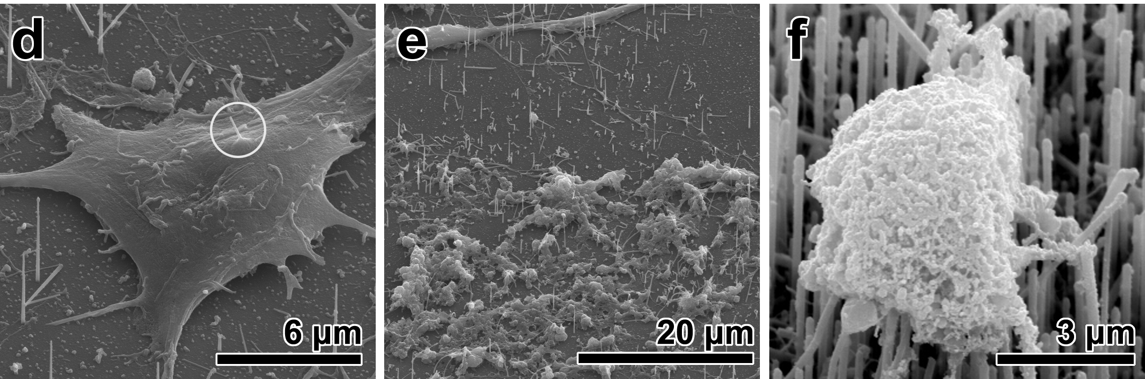
Figure S3. SEM images of primary hippocampal neurons cultured on nanowire-grown substrates in order of figure 1a, 1b and 1c. A white circle in d indicates penetrated nanowire from bottom to top membrane of neuron.

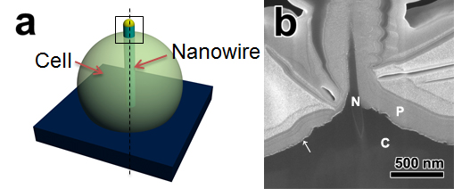
Figure S4. (a) A schematic drawing for observation of cell-nanowire interface. Dotted line represents a sectioning direction of FIB. Square part is the area we observed by SEM (b) SEM images of primary hippocampal neurons-nanowire interface (N: nanowire, P: platinium layer for the protection of upper part of cell, C: cell soma). Arrow indicates cell membrane, which is covered by gold layer for a first SEM observation.

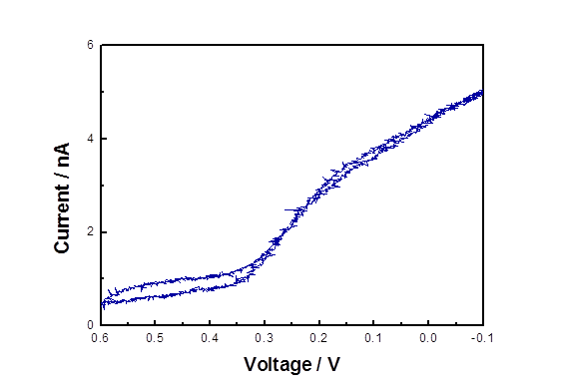Figure S5. Cyclic voltamogram of individual nanoelectrode in 0.1 M K₃Fe(CN)₆. Ag/AgCl electrode was served as the reference electrode and a platinum wire was served as the auxiliary electrode. The scan rate was 10 mV/s.

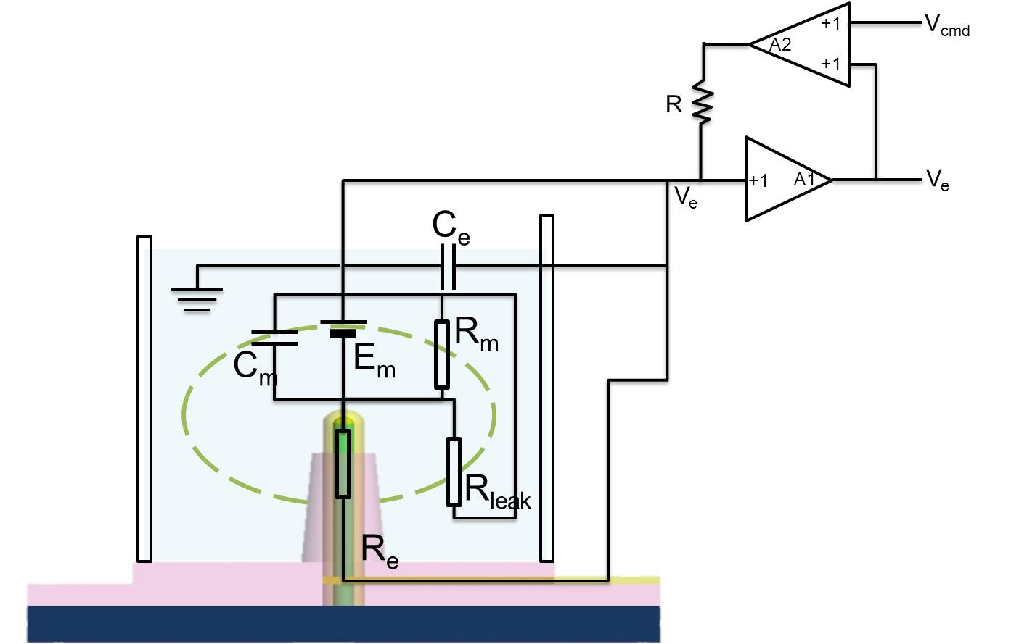
Figure S6. Equivalent circuit of our measurement system (C_{m}: cell membrane capacitance, E_{m}: cell membrane potential, R_{m}: cell membrane resistance, R_{leak}: junction leakage resistance, R_{e}: electrode resistance, C_{e}: electrode capacitance).

