Supplemental Information

SUPPLEMENAL FIGURES

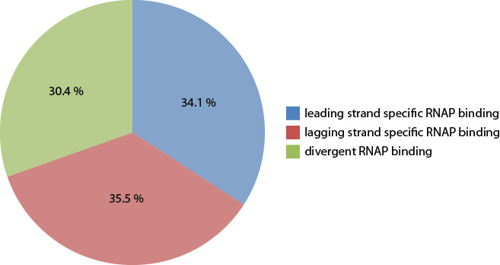
Figure S1. Strand specificity of RNAP bindings.

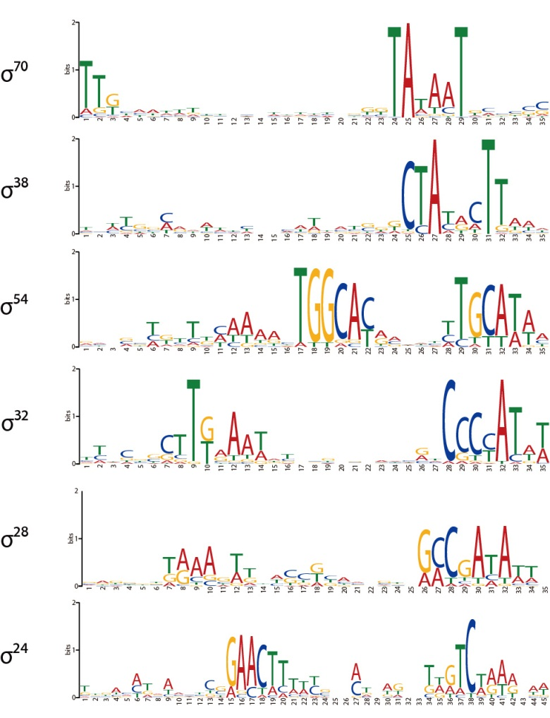
Figure S2. Sequence motifs of σ-factors.

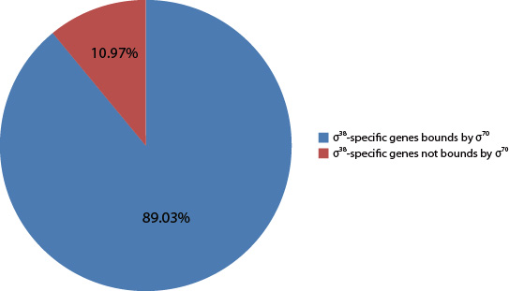
Figure S3. The majority of σ³⁸-specific promoters were bound by σ⁷⁰ when rpoS is missing.

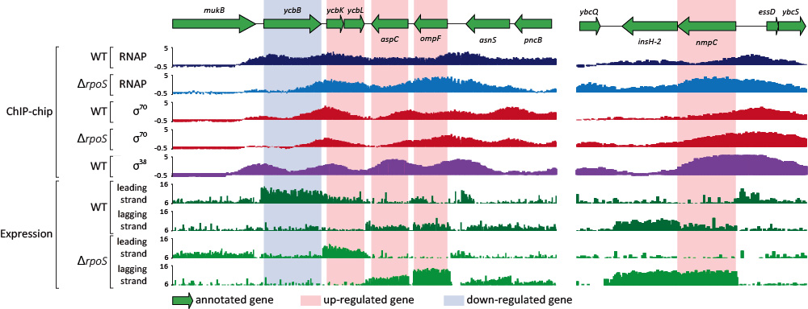
Figure S4. Examples of up-regulated and down-regulated genes when rpoS is knocked out. ycbB is an example of a down-regulated gene upon rpoS knock-out, and ycbK, ycbL, and nmpC are up-regulated genes. ycbB was not bound by σ⁷⁰ when σ³⁸ was missing, which resulted in no significant recruitment of RNAP enzyme complex, which was supported by no transcriptional expression of the particular gene. On the other hand, nmpC was more strongly bound by σ⁷⁰ when σ³⁸ was absent, which resulted in more RNAP binding and stronger expression.

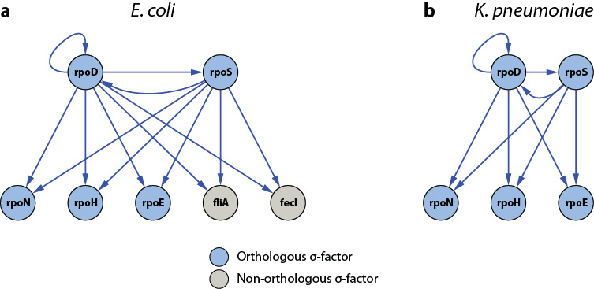
Figure S5. Comparison of transcriptional regulation by two major σ-factors, σ⁷⁰ and σ³⁸, in two closely-related bacteria.

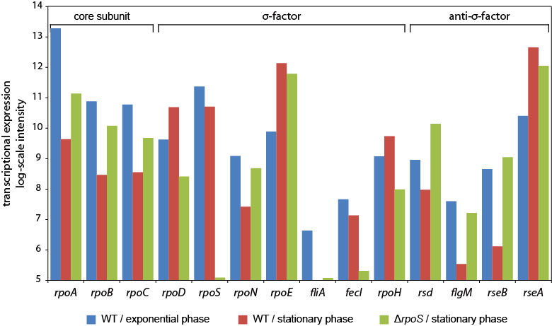
Figure S6. Comparison of transcriptional level of σ-factors and their anti-σ-factors.

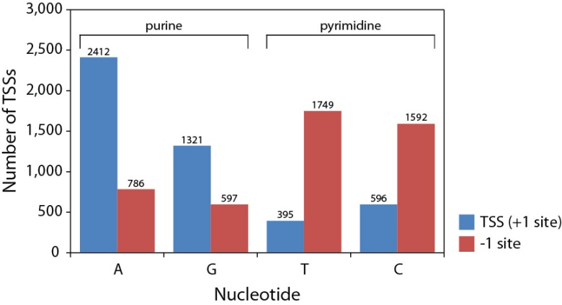
Figure S7. Purine and pyrimidine preferences at TSS and -1 site.

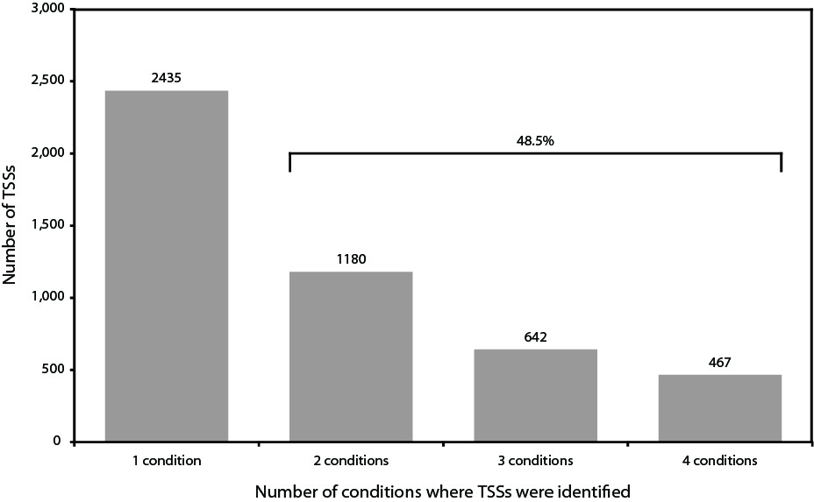
Figure S8. Number of TSSs found in one or multiple conditions.

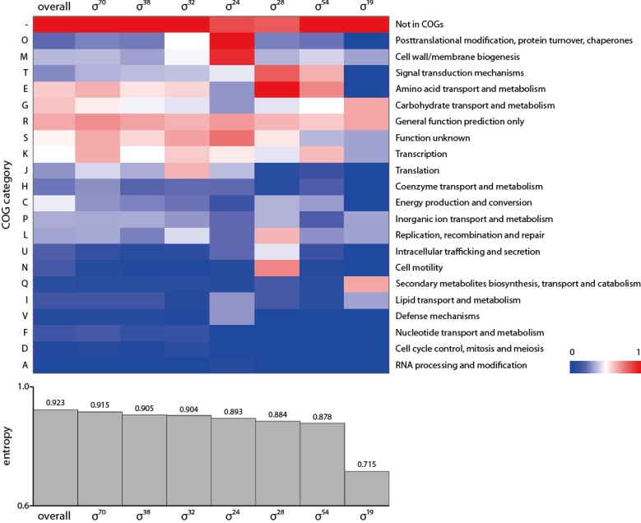
Figure S9. COG clustering analysis of σ-factor regulons.

SUPPLEMENTAL TABLES
Table S1. E. coli strains and culture conditions for ChIP-chip experiments
Table S2. RNAP and σ-factor binding regions in E. coli
Table S3. Binding intensities of RNAP and σ-factor binding regions
Table S4. Identified TSSs of E. coli under 4 different conditions
Table S5. Comparison of σ-factor binding regions with known binding regions
Table S6. Reconstructed σ- TUG network in E. coli
Table S7. Transcription levels of E. coli genes in the wild type and ΔrpoS strain

SUPPLEMENTAL NOTES
Previously reported negative regulation by σ³⁸
The up-regulation of genes with σ³⁸-specific promoters when rpoS is deleted is consistent with previous studies [1, 2] investigating negative regulation by σ³⁸. uspA and uspB, encoding universal stress proteins, are divergently transcribed stasis-induced genes. The expression of uspA that was thought to have a σ⁷⁰-specific promoter increased when rpoS was mutated, while the expression of uspB with a σ³⁸-specific promoter was down-regulated[1]. The expression data from this study confirmed this expression pattern. In another independent study[2], 7 other genes, fimA, glnQ, mglA, mutH, mutS, sdhA, and xylF, were found as negatively affected by σ³⁸, and they all agreed with our data. Thus, negative regulation by presence of σ³⁸ is a regulation mechanism that is not limited to a small number of genes, but covers ~4% of the whole genome.

Expression level of σ⁷⁰ during stationary phase
To confirm the expression level of transcripts and proteins in the E. coli K-12 MG1655 strain, we analyzed the transcriptomic expression level of genes encoding RNAP core subunits, σ-factors, and anti-σ factors under 3 different conditions: WT during exponential phase, WT during stationary phase, and ΔrpoS during stationary phase (Figure 3c, Figure S5). Compared to exponential phase, the transcription level of all RNAP core subunits, rpoA, rpoB, rpoC decreased significantly during stationary phase, whereas transcription of rpoD actually increased, and rsd transcription was down-regulated. This observation suggests the possibility of the concentration of σ⁷⁰ being high enough to have a significant role during stationary phase. Unlike rpoD, the transcription change of rpoS between exponential and stationary phase was less dramatic, resulting in a slight decrease (Figure 3c). However both rpoD and rpoS mRNA transcripts are subject to complicated post-transcriptional regulation in E. coli[2], necessitating measurement of protein levels of those gene products. In E. coli WT, decrease of protein level of RpoB was accompanied with decrease of their transcriptional level, whereas the protein level of σ⁷⁰ remained similar, and the amount of σ³⁸ increased as cells entered stationary phase (Figure 3c). Thus, in E. coli K-12 MG1655, the expression level of σ⁷⁰ in stationary phase is as high as in exponential phase, while the expression level of σ³⁸ increases as cells enter stationary phase.
Does the expression level of σ⁷⁰ change in in ΔrpoS strain during stationary phase? The answer to this question is important because σ³⁸ binds directly upstream of rpoD and regulates its transcription (Figure 1d, Figure 3c). Based on the transcriptomic data, the transcriptional expression of rpoD indeed decreased by 4.9 fold, however the translational expression of σ⁷⁰ did not decrease upon rpoS knock-out (Figure 3c). Thus, in conclusion, σ⁷⁰ is the σ-factor with the highest concentration under stationary phase, and this is also the case when rpoS is knocked out, although some fraction of σ⁷⁰ may be bound to Rsd, an anti-σ⁷⁰ factor.

Comparison of σ-factor binding between E. coli and K. pneumoniae
crp provides a good example for conserved σ-factor binding (Figure 4c). In both species, crp was bound by σ⁷⁰ and σ³⁸ in exponential and stationary phase, and the transcription initiation was detected by TSSs upstream of crp gene. The transcription initiation resulted in primary transcripts under the specified conditions. While crp is regulated in the same manner with two major σ factors, cutA represented altered σ factor binding and changed transcription unit structure. In both species, cutA is located between dcuA and dipZ orthologous genes in the lagging strand. However, those 3 genes were expressed in a contiguous transcript, indicating one transcription unit. The first gene, dcuA, was bound by σ⁷⁰ and had two TSSs. On the other hand, in K. pneumoniae, cutA was directly bound by σ⁷⁰ and dcuA was not. Although no TSS was identified upstream of cutA in K. pneumoniae, a sharp edge at the transcription starting point indicated a transcription initiation from that particular gene. panD showed another noteworthy example of disruption in the transcription unit and change in σ factor association, in two closely related microorganisms. In E. coli, yadD got in between panD and panC, resulting in 3 transcription units, while K. pneumoniae had an intact gene order and one transcription unit. In K. pneumoniae, panBCD made one transcription unit, supported by expression profiling and TSS dataset, and was bound by σ⁷⁰ under exponential phase. However, interestingly, there were 3 distinct transcription units, panD, yadD, and panBC, which were expressed and regulated respectively. Their separate expression was confirmed by expression profiling and TSS determination, and panD and panBC transcription units were both bound by σ⁷⁰. ydeA represents a case where σ factor binding is swapped between σ⁷⁰ and σ³⁸. ydeA and marC are adjacent in both genomes. However, ydeA lies on the leading strand in E. coli, while it is on the lagging strand in K. pneumoniae. Interestingly, it is regulated by σ³⁸ in E. coli; however it is bound by σ⁷⁰ in K. pneumoniae.

Statistics on TSSs
TSSs for 4 conditions, exponential phase, stationary phase, alternative nitrogen source, and heat shock, were analyzed in this study. Only TSSs that lay within promoter regions identified with ChIP-chip datasets were kept, and this resulted in 4,724 TSSs associated with RNAP and/or σ-factors. Identified TSSs showed no strand preference, with 48.2% on the leading strand and 51.8% on the lagging strand. As reported previously[3], purine (A and G) was preferred at TSS/+1 sites, whereas pyrimidine (T and C) was used more at -1 sites (Figure S6). Among 4,724 TSSs, 48.5% were identified in more than two conditions, indicating that a large fraction of TSSs and their promoters were active in transcription initiation under multiple conditions (Figure S7).

SUPPLEMETAL REFERENCES
1. Farewell A, Kvint K, Nystrom T: Negative regulation by RpoS: a case of sigma factor competition. Mol Microbiol 1998, 29(4):1039-1051.
2. Loewen PC, Hu B, Strutinsky J, Sparling R: Regulation in the rpoS regulon of Escherichia coli. Can J Microbiol 1998, 44(8):707-717.
3. Kim D, Hong JS, Qiu Y, Nagarajan H, Seo JH, Cho BK, Tsai SF, Palsson BO: Comparative analysis of regulatory elements between Escherichia coli and Klebsiella pneumoniae by genome-wide transcription start site profiling. PLoS genetics 2012, 8(8):e1002867.
4. Datsenko KA, Wanner BL: One-step inactivation of chromosomal genes in Escherichia coli K-12 using PCR products. Proceedings of the National Academy of Sciences of the United States of America 2000, 97(12):6640-6645.
5. Powell BS, Court DL, Inada T, Nakamura Y, Michotey V, Cui X, Reizer A, Saier MH, Jr., Reizer J: Novel proteins of the phosphotransferase system encoded within the rpoN operon of Escherichia coli. Enzyme IIANtr affects growth on organic nitrogen and the conditional lethality of an erats mutant. The Journal of biological chemistry 1995, 270(9):4822-4839.
6. Cho BK, Zengler K, Qiu Y, Park YS, Knight EM, Barrett CL, Gao Y, Palsson BO: The transcription unit architecture of the Escherichia coli genome. Nature biotechnology 2009, 27(11):1043-1049.
7. Herring CD, Raffaelle M, Allen TE, Kanin EI, Landick R, Ansari AZ, Palsson BO: Immobilization of Escherichia coli RNA polymerase and location of binding sites by use of chromatin immunoprecipitation and microarrays. Journal of bacteriology 2005, 187(17):6166-6174.
8. Cho BK, Barrett CL, Knight EM, Park YS, Palsson BO: Genome-scale reconstruction of the Lrp regulatory network in Escherichia coli. Proceedings of the National Academy of Sciences of the United States of America 2008, 105(49):19462-19467.
9. Cho BK, Knight EM, Barrett CL, Palsson BO: Genome-wide analysis of Fis binding in Escherichia coli indicates a causative role for A-/AT-tracts. Genome research 2008, 18(6):900-910.
10. Salgado H, Peralta-Gil M, Gama-Castro S, Santos-Zavaleta A, Muniz-Rascado L, Garcia-Sotelo JS, Weiss V, Solano-Lira H, Martinez-Flores I, Medina-Rivera A et al: RegulonDB v8.0: omics data sets, evolutionary conservation, regulatory phrases, cross-validated gold standards and more. Nucleic acids research 2013, 41(Database issue):D203-213.
11. Cho BK, Federowicz S, Park YS, Zengler K, Palsson BO: Deciphering the transcriptional regulatory logic of amino acid metabolism. Nature chemical biology 2012, 8(1):65-71.

