Additional file 1

Online supplement to: D Canoy, B J Cairns, A Balkwill, F L Wright, J Green, G Reeves and V Beral. Body mass index and incident coronary heart disease in women: a population-based prospective study.

Figure S1. Body mass index and annual coronary heart disease (CHD) incidence (95% confidence interval) in relation to year of follow-up from baseline. Page 2
Table S1. Cumulative incidence (95% confidence interval) of coronary heart disease in relation to body mass index and attained age (supplement for Figure 2). Page 3
Figure S2. The 20-year cumulative incidence of coronary heart disease (CHD) from age 55 to 74 years in relation to body mass index. Page 4
Table S2. Number of incident coronary heart disease (CHD) events in relation to body mass index and other risk factors (supplement for Figure 3). Page 5
Table S3. Relative risk (95% confidence interval (CI)) of coronary heart disease (CHD) per 5 kg/m² increase in body mass index and correction for measurement error by regression calibration. Page 6
Figure S3.The 20-year cumulative incidence of coronary heart disease (CHD) (cause-specific and with competing causes of deaths) from age 55 to 74 years in relation to body mass index. Page 7

Figure S1. Body mass index and annual coronary heart disease (CHD) incidence (95% confidence interval [CI]) in relation to years of follow-up from baseline. Rates are stratified by region and uniformly age-standardised to match the average CHD rate for each year between ages 50 to 74 years.
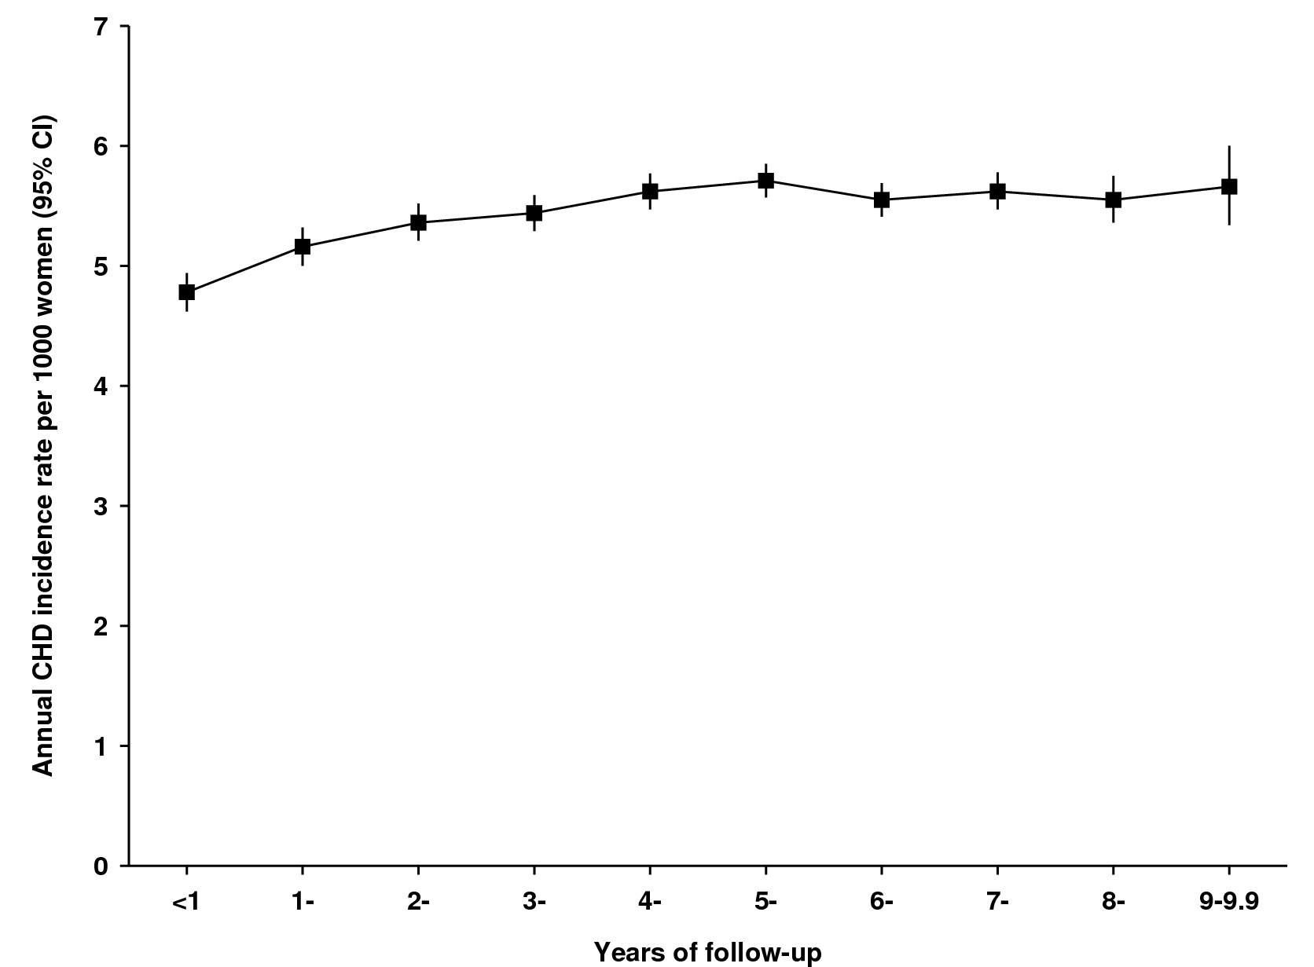
 | Follow-up (years)
 | <1 | 1 to 1.9 | 2 to 2.9 | 3 to 3.9 | 4 to 4.9 | 5 to 5.9 | 6 to 6.9 | 7 to 7.9 | 8 to 8.9 | 9 to 9.9
No. with CHD | 2,781 | 3,628 | 4,228 | 4,750 | 5,167 | 5,719 | 6,209 | 6,295 | 5,495 | 3,374
Person-years | 1,177 | 1,171 | 1,164 | 1,156 | 1,146 | 1,135 | 1,121 | 1,082 | 879 | 517
Incident rate per 1,000 (95% CI) | 4.78 (4.62 to 4.94) | 5.16 (5.00 to 5.32) | 5.36 (5.21 to 5.52) | 5.44 (5.29 to 5.59) | 5.62 (5.47 to 5.77) | 5.71 (5.57 to 5.85) | 5.55 (5.41 to 5.69) | 5.62 (5.47 to 5.78) | 5.55 (5.36 to 5.75) | 5.66 (5.34 to 6.00)

Table S1. Cumulative incidence (95% confidence interval (CI)) of coronary heart disease (CHD) in relation to body mass index and attained age (supplement for Figure 2).
 | Body mass index (kg/m²)
 | <25 | 25 to 29.9 | 30 to 34.9 | ≥35 | All
5-year cumulative incidence
From age 55 to 59 years
No. of women (No. with CHD) | 54,951 (2,036) | 38,078 (2 131) | 13,859 (1,001) | 6,707 (603) | 113,595 (5,771)
Cumulative incidence per 100 women (95% CI) | 1.2 (1.1 to 1.2) | 1.7 (1.6 to 1.8) | 2.1 (2.0 to 2.3) | 2.8 (2.6 to 3.0) | 1.5 (1.5 to 1.6)
From age 60 to 64 years
No. of women (No. with CHD) | 217,026 (3,415) | 152,598 (3,534) | 53,169 (1,542) | 22,439 (825) | 445,232 (9,316)
Cumulative incidence per 100 women (95% CI) | 1.9 (1.9 to 2.0) | 2.6 (2.5 to 2.7) | 3.1 (3.0 to 3.3) | 4.0 (3.7 to 4.3) | 2.4 (2.4 to 2.5)
From age 65 to 69 years
No. of women (No. with CHD) | 144,407 (3,914) | 114,194 (4,245) | 38,553 (1,807) | 14,623 (777) | 311,777 (10,743)
Cumulative incidence per 100 women (95% CI) | 3.0 (2.9 to 3.1) | 3.8 (3.7 to 3.9) | 4.6 (4.4 to 4.8) | 5.2 (4.9 to 5.6) | 3.7 (3.6 to 3.8)
From age 70 to 74 years
No. of women (No. with CHD) | 96,927 (2,122) | 83,039 (2,153) | 28,278 (859) | 9,572 (344) | 217,816 (5,478)
Cumulative incidence per 100 women (95% CI) | 4.4 (4.2 to 4.6) | 5.2 (5.0 to 5.4) | 6.0 (5.6 to 6.4) | 7.2 (6.5 to 8.0) | 5.0 (4.9 to 5.3)
20-year cumulative incidence
From age 55 to 74 years
No. of women (No. with CHD) | 513,311 (11,487) | 387,909 (12,063) | 133,859 (5,209) | 53,341 (2,549) | 1,088,420 (31,308)
Cumulative incidence per 100 women (95% CI) | 10.2 (9.7 to 10.6) | 12.7 (12.2 to 13.2) | 14.9 (14.1 to 15.8) | 17.9 (16.3 to 19.5) | 12.1 (11.9 to 12.2)

Figure S2.The 20-year cumulative incidence of coronary heart disease (CHD) from age 55 to 74 years in relation to body mass index.
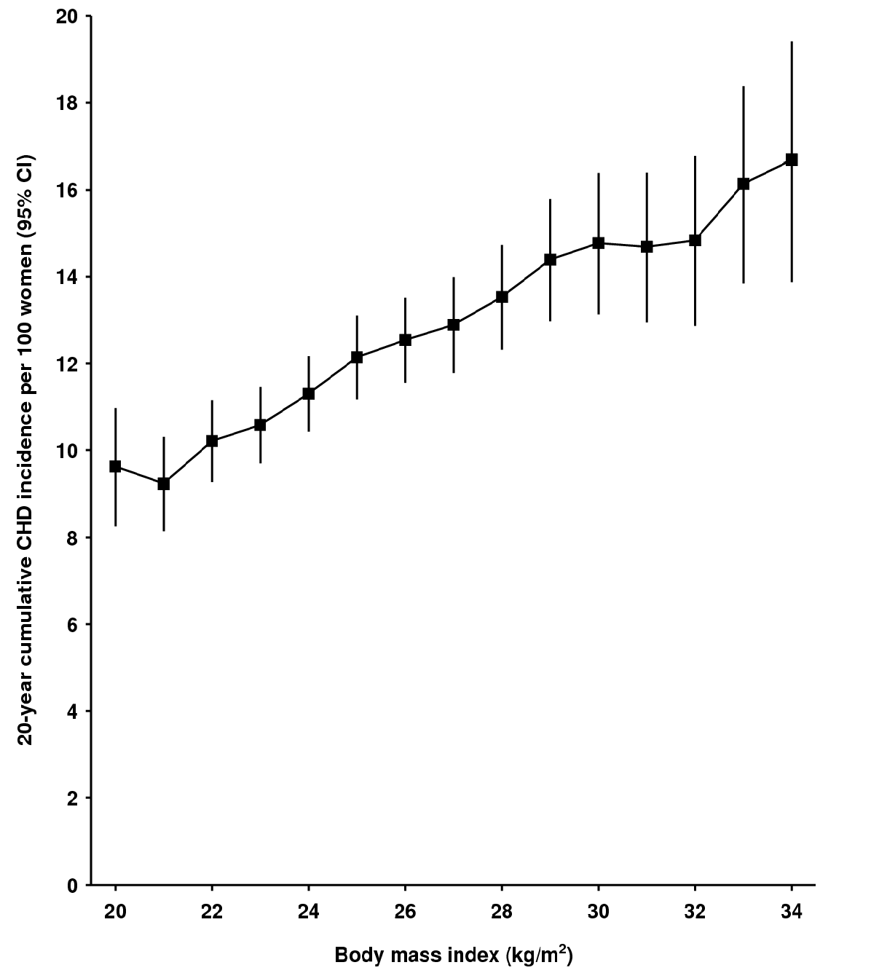
Body mass index, kg/m² | No. of women | No. with CHD | 20-year cumulative incidence  per 100 (95% CI) from age 55 years
20 to 20.9 | 48,685 | 1,030 | 9.6 (8.3 to 11.0)
21 to 21.9 | 77,286 | 1,507 | 9.2 (8.1 to 10.3)
22 to 22.9 | 109,879 | 2,380 | 10.2 (9.3 to 11.1)
23 to 23.9 | 123,695 | 2,848 | 10.6 (9.7 to 11.5)
24 to 24.9 | 126,437 | 3,240 | 11.3 (10.4 to 12.2)
25 to 25.9 | 103,633 | 2,947 | 12.1 (11.2 to 13.1)
26 to 26.9 | 98,099 | 2,967 | 12.5 (11.6 to 13.5)
27 to 27.9 | 78,817 | 2,468 | 12.9 (11.8 to 14.0)
28 to 28.9 | 67,609 | 2,261 | 13.5 (12.3 to 14.7)
29 to 29.9 | 51,053 | 1,855 | 14.4 (13.0 to 15.8)
30 to 30.9 | 39,654 | 1,466 | 14.8 (13.1 to 16.4)
31 to 31.9 | 33,532 | 1,285 | 14.7 (12.9 to 16.4)
32 to 32.9 | 26,023 | 1,034 | 14.8 (12.9 to 16.8)
33 to 33.9 | 22,123 | 912 | 16.1 (13.8 to 18.4)
34 to 34.9 | 15,858 | 666 | 16.7 (13.9 to 19.4)
Table S2. Number of incident coronary heart disease (CHD) events in relation to body mass index and other risk factors (supplement for Figure 3).
Body mass index, kg/m² | Risk factors
Body mass index, kg/m² | % | No. with CHD / N of women | % | No. with CHD / N of women
A. By smoking (N=1,170,462)*†
 |  | Never smokers |  | Current smokers
<25 | 1.7 | 4,260 / 254,459 | 3.7 | 4,027 / 108,121
25 to 29.9 | 2.4 | 4,601 / 189,405 | 4.8 | 3,316 / 69,180
30 to 34.9 | 3.2 | 2,057 / 65,176 | 5.8 | 1,211 / 20,877
≥35 | 4.0 | 1,016 / 25,658 | 7.3 | 538 / 7,332
B. By physical activity (N=1,139,759)*
 |  | Active |  | Inactive
<25 | 1.8 | 5,129 / 291,455 | 2.9 | 5,877 / 206,150
25 to 29.9 | 2.6 | 5,022 / 194,122 | 3.6 | 6,495 / 180,995
30 to 34.9 | 3.3 | 1,817 / 55,722 | 4.3 | 3,155 / 73,308
≥35 | 4.1 | 770 / 18,696 | 5.1 | 1,650 / 32,639
C. By alcohol consumption (N=1,171,446)*
 |  | Drinker |  | Non-drinker
<25 | 2.0 | 8,118 / 412,074 | 3.3 | 3,253 / 98,427
25 to 29.9 | 2.7 | 8,191 / 298,875 | 4.3 | 3,740 / 86,584
30 to 34.9 | 3.3 | 3,124 / 93,756 | 5.2 | 2,018 / 39,091
≥35 | 4.1 | 1,354 / 33,296 | 5.9 | 1,155 / 19,580
D. By socioeconomic status (N=1,270,314)*
 |  | Upper half |  | Lower half
<25 | 1.8 | 5,005 / 273,818 | 2.7 | 6,396 / 235,697
25 to 29.9 | 2.6 | 4,876 / 189,632 | 3.6 | 7,090 / 195,464
30 to 34.9 | 3.1 | 1,788 / 57,652 | 4.5 | 3,388 / 75,209
≥35 | 4.0 | 790 / 19,945 | 5.3 | 1,745 / 33,026
*N of women with complete values for the variable; †Includes former smokers.
Table S3. Relative risk (95% confidence interval (CI)) of coronary heart disease (CHD) per 5 kg/m² increase in body mass index and correction for measurement error by regression calibration.
Outcome | No. of women  (No. with CHD) | Regression dilution ratio (95% CI) | Relative risk (95% CI)
 | No. of women  (No. with CHD) | Regression dilution ratio (95% CI) | Uncalibrated | Calibrated
Incident CHD | 1,118,722 (32,465) | 0.97 (0.94 to 0.99) | 1.23 (1.22 to 1.25) | 1.24 (1.23 to 1.26)
CHD mortality | 1,118,722 (2,431) | 0.97 (0.94 to 0.99) | 1.32 (1.28 to 1.36) | 1.33 (1.29 to 1.38)

Figure S3.The 20-year cumulative incidence of coronary heart disease (CHD) (cause-specific and with competing causes of deaths) from age 55 to 74 years in relation to body mass index.

