+
-
-
-
-
-
-
+
-
-
-
+
-
-
+
-
-
-
-
+
-
+
-
-
-
+
+
-
+
-
-
+
-
-
-
+
-
+
+
-
-
+
-
+
-
-
-
-
+
-
-
+
-
-
-
+
+
+
-
-
-
-
-
-
+
-
-
-
+
+
-
-
-
-
-
+
-
+
-
-
-
-
+
+
+
-
-
-
+
+
-
-
-
-
-
-
-
-
-
-
+
-
-
-
-
+
-
-
-
-
-
-
-
-
-
+
-
-
-
-
-
-
-
+
-
-
-
-
-
+
-
+
-
-
-
-
-
-
-
-
Aβ42
C16
Cocktail
IL-1β
TNF-α
IL-6
Baf
A

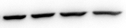
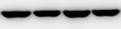
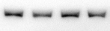
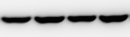
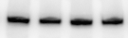
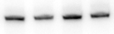
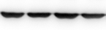
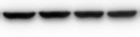
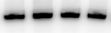
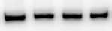
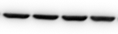
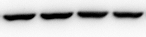
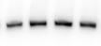
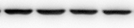
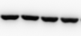
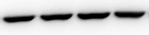
P_{S2448}-mTOR
mTOR
β-actin
β-actin

-
+
-
+
+
-
-
-
+
-
-
+
-
-
+
-
-
-
+
-
-
B

Aβ42
C16
Cocktail
IL-1β
TNF-α
IL-6
Baf
-
-
+
+
+
-
-
-
-
+
-
+
-
-
-
-
+
-
-
+
-
-
-
-
-
-
-
+
-
-
-
-
+
-
+
-
+
-
-
-
-
-
+
-
-
-
-
+
-
+
-
-
-
-
-
-
+
-
-
-
+
+
-
-
-
-
+
+
+
-
-
-
-
+
+
-
-
-
-
-
+
-
+
-
-
-
-
+
-
-
-
-
-
-
+
+
-
-
-
-
-
-
+
-
-
-
-
-
-
-
+
-
-
-
-
-
-
-
-

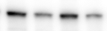
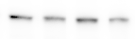
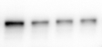
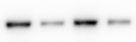
β-actin
P_{T389}-p70S6K
p70S6K
β-actin
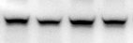
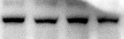
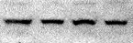
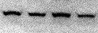
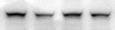
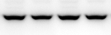
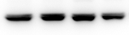
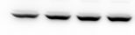
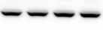
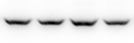

Additional file 4: Activation of mTOR signaling pathway by exogenous cytokines in tri-cultures. Representative immunoblots showed the immunoreactivity of mTOR, P_{S2448}-mTOR (A) and p70S6K, P_{T389}-p70S6K (B), and β-actin from cell lysates of primary tri-cultures exposed to 20 μM Aβ42, pretreated or not with 210 nM C16 in serum-free medium and treated with a cytokine cocktail of 200 pg/mL of IL-1β, TNF-α and IL-6 or with 200 pg/mL of IL-1β, TNF-α or IL-6 alone during 48hrs. Densities were quantified by using Gene Tools software (Syngene, Ozyme France). Data of each protein were reported to data of the corresponding β-actin. The results are expressed as arbitrary units (% of control set at 100%) and are mean ± SEM from 6 independent experiments in duplicate. ***p < 0.001 compared to control; &&p<0.01, &&&p<0.001 compared to C16; ‡‡p<0.01, ‡‡‡p<0.001 compared to inflammatory cocktail; $p<0.05 compared to TNF-α; §§§p<0.001 compared to TNF-α with C16; †p<0.05 compared to IL-6; ^{δ}p<0.05 compared to IL-6 with C16 by one-way ANOVA with a Newman-Keuls multiple comparison test.

