Supplemental Information

TNPO3 protects HIV-1 replication from CPSF6-mediated capsid stabilization in the host cell cytoplasm

Alberto De Iaco, Federico Santoni, Michel Guipponi, Stylianos Antonarakis and Jeremy Luban

- Supplemental Data
Table S1 Represents the raw data of Figure 1D
Figure S1 Extension of the characterization of 2-LTR circles formed in absence of TNPO3 and characterization of 2-LTR circles formed in presence of CPSF6-358
Figure S2 Lack of correlation of inhibition of the 27 HIV-1 CA mutants analyzed in figure 2C infecting CPSF6-358 expressing cells or cells expressing other restriction factor
Table S2 Represents some details of the deep sequencing analysis from Figure 1J

- Supplemental References

- Supplemental Data
Table S1, Related to Figure 1
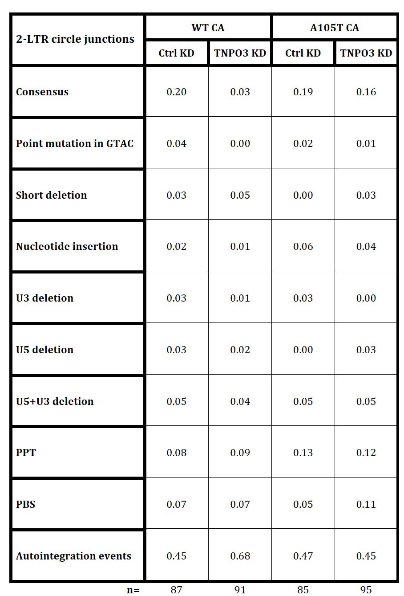

Sanger sequencing of the 2-LTR circle products from PCR using primers flanking the circle junction
2-LTR circle PCR products from Figure 1C were cloned into bacterial plasmids and single colonies were sequenced using a primer overlapping with the T7 promoter. The numbers in the boxes here are the relative frequencies of sequences identified for each type of junction, where 100% equals 1.0. The total number of plasmids sequenced for each condition are represented by n.

Figure S1, Related to Figure 1
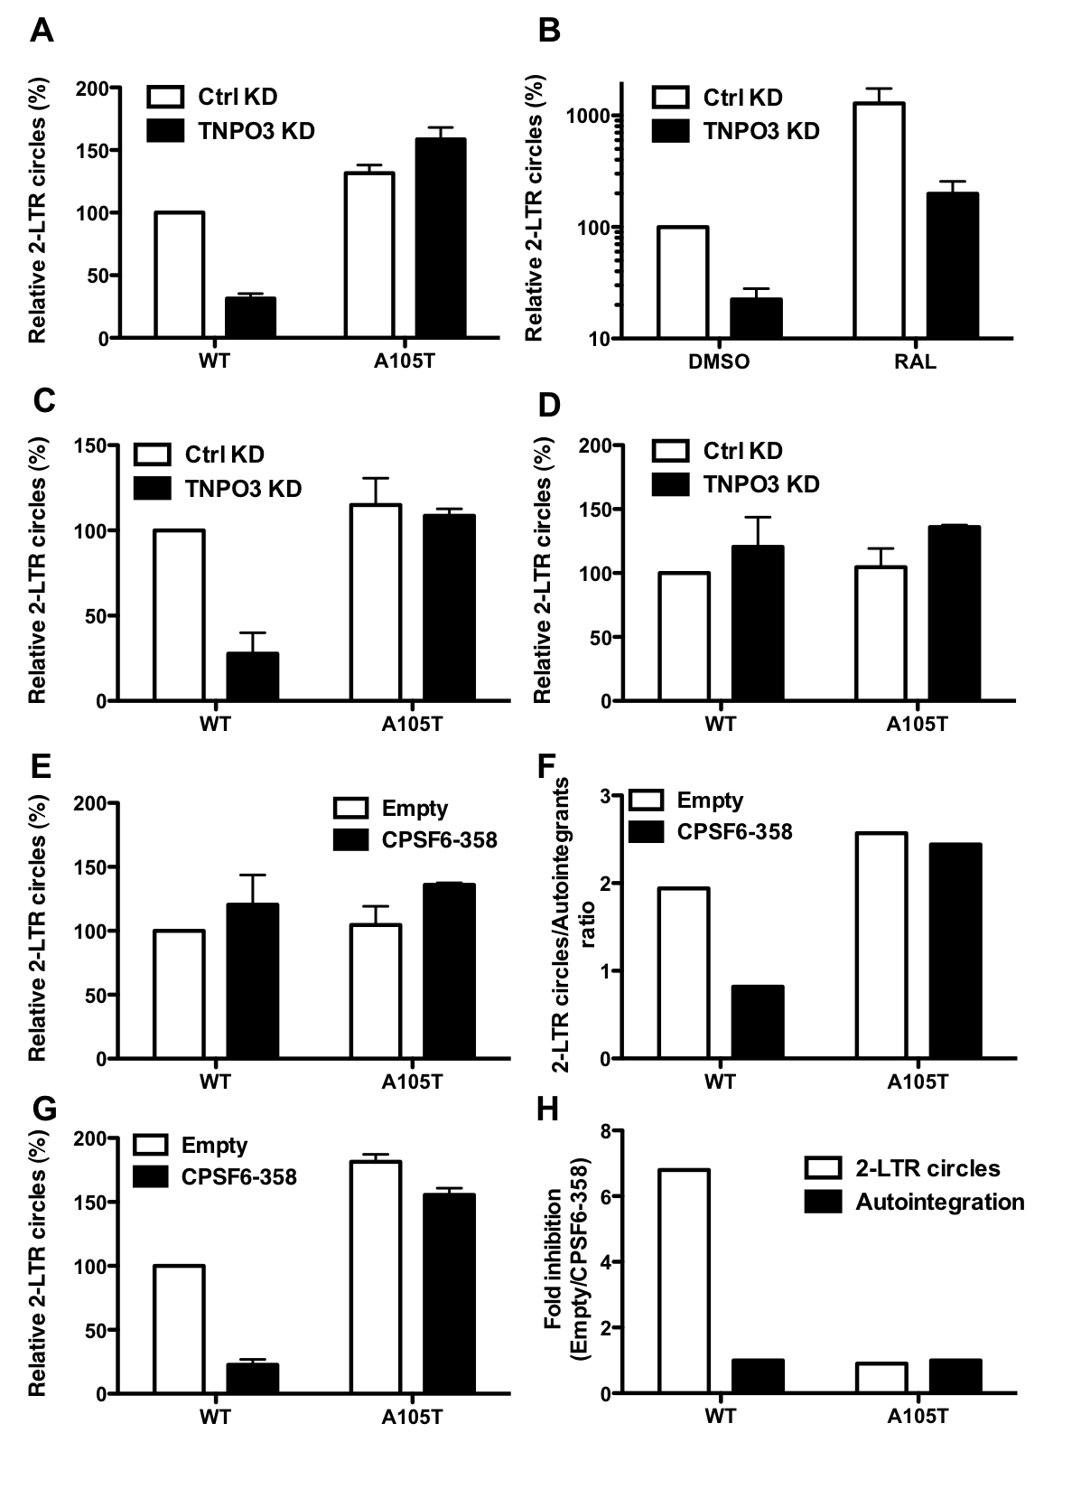
Inhibition of 2-LTR circle formation in the absence of TNPO3 or in the presence of CPSF6-358, assessed with different qPCR methods
(A) Quantification of 2-LTR circle PCR products with forward primer overlapping with 4 nucleotides of the 5’LTR (as indicated in Figure 1G, junct4 fwd) after 24 hours infection of WT and A105T CA mutant viruses on control (Ctrl) or TNPO3 KD TZM-bl cells. (B) Quantification of 2-LTR circle PCR products with forward primer overlapping the junction (junct2 fwd) after 24 hours infection of WT virus on control (Ctrl) or TNPO3 KD TZM-bl cells, treated with raltegravir (RAL) or DMSO as a control. (C) Quantification of 2-LTR circles using primers flanking the circle junction and a TaqMan probe annealing with the 3’LTR [1] (D) Quantification of 2-LTR circles using primers flanking the circle junction and a TaqMan probe annealing within the junction sequence. (E) Quantification of 2-LTR circle PCR products (from analysis represented in figure 1B) after 24 hours infection of WT and A105T CA mutant viruses on TZM-bl cells expressing or not CPSF6-358. (F) The PCR products were cloned and sequenced, and the amount of 2-LTR circles and autointegration events determined. The ratios between 2-LTR circles and autointegration events detected were plotted. (G) Quantification of 2-LTR circle PCR products with forward primer overlapping with 2 nucleotides of the 5’LTR (as indicated in figure 1G) after 24 hours infection of WT and A105T CA mutant viruses on control (Ctrl) or TNPO3 KD TZM-bl cells. (H) 2-LTR circles and autointegration events are quantified by high-throughput sequencing of low-molecular weight DNA extracted from TZM-bl stably transduced with an vector expressing CPSF6-358 or an empty vector as a control infected for 24 hours with WT or A105T CA mutant viruses. Ratios between the levels in empty vs CPSF6-358 expressing cells are plotted. Data represent one of at least three independent experiments. Error bars represent ± SEM (n = 3).

Figure S2, Related to Figure 2
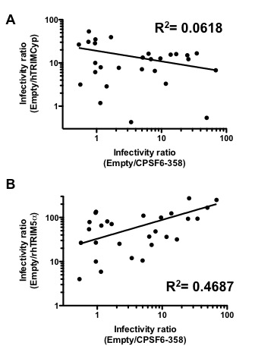
CPSF6-358 inhibition of HIV-1 CA mutants does not correlate with the restriction of other CA-dependent restriction factors
(A) TZM-bl cells stably transduced with human TRIMCyp (hTRIMCyp) expressing vector or empty vector were challenged with 27 CA mutant HIV-1 vectors. Correlation between the infectivity ratios of 27 CA mutants infecting Empty vs hTRIMCyp and Empty vs CPSF6-358 (Figure 2C) (R²=0.0618). (B) TZM-bl cells stably transduced with rhesus TRIM5α (rhTRIM5α) expressing vector or empty vector were challenged with 27 CA mutant HIV-1 vectors. Correlation between the infectivity ratios of 27 CA mutants infecting Empty vs rhTRIM5α and Empty vs CPSF6-358 (Figure 2C) (R²=0.4687). Data represent one of at least three independent experiments. Error bars represent ± SEM (n = 3).

Table S2, Related to Material and Methods
 | # mapped reads | Coverage | 2-LTR Circles | 2-LTR Circles  WT Ctrl normalized* | 2-LTR Circles  Norm Fold Change*
WT  Ctrl* | 1502117 | 14401 | 217 | 217 | 1
A105T  Ctrl | 745319 | 7146 | 113 | 227 | 0.96
WT  TNPO3 KD | 2240139 | 21477 | 91 | 61 | 3.56
A105T  TNPO3 KD | 945335 | 9063 | 167 | 265 | 0.82

 | # mapped reads | Coverage | 2-LTR Circles | 2-LTR Circles  WT Ctrl normalized** | 2-LTR Circles  Norm Fold Change**
WT  Ctrl** | 465114 | 4459 | 55 | 55 | 1
A105T  Ctrl | 946378 | 9074 | 134 | 65 | 0.84
WT  CPSF6-358 | 1056108 | 10126 | 18 | 8 | 6.8
A105T  CPSF6-358 | 487368 | 4672 | 56 | 53 | 0.96

Mapping statistics, coverage and number of 2-LTR circles of whole-genome and junctions high throughput sequencing of WT and A105T mutant preintegration complex on control or TNPO3 KD or CPSF6-358 overexpressing TZM-bl cells. Coverage (number of reads X nucleotide) is calculated by dividing the number of mapping reads by the length in nt. of HIV-1_{NL4-3} multiplied by the read length (100nt). 2-LTR Circles are quantified by counting reads covering 3’LTR-5’LTR junction and containing CTGACTG sequence (or its reverse complement if they cover 5’LTR-3’LTR junction). 2-LTR circles are normalized to corresponding WT Ctrl and Fold Change wrt WT Ctrl is calculated accordingly.

- Supplemental References
1. Butler SL, Hansen MS, Bushman FD: A quantitative assay for HIV DNA integration in vivo. Nat Med 2001, 7:631-634.

