Additional file 7. Starting data for the numerical simulation of the viral load/T-cell dynamics in SIVmac251-infected macaques. The values are referred to a drug-free period. For the starting number of resting latently infected CD4⁺ T-cells, see Ref. [1] below.
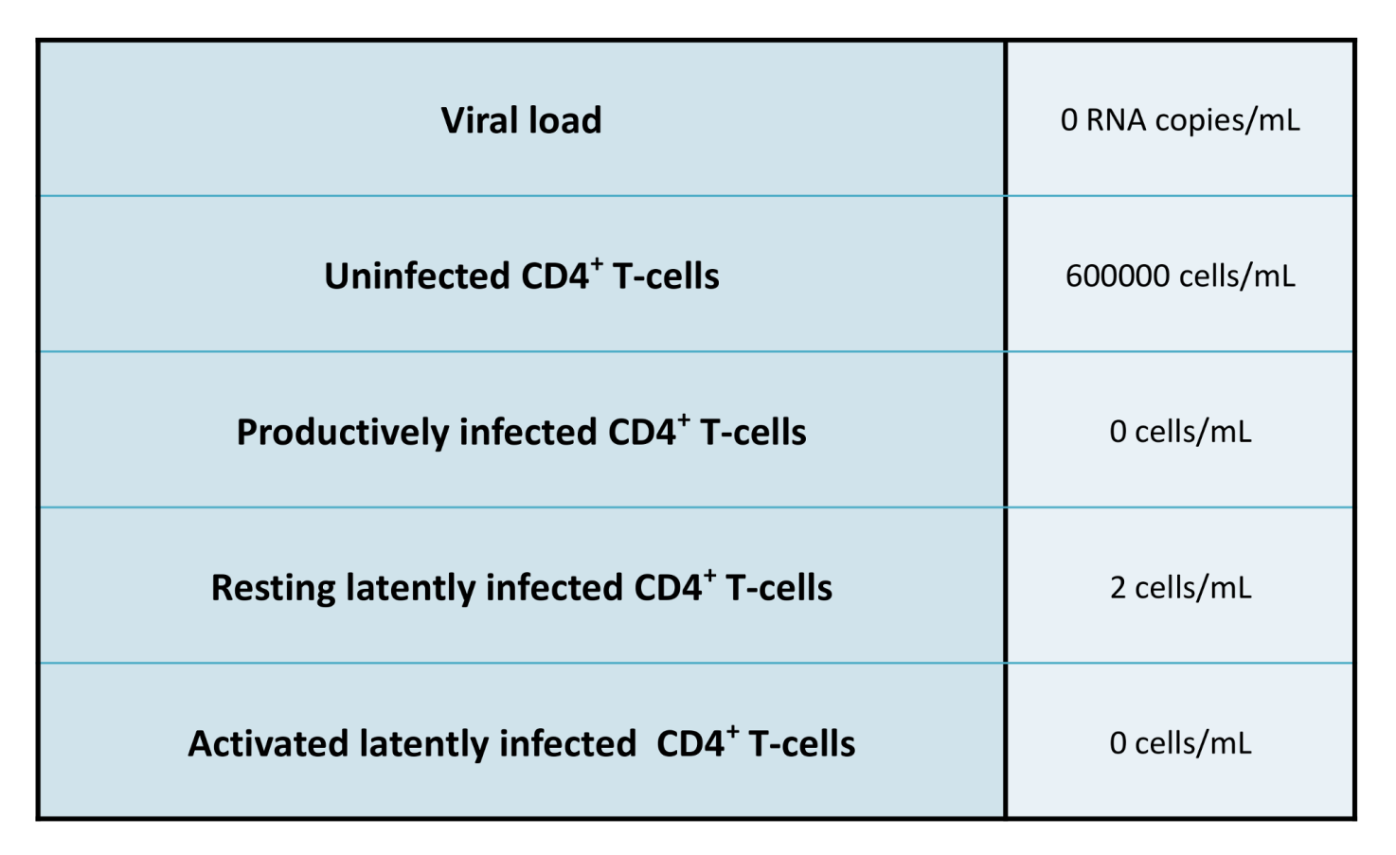

References
- Shytaj IL, Norelli S, Chirullo B, Della Corte A, Collins M, Yalley-Ogunro J, Greenhouse J, Iraci N, Acosta EP, Barreca ML, Lewis MG, Savarino A. A highly intensified ART regimen induces long-term viral suppression and restriction of the viral reservoir in a simian AIDS model. PLoS Pathog. 2012; 8(6):e1002774. doi:10.1371/journal.ppat.1002774.

