Additional files for

A Novel HIV-1-Encoded MicroRNA Enhances Its Viral Replication by Targeting the TATA Box Region

Yijun Zhang, Miaomiao Fan, Guannan Geng, Bingfeng Liu, Zhuoqiong Huang, Haihua Luo, Jie Zhou, Xuemin Guo, Weiping Cai
and Hui Zhang*

This file includes:
Supplemental Data (Fig. S1 to S7)
Supplemental Material and Methods
Supplemental References

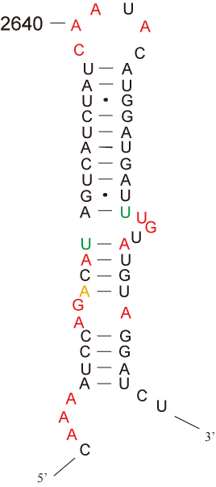
Fig.S1 The genuine secondary structure of miR-H3 precursor corresponding sequence in HIV-1 genome by Watts et al. [31].

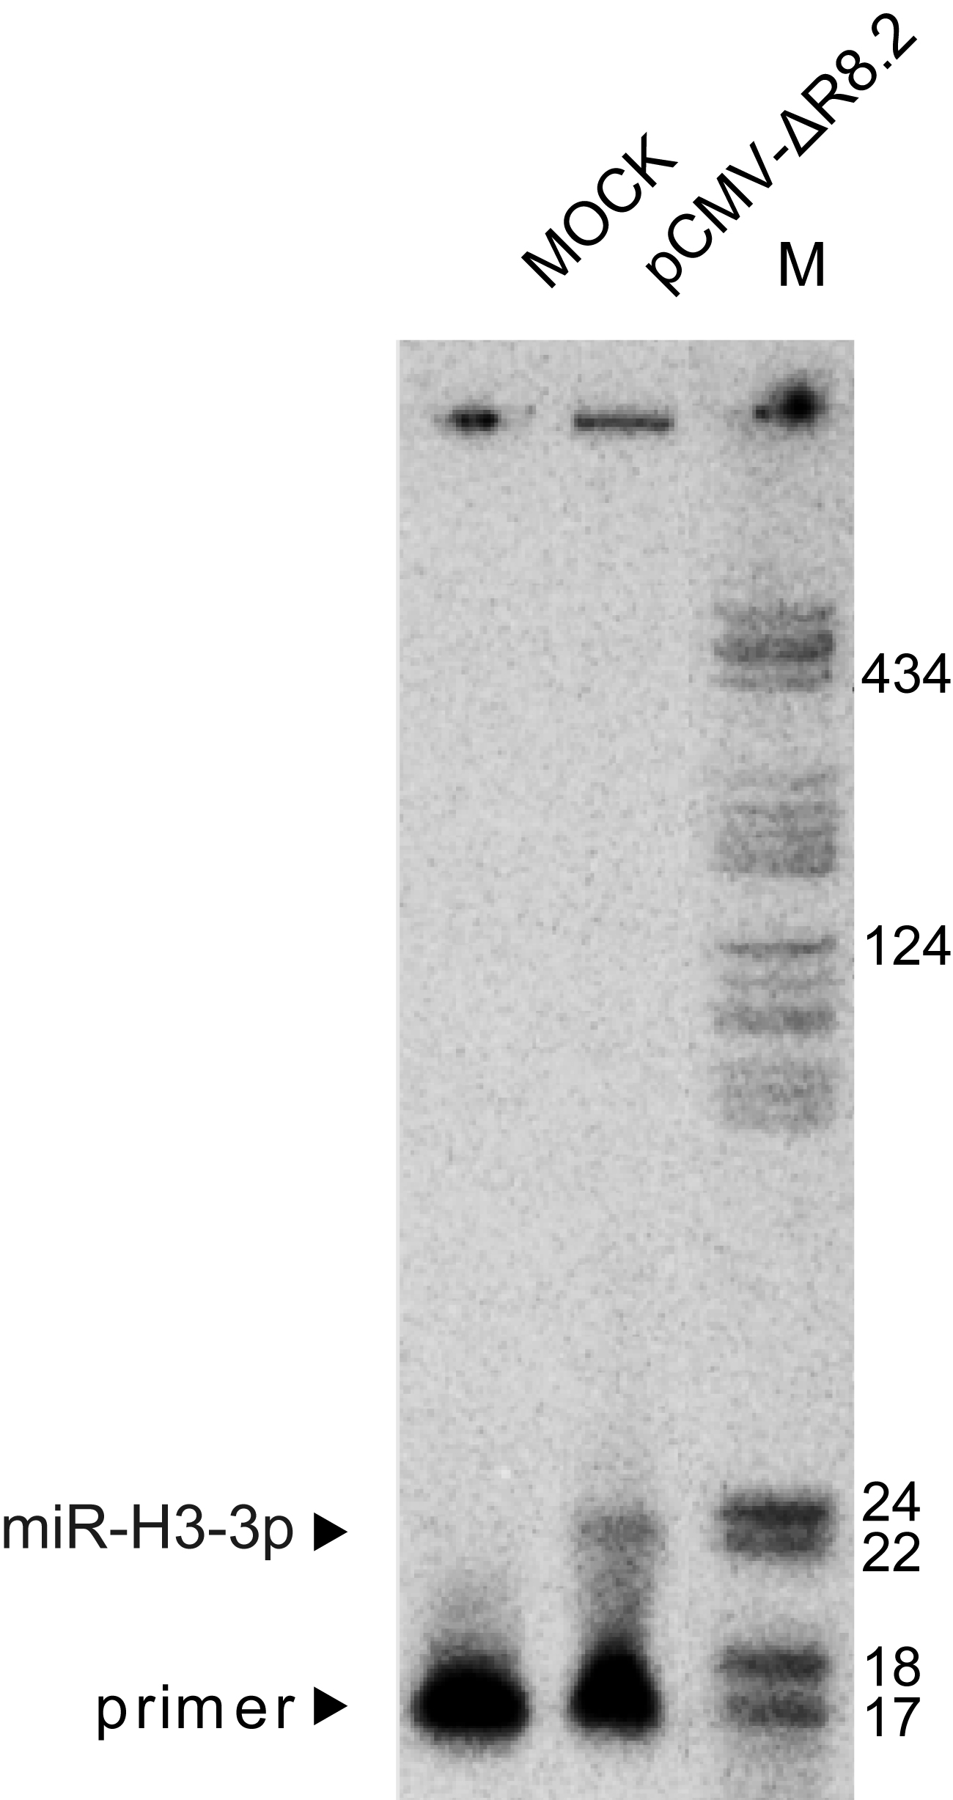
Fig. S2 Primer extension assay of miR-H3-3p. Total RNAs were isolated from HEK293T cells transfected with a lentiviral vector pCMV-ΔR8.2 which contains the miR-H3 precursor or a control plasmid for 48 hrs. A small RNA band was detected only in the lane of pCMV-ΔR8.2 transfection by a probe specific to miR-H3-3p sequence.
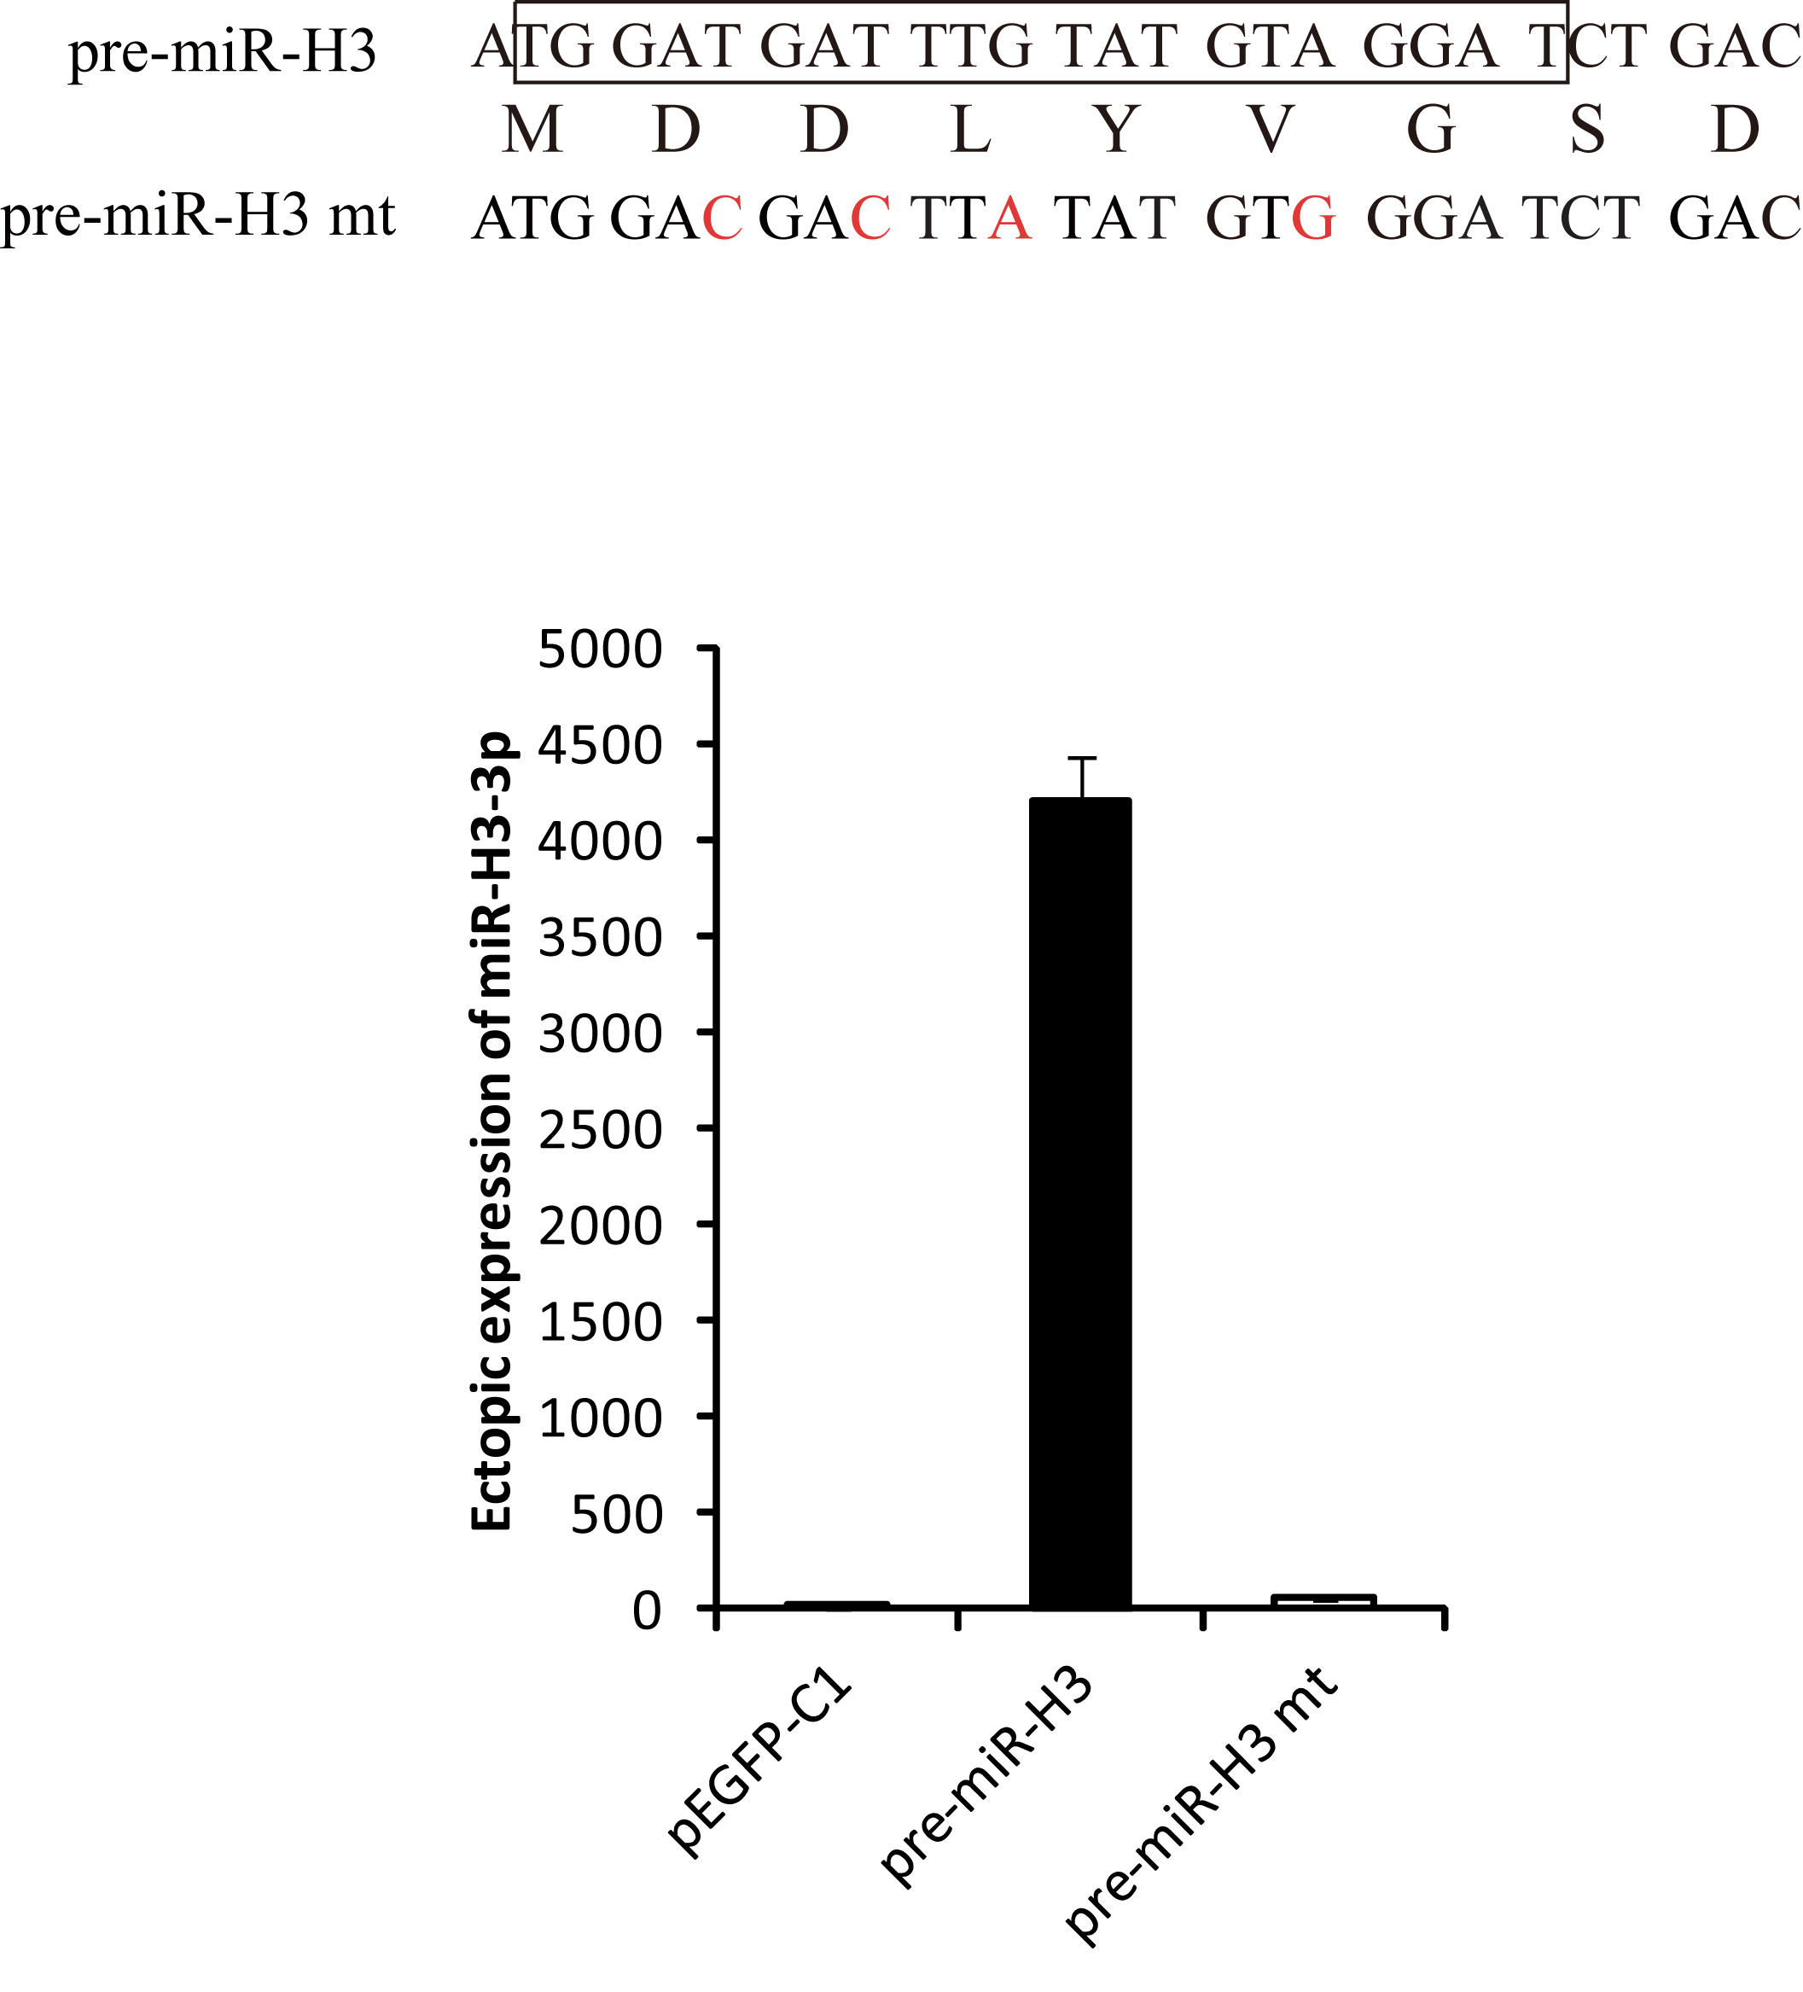
Fig. S3 Ectopic expression of miR-H3 by constructs containing its wildtype or mutated precursors. Top, the mutated nucleotides were indicated in red; bottom, mature miR-H3-3p sequence was tested with real-time qPCR and normalized to U6, an empty vector was transfected as a control.

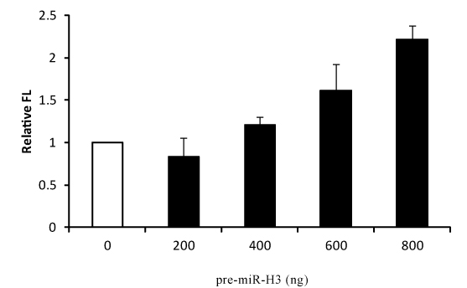
Fig. S4 Effect of miR-H3 on integrated HIV-1 reporter system. TZM-bl cells, containing an integrated HIV-1 promoter-driven luciferase cassette in chromosomal DNA, were transfected with the construct harboring miR-H3 precursor or an empty vector. The transcription activities of HIV-1 promoter were examined by luciferase assay.

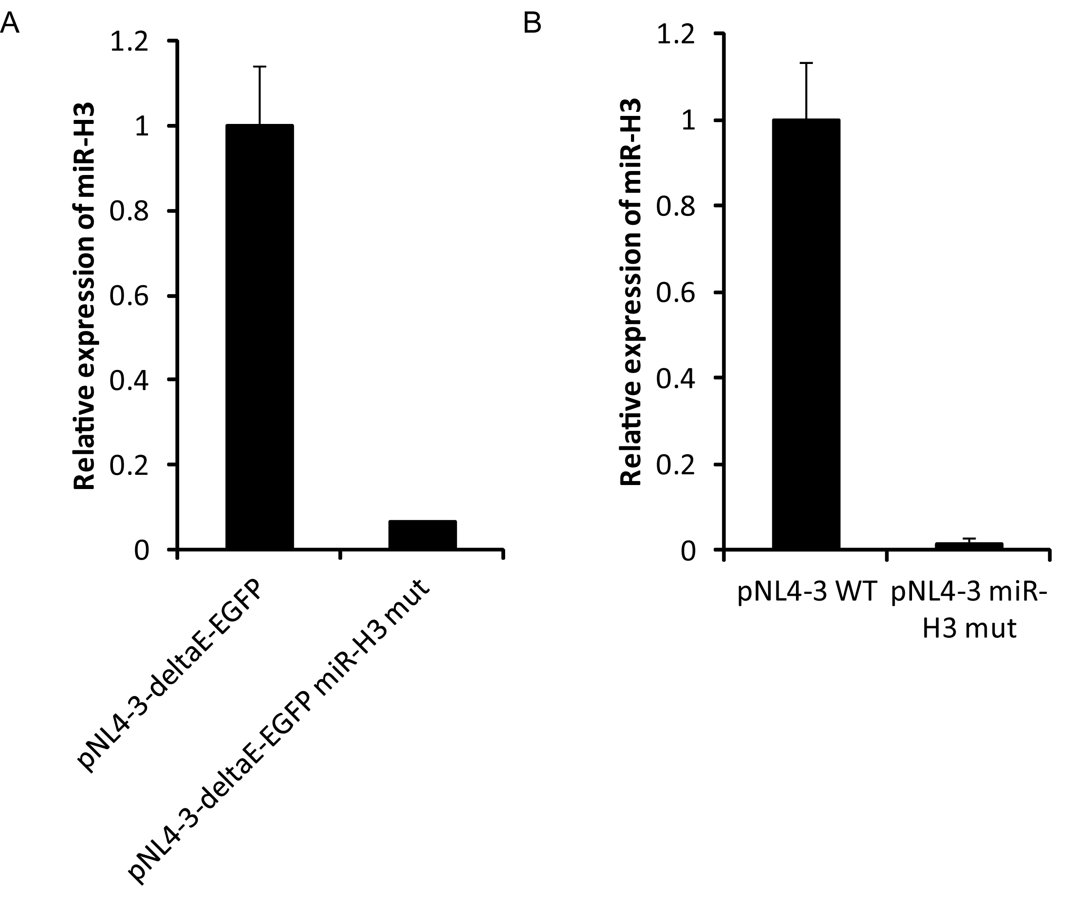
Fig. S5 MiR-H3-3p processed from mutated pNL4-3-deltaE-EGFP (A) or pNL4-3 constructs (B). The plasmid were transfected into HEK293T cells, After 48 hrs total RNAs were isolated and miR-H3-3p expression was determined with qRT-PCR and normalized to U6.

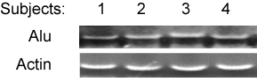
Fig. S6 Confirmation of integrated HIV-1 proviruses in the chromosomal DNA from resting CD4⁺ T cells isolated from HIV-1-infected patients on suppressive HAART using Alu-PCR.

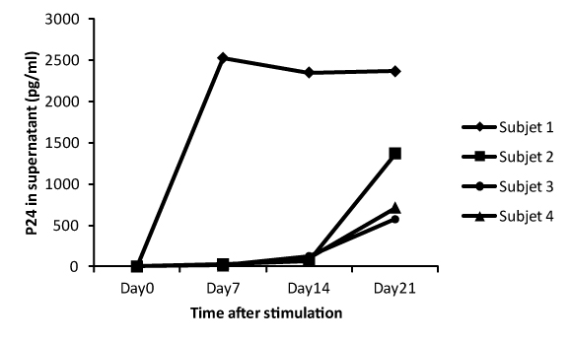
Fig. S7 Virus production was induced from resting CD4⁺ T cells isolated from HIV-1-infected patients on suppressive HAART by anit-CD3/anti-CD28. The viral production in the supernatant was measured by HIV-1 p24 ELISA.

Supplemental Methods
The primer sequences were designed as follows:

Quantitative real-time RT–PCR analysis
SK38, 5’-ATAATCCACCTATCCCAGTAGGAGAAA-3’;
SK39, 5’-TTTGGTCCTTGTCTTATGTCCAGAATGC-3’;
HIVTotRNA-5F, 5’-CTGGCTAACTAGGGAACCCACTGCT-3’;
HIVTotRNA-5R, 5’-GCTTCAGCAAGCCGAGTCCTGCGTC-3’;
β-actin-F, 5’-GCATGGAGTCCTGTGGCA-3’;
β-actin-R, 5’-CAGGAGGAGCAATGATCTTGA-3’;
GAPDH-F, 5’-TGCACCACCAACTGCTTAGC-3’;
GAPDH-R, 5’- GGCATGGACTGTGGTCATGAG-3’;
miR-H3-3p-F, 5’-GCGGCGGTGGATGATTTGTA-3’;
miR-H3-3p-RT, 5’- GTCGTATCCAGTGCAGGGTCCGAGGTATTCGCACTGGATACGACCCTACA-3’;
miR-H3-5p-F, 5’-GCGGCGGAAATCCAGACATAGTC-3’;
miR-H3-5p-RT, 5’- GTCGTATCCAGTGCAGGGTCCGAGGTATTCGCACTGGATACGACATAGAT-3’;
UNIREVERSE, 5’-GTGCAGGGTCCGAGGT-3’;

Quantitative real-time PCR for ChIP assay
HIV5LTRsense398, 5’-TGGGGAGTGGCGAGCCCTCAGATGC-3’;
HIV5LTRantisense493, 5’-GCAGTGGGTTCCCTAGTTAGCCAGA-3’;

Primer extension assay
Total RNAs were isolated from HEK293T cells transiently transfected with pCMV-ΔR8.2 or a control plasmid and harvested 48 hrs later. Primer extension assay was then performed as described previously with some minor modifications [26]. Briefly, 10 μg RNA were hybridized with 5’ radiolabeled DNA oligo-nucleotide complementary to miR-H3-3p and allowed for 1 hr extension at 42°C. The extended primers were separated by denaturing PAGE (15%) and visualized by autoradiography. The probe used to detect miR-H3-3p is 5’ -gatcctacatacaaatc- 3’.

Alu-PCR.
Genomic DNA was extracted from the resting CD4+ T cells isolated from HIV-1–infected individuals. The integrated HIV-1 was first amplified using primer pairs specific to Alu fragments and HIV-1 U3 sequence,, followed by re-amplification with primer pairs within U3 region which are at the upstream of the U3 3’- primer for the first amplification. The primer pairs and procedures described previously was followed [76].
REFFERENCES:
76. Butler SL, Hansen MS, Bushman FD: A quantitative assay for HIV DNA integration in vivo. Nat Med 2001, 7:631-634.

