Figure 1. Timeline of events for two MERS-CoV patients returning to the Netherlands from Saudi Arabia, May 2014*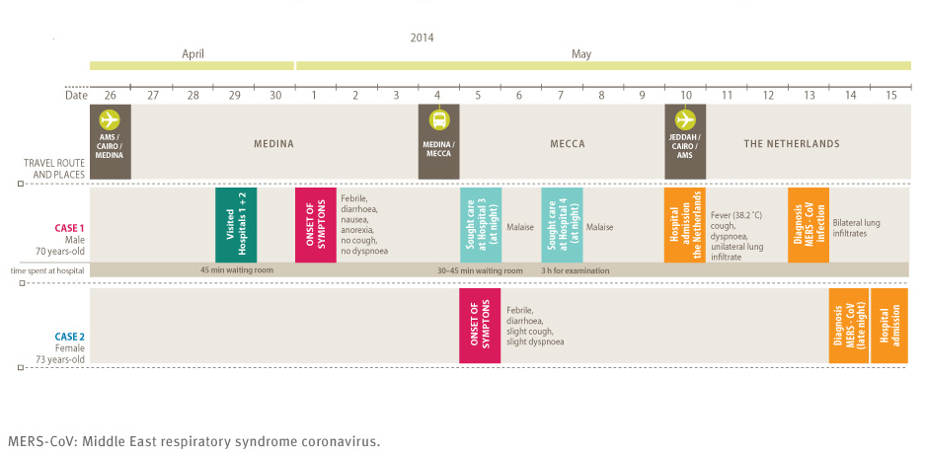
* This is a figure created by Rita de Sousa and published in the following article in Eurosurveillance:
Kraaij – Dirkzwager M, Timen A, Dirksen K, Gelinck L, Leyten E, Groeneveld P, Jansen C, Jonges M, Raj S, Thurkow I, van Gageldonk-Lafeber R, van der Eijk A, Koopmans M, on behalf of the MERS-CoV outbreak investigation team of the Netherlands. Middle East respiratory syndrome coronavirus (MERS-CoV) infections in two returning travellers in the Netherlands, May 2014. Euro Surveill. 2014;19(21):pii=20817.

