Supplemental Table
Secreted levels of IL-1β, HMGB1 and bFGF from BEAS-2B and THP-1 cells in response to silica treatment measured by ELISA.

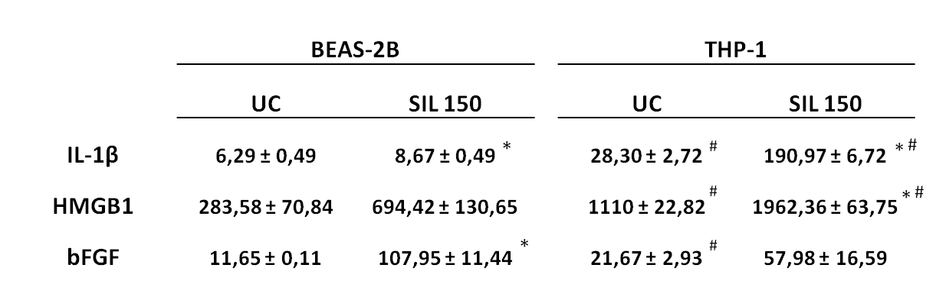
Data represented show IL-1β, HMGB1 and bFGF levels (pg/mL) under baseline conditions and after exposure to 150x10⁶µm²/cm² cristobalite silica (SIL150) for 24h in BEAS-2B and THP-1 cells. * represents p-value < 0,05 for the difference between UC and SIL150 in each cell type. # represents p-value < 0,05 for the difference in concentration between both cell types.

