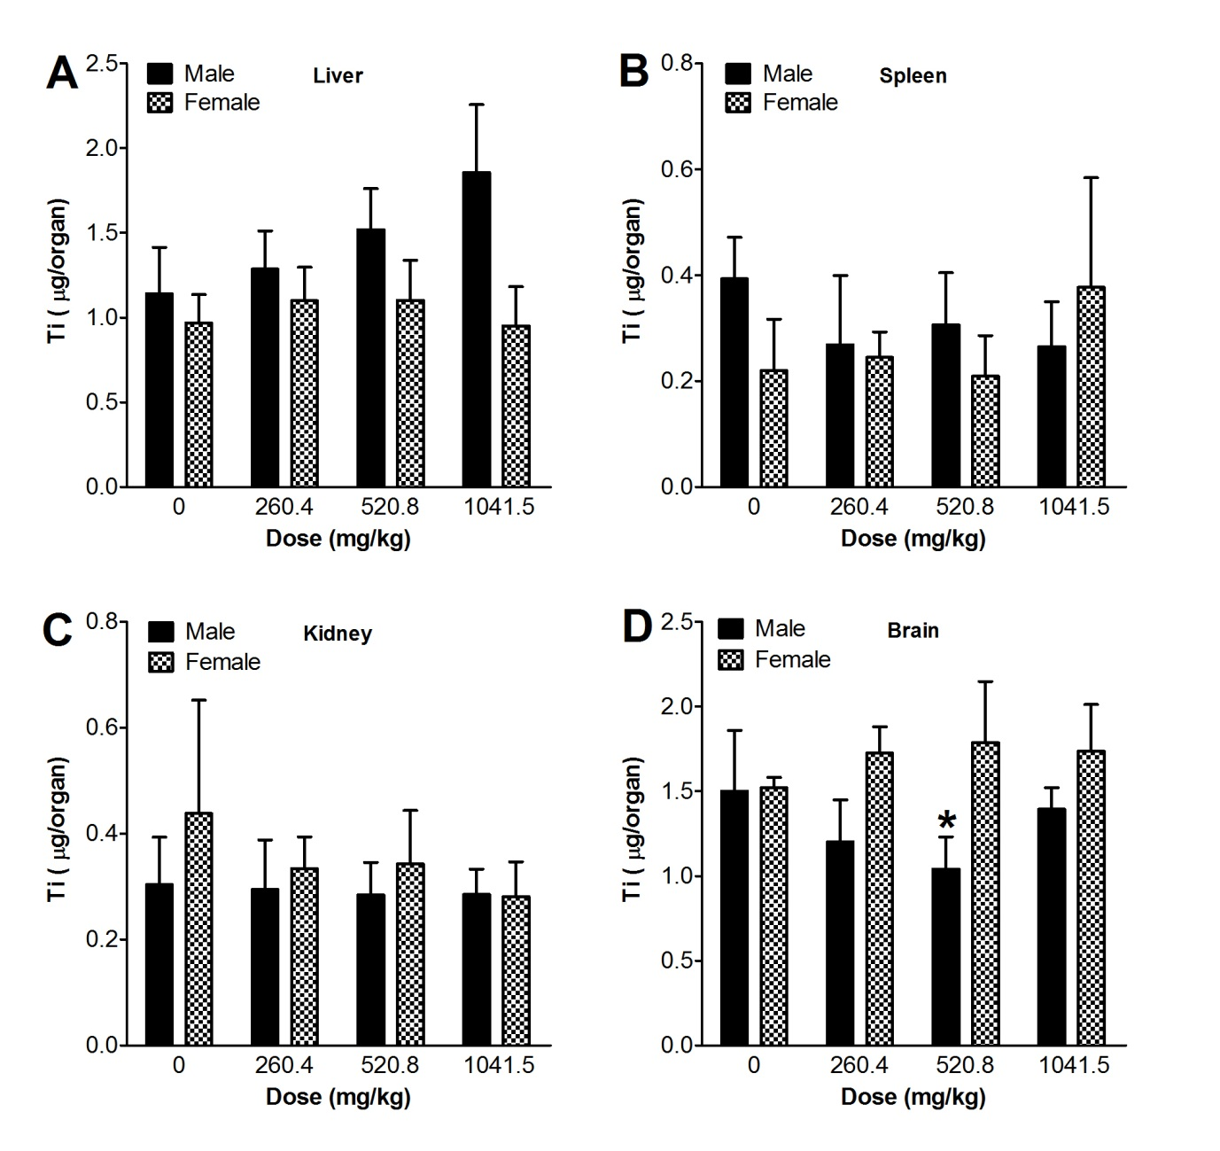
Figure S1. Total concentrations of Ti per organs after 13 weeks of consecutive oral administration of TiO₂ nanoparticles. Values are mean ± S.D. and n = 11. Significance versus vehicle control: * p < 0.05.

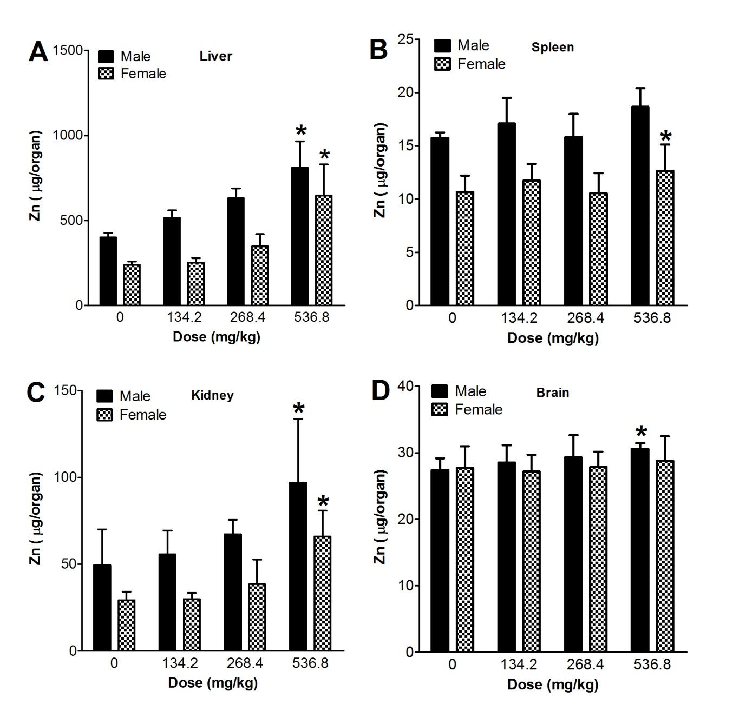
Figure S2. Total concentrations of Zn per organs after 13 weeks of consecutive oral administration of ZnO nanoparticles. Values are mean ± S.D. and n = 11. Significance versus vehicle control: * p < 0.05.

