ADDITIONAL FILE 1
Table A1: Mean (sample standard deviation, inter-trial standard deviation) in absolute (mV²) and relative power for theta, alpha, and beta bands between the ADHD and control group for electrodes Fz, Cz, Pz, and Oz in the eyes-closed condition.

Absolute Power | ADHD |  |  | Control
 | Theta | Alpha | Beta | Theta | Alpha | Beta
Fz | 4.16  (3.46, 5.78) | 0.92  (0.66, 0.45) | 0.21  (0.10, 0.09) | 6.17  (6.01, 13.14) | 1.88  (1.18, 0.92) | 0.35  (0.19, 0.16)
Cz | 1.20  (0.90, 0.89) | 0.77  (0.69, 0.39) | 0.16  (0.10, 0.07) | 2.93  (4.04, 12.85) | 1.76  (1.04, 0.94) | 0.36  (0.23, 0.19)
Pz | 1.64  (0.90, 1.77) | 1.58  (1.77, 0.89) | 0.35  (0.27, 0.18) | 2.60  (2.14, 2.80) | 2.74  (2.23, 1.47) | 0.55  (0.37, 0.27)
Oz | 2.08  (1.47, 2.49) | 1.84  (2.23, 0.86) | 0.43  (0.35, 0.19) | 2.38  (1.49, 2.82) | 3.57  (2.67, 1.82) | 0.72  (0.43, 0.34)

Relative Power X 10⁻² | ADHD |  |  |  |  |  | Control
 |  | Theta |  | Alpha |  | Beta |  | Theta |  | Alpha |  | Beta
Fz |  | 20.18 (3.53) |  | 2.49 (2.01) |  | 0.52 (0.34) |  | 18.70 (4.41) |  | 3.56 (2.60) |  | 0.57 (0.40)
Cz |  | 14.27 (4.75) |  | 5.50 (3.11) |  | 1.19 (0.50) |  | 12.93 (6.59) |  | 6.66 (4.20) |  | 1.15 (0.68)
Pz |  | 12.90 (6.18) |  | 6.04 (3.83) |  | 1.40 (0.62) |  | 11.16 (6.13) |  | 7.37 (3.67) |  | 1.43 (0.92)
Oz |  | 13.96 (6.57) |  | 5.23 (3.81) |  | 1.39 (0.79) |  | 9.69 (4.47) |  | 8.26 (2.95) |  | 1.53 (0.73)

Table A2: Mean (sample standard deviation) in absolute (mV²) and relative power for theta, alpha, and beta bands between the ADHD and control group for electrodes Fz, Cz, Pz, and Oz in the eyes-open condition.

Absolute Power | ADHD |  |  | Control
 | Theta | Alpha | Beta | Theta | Alpha | Beta
Fz | 2.27 (3.16) | 0.18 (0.16) | 0.05 (0.02) | 3.57 (4.44) | 0.30 (0.24) | 0.08 (0.05)
Cz | 2.09 (3.75) | 0.16 (0.19) | 0.04 (0.02) | 2.26 (2.03) | 0.43 (0.43) | 0.10 (0.11)
Pz | 2.35 (3.63) | 0.30 (0.44) | 0.07 (0.07) | 1.70 (2.04) | 0.60 (0.50) | 0.12 (0.10)
Oz | 2.27 (2.65) | 0.28 (0.35) | 0.08 (0.06) | 1.49 (1.79) | 0.53 (0.64) | 0.12 (0.09)

Relative  Power X 10⁻² | ADHD |  |  | Control
 | Theta | Alpha | Beta | Theta | Alpha | Beta
Fz | 18.86 (4.66) | 2.78 (2.42) | 0.82 (0.61) | 18.35 (4.65) | 3.23 (2.73) | 0.80 (0.51)
Cz | 18.31(5.35) | 3.30 (3.09) | 0.79 (0.54) | 16.17 (5.76) | 4.57 (3.66) | 0.96 (0.55)
Pz | 17.42 (5.29) | 3.54 (2.91) | 0.97 (0.59) | 14.33 (6.19) | 5.55 (3.65) | 1.15 (0.72)
Oz | 16.79 (5.65) | 3.61(3.03) | 1.14 (0.69) | 13.77 (6.01) | 5.48 (3.68) | 1.35 (0.67)

Figure A3: Variability in absolute Alpha power (in mV²) for electrode 40 in the eyes closed condition for ADHD subjects on, or off, medication.
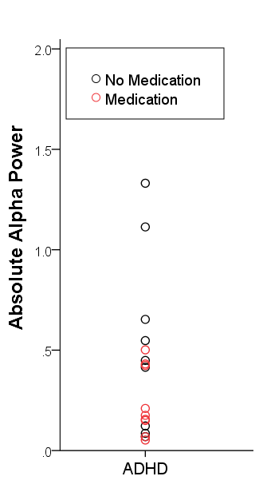

Figure A4: Power (in mV²) x Frequency plot for eyes-closed for Controls, ADHD participants who were on medication, and those ADHD participants who were not.

