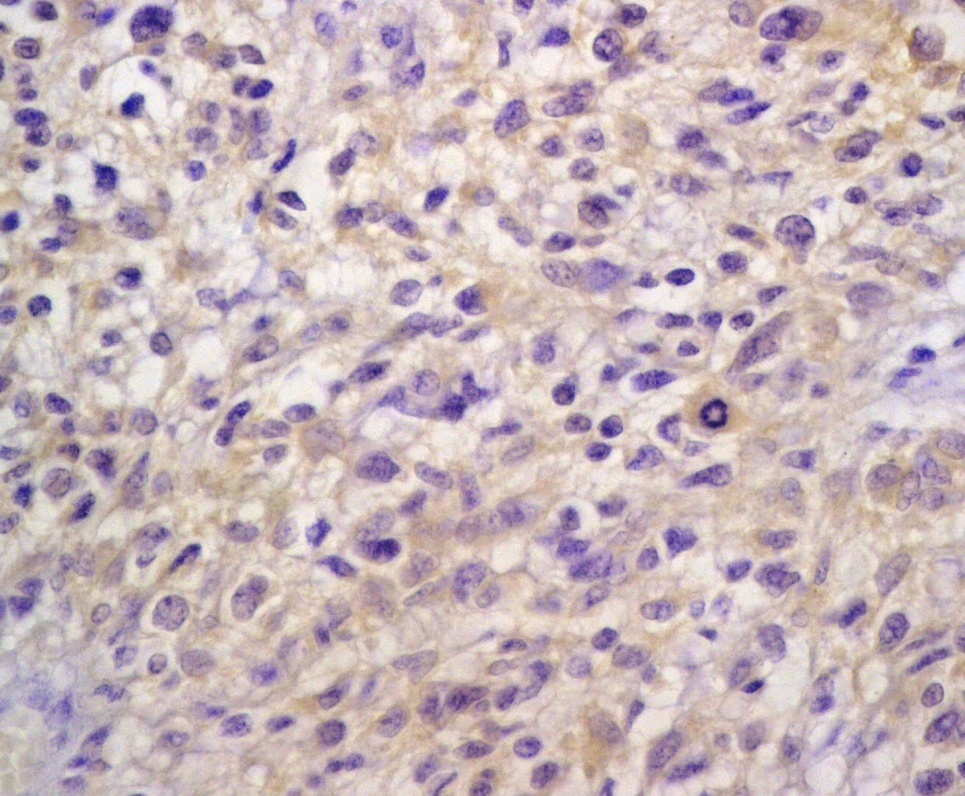
b
Fig. 4b: Moderate staining intensity of DJ-1 in anaplastic astrocytoma (DJ-1 x 400).

