Figure 8 - Median (and interquartile ranges) relative gene expression profiles select genes in articular cartilage (A) and SCB (B) from normal cats and cats with osteoarthritis (OA). *Significant difference.
A.
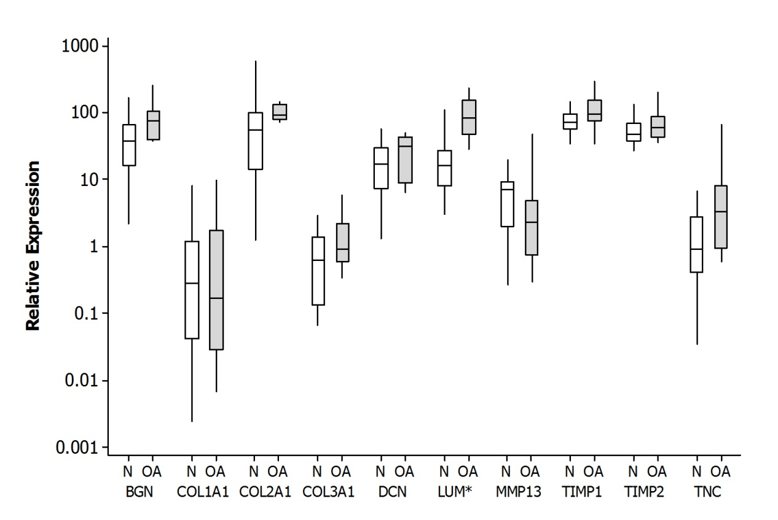

B.
