Additional file 1.

Table S1. Individual data from each dog included in the experimental groups.
ID # | Group | Sex | Age  (years) | Breed | Spaying | Follow-up  (months)¹ | Recurrence | Ki-67 index²
 |  |  |  |  |  |  |  | Computer-assisted | Manual counting
001/08 | Adenoma | F | 7 | Shitzu | Yes | 12 | Yes | 0.24 | 1.33
075/08 | Adenoma | M | 9 | Mongrel | No | 24 | No | 0.22 | 1.00
1101/07 | Adenoma | M | 9 | Siberian husky | No | 9 | Yes | 1.43 | 4.33
1188/06 | Adenoma | M | 9 | Poodle | No | 12 | No | 1.08 | 5.00
1253/07 | Adenoma | F | 5 | Maltese | Yes | 24 | Yes | 0.00 | 0.00
1392/07 | Adenoma | M | 8 | Poodle | No | 18 | No | 0.56 | 1.67
1708/07 | Adenoma | M | 11 | Poodle | No | 12 | No | 0.15 | 0.67
1772/05 | Adenoma | M | 8 | Siberian husky | No | 12 | No | 0.00 | 0.00
260/08 | Adenoma | M | 13 | Poodle | No | 12 | No | 0.78 | 2.00
632/08 | Adenoma | F | 8 | Cocker spaniel | Yes | 8 | No | 0.00 | 0.00
634/07 | Adenoma | M | 7 | Akita | No | 24 | No | 0.27 | 1.00
676/08 | Adenoma | F | 12 | Poodle | No | 24 | No | 0.41 | 1.67
713/05 | Adenoma | M | 9 | English bulldog | No | 24 | No | 0.36 | 1.67
835/08 | Adenoma | M | 10 | Siberian husky | No | 10 | No | 0.60 | 2.67
980/08 | Adenoma | M | 11 | Mongrel | No | 24 | No | 0.51 | 2.33
1148/07 | Epithelioma | M | 15 | Beagle | No | 6 | No | 5.56 | 21.67
1181/07 | Epithelioma | M | 10 | Mongrel | Yes | 10 | No | 2.66 | 12.67
1222/06 | Epithelioma | M | 10 | Rottweiler | No | 24 | Yes | 1.17 | 3.67
1304/06 | Epithelioma | M | 13 | Dachshund | No | 12 | No | 2.42 | 8.67
1365/07 | Epithelioma | M | 10 | Lhasa Apso | No | 12 | No | 1.94 | 7.00
1447/07 | Epithelioma | M | 8 | Akita | No | 24 | Yes | 3.72 | 18.67
1679/07 | Epithelioma | M | 11 | Mongrel | No | 12 | No | 1.41 | 6.00
189/07 | Epithelioma | M | 10 | Mongrel | No | 12 | No | 7.10 | 14.33
236/07 | Epithelioma | M | 11 | Beagle | No | 12 | Yes | 4.02 | 11.33
534/06 | Epithelioma | M | 13 | Pointer | No | 24 | No | 0.54 | 3.00
657/07 | Epithelioma | M | 13 | Cocker spaniel | Yes | 24 | No | 2.70 | 8.33
668/06 | Epithelioma | M | 10 | Poodle | No | 36 | No | 2.31 | 6.67
704/08 | Epithelioma | F | 8 | Mongrel | No | 24 | No | 4.31 | 9.67
858/06 | Epithelioma | M | 11 | Poodle | No | 12 | No | 5.10 | 14.67
873/06 | Epithelioma | M | 10 | Mongrel | No | 8 | No | 2.06 | 15.00
138/06 | Carcinoma | M | 8 | Mongrel | No | 12 | No | 8.47 | 23.00
197/05 | Carcinoma | M | 10 | Mongrel | No | 12 | Yes | 8.89 | 21.67
216/08 | Carcinoma | F | 3 | Mongrel | Yes | 4 | Yes | 24.82 | 39.00
296/06 | Carcinoma | M | 5 | Poodle | No | 6 | Yes | 14.68 | 22.33
521/06 | Carcinoma | M | 12 | Dachshund | No | 24 | Yes | 11.43 | 15.67
554/06 | Carcinoma | M | 6 | Poodle | No | 9 | No | 8.90 | 14.67
566/07 | Carcinoma | M | 11 | Fox Terrier | No | 12 | No | 7.45 | 10.00
677/06 | Carcinoma | M | 11 | Mongrel | No | 5 | Yes | 16.59 | 23.33
678/06 | Carcinoma | M | 10 | Siberian husky | No | 12 | Yes | 11.48 | 31.67
688/06 | Carcinoma | F | 6 | Basset hound | No | 12 | No | 3.09 | 31.33
688/07 | Carcinoma | F | 8 | Cocker spaniel | No | 12 | Yes | 10.03 | 27.00
831/06 | Carcinoma | M | 10 | Akita | No | 7 | Yes | 9.71 | 39.67
C1 | Control | F | 3 | Mongrel | No | - | - | 0.00 | 0.00
C2 | Control | F | 10 | Mongrel | No | - | - | 0.00 | 0.00
C3 | Control | F | 8 | Poodle | No | - | - | 0.00 | 0.00
C4 | Control | M | 9 | Mongrel | No | - | - | 0.01 | 0.33
C5 | Control | F | 10 | Mongrel | No | - | - | 0.00 | 0.00
C6 | Control | M | 5 | Mongrel | No | - | - | 0.00 | 0.00
C7 | Control | M | 9 | Mongrel | No | - | - | 0.00 | 0.00
C8 | Control | M | 6 | Mongrel | No | - | - | 0.00 | 0.00
C9 | Control | M | 8 | Akita | No | - | - | 0.00 | 0.00
C10 | Control | F | 10 | Mongrel | No | - | - | 0.00 | 0.00
C11 | Control | M | 3 | Mongrel | No | - | - | 0.00 | 0.00
C12 | Control | F | 12 | Mongrel | No | - | - | 0.07 | 0.33
C13 | Control | M | 9 | Mongrel | No | - | - | 0.02 | 0.33
¹ time elapsed from the detection of the perianal nodule by the owner to the surgery (nodulectomy)
² median values

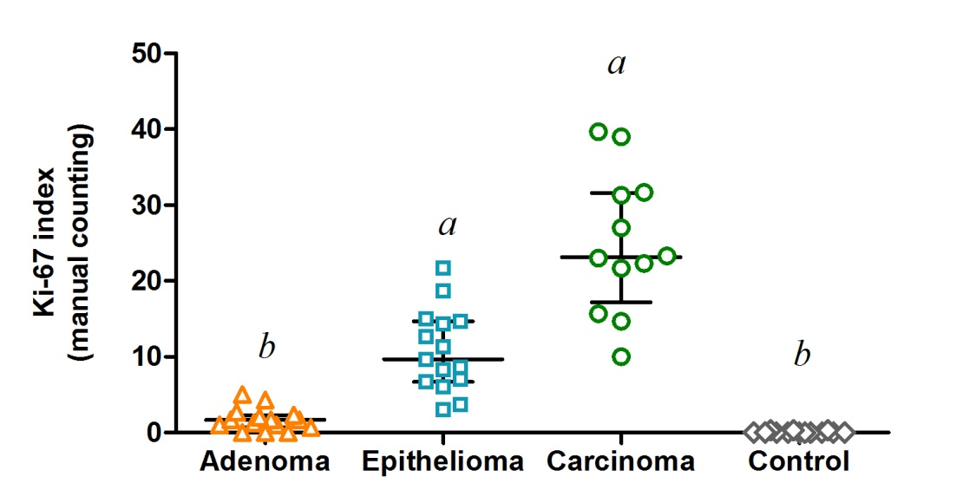
Figure S1. Scatter plot showing the Ki-67 index assessed by manual counting, in different types of canine perianal gland neoplasms: adenoma (n=15), epithelioma (n=15), and carcinoma (n=12), and in control dogs (n=13). Horizontal lines indicate the median and the interquartile range. ^{abc} Groups with no common superscript letter differ significantly by Dunn’s multiple comparison test (P<0.05).

