Figure 2: Representative Case Trajectory: Emerging Patterns
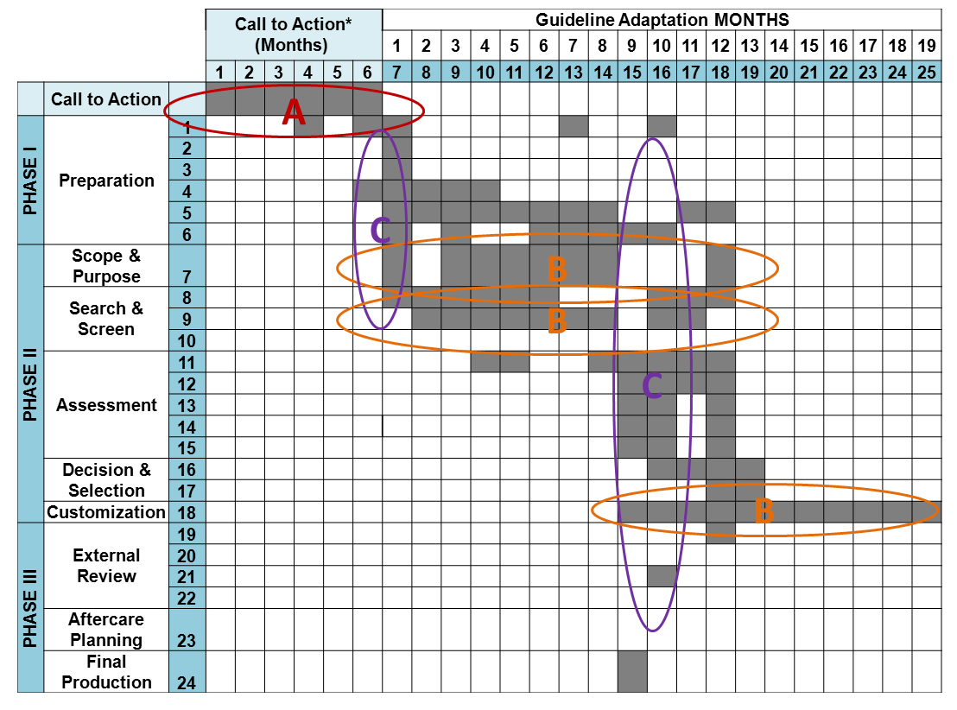
Pattern A: (*new element) a ‘Call-To-Action’ period was observed in groups forming for the first time; distinct from and preceding use of the ADAPTE 3 phase, 24 step guideline adaptation methodology; this activity added as much as 4-6 months to case timeline for guideline initiatives.
Pattern B: Iterative activities required long periods and several cycles, e.g., clinical question refinement and literature searches, evidence appraisal, and customization (drafting and internal review)
Pattern C: Multiple steps/tasks in progress were managed concurrently; not a linear process

