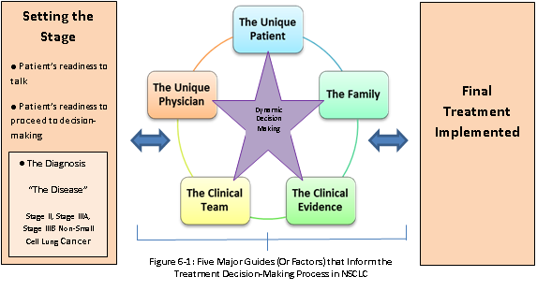
Figure 1. Five Major Guides That Inform Treatment Decision-Making in NSCLC.

