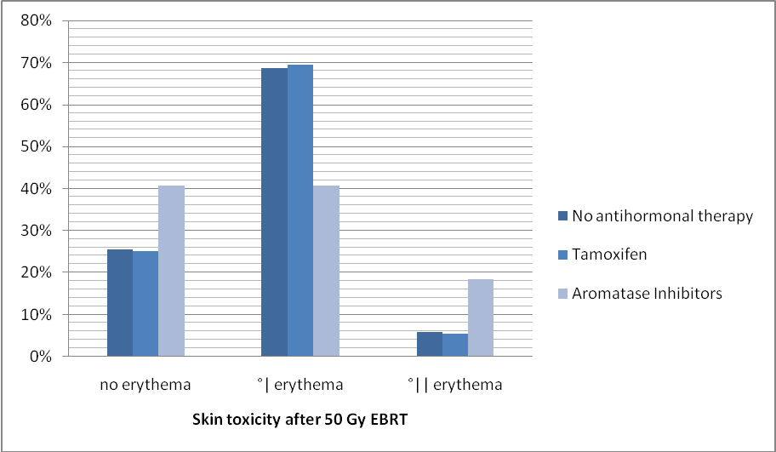

Fig 6.:Antihormonal therapy and skin toxicity after 50 Gy 3D-CRT

