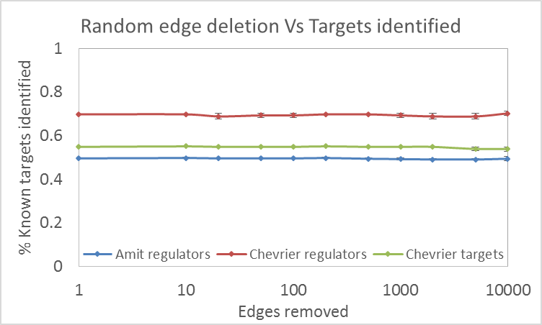
a)
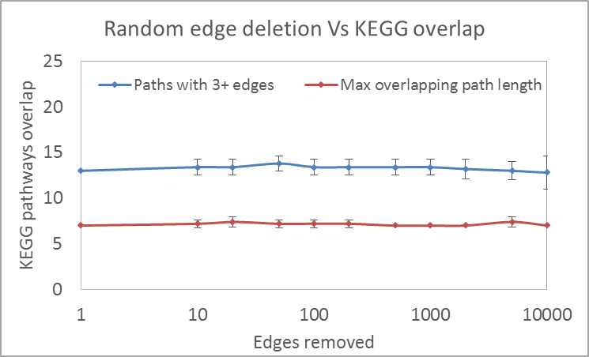b)
Performance of TimeXNet to successive removal of random edges to the initial interaction network. a) Known targets and regulators identified from Amit et al. and Chevrier et al., b) Pathways with up to 3 consecutive edges and the maximum length of overlapping path predicted by TimeXNet in the response network predicted from a basal interaction network with 10, 20, 50, 100, 200, 500, 1000, 2000, 5000, 10000 random edges removed.

