Online solid phase extraction liquid chromatography tandem mass spectrometry (SPE-LC-MS/MS) method for the determination of Sucralose in reclaimed and drinking waters and its photo degradation in natural waters from South Florida

Sudha Rani Batchu¹, Natalia Quinete^{1,2}, Venkata R Panditi^{1,2}, Piero R Gardinali*^{1,2}

¹Department of Chemistry and Biochemistry, Florida International University, Miami, Florida. USA and ²Southeast Environmental Research Center (SERC), Florida International University, Miami, Florida. USA

Email addresses:
Sudha Rani Batchu: sbatc001@fiu.edu
Natalia Quinete: nsoaresq@fiu.edu
Venkata Reddy Panditi: pvenkatreddy06@gmail.com
Piero R Gardinali: gardinal@fiu.edu

*Corresponding author.
Postal Address:
3000 NE 151st ST. FIU Biscayne Bay Campus. MSB-350. North Miami Beach, Florida. 33181. USA.
Tel.: +1 305 348 6354; Fax: +1 305 348 3772

Fig. S1 Structure of sucralose
Fig. S2 Comparison of emission spectrum of a group of 254 nm light source, 350 nm light source and Sun Test versus natural sun light
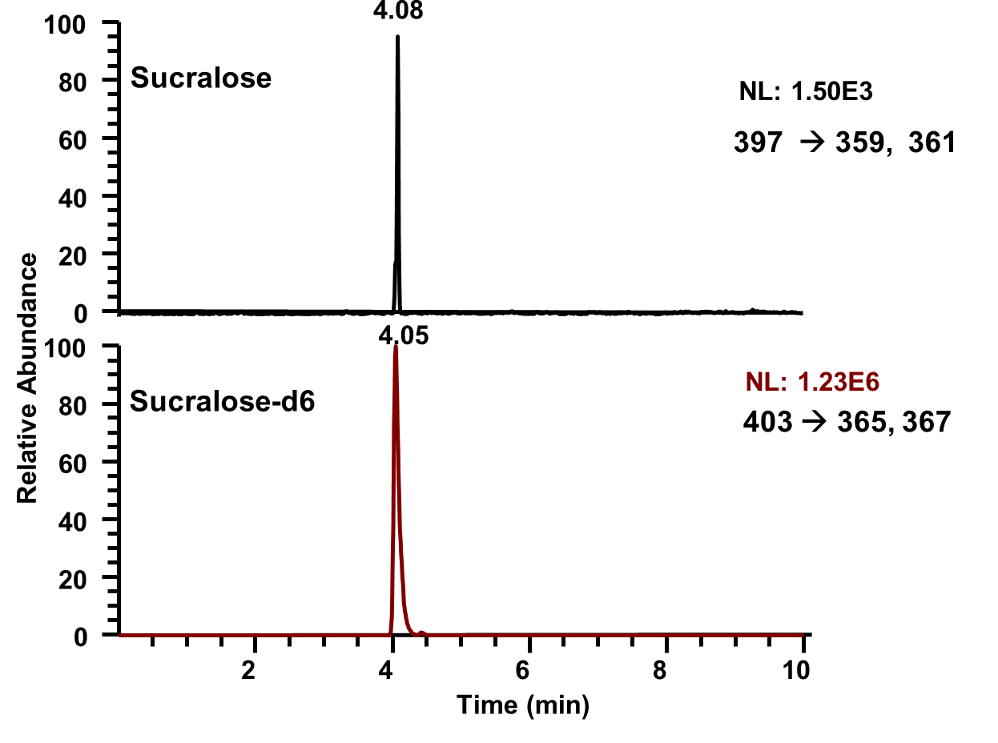
Fig. S3. LC-MS water fortified with sucralose at 200 ng/L (top) LC-MS water fortified with sucralose-d6 (internal standard) at 50 µg/L (bottom). 0.1% formic acid in LC-MS grade water was used as modifier.

Table S1. Characteristics of canal water and sea water used in the experiment
Parameter | Canal water | Sea Water
pH | 8.1 | 7.9
Dissolved organic content (mg-C/L) | 10.4 | 1.37
Electrical conductivity (μS/cm) | 544 | 88000
Fe⁺³ (µg/L) | 187 | 109
Salinity (ppt) | 0.2 | 36

