Supplementary Materials:

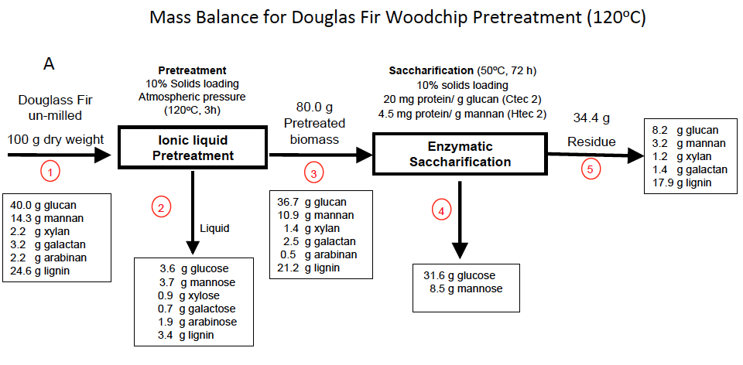

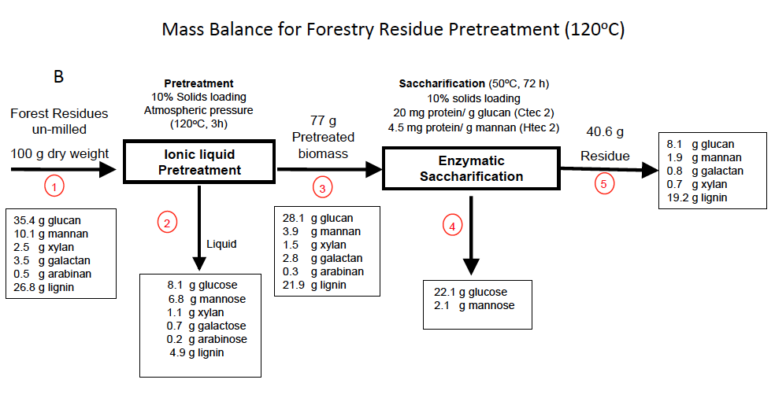

Figure 2: Mass balances for Douglas-fir woodchip and un-milled Forestry Residue Pretreatments at 120 ºC.

