ADDITIONAL FILE 1

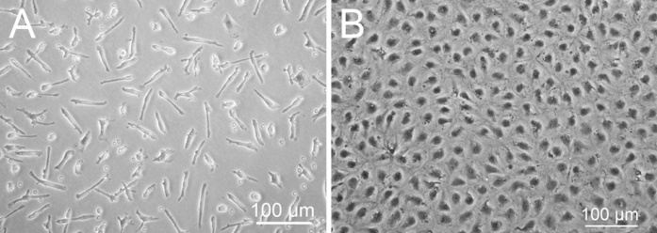
Figure S1. Distinct morphology of different endothelial progenitors. (A) eEPCs are spindle-shaped cells. (B) OECs formed cobblestone cell monolayers.

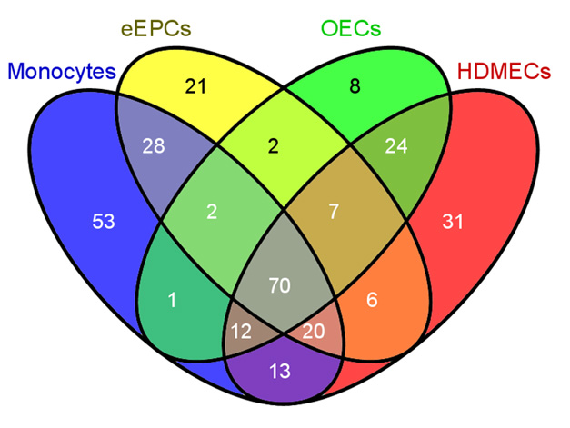
Figure S2. Venn diagram of comparative proteomics showing that the highest number of similar protein spots are found in between monocytes/eEPCs and OECs/DMECs.

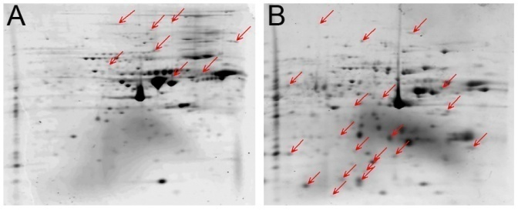
Figure S3. Protein spots characteristic for OECs (A) and eEPCs (B) are indicated by the red arrows.

Table S1
Gene | Primer sequences
HLA-DRA | Forward | TGGAGTCCCTGTGCTAGGAT
 | Reverse | CAGACCGTCTCCTTCTTTGC
LYZ | Forward | CTCATTGTTCTGGGGCTTGT
 | Reverse | TAACCACTCTCCCATTTGGC
CD14 | Forward | AAGAGAGGTGGGGAGGTGAT
 | Reverse | CAGCAGCAACAAGCAGGAC
CAV1 | Forward | GGGGCAAATACGTAGACTCG
 | Reverse | ACTTGCTTCTCGCTCAGCTC
VE-CAD | Forward | TGTGGGCTCTCTGTTTGTTG
 | Reverse | CGACGATGAAGCTGTATTGC
VWF | Forward | TGAGTGCAACGACATCACTG
 | Reverse | TGGAGTACATGGCTTTGCTG

Table S2

Correlation Matrix* for Log-intensity values of PB eEPCs vs. OECs
 | 1 | 2 | 3 | 4 | 5 | 6
1. eEPC.PB.A | 1 | 0.983 | 0.989 | 0.769 | 0.764 | 0.767
2. eEPC.PB.B | 0.983 | 1 | 0.988 | 0.774 | 0.769 | 0.768
3. eEPC.PB.C | 0.989 | 0.988 | 1 | 0.769 | 0.766 | 0.770
4. OEC.PB.A | 0.769 | 0.774 | 0.769 | 1 | 0.972 | 0.967
5. OEC.PB.B | 0.764 | 0.769 | 0.766 | 0.972 | 1 | 0.986
6. OEC.PB.C | 0.767 | 0.768 | 0.770 | 0.967 | 0.986 | 1
* Values generated by paired comparison of samples using NIA array.

Table S3
Clusters of differentially expressed transcripts
eEPC transcripts |  | OEC transcripts
Annotation cluster | Enrichment score* | Annotation cluster | Enrichment score*
Immune response | 9.30 | Developmental process | 2.81
Inflammatory response | 9.25 | Vasculature development | 2.81
Response to stress | 9.25 | Angiogenesis | 2.81
* Value obtained by assessing enrichment of functional categories using DAVID bioinformatics software.

Table S4
Percentage of protein spots that were similar to cell comparator proteome profile
 |  | OECs | DMECs | eEPCs | Monocytes
OECs | Percentage | 100% | 90% | 64% | 67%
 | Number of spots | 126 | 113 | 81 | 85
DMECs | Percentage | 62% | 100% | 56% | 62%
 | Number of spots | 113 | 183 | 102 | 113
eEPCs | Percentage | 52% | 65% | 100% | 77%
 | Number of spots | 81 | 102 | 156 | 120
Monocytes | Percentage | 43% | 57% | 60% | 100%
 | Number of spots | 85 | 113 | 120 | 199

