Supplemental Information

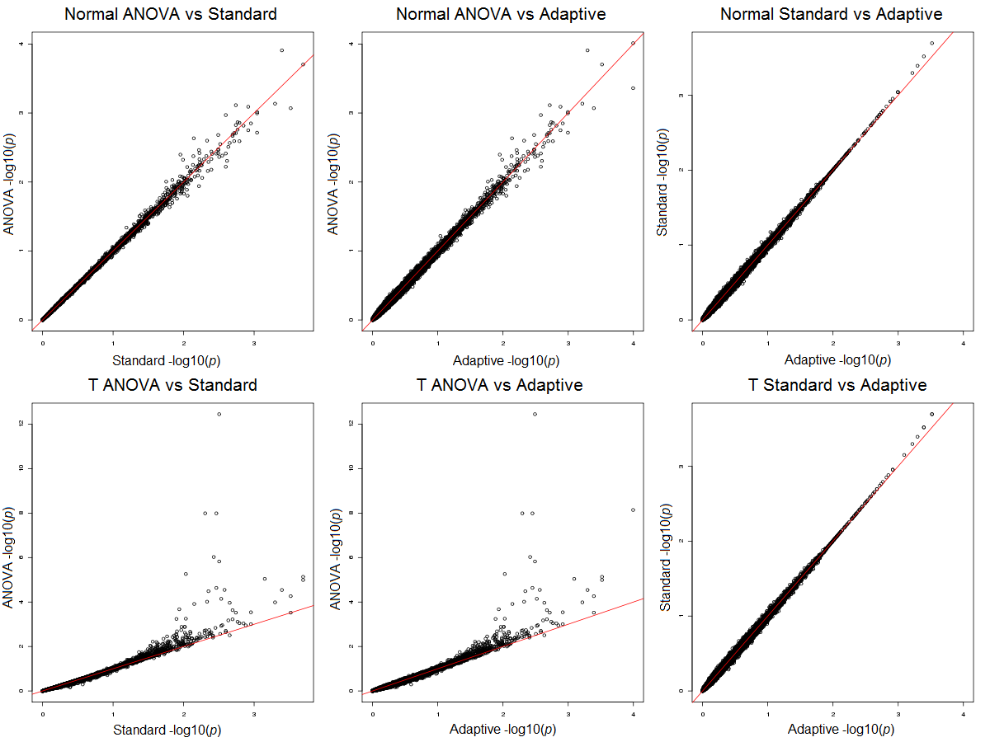
Figure S1: Pair-wise comparisons for ANOVA, standard and adaptive permutation -log10(p) under normal and t (df=5) null model, with 10,000 replications and 9,900 permutations.

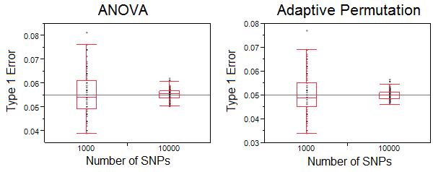
Figure S2: Boxplots of type I error rate of ANOVA (0.055) and adaptive permutation (0.050), under the null t-distribution model (a paired t-test p<0.0001).

Table S1: Computation time (hours) comparison of standard and adaptive permutation for varying effect sizes, with 10,000 SNPs and 99,900 permutations, under the null model.
 | Time
Effect size ($β$) | Standard predicted | Adaptive empirical (SD)
No ($0$) | 37 | 0.33 (0.063)
Weak (0.20) | 37 | 0.71 (0.11)
Moderate (0.50) | 37 | 5.1 (0.44)
Strong (0.80) | 37 | 17 (2.2)
Note: Adaptive permutation time is mean (standard deviation) of 100 replicates. Standard permutation time is predicted based on a multiplicative model (Equation 4).

Figure S3: Pairwise comparison of uncorrected (y-axis) and corrected (x-axis) negative log transformed p-values from a previously published GWAS. Each SNP (point) is colored according to genotype frequencies (AA, Aa, aa), where black denotes at least 20 individuals for all three possible genotypes..

