Additional file 2: Figure S1: Ductular reaction in the study cases.
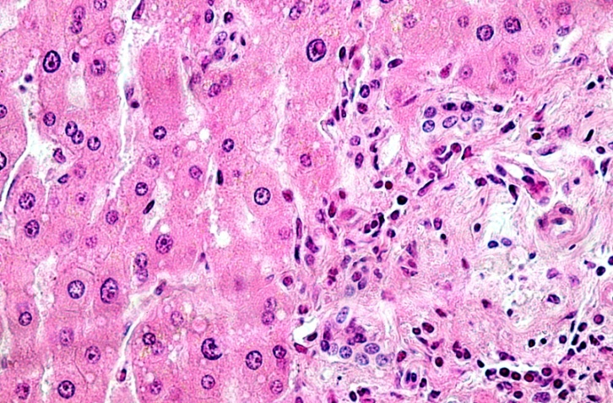
a
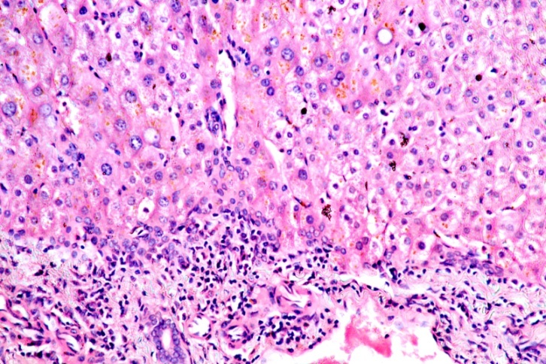
bb

