Additional file 1

TABLE S1. Primer sequences for β-actin and NADH dehydrogenase subunit 5. Primers were designed to validate the reliability and accuracy of our assembly and annotation.
Primer name | Primer sequence | Fragment length (bp)
Beta-actin-Nm (F) | GAAGCTGTGCTATGTTGTCCTC | 450
Beta-actin-Nm (R) | GATCTTGATCTTCATGGTGCTG | 450
NADH (F) | GGCGCATTAGCATCTCAAAT | 414
NADH (R) | GCTCCTGCAAGGGTAACTGA | 414

Figure S1. Visualisation of PCR products. Agarose electrophoresis gel showing two candidate genes beta-actin (A) and NADH dehydrogenase (B) (Molecular marker Hyperladder IV)
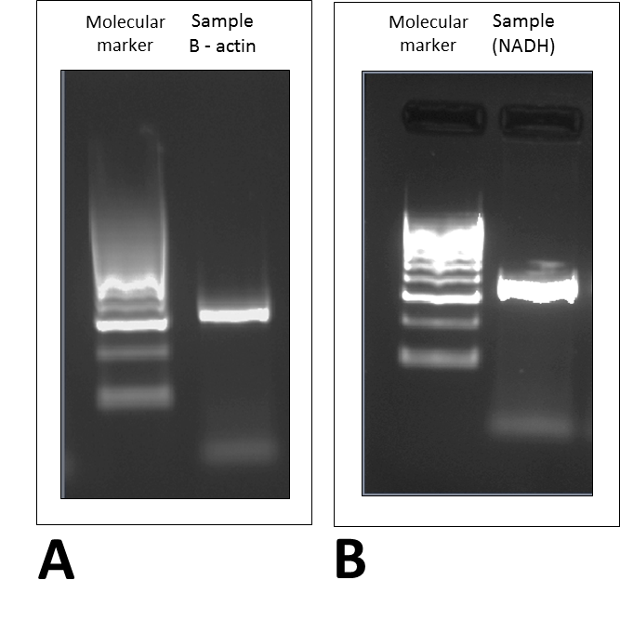
500 bp
300 bp
200 bp
100 bp
Figure S2. Nerita melanotragus transcriptome functional annotation based on Trinity Blast2GO analysis. Functional annotation results indicate the relative amount of each category of contigs with protein hits. The results are summarized as follows: Biological Process (BP), Molecular Function (MF) and Cellular Component (CC).

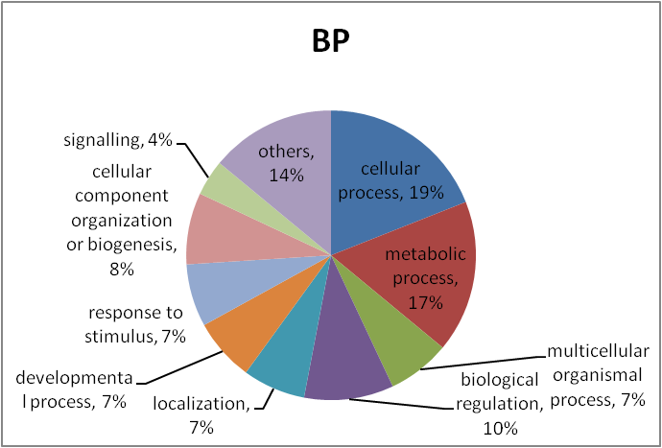

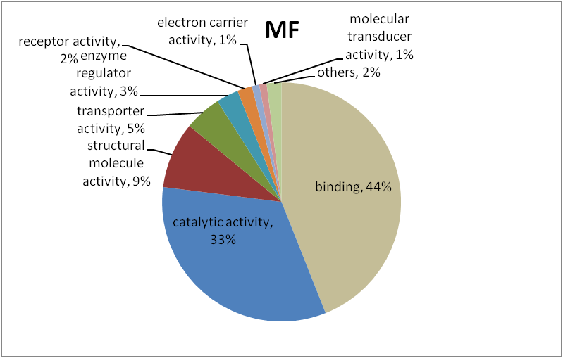
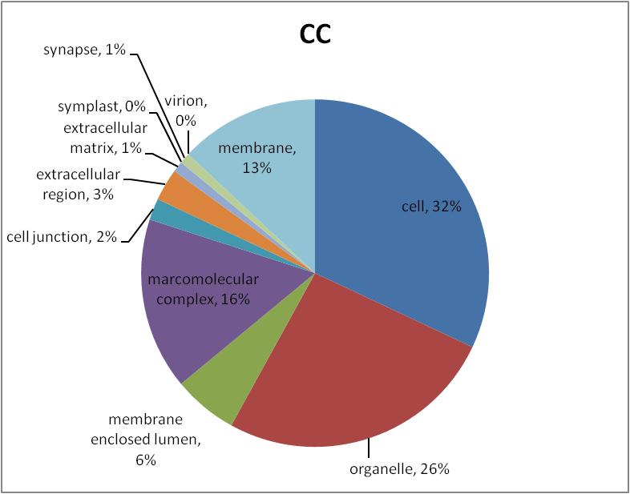

Figure S3. Nerita melanotragus transcriptome functional annotation based on Oases Blast2GO analysis. Functional annotation results indicate the relative amount of each category of contigs with protein hits. The results are summarized as follows: Biological Process (BP), Molecular Function (MF) and Cellular Component (CC).

