Additional file 1
Table A1 Results from model selection of the prevalence of B. burgdorferi in Sogn og Fjordane, Norway. 1 = variable included in model. AIC= Akaike Information Criterion. ΔAIC = difference in AIC relative to the best model. “Municipality” was fitted as a random term.
Stage of tick | log(abundance of ticks+1) | month | altitude | log(distance from the coast) | log(distance from the fiord) | slope | Habitat suitability for red deer | Density of red deer | AIC | ΔAIC
1 | 1 | 1 | 1 | 1 | 1 | 1 | 1 | 1 | 573.2 | 4.2
1 | 1 | 1 | 1 | 1 | 1 | 1 | 1 |  | 574.2 | 5.2
1 | 1 | 1 | 1 | 1 | 1 | 1 |  | 1 | 574.1 | 5.1
1 | 1 | 1 | 1 | 1 | 1 |  |  | 1 | 582.4 | 13.4
1 | 1 | 1 | 1 | 1 |  | 1 |  | 1 | 572.1 | 3.1
1 | 1 | 1 | 1 |  |  | 1 |  | 1 | 572.6 | 3.6
1 | 1 | 1 |  | 1 |  | 1 |  | 1 | 570.5 | 1.5
1 | 1 |  |  | 1 |  | 1 |  | 1 | 573.4 | 4.4
1 |  | 1 |  | 1 |  | 1 |  | 1 | 569.0 | 0
 |  | 1 |  | 1 |  | 1 |  | 1 | 572.5 | 3.5

Table A2. Results from model selection of the prevalence of A. phagocytophilum in Sogn og Fjordane, Norway. 1 = variable included in model. AIC = Akaike Information Criterion. ΔAIC = difference in AIC relative to the best model. “Transect” was fitted as a random term.
Stage of tick | log(abundance of ticks+1) | month | altitude | log(distance from the coast) | log(distance from the fiord) | slope | Habitat suitability for red deer | Density of red deer | AIC | ΔAIC
1 | 1 | 1 | 1 | 1 | 1 | 1 | 1 | 1 | 483.5 | 14.6
1 | 1 | 1 | 1 | 1 | 1 | 1 | 1 |  | 481.9 | 13.0
1 | 1 | 1 | 1 | 1 | 1 | 1 |  |  | 480.0 | 11.1
1 | 1 | 1 | 1 | 1 | 1 |  |  |  | 478.8 | 9.9
1 | 1 | 1 | 1 | 1 |  |  |  |  | 477.0 | 8.1
1 | 1 | 1 | 1 |  |  |  |  |  | 475.5 | 6.6
1 | 1 | 1 |  |  |  |  |  |  | 473.5 | 4.6
1 | 1 |  |  |  |  |  |  |  | 479.1 | 10.2
1 |  | 1 |  |  |  |  |  |  | 471.7 | 2.8
 |  | 1 |  |  |  |  |  |  | 468.9 | 0.0

Figure A1 A map of the study area in Sogn og Fjordane, Norway with prevalence of
(A) A. phagocytophilum and (B) B. burgdorferi at the scale of transects.

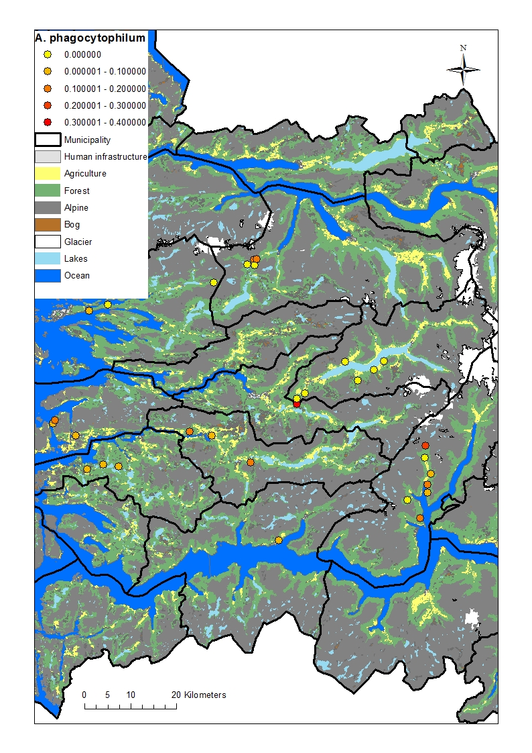

Fig. 1A
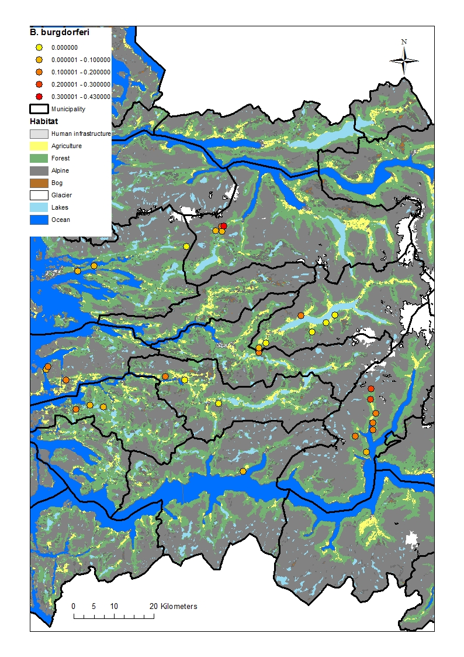
Fig. 1B

