Supplemental Table and Figures
Supplemental Table 1. Percentage of Animals Presenting with Selected Early Clinical Signs on One or More Days Following TBI
rHuIL-12 Dose Group
(ng/kg)
Clinical Sign | 0  (N= 18) | 50  (N= 18) | 100  (N= 18) | 250  (N= 18) | 500  (N= 18)
 | n (%) | n (%) | n (%) | n (%) | n (%)
Vomiting | 13 (72.2) | 12 (66.7) | 9 (50) | 11 (61.1) | 13 (72.2)
Diarrhea | 12 (66.7) | 10 (55.6) | 10 (55.6) | 12 (66.7) | 14 (77.8)

Supplemental Figure 1. Decrease in Physical Activity. Average score for decrease in activity, calculated per live animal, by dose groups. Scoring rubric: 1 = slight decrease; 2 = moderate decrease; 3 = severe decrease.
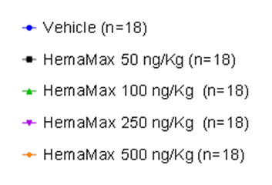
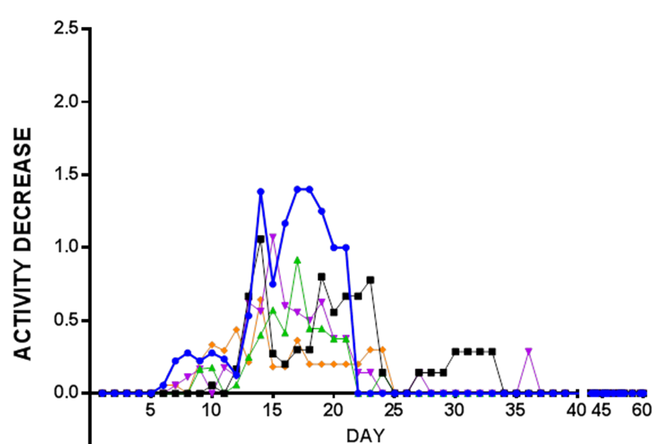

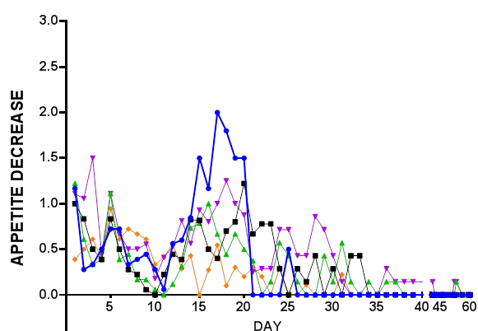
Supplemental Figure 2. Decrease in Appetite Score. Average score for the decrease in appetite, calculated per live animal, by dose groups. Scoring rubric: 1 = slight decrease; 2 = moderate decrease; 3 = severe decrease.

Supplemental Figure 3. Body Weight over Time. Average percent body weight (± standard error of the mean) relative to baseline body weight, by dose group, over time.

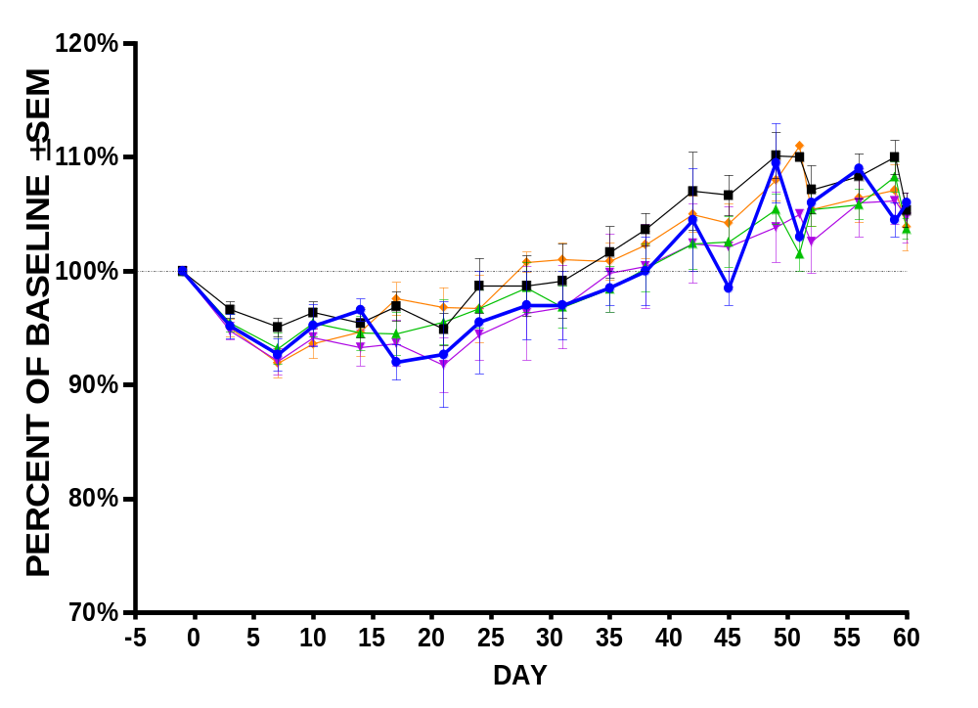

Supplemental Figure 4. Blood counts over time in surviving vs. non-surviving rhesus monkeys exposed to lethal TBI and treated 24 hours after TBI with either vehicle or rHuIL-12 (Average ± SEM).
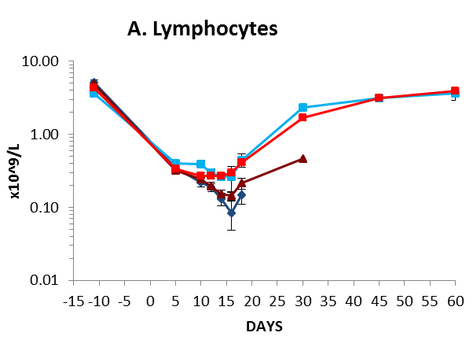
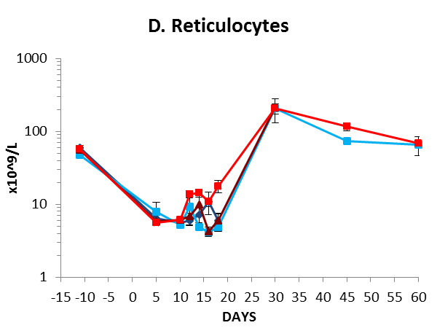
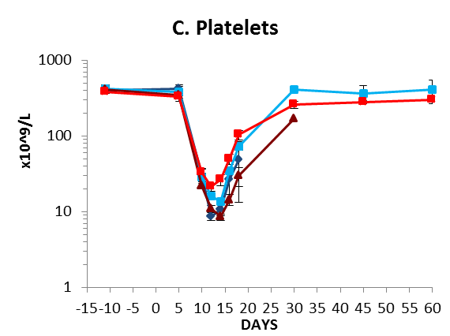
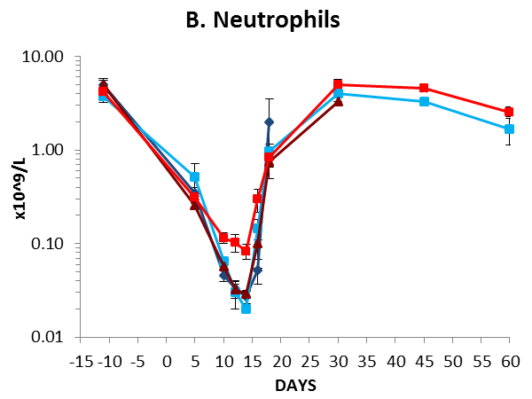
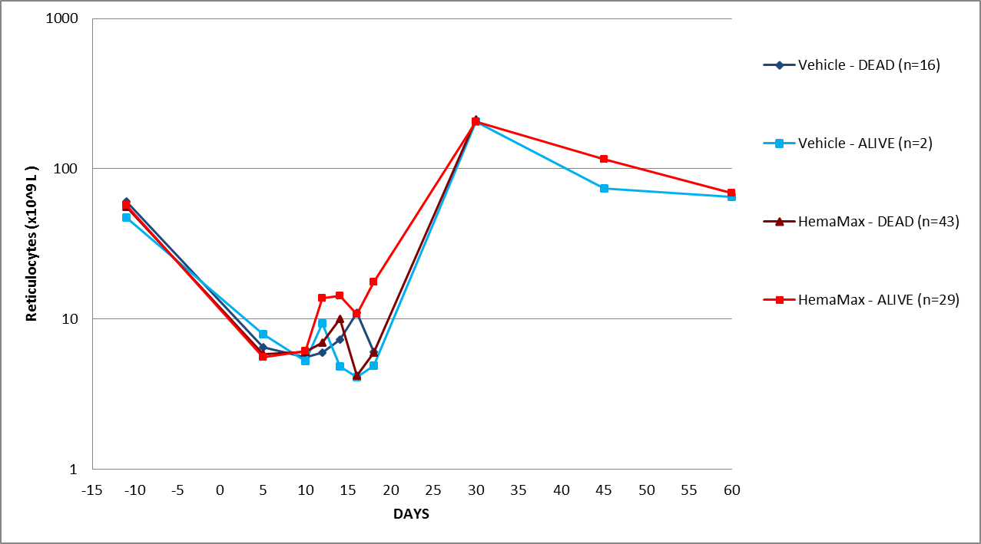
A) lymphocytes; B) neutrophils; C) platelets; D) reticulocytes. Normal ranges are as follows: lymphocytes, 1.85 to 8.71 x 10⁹/L; neutrophils, 1.21 to 10.29 x 10⁹/L; platelets, 252 to 612 x 10⁹/L; reticulocytes, 29.9 to 103.9 x 10⁹/L.

