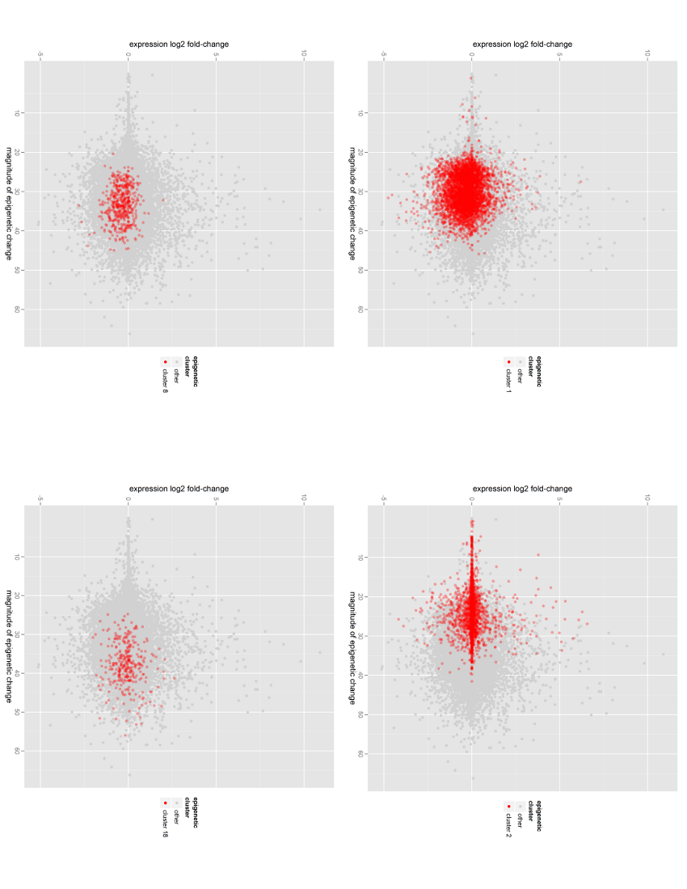
Supplementary Figure S4: Clusters in the differential expression-epigenetic plan

