Supplementary Figure S5: Heat map of differential enhancer clusters
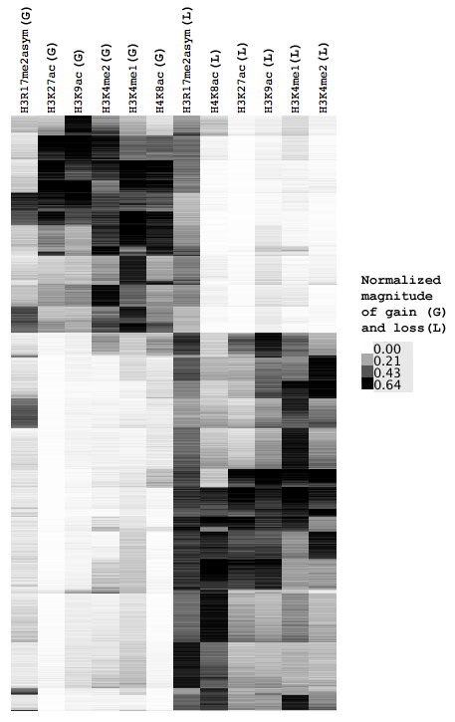
Heat map showing differential enhancer clusters that are either activated or repressed. These clusters generally show gain (G) or loss (L) across all marks, corresponding to activation or repression, respectively. While H3R17me2asym shows correlation with differential H3K27ac levels at enhancers, it has relatively little coherence across the globally activated and repressed clusters. Additionally, of the marks that correlate with differential H3K27ac or H3K4me1 levels at enhancers, H3R17me2asym shows the weakest correlation (Supplementary Figure S1).

