Supplementary Figure S2: Gene segmentation and differential signal quantification
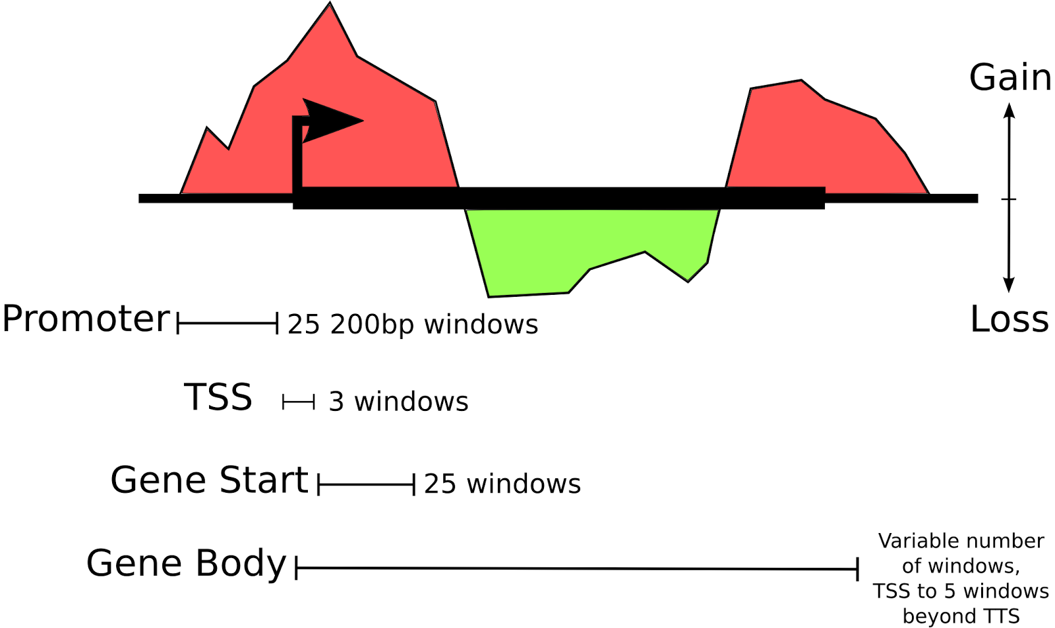

Gene segmentation and differential signal quantification. Gene loci were segmented into four regions: promoter, TSS, gene start, and gene body. Within each segment two values were computed for each mark: the sum of the differential gain in the mark, and the sum of the differential loss in the mark (absolute value, mesenchymal minus epithelial). These values together form the differential epigenetic profile (DEP) for each gene. Enhancers were treated similarly; however, enhancer loci were not segmented.

