MS: 8974494011141216
Pahl - Macrophages inhibit human osteosarcoma cell growth after activation with the bacterial cell wall derivative liposomal muramyl tripeptide in combination with interferon-gamma

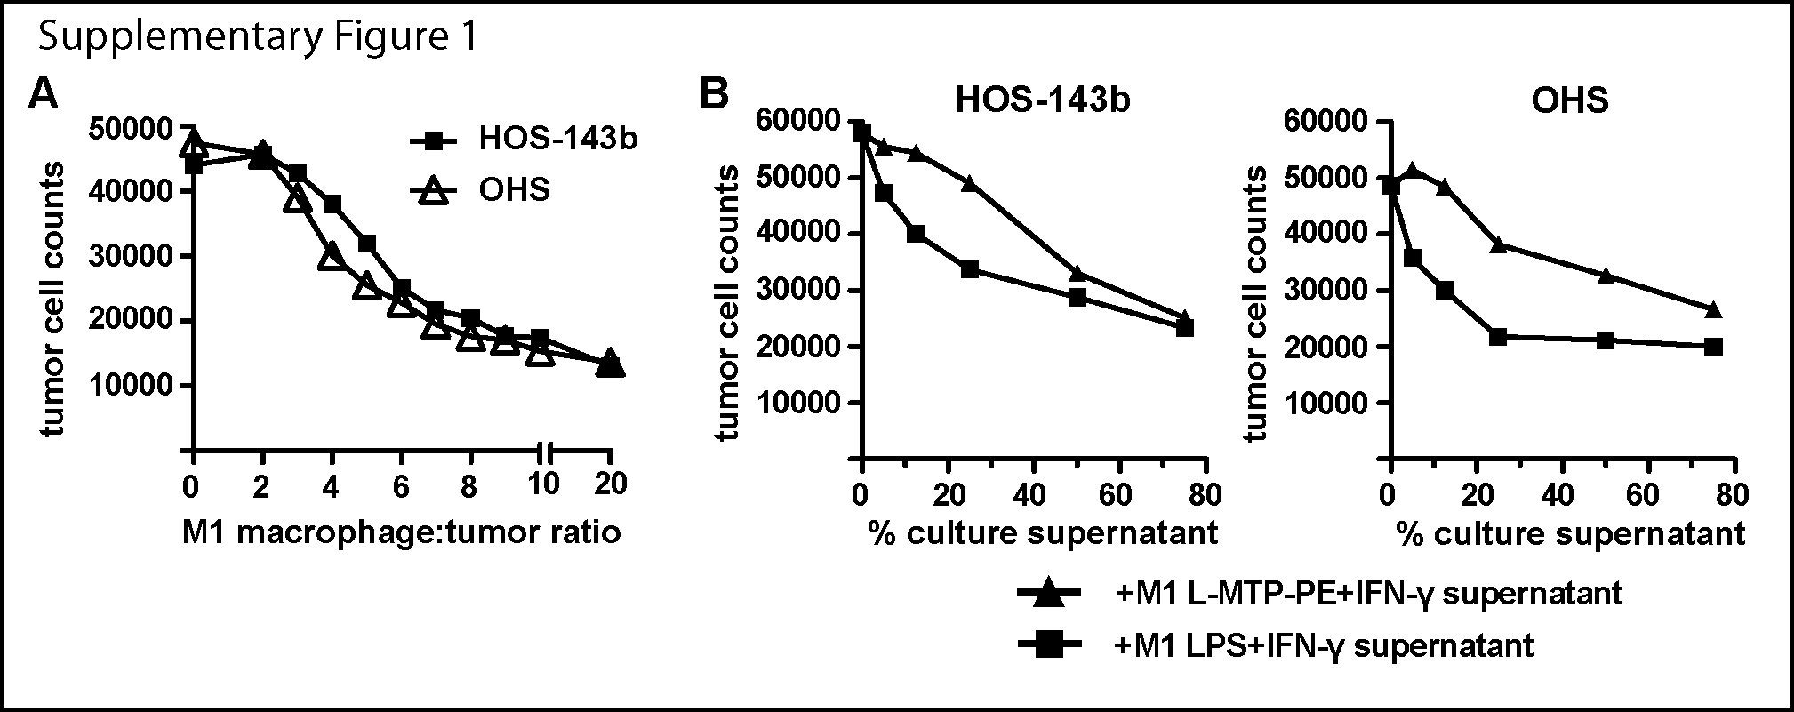

Inhibition of tumor cell growth by activated M1-like macrophages is dose-dependent
(A) HOS-143b and OHS cells were incubated with increasing numbers of LPS+IFN-γ–activated M1-like macrophages as indicated by the macrophage:tumor ratios from 0 to 20. (B) HOS-143b and OHS cells were incubated with increasing amounts of cell-free culture supernatant of LPS+IFN-γ and L-MTP-PE+IFN-γ–activated M1-like macrophages as indicated by the percentage of culture supernatant present during tumor cell culture. Of note, supernatant from LPS+IFN-γ-activated M1-like macrophages was slightly more potent in tumor growth inhibition than supernatant of L-MTP-PE+IFN-γ activated M1-like macrophages.

